IN BRIEF – The use of AI tool for the video
This film was created through a fully AI-assisted creative process. I used ChatGPT as a research and creative partner to explore Gyeonggi-do, identify its most iconic and meaningful locations, and develop the visual concepts behind the project. ChatGPT was also used to design the imagery and generate the prompts later transformed into moving images using Kling AI.
The video sequences were produced with Kling AI, while the voice narration is based on my own voice, transformed and reinterpreted through Voices AI to better match the film’s poetic and dreamlike tone. One of the two musical tracks was also composed by me using AI tools, created specifically for this film through Suno, blending sound design and music into a unified emotional experience. Editing was made by CapCut, using AI for effects of filter to the voice.
Rather than using artificial intelligence as a mere technical tool, this project embraces AI as a creative collaborator—one that helps translate memory, silence, and imagination into a cinematic language capable of speaking to a global audience.

CHATGPT – Image creation and prompt definition
Some Examples of the chatgpt project
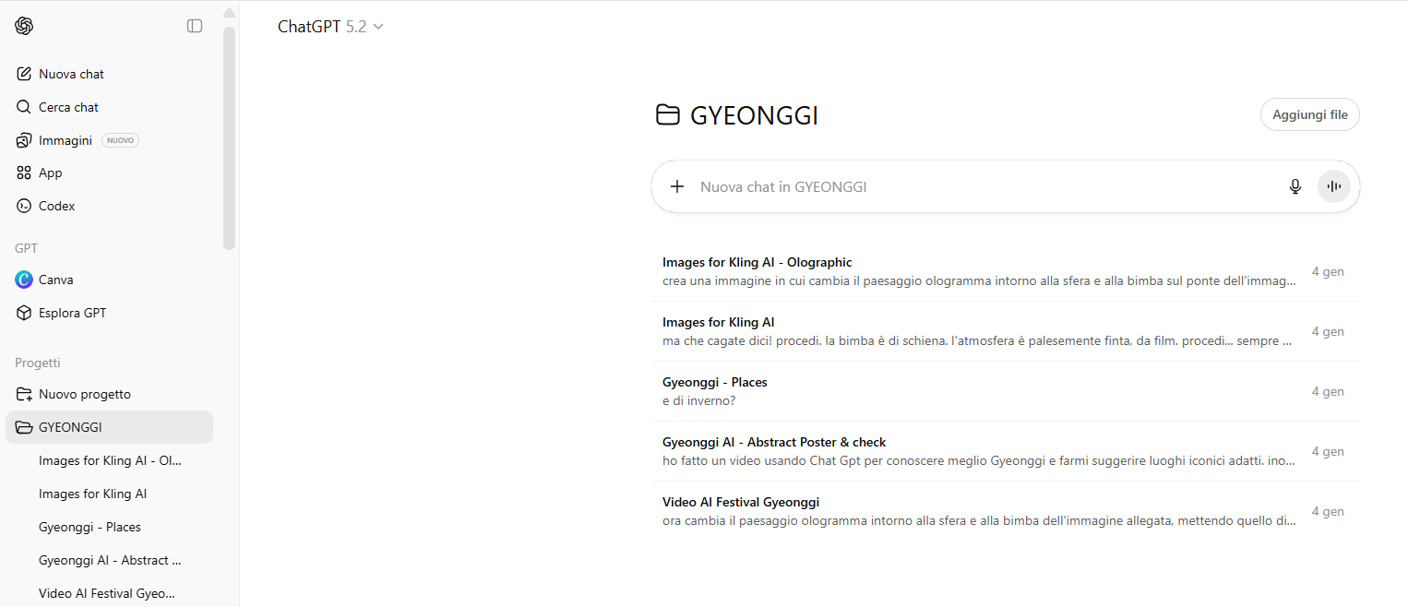
- Research assistant and real images collection
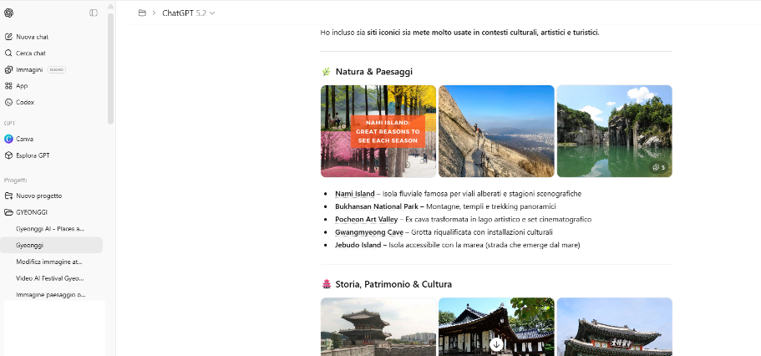
- Images creation
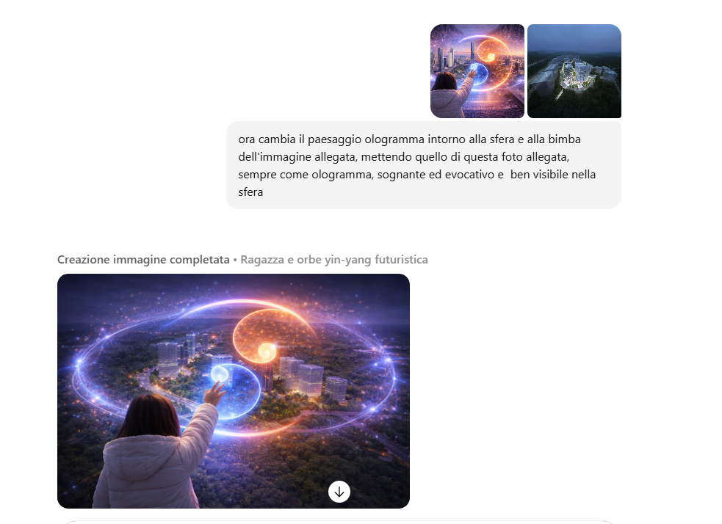
- Prompt design optimization for kling AI
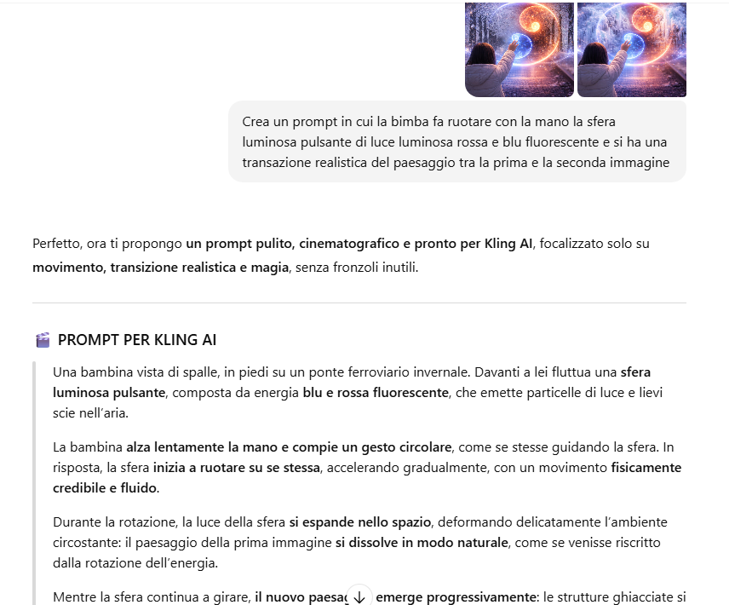

KLING AI – Video generation
Feature used: mostly image to video (usually turbo 2.5 or 1.6)
Some Examples:
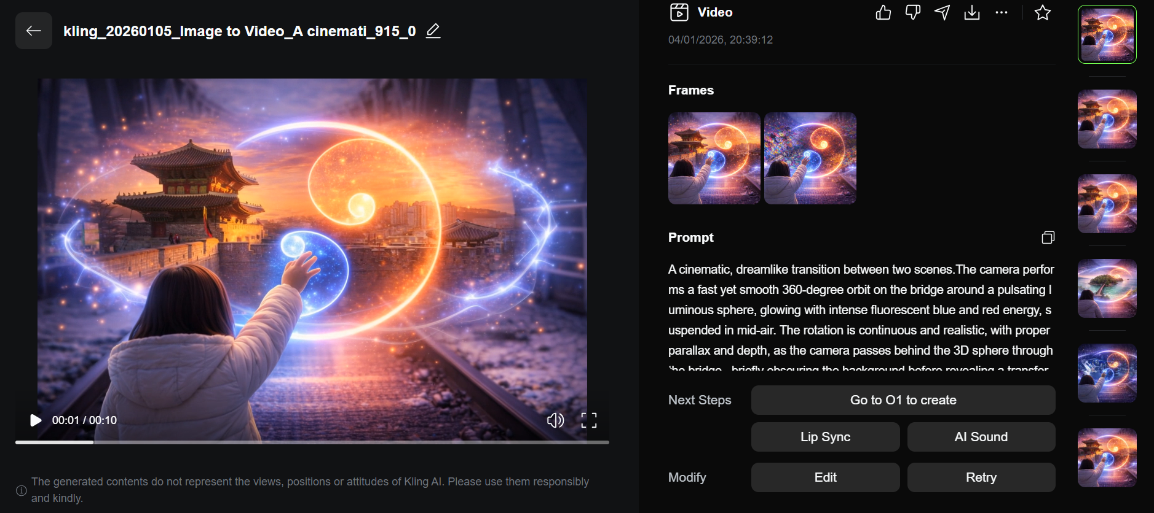
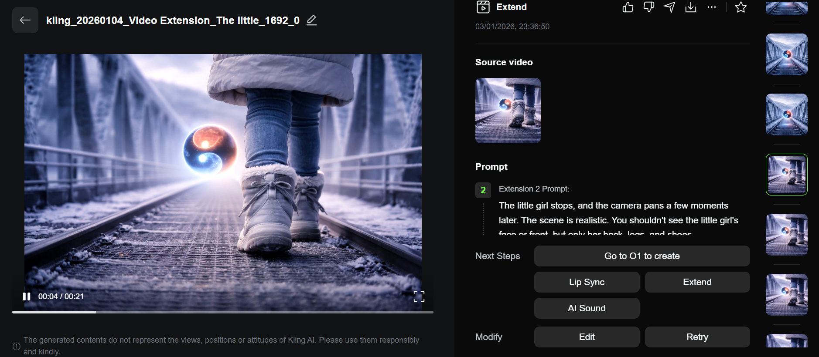

SUNO – Music
