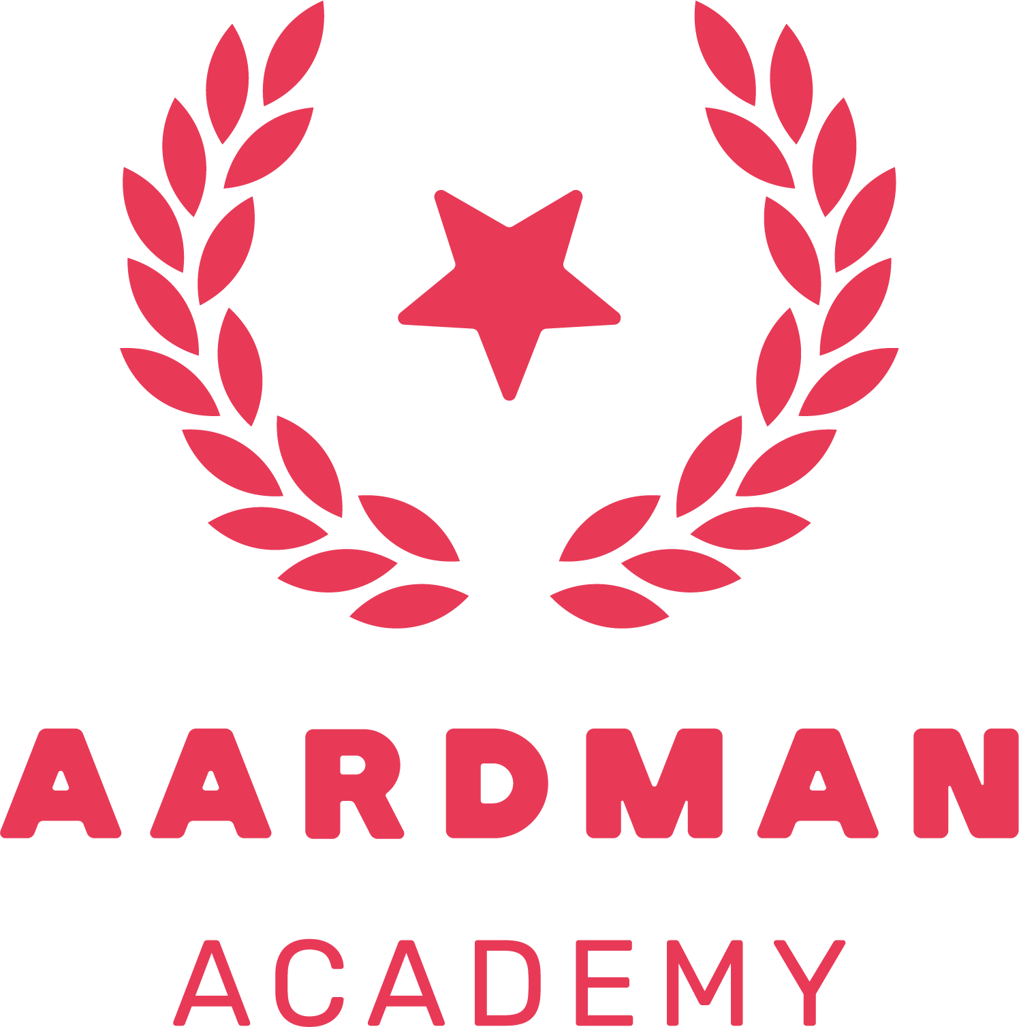

PROOF OF STUDENT STATUS

Student Name: Tortor Smith

Details of Study
- Date of Course Start: November 2023
- Date of Course End: June 2024
- Name of Course: In Studio Stop Motion
      - Course Leader: Mark Simon Hewis

For any further details or references, please feel free to contact us directly at academy@aardman.com.

All the best,
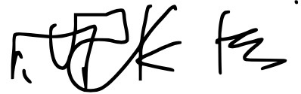

Mark Simon Hewis
Head of the Aardman Academy
Aardman Animations Ltd
Gas Ferry Road
Bristol.
Bs1 6Un

