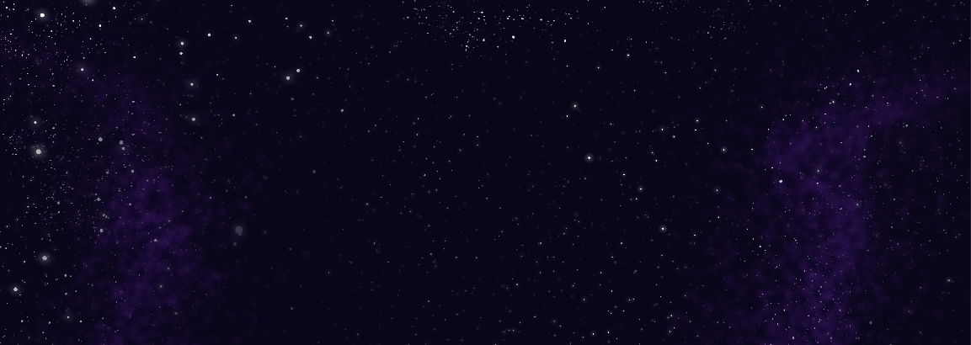

A film by Ash Bieber
bieber.ashton@gmail.com
SYNOPSIS
An alien student enrolled in an exchange program comes to Earth to experience a real-life human school. An unsuccessful attempt at fitting in later, they are approached by a lone boy that knows exactly how it feels to fall outside of the norm.

DIRECTOR BIOGRAPHY
Ash is a queer artist born and raised in the Lafayette, Louisiana area. From a young age, he’s always been fascinated with the art of animation and stories told using the medium. During his time at UL, Ash came to realize his love for storyboarding and plans to pursue a path as a story artist for animation. His work often portrays a silly, lighthearted type of humor, as he is always looking for laughter in his everyday life. Even so, Ash is typically drawn to emotional stories of internal conflict. As a transgender man, he finds much of his inspiration in topics of identity, personal connection, and social norms.

DIRECTOR’S STATEMENT
The preteen phase is filled with enough change as it is—try discovering that your gender doesn’t match your body and moving to a new school full of people you don’t know, who certainly don’t want to know you because you’re strange and weird. At such an age where your reputation is everything, appearing different is by far the worst thing imaginable. Though despite feeling like all hope is lost, just one single connection can make all the difference. These are triumphs and pitfalls that I have faced during my own youth that reflect themselves in my work. I have always felt myself drawn to stories of internal struggle that utilize fictional characters and animated worlds. Animation to me is a wholesome, heart-warming reprieve from a harsh reality, where I can lose myself in the characters' lives and empathize with their stories as a way of dealing with my own struggles. In my work, I reflect on important yet difficult topics of self-identity and connection through a fun, lighthearted lens that still manages to resonate emotionally.

