PRESS RELEASE
PRIMORDIAL
A Poetry Film (GREECE, 2024)
by George Zorbas & Nana Papadaki

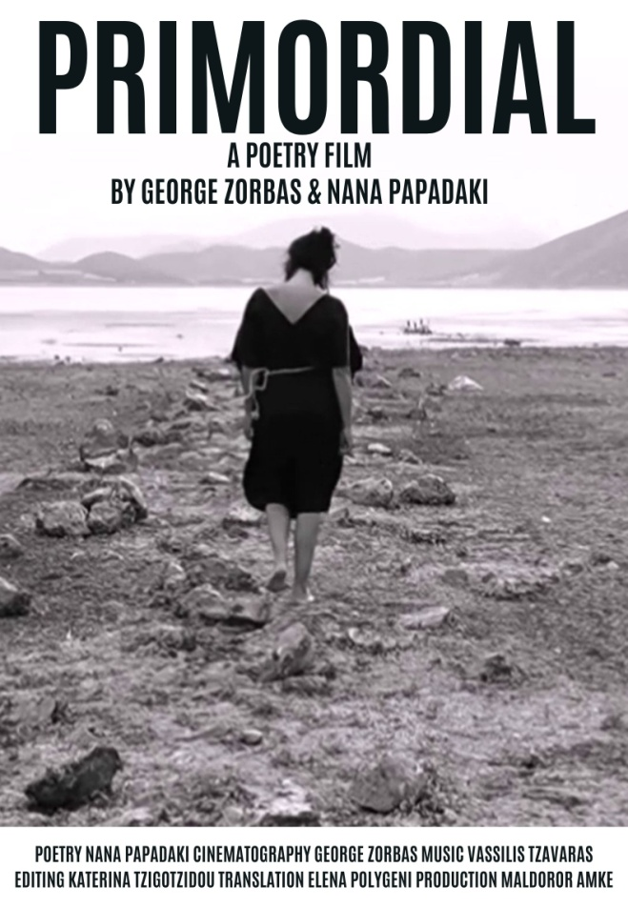
- AWARD WINNER BEST INDIE SHORT FILM, CAMBRIDGE SHORT FILM FESTIVAL, CAMBRIDGE, UNITED KINGDOM 2025
- AUDIENCE CHOICE AWARD [STORY.LAND] INTERNATIONAL SHORT FILM FEST, PLOVDIV, BULGARIA 2025
- OFFICIAL SELECTION LOS ANGELES MOVIE AND MUSIC VIDEO AWARDS, LOS ANGELES, CALIFORNIA, USA 2025
- AWARD WINNER BEST EXPERIMENTAL FILM (OUTSTANDING ACHIEVEMENT) & BEST EXPERIMENTAL FILM – DIRECTOR (SPECIAL MENTION) iDEAL INTERNATIONAL FILM FESTIVAL iIFF 2025, SILLOD, MAHARASHTRA, INDIA 2025
- ΟFFICIAL SELECTION ΒEST INSPIRATIONAL FILM, YOUR WAY INTERNATIONAL FILM FESTIVAL, MALTA 2025
- OFFICIAL SELECTION NEW YORK FILM & ACTRESS AWARD, NEW YORK, USA 2025
- OFFICIAL SELECTION ΝΕW YORK FILM & CINEMATOGRAPHY AWARDS, NEW YORK, USA 2025
- OFFICIAL SELECTION ART GIRAFFE INTERNATIONAL FILM FESTIVAL, NICE, FRANCE 2025
- POETRY EXPO 2025, VERSOPOLIS, THE ECOLOGY OF LANGUAGE – POETRY AND ENVIRONMENTAL ACTION
- ΟFFICIAL SELECTION BELGRADE INTERNATIONAL FILM FESTIVAL BIFF, BELGRADE SERBIA 2025
- AWARD WINNER POETRY INTERNATIONAL ART FILM FESTIVAL IAFFEST 2024, LONDON 2024
- AWARD WINNER BEST EXPERIMENTAL FILM SPECIAL JURY AWARD, ASIAN TALENT INTERNATIONAL FILM FESTIVAL 2024, AHMEDNAGAR, MAHARASHTRA INDIA 2024
- OFFICIAL SELECTION HELIOS: FESTIVAL INTERNACIONAL DE CINE POETICO IV. MEXICO CITY, MEXICO 2024
- OFFICIAL SELECTION 3rd SPICY INDIE INTERNATIONAL FILM FESTIVAL SIIFF 2024, ATHENS 2024
- OFFICIAL SCREENING INTERNATIONAL PERFORMANCE POETRY BIENNIAL SYMPOSIUM-FESTIVAL PERPOSF 2024, THESSALONIKI 2024
- OFFICIAL SELECTION SHORT SHOT FEST, MOSCOW 2024
- OFFICIAL SELECTION FESTIVAL FOTOGENIA, MEXICO 2024
- AWARD WINNER CINEMATIC ACHIEVEMENT AWARD, 2nd KARDITSA INTERNATIONAL SHORT FILM FESTIVAL OPSEIS KISFFO 2024, KARDITSA 2024
- OFFICIAL SELECTION EXPERIMENTAL BRASIL, RIO DE JANEIRO 2024
- OFFICIAL SCREENING 10th TINOS INTERNATIONAL LITERARY FESTIVAL 2024, TINOS 2024
- OFFICIAL SELECTION 11th INTERNATIONAL VIDEO POETRY FESTIVAL, ATHENS 2024

ABOUT THE FILM
The film PRIMORDIAL establishes an inner dialogue between poetry and a timeless landscape. Through cinema, word and music the film reflects nature’ s abandonment, spiritual emptiness and ending times through the eyes of a woman, who could be nature, history, an idea or just a human being of our times.
DIRECTORS’ BIOGRAPHY
GEORGE ZORBAS has studied Film Directing and Sound Engineering. He works as video director, assistant theater director, lighting designer, sound engineer and production manager, at several theater performances and films.
NANA PAPADAKI is an actress, director and poet. She is a graduate of Karolos Koun Greek Art Theater, E. Hatzikou Film School, Athens University of Economics and Business and German School of Athens. As an actress she has collaborated with Karolos Koun Greek Art Theater, National Theater of Greece, National Theater of Northern Greece, Athens and Epidaurus Festival, Municipality Theater of Piraeus etc. She has directed three theater plays and published four poetry books.
Their ARTISTIC COLLABORATION includes many theatre plays presented, among others, in Athens, Elefsis, Skiathos and Brussels. Their latest theater work was subsidized by Greek Ministry of Culture and presented under the auspices of Greek Ministry of Culture and Swedish Institute of Athens.
DIRECTORS’ STATEMENT

The film PRIMORDIAL expands our artistic collaboration from theater stage to film poetry, experimental film and the art of video poetry. It explores the potential of non-narrative construction and broadens our look into nature and the core of existence. The film is based on the poetry book of same name by Nana Papadaki.
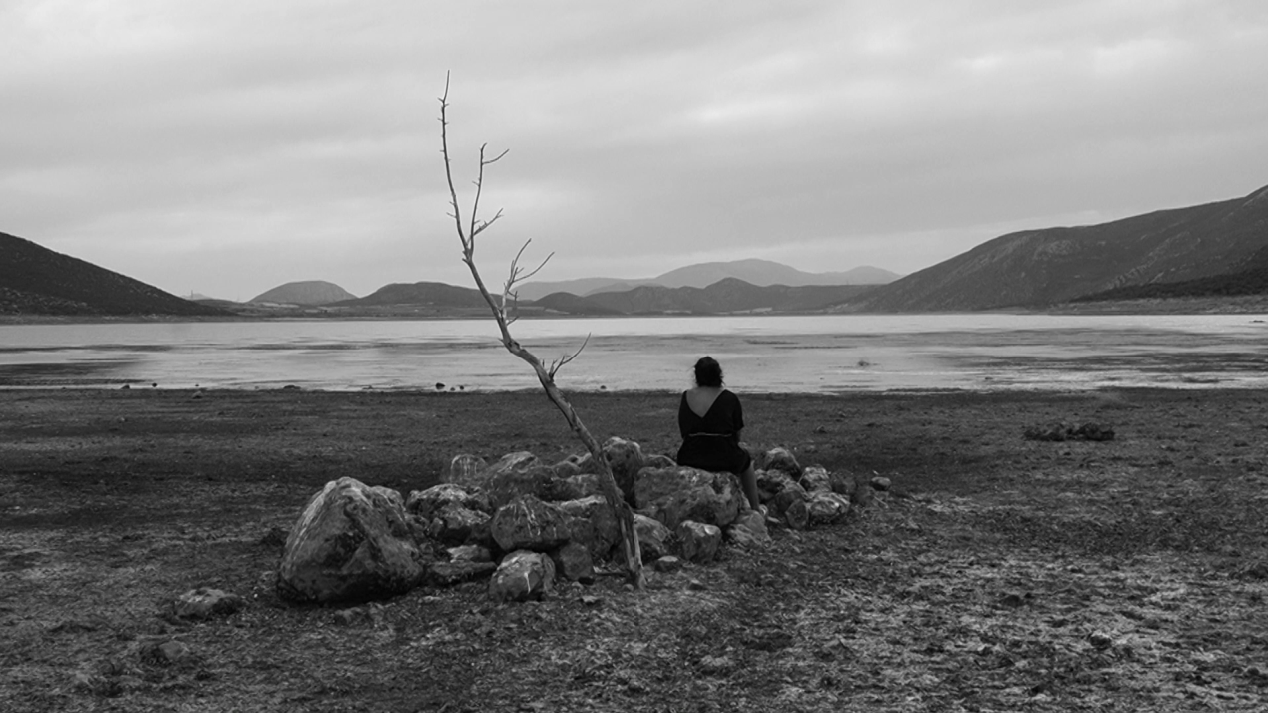

PRIMORDIAL
Poetry Film, Experimental Film, Video Poetry
Greece, 2024, 12min
Trailer: https://vimeo.com/904933925
Directing: George Zorbas & Nana Papadaki
Cast: Nana Papadaki
Cinematography: George Zorbas
Music: Vassilis Tzavaras
Editing: Katerina Tzigotzidou
English Translation: Elena Polygeni
Spanish Translation: Kyriaki Christoforidi
Production: Maldoror AMKE
Based on the poetry book “Primordial” (Melani Publications, 2023)
by Nana Papadaki
- The bοok PRIMORDIAL was longlisted for Poetry Awards 2023 of Greek Literature Magazine Hartis
- A first draft of the film was screened at the book presentation (01.12.2023) organised by Melani Publications and Athens Book Space of Municipality of Athens.

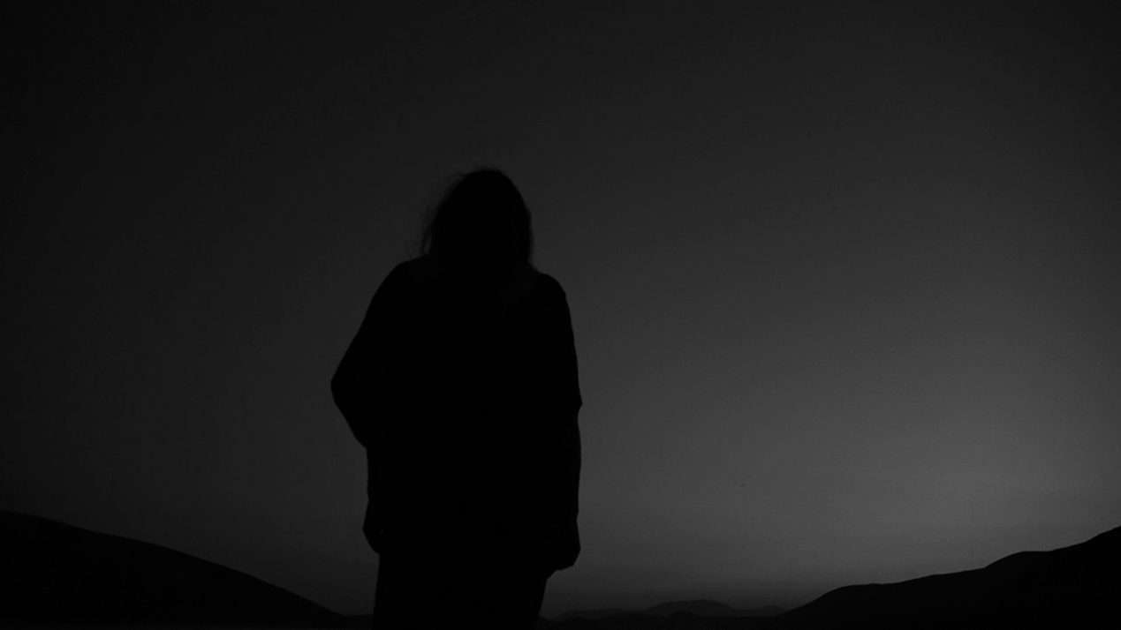

BOOK REVIEWS
“The poet searches, interprets, wonders about the creation of silence, existence, time, woman.”
Aggeliki Lalou, allyou
“Like another Prospero, the poet, with the magic of poetry, in her own strange island, prison or mental hospital cell, attempts a Descent, a journey to the Underworld of the Soul.”
Margarita Papageorgiou, fractal
“It affirms the concept of time, through the prism of acquired or approachable knowledge, where its truth is incarnated into consciousness.”
Vassilis Rouvalis, vassilisrouvalis.blogspot
“Primordial leaves you with a shakespearean and ibsenic aftertaste in the soul”
Pavlos Methenitis, athinorama
“Through the darkness of each of us, in that unconscious room of ourselves”
Dionysis Marinos, Bookpress
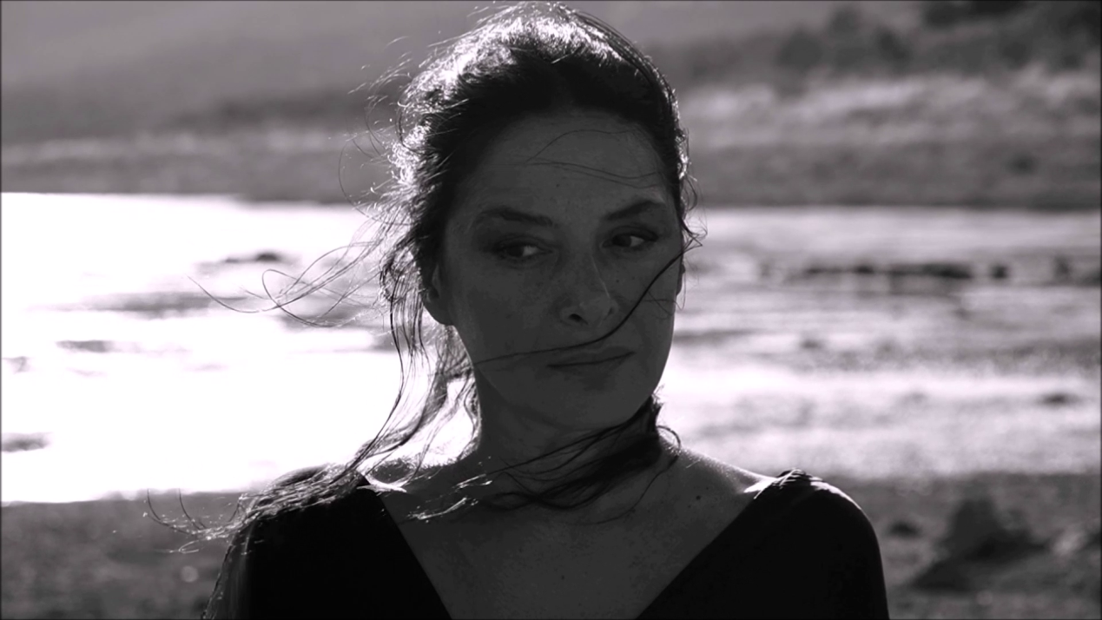

She is still there.
She gnaws the sun like a mouse.
Her eyes are illuminated by their own light.
She is so peculiar.
She's speaking and she's spoken in the shadows.
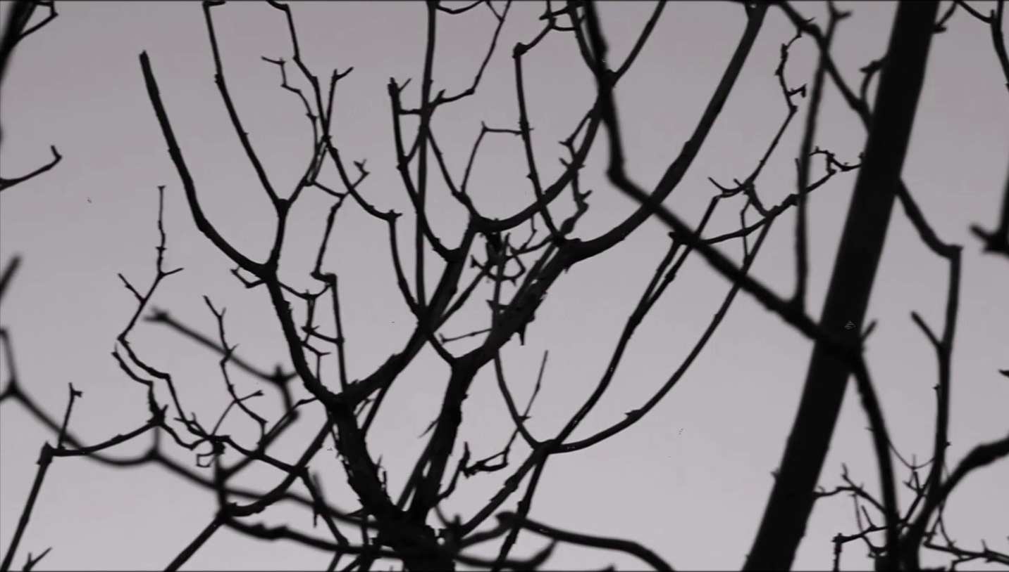

USEFUL LINKS
https://www.greeknewsagenda.gr/reading-greece-nana-papadaki-on-logos-as-the-meeting-point-between-poetry-and-theatre/
https://all4fun.gr/synentefkseis/theatro-kinimatografos/87826-nana-papadaki-kapos-me-odigoun-ta-pragmata-to-ena-sto-allo
https://www.monopoli.gr/2024/11/26/promotional-items/cine-news/837662/primordial-i-vraveymeni-poiitiki-tainia-tis-nanas-papadaki-kai-tou-giorgou-zormpa-ston-kinimatografo-mikrokosmos/
https://www.in2life.gr/article/2008531/primordial-h-poihtikh-tainia-ths-nanas-papadakh-kai-toy-giorgoy-zormpa-erhetai-sthn-athhna
https://www.cuemagazine.gr/2024/11/29/nana-papadaki-i-poihsh-ston-kinhmatografo/
https://www.kisffo.com/primordial/
https://tinostoday.gr/kathierosi-provolon-poiitikou-kinimatografou-stin-tino/
https://www.hartismag.gr/stigmata#stigma_425722
https://www.greeknewsagenda.gr/reading-greece-nana-papadaki-on-logos-as-the-meeting-point-between-poetry-and-theatre/
https://www.culturenow.gr/nana-papadaki-paroysiasi-poiitikoy-vivlioy-arxegoni-sto-athens-book-space/
https://popaganda.gr/art/nana-papadaki-den-mporo-na-min-elpizo-oti-enas-kalyteros-kosmos-einai-efiktos/
https://www.cityofathens.gr/parko-eleytherias-oi-dorean-draseis-po-3/
https://bookpress.gr/stiles/protaseis/19110-elliniki-poiisi-30-sylloges-pou-diavasame-kai-ksexorisame-to-2023
https://www.monopoli.gr/2023/07/25/promotional-items/702026/arxegoni-kykloforise-apo-tis-ekdoseis-melani-to-tetarto-poiitiko-vivlio-tis-nanas-papadaki/
https://www.fractalart.gr/archegoni/
https://www.cuemagazine.gr/2023/09/11/nana-papadaki-o-pyrhnas-twn-lexewn/
https://popaganda.gr/newstrack/culture/parko-eleytherias-oi-dorean-draseis-poy-erchontai-ton-dekemvrio-sto-athens-book-space-toy-dimoy-athinaion/
https://bookpress.gr/stiles/protaseis/19110-elliniki-poiisi-30-sylloges-pou-diavasame-kai-ksexorisame-to-2023
https://www.protoselidaefimeridon.gr/.../ta-nea.../23-12-16
https://www.poiein.gr/2023/11/20/νανά-παπαδάκη-ο-άνθρωπος-γεννιέται-ό/
https://soundcloud.com/rad.../i-n-papadaki-sto-radio-ena-102
https://www.ertecho.gr/.../iliotropia-me-ton-gianni.../
https://www.poiein.gr/2023/10/25/νάνας-παπαδάκη-αρχέγονη-εκδ-μελάνι/
https://strophess.blogspot.com/2023/10/2023_17
https://vassilisrouvalis.blogspot.com/2023/11/blog-post.html
https://www.allyou.gr/living/proti-yli/64266-11-5
https://www.athinorama.gr/texnes/3020661/apodimitika-biblia/

