FOR IMMEDIATE RELEASE
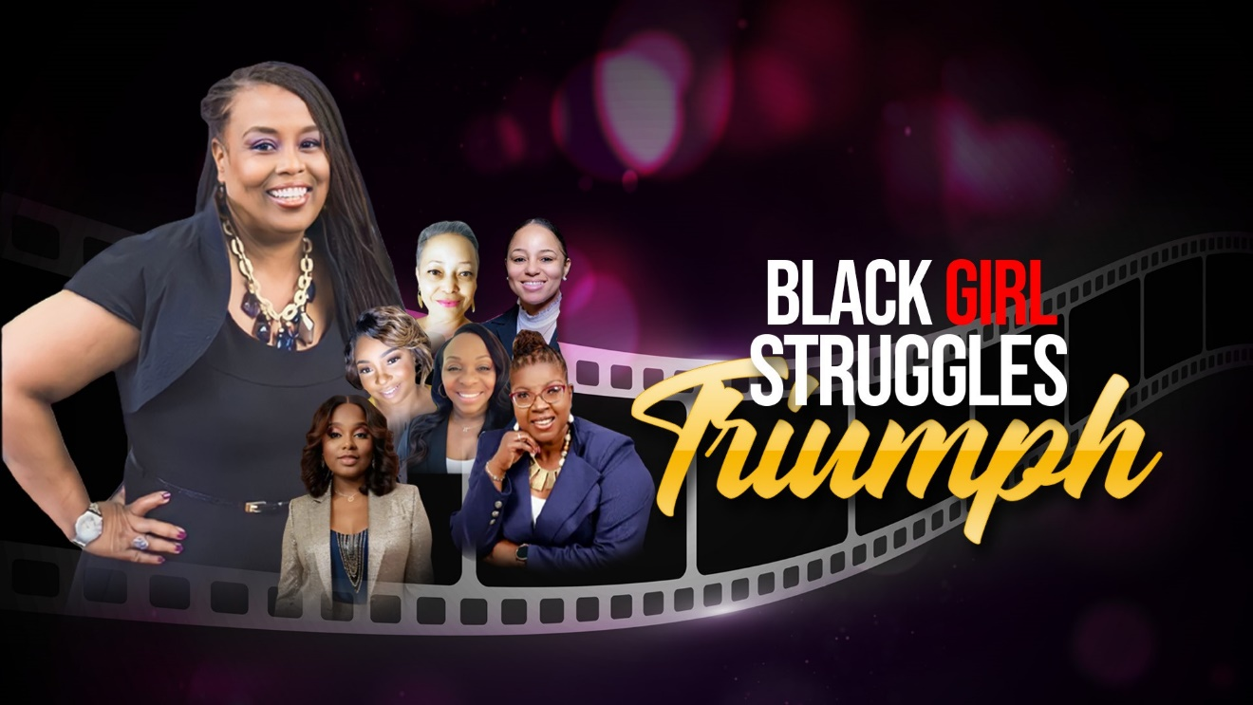
"Black Girl Struggles Triumph" Documentary Sheds Light on the Strength and Resilience of Black Women
Filmmaker and activist Carolyn Ayers takes audiences on an inspiring cinematic journey with her latest documentary, "Black Girl Triumph." This groundbreaking film delves into the multifaceted experiences of Black women, uncovering their struggles and triumphs through the stories of ten extraordinary women.
"Black Girl Triumph" celebrates the richness of diverse backgrounds, revealing the common threads of strength and perseverance that unite Black women. Through Ayers' lens, viewers are provided with a rare glimpse into the lives of these women who have forged their paths against all odds, fostering a deep sense of connection and engagement.

As a Black woman, Ayers brings her personal experiences and passion for social justice to this project. With authenticity and representation at the core of her storytelling, she aims to illuminate the beauty, strength, and resilience inherent in every Black girl and woman. Through her lens, adversity is transformed into courage, and every challenge becomes another victory waiting to be claimed.

"Black Girl Triumph" is an act of reclamation, challenging society's monolithic portrayal of Black womanhood and giving voice to narratives often overshadowed. This documentary transcends mere storytelling, offering viewers a transformative and empowering experience.

The stories featured in "Black Girl Triumph" touch upon various life struggles and grief, showcasing the immense power and resilience found within the Black female experience. The documentary seeks to inspire and uplift audiences from all walks of life by sharing intimate and personal journeys.
Carolyn is genuinely excited that her documentary film is being considered!
She wants to clarify the submission process because she tried submitting a video with her trailer, but it was not allowed. Carolyn's documentary "Black Girl Triumph;" features episodes such as "Real Love," "Between the Lines," "The Journey Home," "A Mother's Love," "Free Indeed," "Amazing Grace," and "Against All Odds." Furthermore, She is thrilled to announce three new episodes: "Live Reimagine," "She Defies Death," and "A Mother's Loss," and she has been encouraged to include even more episodes. Carolyn has submitted her trailer and one of the episodes. She hopes that is acceptable but seeks assurance that her documentary aligns with your festival’s vision before submitting my entire footage for review.

Carolyn Ayers' "Black Girl Triumph" is a must-see documentary that illuminates the triumphs and struggles of Black women. Through the stories of ten incredible individuals, viewers are taken on a transformative journey that celebrates the strength and resilience of the Black female experience.
For more information, please visit https://www.blackgirltriumph.com/ or contact Carolyn Ayers at carolynayers@blackgirltriumph.com or 443-678-2099.
About Carolyn Ayers:
Carolyn Ayers is a filmmaker and activist dedicated to illuminating women's stories and experiences. With a passion for empowering women and allowing them to tell their stories, Ayers seeks to create impactful films that challenge societal norms and amplify underrepresented voices. "Black Girl Triumph" is her latest project, showcasing her commitment to promoting empathy, understanding, and empowerment.
