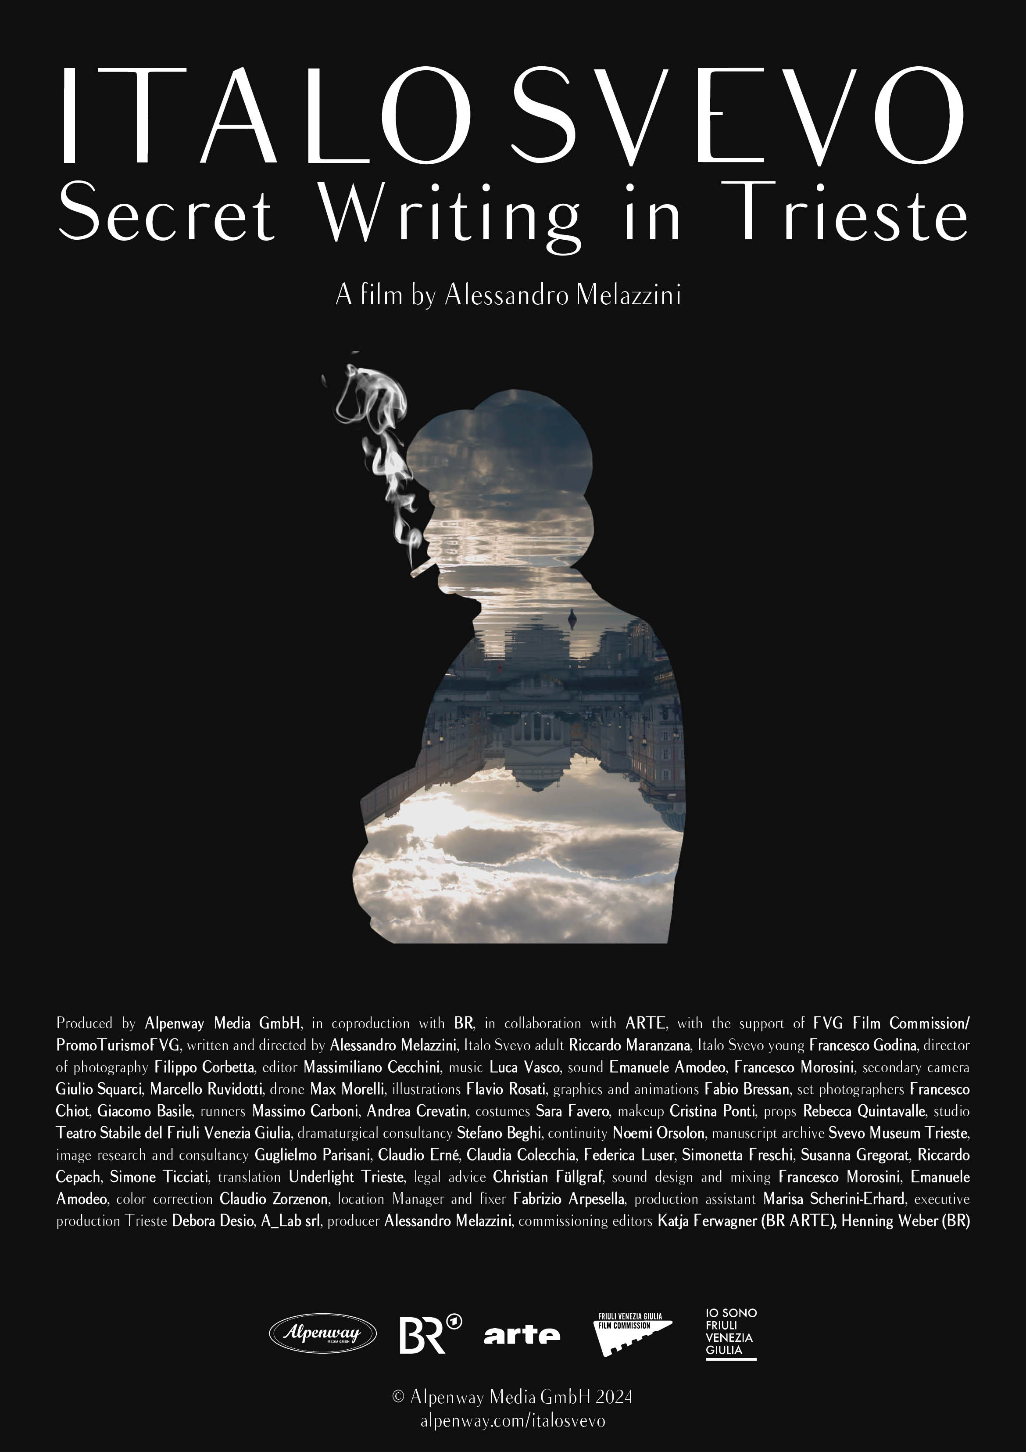

Paese di produzione Italia e Germania
Country of production Germany
Relase date 2024
Running time 61, 52 e 43 minutes
Shooting formart 4K
Exhibition format DCP 4K, MP4 4K
Audio Stereo, Dolby 5.1
Languages Italiano, German
Dubbing versions Italian, German, French
Subtitles English
Pagina ufficiale alpenway.com/italosvevo
Electronic Press Kit Dropbox

Written and directed by Alessandro Melazzini
Italo Svevo adult Riccardo Maranzana
Italo Svevo young Francesco Godina
Filmed by Filippo Corbetta
Edited by Massimiliano Cecchini
Musik Luca Vasco
Sound Emanuele Amodeo, Francesco Morosini
Second Camera Giulio Squarci, Marcello Ruvidotti
Drone recordings Max Morelli
Illustrations Flavio Rosati
Graphic and animation Fabio Bressan
Set photographers Francesco Chiot, Giacomo Basile
Runner Massimo Carboni, Andrea Crevatin
Costumes Sara Favero
Make up Cristina Ponti
Props Rebecca Quintavalle
Studio Teatro Stabile del Friuli Venezia Giulia
Dramaturgical consultancy Stefano Beghi
Continuity Noemi Orsolon
Manuscript archive Museo Svevo Trieste
Image research and consultancy Guglielmo Parisani, Claudio Erné, Claudia Colecchia, Federica Luser, Simonetta Freschi, Susanna Gregorat, Riccardo Cepach, Simone Ticciati
Legal advice Christian Füllgraf

Sound and mixing Francesco Morosini, Emanuele Amodeo
Color correction Claudio Zorzenon
Location manager and fixer Fabrizio Arpesella
Production assistant Marisa Scherini-Erhard
Executive production Trieste Debora Desio, A_Lab srl
Producer Alessandro Melazzini
Commissioning editors Katja Ferwagner (BR ARTE), Henning Weber (BR)

Produced by Alpenway Media GmbH
In coproduction with Bayerischer Rundfunk
In collaboration with ARTE
With the support of FVG Film Commission FVG/PromoTurismo FVG

Logline

The many Souls of Italo Svevo.
Subject

Italo Svevo was a writer who was largely ignored for most of his life, only finding success with Zeno’s Conscience, thanks in part to the support of James Joyce. The documentary explores the modernity of his works and the complexity of his personality, as well as that of his evocative hometown: Trieste.
Synopsis

Italo Svevo was a writer who, during his lifetime, was almost entirely ignored by both literary circles and the public. Only with his third novel, The Confessions of Zeno, which portrays a neurotic liar undergoing psychoanalysis, did he achieve success.

The modernity of the work captivated his friend James Joyce, who opened the doors of the Parisian literary scene of the 1920s to him. Psychoanalysis, the banality of everyday life, irony, as well as the use of the stream-of-consciousness technique, were concepts that readers of his time were not yet ready for.

Italo Svevo anticipated many themes of modernity. It is no surprise that his contemporaries did not understand him. This documentary paints a portrait of the complex personality of the author and his characters, set against the captivating backdrop of his hometown, Trieste.
The author
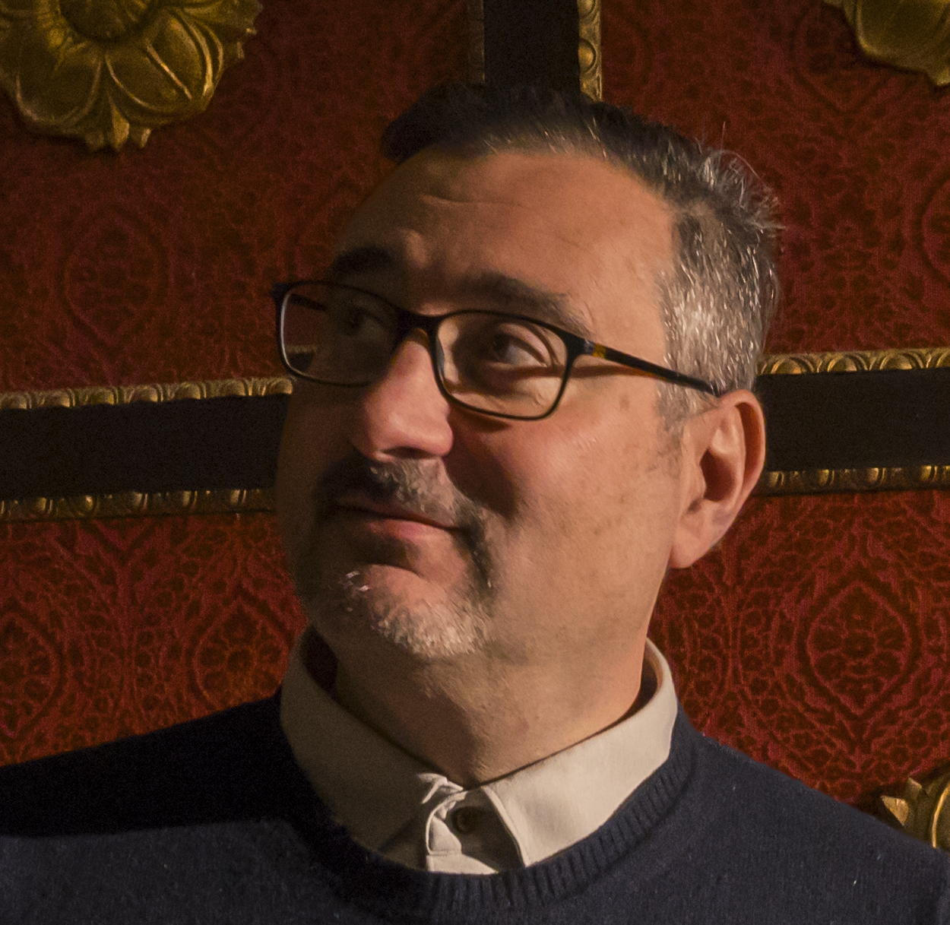
Alessandro Melazzini is an Italian documentary filmmaker naturalized as a German citizen. He lives in Munich, was born in Sondrio, and graduated in political economy from Bocconi University in Milan and in philosophy from Heidelberg.

After working as a freelance writer, journalist, and translator, he self-produced his first documentary film and, in 2010, founded his own production company: Alpenway Media GmbH. As a director and/or producer of documentaries, he collaborates with RAI, ARD, ZDF, and ARTE.

His films are known for their extreme eclecticism, ranging from the life and deeds of Ilona Staller (Cicciolina. Godmother of Scandal), to the world of Italo Disco (Italo Disco. The Sparkling Sound of the 80s), to the depiction of Cistercian art and spirituality (The Legacy of the Cistercians in Italy).

The documentaries produced by Alpenway regularly participate in international festivals. For his entrepreneurial work as a migrant citizen, in 2015 the city of Munich awarded Alessandro Melazzini the Phönix Prize.

He often travels across the Alps, one of the reasons why he named his company Alpenway, a symbol of his constant desire to cross borders.
Author’s statement

My first love was literature. With this film, I ideally close a circle, combining an old passion with my profession. I do so by dedicating myself to one of the great Italian authors who is less prominent on the international stage.

Italo Svevo captivated me from a young age, and for many years I questioned his allure, his complexity, and his irony. On a human level, I have always found his story—his success denied for many years, combined with his determined desire to write—one of the most interesting to explore.

What I have always loved about Svevo is his deep individualism, his refusal to align with ideologies, literary circles, or cliques, fully aware that the price he paid for many years was being ignored by everyone.
And then there’s Trieste, a city that has always fascinated me, for its position at the crossroads of countless borders, for its breath of freedom, for the vibrancy of its citizens, standing between the Austro-Hungarian Empire, Italy, and just a step away from the Balkans. Despite all the rightful criticisms that can be directed at those who promote a postcard-like image, and fully aware of its many conflicts, the cosmopolitan spirit of Trieste lives on in every street.

Of Trieste, as with Svevo, I have always loved the ability to be authentic while remaining contradictory. There is no Hegelian synthesis in them, no dialectical process. There is a mosaic-like mixture of fragments, pages, alleys, attempts, and failures. All united by the great humanity of their irony. After I die, it might happen that my wife takes me to Serbia to rest with her. Along the way, please let me make a stop in Trieste.

Alessandro Melazzini

Director of photography’s note

For the occasion, Trieste has made herself beautiful: retouching her makeup with immaculate facades and soft yet vibrant colors, she has skillfully used urban policies to present an authentic image of her past to the fresh eyes of our camera. The interplay of light tones, sky blue, and ochre is enhanced by a pure winter light, made even brighter by the gentle collaboration of the sea breeze.

During sunrise and sunset, these elements blended together, creating impressions that allowed us to imagine Trieste through the eyes of Italo Svevo and the surrealism of Magritte. In doing so, we captured evocative images, inspired by works such as The Happy Donor, choosing to explore that fine line that unites reality and mystery, dream, doubt, and the unconscious.

The richness of the interior decorations in the city’s buildings provided the perfect backdrop for the subjects of our interviews. To avoid artificial reenactments, we minimized the set design to the essentials, working within the spirit of Italo Svevo, in a timeless space that transcends his city, his era, and any possible interpretation.

Filippo Corbetta

Composer’s note

I had this dream many years ago. I was little more than a teenager, and as I read The Magic Mountain by Thomas Mann and then almost simultaneously The Confessions of Zeno, I never would have imagined that I might one day compose the soundtrack for a film (because this is not just a documentary) about Italo Svevo.

But sometimes dreams do come true, thankfully.

What should I have done, feeling as intimidated as a boy by this giant of world literature? Be reckless, above all, trusting in my lucky star and striving to be very thorough in my preparation. So I undertook meticulous philological research, not only from a musical perspective but also by trying to immerse myself in the “world” of Italo Svevo.

His friendship with Joyce, the already well-established revolution of psychoanalysis, the search for his own style within Central European writing, and the artistic environment that surrounded the writer throughout his life.
All these elements helped me enter the spirit that lingers in early 20th-century Europe. In the film, various musical styles appear—along with original compositions—arranged or adapted, of course, by the composers of that golden age: Debussy, Ravel, Puccini (of whom Svevo was a great admirer), and naturally, the Wagnerian influences of the time. But the soundtrack also features reworkings of Brahms, Khachaturian, and Rachmaninov.

All of this nourished the creation of the soundtrack for this film, which is beautiful and a bit timeless itself. I hope I’ve encapsulated all these diverse elements with harmony and coherence, and that I have thus contributed to the complete success of this cinematic work, unique in its kind.

It has been a wonderful journey, back in time to an era we often nostalgically long for, yet one that also serves as a warning to avoid tragedies we have already experienced.
Luca Vasco

Interview with Alessandro Melazzini

Why a film about Italo Svevo?
As always, for a variety of reasons. Italy’s presence as the guest country at the 2024 Book Fair served as a springboard to convince broadcasters, but the idea was born many years ago. Perhaps from a college roommate who held strong opinions about reading La Coscienza di Zeno. I was warned it was deadly boring. Maybe because of that definitive judgment, I read the novel in one go. I probably didn’t understand much, but I found it fascinating, and since then, I’ve always wondered why Italo Svevo remains, even today, one of the lesser-known Italian classics among the general public.

Did you find out why?

Honestly, no. Also because maybe my impression of his popularity is mistaken. I hope I’m wrong. Perhaps it’s an impression due to the fact that I live in Germany, where every Italian cultural circle honors and praises Pirandello and Pasolini, rightly so, but it’s much less common for someone to engage with Svevo’s work.

Why is that?

If I had to pinpoint a reason, I’d point to his irony—both as a man and as a writer. Irony is unsettling, it brings insecurity, it clashes with rhetoric and bombast, and it doesn’t allow for easy identification. That’s what I’ve always loved about Svevo—his profound irony. Which, of course, is just one facet of his complex personality, along with his melancholy, his deep sense of death, and the multiple identities of this author. If every writer is a world, Svevo is a multiverse.
What is the key to the documentary?

I’d gladly leave the keys to the locksmith. But if I have to say, I believe it’s about portraying the polarity of this man, of this author, and of this city. Italian and German, Jewish and Catholic, industrialist and writer. The souls of Italo Svevo are many, just like those of Trieste.

What challenges did you face in producing this documentary?
Unfortunately, while documentary filmmaking is praised in words by many, the reality is that it’s always difficult to find the funds to make a project happen. Even more so because a documentary for television can’t afford to hold its audience hostage—you have to capture the viewer’s attention right away, addressing complex themes without falling into superficiality. All of this is made even more challenging by the fact that ARTE is an international channel by nature, so you’re speaking simultaneously to at least a German and a French audience. On top of that, ARTE wanted the film to be broadcast in Poland and Spain from the very beginning, so even in distribution, we’ve been cosmopolitan.

And the Italian audience? Why isn’t a film like this co-produced with RAI?

The documentary’s production schedule was tight once we got the green light from the broadcaster. Fortunately, over the past years, I had read and reread everything I could find about Svevo, so I was able to dive straight into production. Involving RAI would have meant extending the production timeline considerably, and that wasn’t feasible, considering time flies and we had to be ready for the Frankfurt Book Fair. And if I think about the fate of my previous film, dedicated to another kind of “Italo”…

Italo Disco. The Sparkling Sound of the 80s.

Exactly. The film went to dozens of festivals, was broadcast in various countries, but RAI, which is a co-producer, still hasn’t aired it in Italy. Given this experience, I decided to tighten the ranks and work with the broadcasters involved from the beginning, namely ARTE and Bayerischer Rundfunk. FVG Film Commission also joined, which was essential in securing resources to shoot some acting scenes as well.

How was it working with Francesco Godina and Riccardo Maranzana?

Fantastic. This was my first experience directing actors, and the chemistry with Francesco, who played young Svevo, and Riccardo, who played the older Svevo, was perfect from the start. Since we were speaking to an international audience, ARTE only allowed scenes without dialogue for this slot, so we worked a lot on looks, details, and a certain surrealism in the scenes. Godina and Maranzana understood me right away, and with great professionalism, they helped me and my team get the most out of what we had. I also want to thank the entire staff of the Teatro Stabile del Friuli Venezia Giulia and it’s director Paolo Valerio in Trieste for assisting us with costumes, filming, and props.

Why did you choose to portray Svevo entirely immersed in darkness?
To symbolize the obscurity that enveloped the writer for most of his life. Film buffs will spot some cinematic references in those scenes, as well as others throughout the film, but naturally, I can’t reveal them here.

The film is filled with paintings. Why is that?
It’s another nod to Trieste. All the paintings shown are by artists from Trieste or who worked in Trieste, especially during the time Svevo lived. Some I already knew, others I discovered while visiting the Museo Revoltella or the Museo Sartorio, and they immediately captivated me. Just like Flavio Rosati’s illustrations, animated by Fabio Bressan, and the photography selection, for which I am indebted to the Fototeca di Trieste and Claudio Erné, who opened the doors to their astounding archives. Having such illustrative material is crucial for a documentary that cannot rely on footage of its subject. To be honest, a video of Svevo may have existed, as it seems he was filmed as a vacationer during a stay in Davos, but unfortunately, it appears to have been lost.

In the end, who do you think should read Svevo?

I’ll answer with the words of Riccardo Cepach, curator of the Museo Svevo, in the film: “Reading an author like Svevo is worthwhile for curious people—people who are curious not so much about what is being told, but curious about themselves, curious to take, through literature, this exceptional, unique, and irreplaceable tool, a journey within themselves.”

Contacts

Alpenway Media GmbH
Albrechtstr. 43
80636 Munich
Germany www.alpenway.com
info@alpenway.com
T +49 89 12011239‬‬

Premiere
Friday, October 18, 2024, at 6:00 PM. Free entry
DFF - Deutsches Filminstitut & Filmmuseum, Schaumainkai 41, 60596 Frankfurt

First broadcast
ARTE, Wednesday, October 23, 2024, at 10:10 PM

Alpenway Media GmbH
presents

Italo Svevo
Secret writing in Trieste
A film by Alessandro Melazzini
Produced by Alpenway Media GmbH, in coproduction with BR, in collaboration with ARTE, with the support of FVG Film Commission FVG/PromoTurismo FVG, written and directed by Alessandro Melazzini, Italo Svevo adult Riccardo Maranzana, Italo Svevo young Francesco Godina, director of photography Filippo Corbetta, editor Massimiliano Cecchini, Music Luca Vasco, sound Emanuele Amodeo, Francesco Morosini, secondary camera Giulio Squarci, Marcello Ruvidotti, drone Max Morelli, illustrations Flavio Rosati, graphics and animations Fabio Bressan, set photographers Francesco Chiot, Giacomo Basile, runners Massimo Carboni, Andrea Crevatin, costumes Sara Favero, makeup Cristina Ponti, props Rebecca Quintavalle, studio Teatro Stabile del Friuli Venezia Giulia, dramaturgical consultancy Stefano Beghi, continuity Noemi Orsolon, manuscript archive Svevo Museum Trieste, image research and consultancy Guglielmo Parisani, Claudio Erné, Claudia Colecchia, Federica Luser, Simonetta Freschi, Susanna Gregorat, Riccardo Cepach, Simone Ticciati, Translation Underlight Trieste, legal advice Christian Füllgraf, sound design and mixing Francesco Morosini, Emanuele Amodeo, color correction Claudio Zorzenon, location Manager and fixer Fabrizio Arpesella, production assistant Marisa Scherini-Erhard, executive Production Trieste Debora Desio, A_Lab srl, Producer Alessandro Melazzini, Commissioning editors Katja Ferwagner (BR ARTE), Henning Weber (BR)

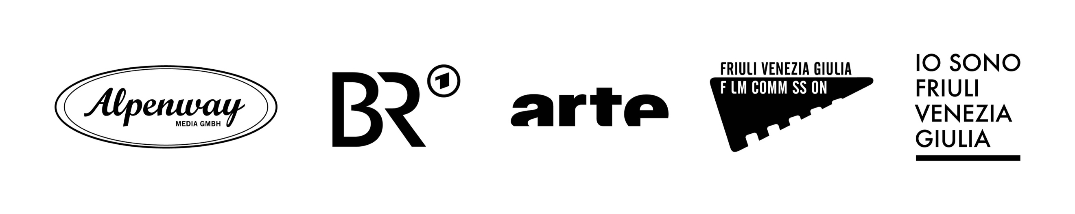

© 2024 Alpenway Media GmbH
alpenway.com/italosvevo

