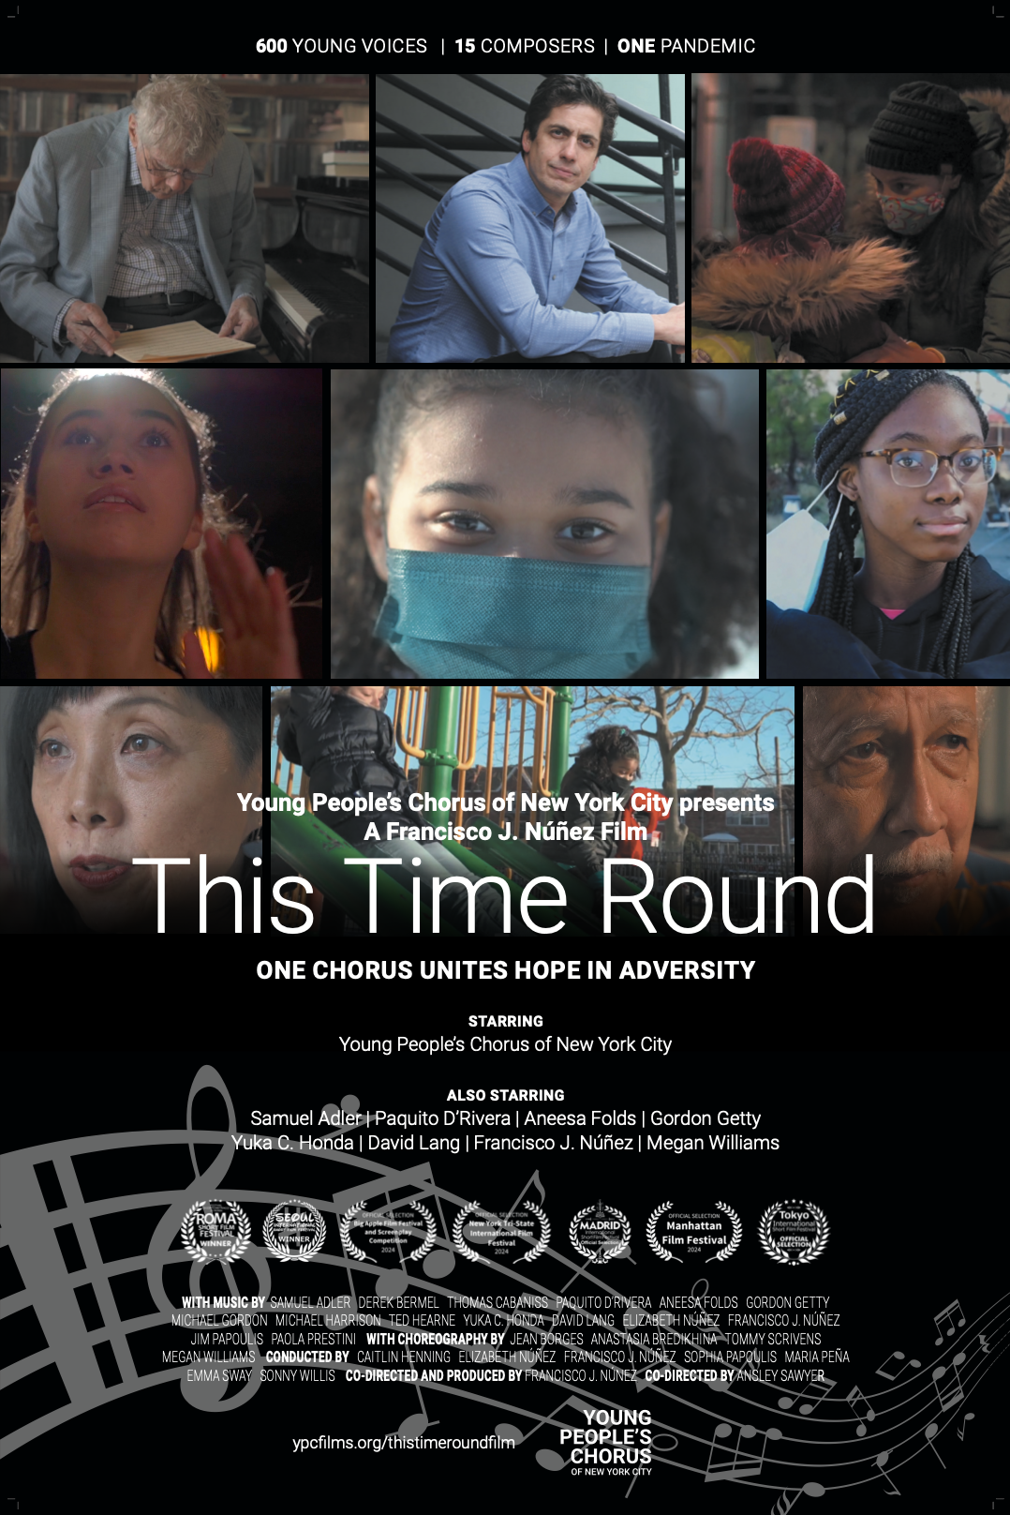
SYNOPSIS | 600 CHILDREN, 15 COMPOSERS, ONE PANDEMIC

One Chorus Unites Hope in Adversity

This Time Round captures the emotional journey via the voices and stories of the Young People's Chorus of New York City (YPC) that started during the first year of pandemic lockdown. Founder and artistic director Francisco Núñez realized that staying connected and continuing singing was essential. He embarked on a collaborative journey with illustrious composers to each create a 'round,' a musical term for a simple song with a repeating phrase, designed to be easily sung by the children over Zoom and on their phones. The 15 pieces chronicle a singular moment, representing their isolation, yearning, and joy sung by nearly 600 children ages eight to 18 through their perspectives. The project initially debuted as an art exhibit in Manhattan's Chelsea district to support students' mental health during COVID-19. Núñez then enlisted social impact filmmaker Ansley Sawyer to blossom into a feature film documenting the personal stories of the choristers and composers’ profound exploration of resilience and hope.

Genre: Documentary, Music
Run Time: 1 hr 7 minutes 20 seconds

FRANCISCO J. NÚÑEZ | PRODUCER, COMPOSER, CO-DIRECTOR, FILMMAKER, ARTISTIC DIRECTOR

Francisco J. Núñez, a 2011 MacArthur Fellow and Musical America’s 2018 Educator of the Year, is a composer, conductor, visionary, leading figure in music education, and the artistic director/founder of the Young People’s Chorus of New York (YPC), renowned worldwide for its diversity and artistic excellence. Since he founded YPC in 1988, Mr. Núñez has established recognition among composers of the child’s voice as a significant instrument for making music.

He also leads the University Glee Club of New York City, its fifth conductor since the all-men’s chorus was established in 1894 and from 2003 to 2010 was the director of choral activities at New York University. He’s widely sought after not only as a guest conductor by professional orchestras, chamber ensembles, and as a master teacher and advisor for choral workshops, demonstrations, and festivals worldwide, but also as a keynote speaker as a leading authority on the role of music in achieving equality and diversity among children in today’s society.

Since 2015, when he conducted the U.S. debut of American Young Voices (AYV) in Newark’s 19,000-seat Prudential Center, Mr. Núñez has been the principal conductor of this music education phenomenon. Each year—in collaboration with the National Association for Music Education (NAfME)—AYV brings together thousands of schoolchildren to sing—and dance—as one ensemble in huge stadiums in the Northeast. Initially born in the U.K. over two decades ago as Young Voices, this transformative program continues to inspire a lifelong love of music among the singers in their homes, schools, and communities, and to date has reached millions of schoolchildren in some of the largest arenas in England, Ireland, Germany, Trinidad/Tobago, South Africa, and now, the USA.

Mr. Núñez’s early years contributed to his passion for providing children with a path to fulfilling their life’s potential. He grew up in close-knit Dominican family in New York City’s Washington Heights. As a piano prodigy, he spent his time away from school at home practicing piano. Through his musical talent, he met other children with the same interests in music but from different cultural and economic environments. He learned from them, and they learned from him. After he graduated from NYU as a piano performance major, he formed the Young People’s Chorus of New York City, bringing children from underserved neighborhoods together with children from more privileged circumstances. With music as the equalizer, the diversity in the group resulted in new vocal colors and a confident urban style, creating not only a vibrant new choral sound, but also an avenue for children to succeed.

Mr. Núñez has greatly extended and invigorated the repertoire for young voices by commissioning well over 100 pieces of music from many of today’s most distinguished established and emerging composers, greatly contributing to the ever-evolving fabric of music in the 21st century. As a composer himself, Mr. Núñez wrote his first choral work, Misa Pequeña, at age 15, winning early acclaim for seamlessly fusing a wide gamut of cultures and musical idioms. Today, he composes countless compositions and arrangements in all musical formats and styles, from classical to pop, commissioned from him for choirs, orchestras, and solo instruments.

To advance and expand the instructional methods that have been so successful with YPC choristers, Mr. Núñez created a conducting fellowship program, which provides young conductors with the unique opportunity to work hands on with all YPC choral divisions under the mentorship of himself and YPC’s Creative Director Elizabeth Núñez.

Mr. Núñez launched YPC National, in response to requests for guidance, training, and assistance from choruses across the country and the Caribbean, inspired by the YPC model. It held its first YPC National Lab and Studio training sessions for chorus members, conductors, and teachers in Santo Domingo followed by a week-long residency at Lee University in Cleveland, Tennessee. The weeks’ events culminated in concerts featuring the debut of Concinamus, the combined ensemble of YPC National singers. YPC National also conducts an annual week-long residency at Music Academy in Santa Barbara in July.

Among Mr. Núñez’s many awards and honors are an ASCAP Victor Herbert Award and the New York Choral Society’s Choral Excellence Award. Hispanic Business magazine named him one of 100 Most Influential Hispanics, ABC-TV named him as a “Person of the Week, and Fox News profiled him “for “changing young lives with music.” Musical America Worldwide named him among 30 “Influencers” for his contributions to the music industry; Bang on a Can presented him with its Visionary Award for making the commissioning of new music a key part of the YPC mission; NYU Steinhardt honored him with its Distinguished Alumnus Achievement Award; and both Ithaca College and Gettysburg College have presented him with honorary Doctor of Music degrees.

Núñez received a 2023 Emmy® Award for Artistic Direction of the feature-length holiday special Topsy Turvy New York. The year prior, he won an Emmy® Award for Holiday Jingles, a holiday commercial he composed for WNJU Telemundo 47. He most recently produced and co-directed the documentary film, This Time Round.

FRANCISCO J. NÚÑEZ | DIRECTOR’S STATEMENT
The vision guiding This Time Round was to capture the emotional journey of children during the chaotic and challenging period of the first year of the Pandemic. As the doors to our rehearsal rooms closed and deep isolation set in throughout New York City, it was all too clear that our community needed to evolve in new ways to connect. This project was born of an essential necessity: to find a way to keep my children’s chorus, YPC, singing despite being quarantined in their homes.

I began to talk with the children as a group, via Zoom, about their feelings and experiences. As we began to sing again, it also became apparent that the children were increasingly less connected, just as much, if not more so, than adults around us. My choristers were overwhelmed by the daily news, and their parents going out to care for others, not knowing if they would come back home that night.
In response, I was inspired to commission fifteen incredible composers, who created an assemblage of masterpieces capturing this unprecedented moment we were collectively and individually facing. The new pieces had to be musically simple because we were limited to recording remotely. Each composition is a ‘round,’ a musical term for a simple song with a repeating phrase, which I thought would be easier to sing over Zoom. I chose these composers because they are trusted friends and collaborators of the Young People’s Chorus. They know our voices, they know us – but also, they happen to be the best in the world. The documentary’s title, This Time Round, is a play on words, because we sang rounds during this time.

The stories of these young singers were so strikingly vivid and raw, I knew they needed to be connected to and interwoven with these fifteen new compositions, fusing a multiplicity of perspectives, thoughts and feelings about this moment of crisis into one quilt of community experience. So, I purchased my first camera. And I began to record, socially distanced and masked. And the camera became an eye, a witness to the multifaceted fallout of this exceptional time in our lives. As the storytelling developed, I knew I needed to collaborate with a real pro to capture the experiences of these children. I asked an extraordinary, social impact filmmaker Ansley Sawyer, to help capture these stories sung by nearly 600 children and led by the dedicated conductors at YPC. The children recorded on their phones from closets and crowded living rooms. Gathering all of these vocal clips, we mixed and merged the melodies together, creating from a distance what we couldn't create in person: one song, one voice.

These resulting vignettes were first debuted as an art exhibit at High Line Nine art gallery in Manhattan’s Chelsea district. What began as an art show aimed at supporting students' mental health during Covid, blossomed into a profound exploration of resilience and hope. The unexpected success of the exhibit led to a visit from a former Board Member of the Toronto Film Festival. This person proposed that I submit this unique collection of children’s voices to their festival.

As COVID continued into the second year, my next step was to follow up with the composers and children, filming interviews about their individual stories—reflecting and looking ahead. Through these interviews, we unveiled layer upon layer of emotions experienced during the quarantine-- fear, isolation, grief, and, ultimately, glimmers of hope.

Contrary to misconceptions at the time, the impact of the Pandemic on children's mental health cannot be underestimated. The film, This Time Round, is as a visual testament to these composers’ and young artists' struggles and triumphs, from the depths of isolation to their gradual reemergence into a changed world. Through the lens of the camera, we witness the resilience of 600 children, finding solace in music and sharing their voices with the world.

ANSLEY SAWYER | FILMMAKER

Ansley Sawyer is a semi-nomadic film director and producer. A speaker, advocate, and entrepreneur, her docu-vérité work has been featured on Vimeo Staff Picks, BBC, National Geographic, and TEDx. She specializes in run-and-gun filmmaking, producing difficult-to-access human stories around the world. She integrates her sensitivity for documentary production within the world of commercial videography as Founder and Creative Director of her company Freehand Films.

"After nearly ten years as a serial traveler, I've learned that no matter what language you speak, there's a universal desire to connect. I believe we can better the world by focusing on stories of kindness, innovation, or underrepresented voices.
From passion projects to commercial work, I aspire to capture these profound moments that convey the vision of each community, brand, or story worth telling."

After over a decade of experience producing projects on the road, Ansley's passion is finding new ways to connect these stories with qualified audiences for great impact.

Ansley has directed/produced small-medium sized teams for short documentary and verite-style films all over the world, from: the nomads of Mongolia, to the Hong Kong Chinese New Year, to the Olympics docu-series about breaking becoming a global sport, to a film about the longest ongoing civil war in the world on the Thai-Burmese border.

She believes that emotional digital media, in both commercial and artistic spaces, can meaningfully impact international relations by building mutual experience, and potential for transformative empathy.

FEATURED CAST | CREDITS

Starring
Young People's Chorus of New York City

Also Starring
Samuel Adler | Paquito D’Rivera | Aneesa Folds | Gordon Getty | Yuka C. Honda | David Lang | Francisco J. Núñez | Megan Williams

With Music by
Samuel Adler
Derek Bermel
Thomas Cabaniss
Paquito D’Rivera
Aneesa Folds
Gordon Getty
Michael Gordon
Michael Harrison
Ted Hearne
Yuka C. Honda
David Lang
Elizabeth Núñez
Francisco J. Núñez
Jim Papoulis
Paola Prestini

With Choreography by
Jean Borges
Anastasia Bredikhina
Tommy Scrivens
Megan Williams

Conducted by
Caitlin Henning
Elizabeth Núñez
Francisco J. Núñez
Sophia Papoulis
Maria Peña
Emma Sway
Sonny Willis

Co-directed and Produced by Francisco J. Núnez
Co-directed and Cinematography by Ansley Sawyer

FEATURED CHORISTERS | BIOGRAPHY

ISABEL MEDINA | 13 YEARS OLD, NOW 17
Isabel Medina, 13 years old at time of filming, lives in Queens with her parents and younger sister. Until the start of the pandemic lockdown, she was performing as Young Nala in the Broadway Tour of “The Lion King.”

ANASTASIA BREDIKHINA | 17 YEARS OLD, NOW 21
Anastasia was 17 years old at the time of filming and living with her family in Brooklyn. She was a Senior at LaGuardia High School. During the pandemic, she found an artistic voice through solo choreography.

IRENE CUNTO | 10 YEARS OLD & SEBASTIAN CUNTO | 13 YEARS OLD, NOW 14 and 17
Irene Cunto (10 years old), Sebastian Cunto (13 years old) and their parents found joy in the small things within their Manhattan apartment during the pandemic – cooking Venezuelan food and dancing together.

AHANA GUPTA | 9 YEARS OLD, NOW 13

LEELA GUPTA | 7 YEARS OLD, NOW 11

KAIA GUPTA | 13 YEARS OLD, NOW 17
Ahana (9), Leela (7) and Kaia Gupta (13) relied heavily upon one another during the pandemic, as they took care of each other and tried to support their mother, who was working as a doctor.

SERGIO MALLO FRAGOSO | 15 YEARS OLD, NOW 19
Sergio was 15 at the time of filming, living in Bushwick with his family. He found solace in long walks through his neighborhood each night.

SOFIA ABREU | 10 YEARS OLD, NOW 14

ISABELLA NÚÑEZ | 17 YEARS OLD, NOW 21
Sofia (10) and Isabella (17) moved out of NYC during the pandemic. With their mom still working in the city, they often took care of each other.

HELENE LAFOURCADE | 10 YEARS OLD, NOW 14
Helene was 10 years old at the time of filming and living in Manhattan. Throughout the pandemic, she took up knitting as a way of showing people she cared.

JULISA RICHARDSON | 10 YEARS OLD, NOW 14
Julisa was 10 years old at the time of filming and attending PS 64 – a school in Queens with a YPC chorus. YPC meant so much to her, as a reminder of joy, family, and friendship.

JENIA MARQUEZ | 17 YEARS OLD, NOW 21
Jenia was 17 years old and a senior at Hunter Science High School at time of filming. For Jenia, lockdown was a time of deep internal reflection and self-discovery.

ARWEN MONZÓN-SANDERS | 10 YEARS OLD, NOW 14
Arwen was 10 years old at time of filming. Before the pandemic, she was performing as Young Elsa in “Frozen on Broadway.” She loves to dance.

PRESTON WASHINGTON | 11 YEARS OLD, NOW 15
Preston was 11 years old at time of filming. He joined YPC through his YPC school chorus at PS 84 in lower Manhattan. He loves to dance.

ATHENA LEADER | 16 YEARS OLD, NOW 20
Athena was 16 years old at time of filming, and a Junior in High School. Though she moved to Jersey City with her mom, she continued to make a long commute to go to school in New York City.

CARTER PATERSON | 16 YEARS OLD, NOW 20
Carter was 16 years old at time of filming, living in Harlem, a neighborhood with deep historical connection and significance to his family.

JULIAN CORREA CIFUENTES, JR. | 14 YEARS OLD, NOW 21
Julian was 14 years old at the time of filming, living with his family in Queens. A skilled ballroom dancer, his apartment transformed into his dance studio.

MARLEE SEVERE | AGE 15, NOW 19
Marlee was 15 at time of filming, living in Brooklyn with her family, including her younger sister Harley, who also sings in YPC. Marlee and Harley joined YPC after singing in the YPC school chorus at PS 268.

JACLYN MARKHAM | AGE 15, NOW 19
Jaclyn was 15 at time of filming, and attending Frank Sinatra High School for visual art.

CLYDE PAUL | AGE 16, NOW 20
Clyde was 16 at time of filming, living with his family in Brooklyn, including his sister Cailin, who also sings in YPC.

Full credits list available upon request

PHOTOGRAPHY | PRODUCTION STILLS

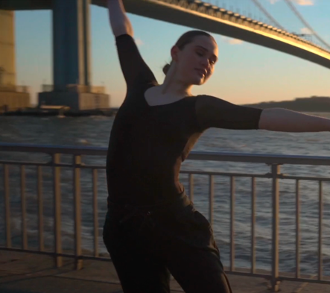 | ANASTASIA BREDIKHINA
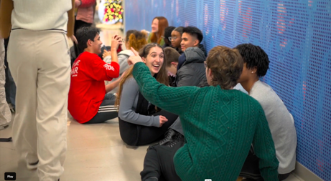 | CHORALE IN THE YPC'S HOME HALLWAY
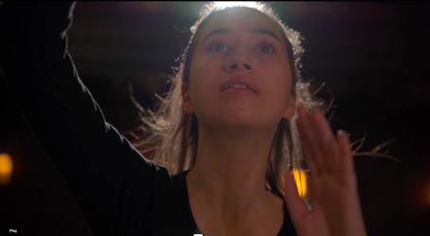 | JENIA MARQUEZ (SOFIA)
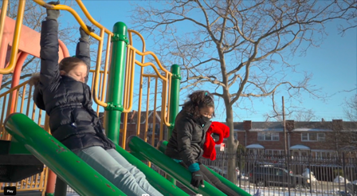 | HELENE LAFOURCADE AND JULISA RICHARDSON
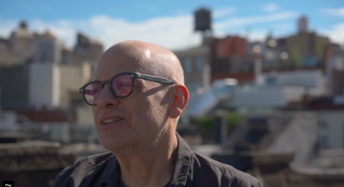 | DAVID LANG
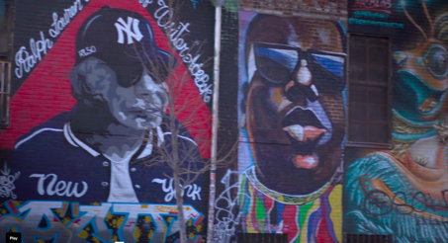 | BUSHWICK GRAFITTI

