Date: 27/01/24

To Whomsoever It May Concern

This is to certify that “The Coconut Man” has been created as a student film project by Vedanga Nag, K.S. Ujwal, Harsh Humnekar and Aniket Shankar, during the calendar year 2023.

We hereby agree to the Rules/Terms of the RMVCA competition and by submitting this film, do hereby indemnify The Animation Society of India, TASI Animation Association, Anifest India 2024, Directors, Trustees, Organisers, Partners, Vendors and Affiliates from any/all claims arising on account of any copyright / IP infringement.

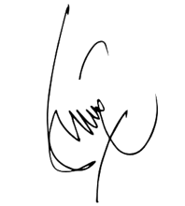

sbhattacharya@ddn.upes.ac.in
Signed & Stamped by Communication Cluster Head
Proff. Soumitra Bhattacharya
School of Design at
UPES

