
FOR IMMEDIATE RELEASE

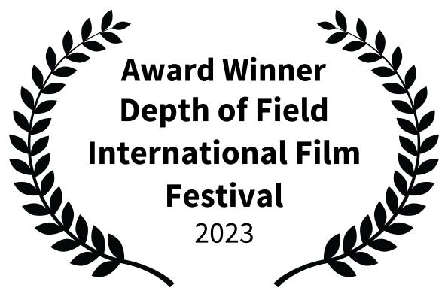

Contact: NuJu Films: 917 690-7912 / nujufilms@gmail.com

Adeena Karasick & Frank London’s, Eicha: The Book of Lumenations Wins 10 International Film Awards

New York, NY, Nov. 18, 2023. Poet, professor, media artist and cultural theorist, Adeena Karasick and internationally acclaimed composer and trumpet player, Frank London have won 3 prestigious Awards of Recognition from the 2023 IndieFEST Film Awards: Experimental Film Award, Jewish Film Award, and Award for Women Filmmakers; 2 Awards from the Depth of Field International Film Festival in the categories of Experimental and Alternative Media; 2 Awards of Merit in the categories of Experimental and Poetry and 2 awards of Exceptional Merit in the categories of Original Concept and Original score at the 2024 WRPN Women’s International Film Festival; 2023 Winner of Best Experimental Film, from the Seattle Indie Film Festival, as well as 2 Awards of Recognition from the Accolade Global Film Competition: Best Experimental Film and Best Jewish Film.
The awards were given for Karasick and London’s riveting poetic drama, Eicha: The Book of Lumenations. Calling attention to the ecology and concerns relating to physical, emotional, psychological, historical and environmental disaster, their visually explosive 5-part suite soars through desolation, misery, hope, lament, and prayer, re-situating the biblical Book of Lamentations to the horrors and hope of the present moment. Marked by a luxurious visual landscape of fragmented text and shadowed identity, mirroring an ever-disintegrating environment, coupled with a haunting score punctuated with pathos and profundity, this “textural tour de force” speaks to aspect of desire and recovery in an otherwise fraught time.
Eicha: The Book of Lumenations was created and performed by Karasick; music written and performed by Grammy award winning composer and trumpet player, Frank London; “vispo” by Jim Andrews, Jim Leftwich and Daniel F. Bradley. Eicha 2,3 and 4 were created in collaboration with Italian filmmaker, Igor Imhoff, edited by Max Drexler, with cinematography by Marvin Davis.
Karasick states “I could not be more pleased at receiving these awards in 3 separate categories, and being able to bring a sense of the past into an ever-arriving future – …especially in that the entire text of the film was recently published as a book, Ærotomania, The Book of Lumenations, (Lavender Ink, New Orleans, 2023), and it’s thrilling to see language exploding off the page and on to the screen and how that contributes to an extraordinarily sensorious experience, leading to new ways of thinking and being.
Both The Accolade Global Film Competition and The IndieFEST Film Awards recognizes film, television, videography and new media professionals who demonstrate exceptional achievement in craft and creativity, and those who produce standout entertainment or contribute to profound social change. Eicha: The Book of Lumenations is an extraordinary achievement in experimental and Jewish film, paving the way poetry can express the inexpressible in new and innovative ways. And as such, Eicha has also been “Officially Selected” for the 2023 ARFF Berlin International Awards, 2023 Depth of Field International Festival, The Independent Shorts Awards; 2024 Religious Faith International Film Festival in the categories of Best Experimental and Best Original Score; an official nominee for the Seattle Indie Film Festival and a Semi-Finalist for the Florence Indie Festival, The Paris Lady Movie Makers Festival, Hawaii International Film Awards, Dubai Independent Film Festival, New York International Women Festival, The Hong Kong Indie Film Festival, The International Cosmopolitan Film Festival of Tokyo and the Vancouver Independent MovieMaker Awards. Additionally, the film received an Honorable Mention for the European Short Awards and an Honorable Mention for Web and New Media for the 2023 Indie Short Fest, Los Angeles International Film Festival.

“Karasick’s spoken-word performance sizzles your ears with the breathy heat of her voice… Her delivery is hypnotic and erotic as waves of text roll and break, sometimes starting as whispers before sliding into chant-like passages that culminate in a libidinous frenzy.,” (Chris Rule, Opera Wire).

Adeena Karasick, Ph.D, is a New York based Jewish poet, performer, filmmaker, cultural theorist and media artist and the author of 14 books of poetry and poetics. Her Kabbalistically inflected, urban, Jewish feminist mashups have been described as “electricity in language” (Nicole Brossard), “proto-ecstatic jet-propulsive word torsion” (George Quasha), noted for their “cross-fertilization of punning and knowing, theatre and theory” (Charles Bernstein) "a twined virtuosity of mind and ear which leaves the reader deliciously lost in Karasick's signature ‘syllabic labyrinth’” (Craig Dworkin); “demonstrating how desire flows through language, an unstoppable flood of allusion (both literary and pop-cultural), word-play, extravagant and outrageous sound-work.” (Mark Scroggins). She is the winner of the 2023 Susanne K. Langer Award for Outstanding Scholarship in the Ecology of Symbolic Form for her recent book, Massaging the Medium: 7 Pechakuchas, (MEA), Andrew W. Mellon Foundation Award recipient and winner of the Voce Donna Italia award for her contributions to feminist thinking. Karasick teaches Media and Culture at Pratt Institute in New York, is Poet Laureate of the Institute of General Semantics, “The Adeena Karasick Archive” is established at Special Collections, Simon Fraser University. Hot off the press is Ærotomania: The Book of Lumenations, and Ouvert: Oeuvre: Openings, (Lavender Ink Press, 2023) and Eicha: The Book of Lumenations film, NuJu Films, NY, 2023.

Frank London is a Grammy-award winning composer, trumpeter and innovative force in Jazz, Klezmer, New Music and Word Music. A founding member of The Klezmatics, Hasidic New Wave and Frank London’s Klezmer Brass Allstars, he has performed with John Zorn, LL Cool J, Mel Torme, Lester Bowie’s Brass Fantasy, Itzhak Perlman, LaMonte Yong, They Might Be Giants, Jane Siberry, Ben Folds 5, Mark Ribot, Maurice El Medioni and Gal Costa, and is featured on over 500 records. His projects include the folk -opera A Night in the Old Marketplace; 1001 Voces: A Symphony for a New America with Judith Sloan and Warren Lehrer; Salom$é$: Woman of Valor with Adeena Karasick. He was music director for David Byrne and Robert Wilson’s The Knee Plays. His many film scores include John Sayles’ The Brother From Another Planet and Men With Guns, Yvonne Rainer’s Murder and Murder, Maxim Pozdorovkin’s The Conspiracy.

For more information contact NuJu films at nujufilms@gmail.com / 917 690-7912
More info on Eicha: The Book of Lumenations is available at https://filmfreeway.com/EichaTheBookofLumenations

