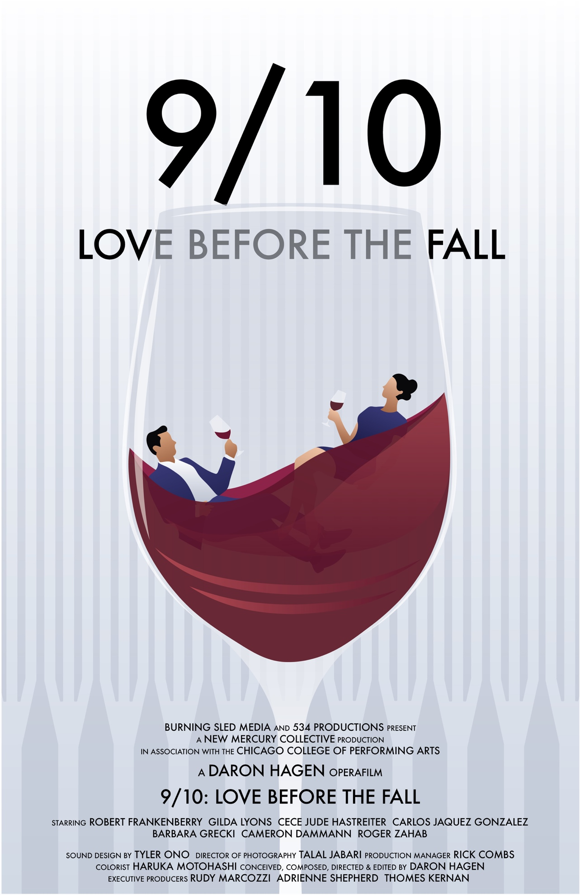
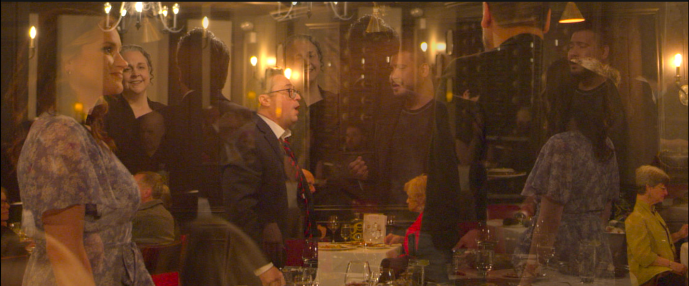

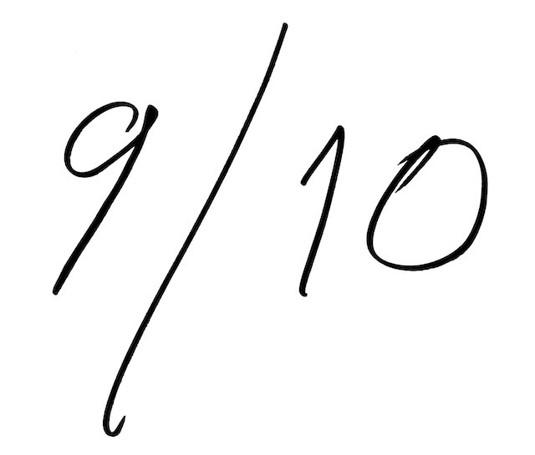
Four souls. One perfect night before the fall.
Synopsis

The myths of Orpheus and Charon are interwoven with the entirely sung magical-realist story of four friends dining in an Italian bistro who are fated to perish the next morning in the attack on the Twin Towers. At meal’s end, through magical realism, the restaurant’s mysterious strolling violinist is revealed to be Charon, hand extended, awaiting payment. Complying, each reconciles with death, and departs to the sounds of the next morning’s busy signals and the calls of first responders.

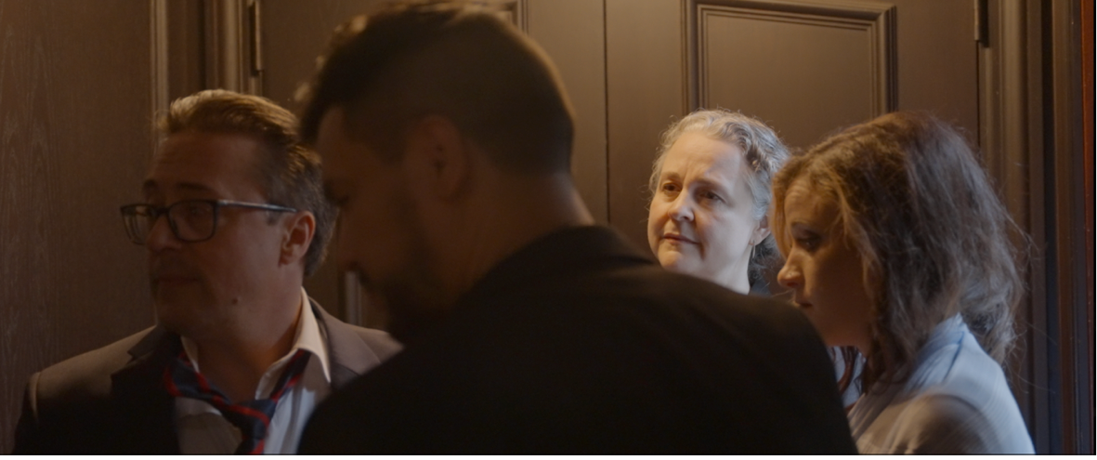

Director’s Statement
“Together, we've creating something new here that combines the emotional punch of cutting-edge live operatic performance with magical realism and the psychological verisimilitude of gritty, intimate, indie-auteur filmmaking. Neither cinema nor opera, but storytelling that combines multiple filmic, theatrical, and musical languages, directed, and edited to the rhythm of the score by the composer themself, brought vividly to life by brave, fiercely committed performers.”
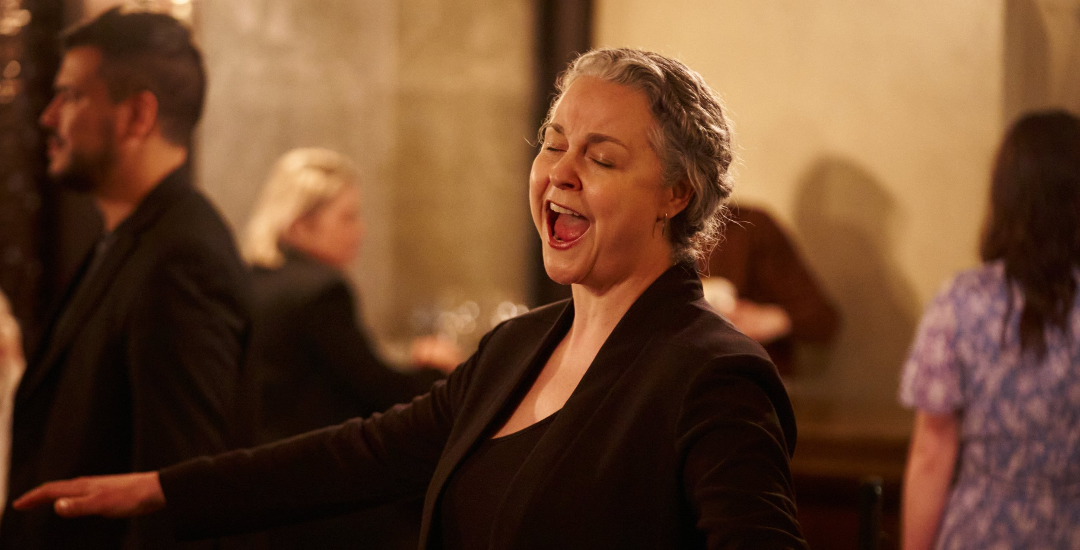
Specifications
Project Type: Magical Realist Symbolic Narrative
Genres: Opera, Operafilm, Auteur-Independent, Poly-Stylistic
Runtime: 58 minutes
Completion Date: August 25, 2023
Country of Origin: United States
Country of Filming: United States
Language: English; sung, with surtitles.
Shooting Format: Digital
Sound Format: Dolby Atmos Surround 5.1
Aspect Ratio: 16:9
Film Color: Color

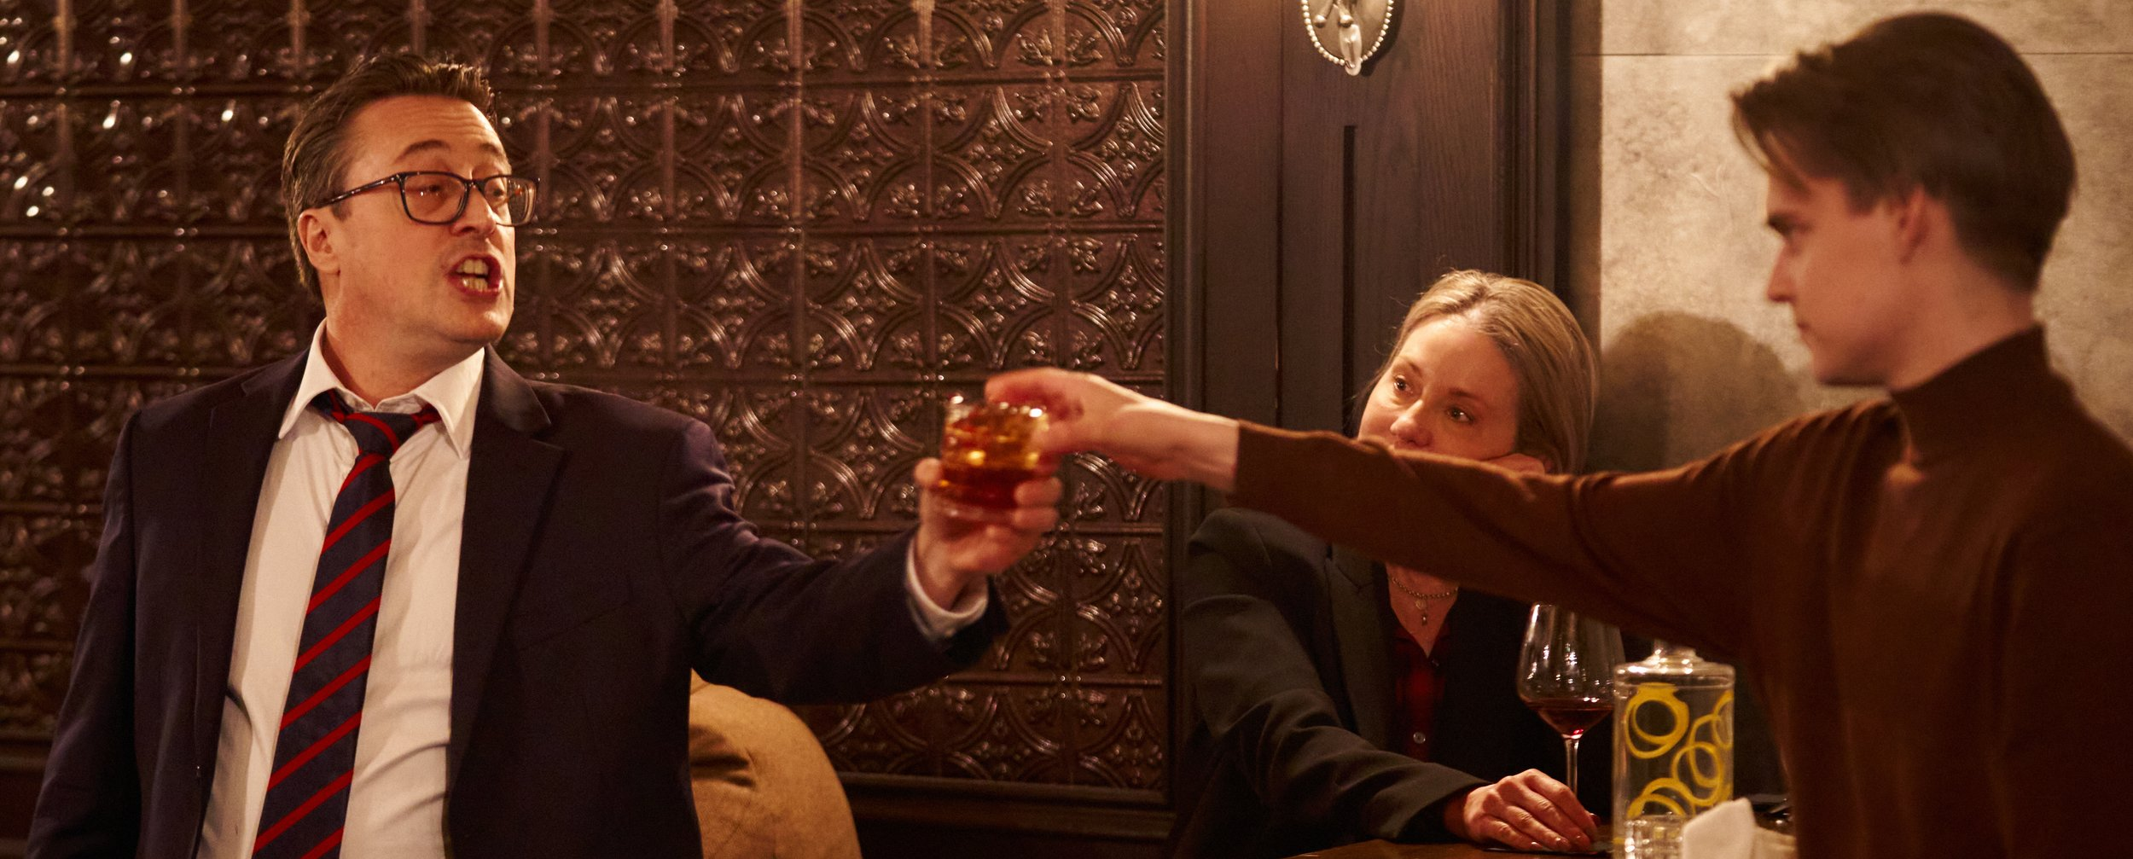

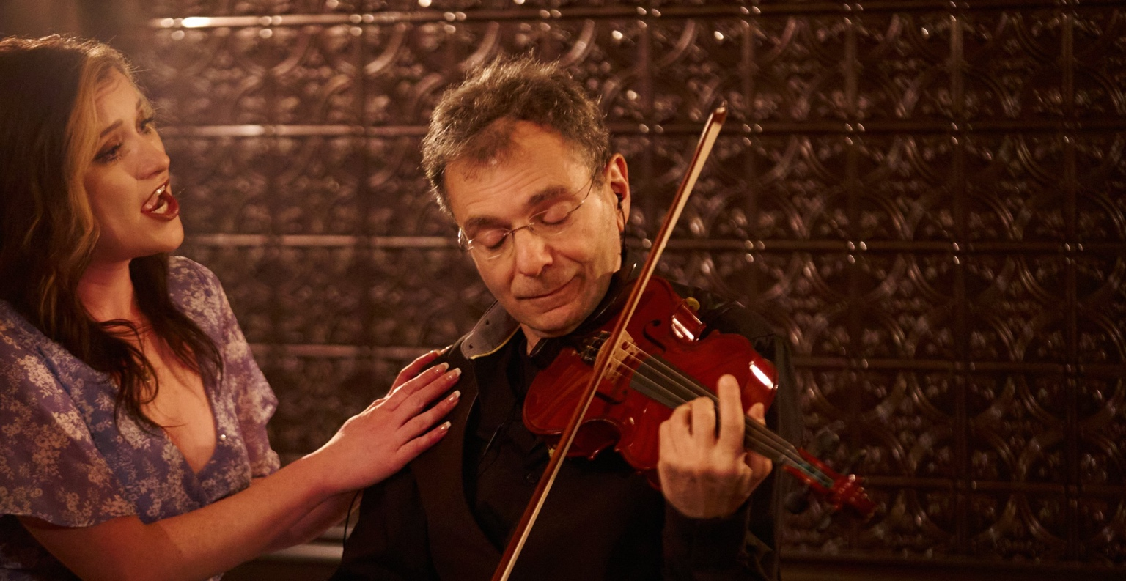
THE NEW MERCURY COLLECTIVE
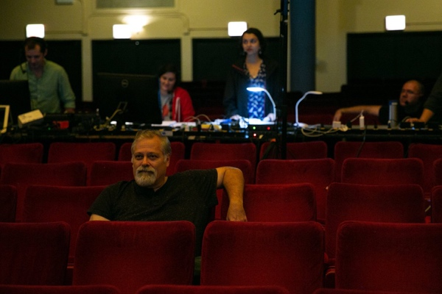
Daron Hagen’s (Composer, Writer, Director, Conductor, Editor) widely ranging activities are evidence of his lifelong passion as an artist-citizen for sharing the dividends of living an examined life. His work’s impeccable craftsmanship and heartfelt, emotional accessibility inspired Opera News to declare, “to say that he is a remarkable musician is to underrate him. Daron is music.” Composer of 14 operas and two internationally-laureled composer-directed opera films, 6 symphonies (major works for ASCAP’s 75th Anniversary, the New York Philharmonic’s 150th, the Curtis Institute’s 75th, Yaddo’s 100th, and the Seattle Opera, Philadelphia Orchestra, National Symphony, Buffalo Philharmonic, Albany Symphony, and Orpheus Chamber Orchestra), 14 concertos, chamber music and over 300 widely-performed art songs, he is also a stage and auteur film director, librettist, conductor, collaborative pianist, and the author of the critically acclaimed memoir, Duet With the Past and the operafilm Orson Rehearsed. Trained at Curtis and Juilliard, he has led music festivals and non-profit foundations and taught at schools from Bard to Curtis, the Chicago College of Performing Arts to the Princeton Atelier. A Lifetime Member of the Corporation of Yaddo, he has served as a panelist for the NEA, Copland House, CRI, Joy in Singing, NATS, Opera America, VCCA, ASCAP, received two awards from the American Academy of Arts and Letters, the Friedheim Prize, Guggenheim Fellowship, two Rockefeller Foundation Bellagio Residencies, and the Barlow Endowment, Bearns, and Nissim Prizes. His music is recorded on numerous labels and published by Peermusic Classical. Represented by Encompass Arts, he lives in Rhinebeck, NY with his wife Gilda Lyons and their sons.
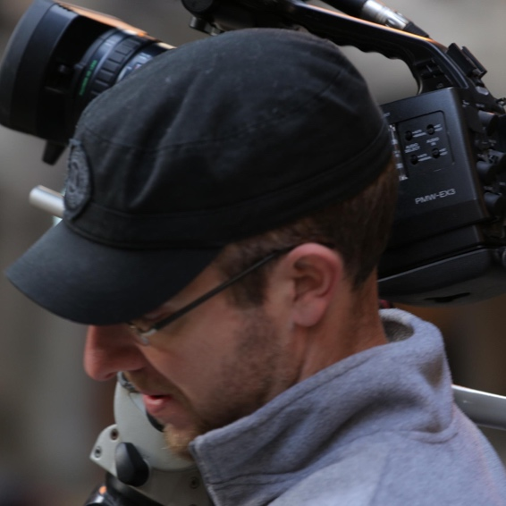
Talal Jabari (Director of Photography) is an Arab-American filmmaker and the producer of One Night in Tantura (post-production), a personal journey of discovery into the root of the Palestinian refugee issue and Tattoo Mike, the personal story of an 80s pop icon who struggled with his sexuality, drugs and diabetes, in the midst of the underground tattoo movement in New York City. Talal is best known for producing and directing Full Signal (Big Sky 2010), which garnered 3 distribution deals after a successful festival run and being screened in Congress. The film continues to be used for advocacy around the world. Talal is also known for Enemies of the South, commissioned by Al-Jazeera Documentary Channel, and which spent over a year ranked in the station's Top 30 documentaries. In addition, Talal also co-produced the Critic's Choice-nominated Speed Sisters (Hot Docs 2015) and is the cinematographer of Naila and the Uprising (IDFA, 2017). His other work includes 24h Jerusalem (TV documentary-2014) as Contributing Director & Cinematographer as well as Holy Blood (TV Documentary Series-2013) as Field Producer. A multi-linguist, Talal has worked extensively in the Middle East, Sub-Saharan Africa, Eastern and Western Europe as well as North America. Talal currently lives in NY.
THE CAST
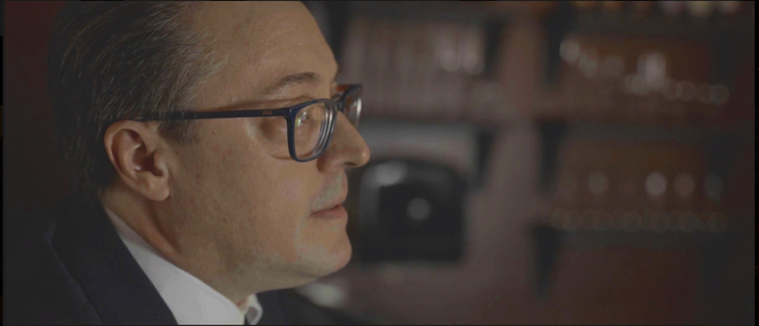
Robert Frankenberry (Musical Director / CORY) leads a multi‐faceted career as a vocalist, pianist, educator, actor, and conductor. His credits in musical direction cover the span of opera on film, Orson Rehearsed (Principal Coach / Orson #2), opera on stage, including Sweeney Todd (Weathervane Theatre), The Tales of Hoffmann (D’Angelo Opera Theatre), Cosi fan Tutte (DaCorneto Opera), Monteverdi’s 8th Book of Madrigals (Opera Theater of Pittsburgh), Robert X. Rodriguez’ Frida (microscopic opera), and the world staged premiere of Daron Hagen’s Vera of Las Vegas (Center for Contemporary Opera). During the 2013-2014 season, he served as Associate Music director for Glass/Ginsberg’s Hydrogen Jukebox and Music Director for the premiere of Hagen’s I Hear America Singing at Skylight Musical Theatre and returned in the Spring of 2015 as Music Director/Alberich/Hunding/Mime/Hagen for the premiere of The Skylight Ring. This past summer, he conducted the premiere of Gilda Lyons’ and Tammy Ryan’s opera, A New Kind of Fallout, based on the life and work of Rachel Carson, for Opera Theater of Pittsburgh’s SummerFest.
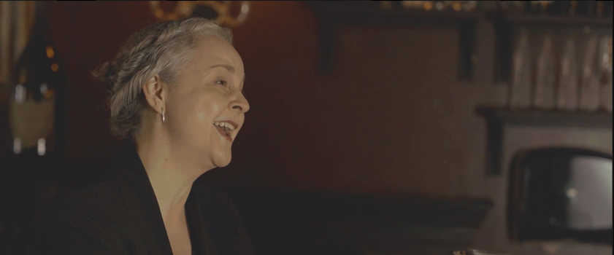
Gilda Lyons (TRINA) composer, vocalist, and visual artist, combines elements of renaissance, neo-baroque, spectral, folk, agitprop Music Theater, and extended vocalism to create works of uncompromising emotional honesty and melodic beauty. The premiere of A New Kind of Fallout—Lyons’ mainstage opera inspired by the life and work of environmentalist Rachel Carson, written with librettist Tammy Ryan, and commissioned by Opera Theater of Pittsburgh—was described as “powerfully effective” (Pittsburgh Stage Magazine), “haunting” (Pittsburgh Post-Gazette) and “spot-on at re-creating the atmosphere of the early '60s” (Pittsburgh Tribune-Review). An active vocalist and fierce advocate of contemporary music, Lyons has commissioned, premiered, and workshopped new vocal works by dozens of composers; this season she stars in Daron Hagen’s operafilm 9/10: Love Before the Fall which has its festival premiere in September 2023. Of her work as vocalist, Opera News describes Lyons’ collaboration with Laura Ward (Naxos) as “winning delivery, full of character.” Of her performance in Hagen’s Shining Brow (Buffalo Philharmonic/Falletta/Naxos), David Shengold of Opera, UK writes “Gilda Lyons's clear soprano compels admiration.”
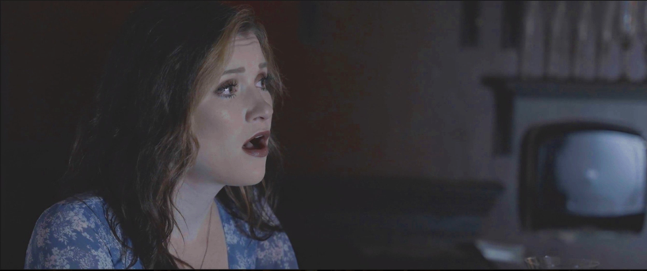
CeCe Hastreiter (BIBI) is a classically trained lyric soprano and is known for her bright and clear tone and her ability to tell a story. She obtained her BM in Vocal Performance at Nebraska Wesleyan University in 2019. While at NWU, she performed multiple roles, including Prima Donna (Fiammetta), Die Fledermaus (Adele), Gallantry (Lola), and La Rondine (Lolette). She participated in La Musica Lirica in Novafeltria, Italy where she played Despina in Così fan tutte. She earned her MM in Vocal Performance at Roosevelt University in May of 2021. She also performed as a soloist in Hilary Tann’s Arachne.

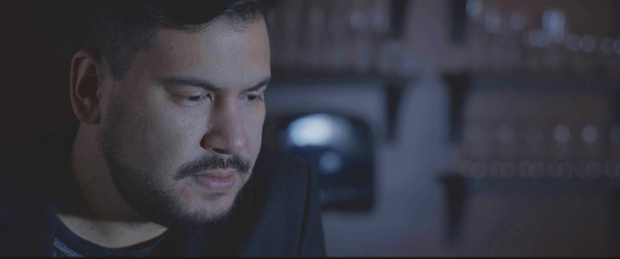
Carlos Jaquez Gonzalez (TONY), a first-generation California-born Mexican American composer, vocalist, guitarist, and pianist, left his job as a chef to begin his musical training as a composer and vocalist at San Francisco State University, where he earned his BM. As a composition student of Richard Festinger and voice student of Nikolas Nackley, he founded the RGB Arts Festival, programming, securing funding, and coordinating university departments in programs featuring music, dance, film, art song, and poetry. In Spring 2021 he earned his MM at the Chicago College of Performing Arts at Roosevelt University, studying composition with Daron Hagen and voice privately with Alexandra LoBianco. He has composed multiple works for chorus, soloists, percussion, chamber ensembles, electro-acoustic soundscape and orchestra. Most recently gaining recognition by the Chicago Tribune for premiering his Immigrant Mass, in collaboration with the Chicago Composers Orchestra, CCPA, and documentary photographer Greg Constantine. He is also most known as the primary writer, singer, and guitarist of the band "The Silhouette Era."
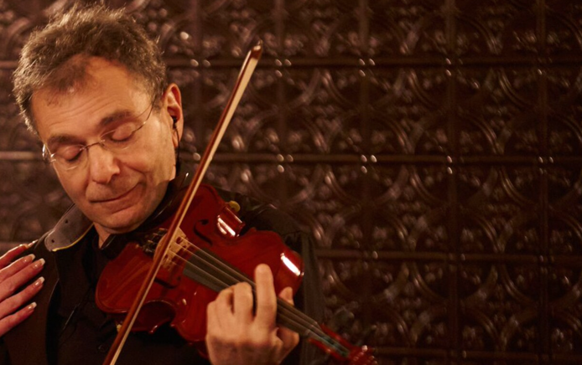
Roger Zahab (CHARON) instigates complex relations through his activities as composer, violinist, conductor, teacher and writer. His work has been performed throughout North and South America, Europe and Asia by such soloists and ensembles as cellists David Russell and Lawrence Stomberg, violists David Cerutti and Hannah Levinson, violinists Wyatt True and Nathalie Shaw, flutists Elizabeth Brown, Lindsey Goodman, George Pope and Rachel Rudich, guitarists James Ferla, James Marron and John Muratore, pianists Robert Frankenberry, Bennett Lerner, and Eric Moe, percussionists Lisa Pegher, Joshua Quillen, William Sallak, David Skidmore and Dale Speicher, new music groups California EAR Unit, Flute Force, The Furious Band, IonSound Project and Pittsburgh New Music Ensemble, and orchestras such as The New Amsterdam Symphony Orchestra, Robert Black, conductor, and the Akron Symphony Orchestra, Christopher Wilkins, conductor.

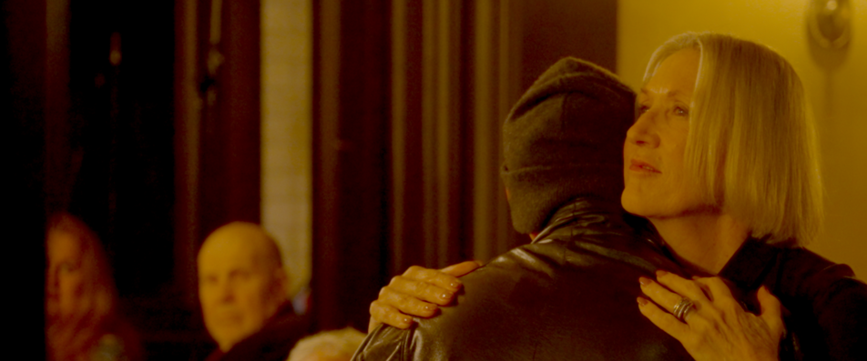
Barbara Grecki (Co-Producer, LULU) is a writer, director, performer, and teacher. She has co-written the libretti with Daron Hagen, for New York Stories, and A Woman In Morocco. Her collaboration on In Our Own Words, a theater performance piece of documented interviews of the 9/11 experience and Same Difference, follow-up interviews of the aftermath and interfaith outreach, has been presented at the United Nations, and theaters around the country. She was a finalist in the Empire Screen Writing Competition for Being Loved By You. She is a member of The Writers Guild. She is currently collaborating with Hagen on an opera based on The Deputy by Rolf Hochhuth.

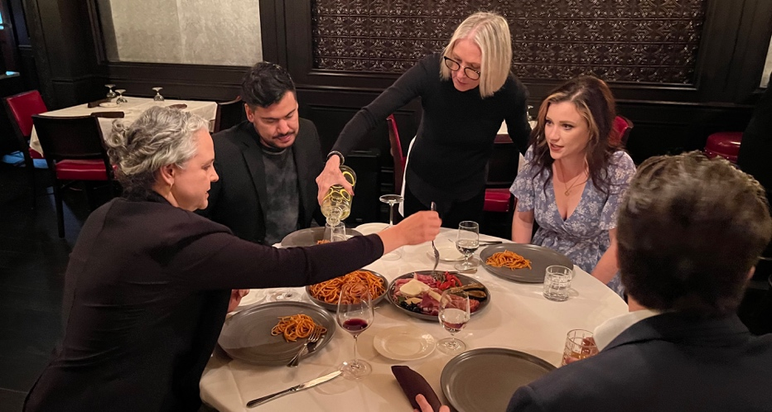
WEB-BASED MEDIA RESOURCES
Promotional Posters
- Poster (vertical)
- Poster (horizontal)

Websites / Downloads
- 9/10: Love Before the Fall Official Website
- Trailer #1 Download: YouTube / Vimeo
- Trailer #2 Download: You Tube / Vimeo
- IMDB Page
- Facebook
- Instagram

Articles / Interviews
- Broadway World: 9/10 Interview with Daron Hagen
- 9/10: Try the Soup: Essay
- 9/10: So Rossetti, Cassavetes, Auden, and Wenders Walk Into a Bar
- Picking Up the Keys: Beginning 9/10

THE PRODUCTION TEAM
Producers Daron Hagen, Burning Sled Media
Rudy Marcozzi, The Chicago College of Performing Arts
Adrienne Shepherd, 534 Productions
Director, Composer, Editor Daron Hagen
Director of Photography Talal Jabari
Assistant Director Cameron Dammann
Production Manager Rick Combs
Production Coordinator Erika Meyer
CCPA Project Administrator Elizabeth Sustar Nye
Camera & Sound Operators Aaron Gottl, Matthew Peckham; Atlas Arts Media
Audio Production Assistant Austin Gray Williams

Postproduction Advisor Rabab Haj Yahya, Capture Media
Sound Designer Tyler Ono, Bento Box Media
Colorist Haruka Motohashi
Music Preparation Neil Erickson, TOG Music Services, New York

FOR NEW MERCURY COLLECTIVE
Music Director & Vocal Coach Robert Frankenberry
Eurydice’s Pre-Recorded Voice
& Female Coro Gilda Lyons

FOR BENTO BOX MEDIA
Cavatina Vocal Erika Meyer
Flute Elizabeth Kijowski
Acoustic Guitar Kevin Merlita

FOR THE RIZE ORCHESTRA
Orchestral Conductor Daron Hagen
Manager Aaron Gottl
Recording Team Peckham Media Productions

Art Director Christopher Lyons
Legal Representation Corey Field Law Group, P.C
Mr. Hagen’s Representation Kathy Olsen, Encompass Arts
Music Publishing Karen Heymann, Todd Vunderink; Peermusic Classical
Location Services Daniele Sotgiu, Executive Chef, La Storia, Chicago, Illinois, USA

Both the Chicago Location Filming and the Silver Cast Live Production of 9/10
were made possible in part by the generous support of the Chicago College of Performing Arts,
Roosevelt University, Rudy Marcozzi, Dean.

The composer gratefully acknowledges
the John Simon Guggenheim Foundation Fellowship
that made possible the creation of the screenplay and musical score.

The composer acknowledges with gratitude a residency at
the Corporation of Yaddo
during which the film was completed.

Special Thanks Mark Adamo, John Corigliano, Hershey Felder,
Slavis Manigoda, H. Paul Moon, Karen Pearson, Matthew Wright

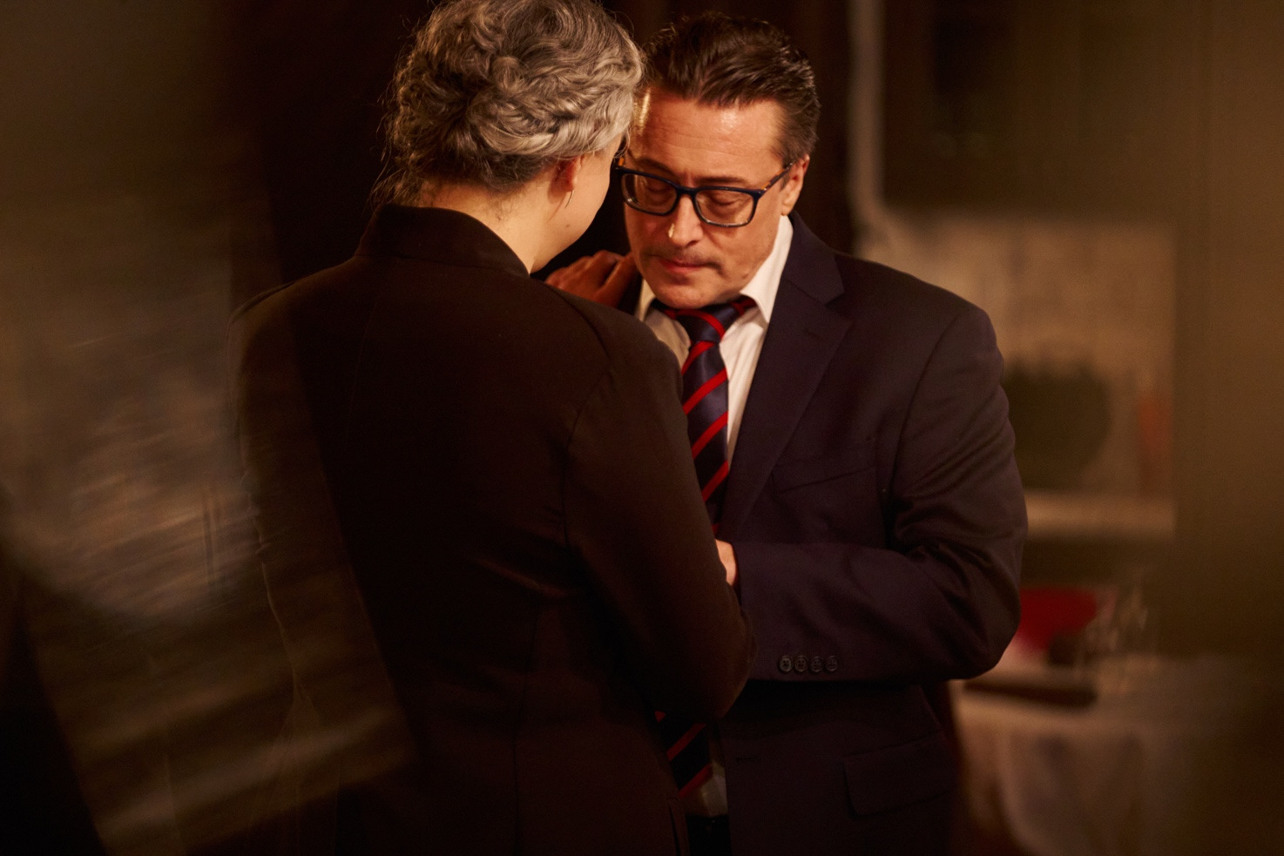
PRODUCTION STILLS

ROBERT FRANKENBERRY portrays CORY, an attorney with offices at the World Trade Center in New York City in 9/10: Love Before the Fall.
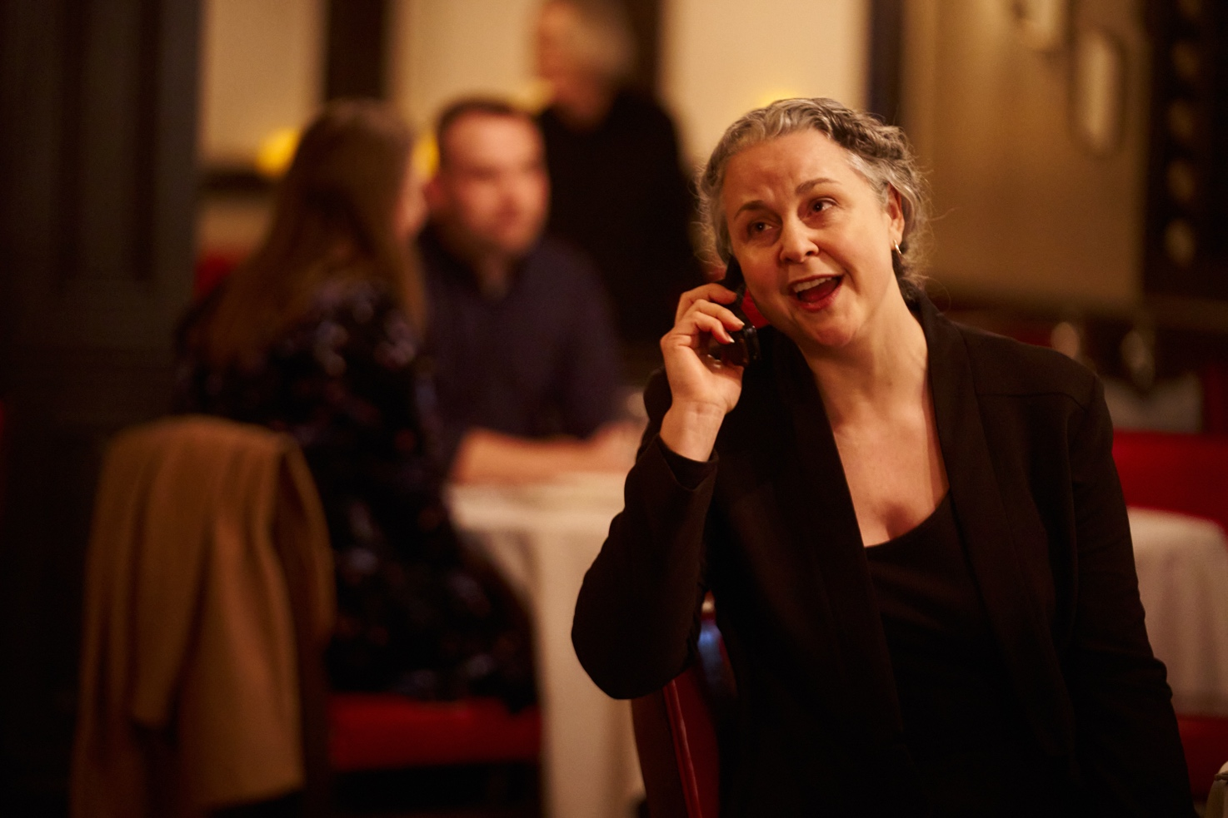

GILDA LYONS portrays TRINA, an attorney with offices at the World Trade Center in New York City in 9/10: Love Before the Fall.

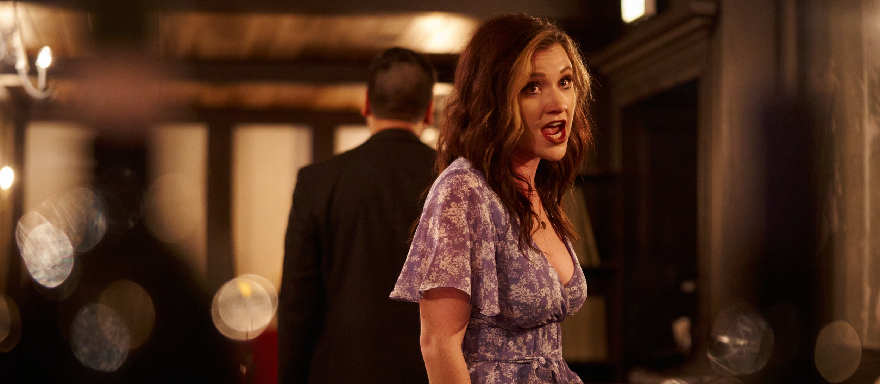
CECE JUDE HASTREITER portrays BIBI, a singer who works as a hostess at Windows on the World in 9/10: Love Before the Fall.
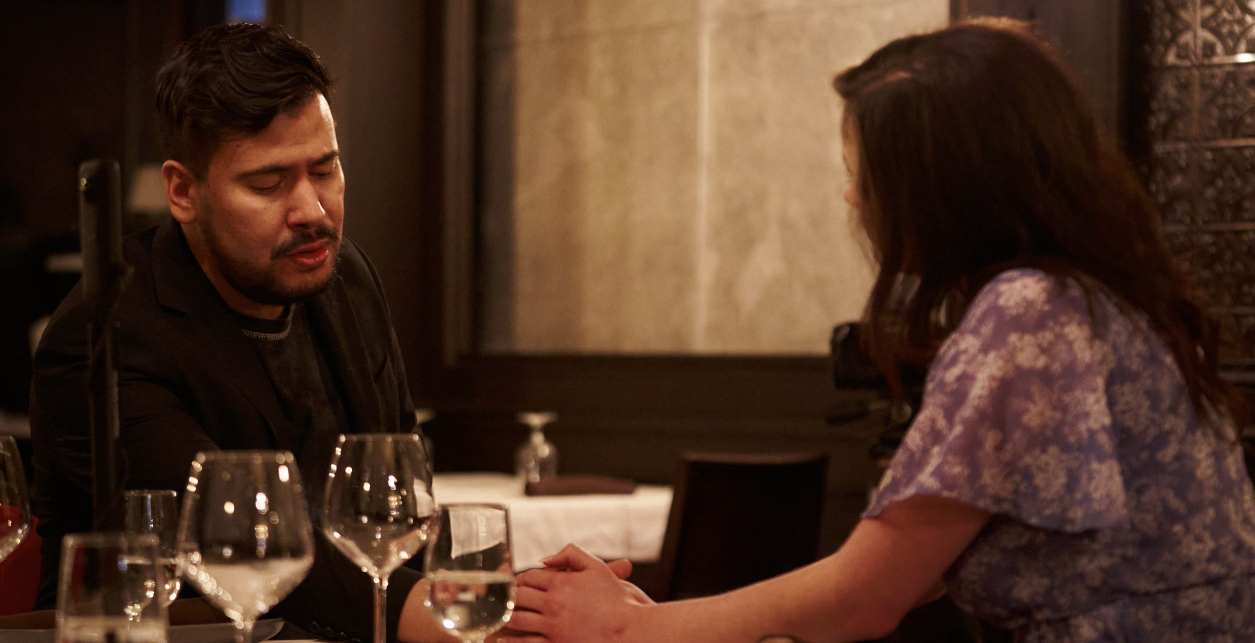
CARLOS JAQUEZ GONZALEZ portrays TONY, a chef at Windows on the World in 9/10: Love Before the Fall.

PROJECT CONTACT

daron@daronhagen.com
Personal Representation
Encompass Arts, LLC (USA)
Kathy Olsen
119 West 72nd Street
New York, NY 10023
Email Contact: Kathy Olsen
Tel: +1 212.439.8055
Music Publisher
Peermusic Classical (USA)
152 W. 57th Street, 10th. Floor
New York, NY 10109
Email Contacts: Karen Heymann , Todd Vunderink
Tel: +1 212.265.3910 x 116 and x117

Legal Representation
Corey Field Law Group (USA)
Corey Field
8033 W. Sunset Blvd., Suite 978
Hollywood, CA 90046
Email Contact: Corey Field
Tel: +1 310.467.5855

