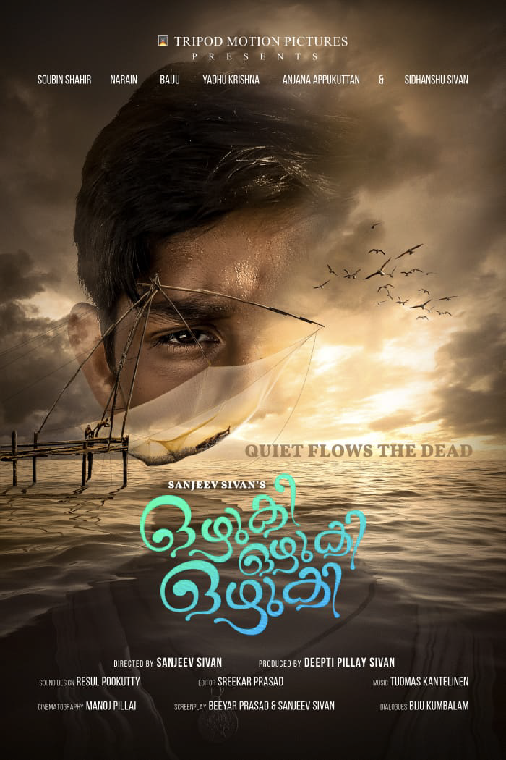

“OZHUKI, OZHUKI, OZHUKI”
(QUIET FLOWS THE DEAD)
- PROJECT DETAILS
Category : Feature Film
Duration : 90 Minutes
Language : Malayalam
Country : India
Subtitles : In English
Produced by : Tripod Motion Pictures
Landing Page : http://websoultech.com/ozhuki/final/

- LOGLINE OF THE FILM
The film is dedicated to the thousands of unidentified dead bodies floating in the global waters without getting a proper funeral from their loved ones. The story is about the determination of a 12-year boy to give a decent farewell to the body, but in the pursuit, he gets embroiled in murder charges, how his life takes a different turn.

- SHORT SYNOPSIS
Paakaran, a twelve-year-old boy. His father was a boatman, who went missing when their boat capsized in a storm, & his body was never recovered. While going fishing, with two other people one morning, they encounter a corpse in the water, which they throw back into the river, lest they would get into trouble with the police. This becomes a major fright for him, who starts having nightmares fully knowing that it is not his father’s body.
When he hears from the village astrologer about wandering souls whose last rites have not been done by their sons. He finds the corpse & alerts the police. The police, however, avoid the responsibility of tracking the identity of the corpse by pushing it back into the river.
Paakaran, sets off on a quest to find the corpse again, to give a proper funeral as per advice of the astrologer. While he is burying it; the town police intercept him & takes him in for questioning. He is accused of murdering the man & getting rid of the dead body.
He is terrorized, but finds a sympathizer in the same police station. Fate plays a game & he is released from police station. Miscellaneous events in his life lead to him leaving the village. While his boat leaves the shores suddenly, another body emerges out of the water.
It’s another ‘unidentified’ body– with no one to care for them, or eager to identify them, or give them a proper farewell. It’s another dead soul floating into the sea. Nameless & inconsequential.
******************************************
- BRIEF PROFILE OF THE CREW

- DIRECTOR/WRITER : Sanjeev Sivan

https://en.wikipedia.org/wiki/Sanjeev_Sivan
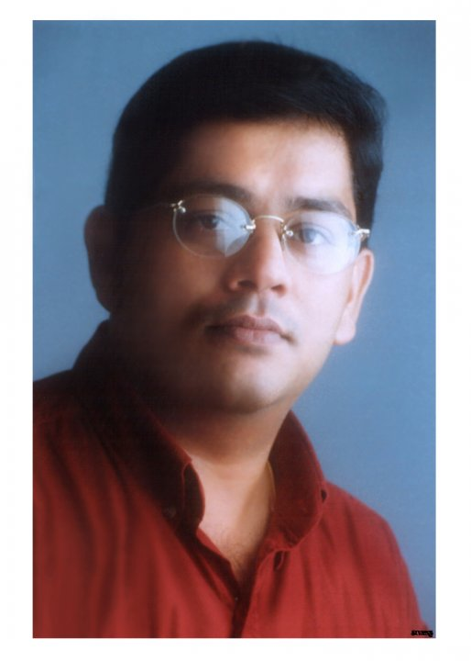

Sanjeev undertook a comprehensive course in direction at the very prestigious New York University. In all of his projects be it feature, documentary or docu-features, he believes each story has to be told differently.
He made his directorial debut with Malayalam feature film Aparichitan which went on to become sleeper hit. The film changed the face of Kerala film industry with is never seen before technique & craft.
His next feature film Venalodungathe was awarded best film at the Hidden Gems International Film Festival Calgary, Canada. Sanjeev’s projects have also been widely cherished – both domestically and abroad. His documentaries and docu-features like Underground Inferno for National Geographic Channel, won the Best Documentary Award at the International Film Festival of India, Goa, & the best documentary at the Greece International Film Festival.
He has a long list of completed international projects. To name a few: The Aryan Saga; Sex Lies & A Book; Karaoke Cops for Al Jazeera, London; Life After Death for Asian Pitch, Singapore, Dharavi – Underbelly Economy for MediaCorp, Singapore, In the Shadows of Taj for MediaCorp, United Colours of Bollywood, Fight Piracy Today, Little Women all for PSBT, Arunima’s Story, Boys & Girls, The Doll Story all for Government of India.
Sanjeev Sivan has collectively earned numerous state awards, national awards and international awards in his career He was also the jury member of the Indian Documentary Producers Association (IDPA) Film Awards also served as a jury member for the 57nth National film awards
Currently, Sanjeev is busy directing a Bollywood project with Emmy nominated hero of Sacred Games Nawazuddin Siddiqui & two Malayalam feature films.
- PRODUCER : Deepti Pillay Sivan
https://in.linkedin.com/in/deeptipillaysivan

Deepti is a Law graduate armed with M.B.A; with 25+ years’ experience in Media & Entertainment Industry that includes Events, Film, Television and Radio. She topped academically and was all-rounder in sports & arts during her student days.
Her foray into the entertainment industry was as an actress in the much acclaimed superhit film Kalipattam, but she preferred to be behind the camera; thus she started working for Amitabh Bachchan Corporation Ltd as the Associate Director for the Miss World Pageant.
She set up the Red FM Radio Station, making it No:1 Station while at the helm as Station Director. She progressed to Head a Channel of the India’s largest Television Network- the Sun TV, later joined Zee TV and progressed to various roles from Business Head to Commissioning head.
Post her marriage to Filmmaker Sanjeev Sivan; as Production Designer she handled feature films in Malayalam & Hindi, Non-Features, Advertisements, Documentaries for National Geographic Channel, Al Jazeera Public Service Broadcasting Trust, Government of India etc.
Her calling and passion being films, she moved on to Film Production handling Production of Feature films. Her most successful Directorial documentary was titled Decoding Shankar which was chosen in the “Indian Panorama” of International Film Festival of India at Goa. This documentary film drew rave reviews from critics and cinema buffs alike, both domestically and internationally. The film went on to win 25 International Awards across the globe.
Currently she is making features films in Malayalam & Hindi with Emmy nominated actor Nawazuddin Siddiqui and writing her Directorial feature film in Tamil.
    - STORY & SCREENPLAY : Beeyar Prasad
https://en.wikipedia.org/wiki/Beeyar_Prasad
Beeyar Prasad was an Indian Malayalam lyricist and poet, who made his debut in the Malayalam film industry through film Kilichundan Mampazham. He was a multi-talented person, who has written many librettos for the Kathakali dance.
In the year 1993, Beeyar Prasad scripted the movie Johny, which won Kerala State Film Award for Best Children's Film. In the year 2001, Prasad had played a role, Narayanan in the film Theerthadanam. Prasad died from complications of a stroke in Changanassery, Kottayam district, on 4 January 2023, at the age of 61. His last film was Ozhuki Ozhuki Ozhuki.
- EDITOR : A. Sreekar Prasad
https://en.wikipedia.org/wiki/A._Sreekar_Prasad

Akkineni Sreekar Prasad is an Indian film editor. He works predominantly in Telugu, Malayalam, Tamil, and Hindi language films. In a career spanning more than 35 years, he has edited over 600 films. He is a recipient of nine National Film Awards including seven wins for Best Editing which is a record in that category. He also won five Kerala State Film Awards, two Andhra Pradesh state Nandi Awards, and two Filmfare Awards among others.
He was included in the Limca Book of Records 'People of the Year - 2013' list for his contribution to Indian cinema in several languages. Prasad also holds the record for "films edited in most number of languages" in Limca Book of Records. He has edited films from 17 languages so far. His latest work is Rajamouli’s RRR (which won the Golden Globe for music) and Mani Ratnam’s PS1 & PS2.
- SOUND DESIGNER : Resul Pookutty
https://en.wikipedia.org/wiki/Resul_Pookutty

Resul Pookutty (born 30 May 1971) is an Indian film sound designer, sound editor and audio mixer. Pookutty has worked in Hindi, Tamil, and Malayalam languages in addition to British films. He is a recipient of Padmasree. Pookutty moved to Mumbai after his graduation. Pookutty got his big break with the critically acclaimed 2005 film Black, Directed by Sanjay LeelaBhansali. He subsequently engineered sound for major productions like, Zinda, Traffic Signal, Saawariya, Kerala VarmaPazhassi Raja, Enthiran etc.
He won the Academy Award for Best Sound Mixing, along with Richard Pryke and Ian Tapp, for Slumdog Millionaire. He also won BAFTA for Best Sound for the same movie.
- MUSIC DIRECTOR : Toumas Kantalinen
https://en.wikipedia.org/wiki/Tuomas_Kantelinen

Composer Tuomas Kantelinen works in the wonderful world of film, TV, Opera and Ballet. He has scored music for almost 100 feature films, including Stephen Fung’s The Adventurers, Timo Vuorensola’s The Ark, Renny Harlin’s The Legend of Hercules and Mindhunters, Sergei Bodrov's Oscar nominated Genghis Khan epic Mongol, Klaus Haro's awarded Mother of Mine, as well as Sweden's biggest production, Peter Flinth’s Crusades trilogy and TV mini-series Arn - The Knight Templar. He is known for his ability to adjust his musical skill to any culture and film territory. His knowledge of Hollywood film scoring techniques, electronic programming, classical Western Concert music styles and East Asian music cultures makes it easy for him to travel between Europe, US, China, India and beyond.
- CINEMATOGRAPHER : Manoj Pillay
https://www.imdb.com/name/nm2372630/

Manoj Pillai started his career under the tutelage of the acclaimed veteran filmmaker Mr. Sivan. He later joined as the associate cameraman to the India’s ace Cinematographer Santosh Sivan, ASC, ISC. His work as his associate includes some of the films like Santosh Sivan’s Terrorist, Mani Ratnam’s Dil Se, Priyadarsan’s Kalapani, Khalid Mohammed’s Fiza, Shahrukh Khan’s Phir Bhi Dil Hai Hindustani & Ashoka, M.F. Hussain’s Meenakshi and some international projects like Gurinder Chaddha’s Bride & Prejudice, Mistress of the Spices, Before the rains etc.
His independent work as a Cinematographer fetched him the Kerala State Award for Best Cinematography for Kaioppu. Some of his brilliant works include Achanorungathaveedu, Vasthavam, Arabikatha, Palerimanikkam, Gaddhamma, Mammagam, Red Wine, 22 Female Palayam Kotte (Tamil). He has also shot documentaries like multiple international award winning film Decoding Shankar, Wave Riders for the Ministry of External Affairs etc. The current trending and viral anthem of the Indian Navy Call of the Blue Waters was shot by him.
- PRODUCTION HOUSE : TRIPOD MOTIOM PICTURES

Tripod Motion Pictures is a Production house of Partners in real life - Sanjeev Sivan and Deepti Pillay Sivan– to explore and expound uncharted territories in the domain of audio-visual story telling.
With a determined agenda of delivering unique content in seamless quality, the organization brings with it the assurance of over 50 years of collated experience of excellence. They have together consolidated their creative partnership, collating their strengths acquired over the years – they deliver truly mind-blowing audio visuals across all formats, with global-class quality.
The team has to their credit 48 state, national and international awards collectively and their films have represented at numerous International Film Festivals including Seattle, Cannes, Hong Kong, Fukuoka, Stuttgart, Jecheon, Venice to name a few.
Leaning on the diversity of their experiences, and willing to experiment with brave, new ideas – Tripod Motion Pictures ushers in a new wave of storytelling – one that will regale and relate to audiences worldwide.
They are a force to reckon and dream team to work with. They create nothing but the best which leaves audience spellbound and asking for more.
******************************************
- BRIEF PROFILE OF THE ACTORS

- CHARACTER LIST WITH ARTISTS NAME

- Pakkaran -Sidhanshu Sanjeev Sivan
- Velladi Vishwam -Yadu Krishnan
- Binoy -Soubin Shahir
- Pakkaran Father -Narain
- Velu Police -Baiju Santhosh
- Amminiyamma -Saritha
- Gomathy -Anjana Appukuttan
- Meenu -Devu Manoj
- Binoy Mother -Pauly Vilson
- Damu -Suryakanth

- SIDHANSHU SIVAN - Debutant

Sidhanshu Sanjeev Sivan is an Indian Actor, is the third generation of Sivans clan; who dominates the Southern film industry in India. His father Sanjeev Sivan, is the youngest of the family of filmmakers that includes his late father Sivan - an acclaimed Director, Producer & Cinematographer and master craftsmen elder brothers Sangeeth Sivan – Director, Producer and Padmasree awardee Santosh Sivan – an ace Cinematographer, Producer and Director.
Sidhanshu’s parents noticed his passion for acting and his appetite for films. He is happiest while watching movies irrespective of language. He has been constantly pursing his interest in acting by attending acting workshops. Seeing his dedication and perseverance they decided to introduce him into the film industry at the young age of 12. Sidhanshu’s debut film is “Ozhuki Ozhuki Ozhuki” Directed by his dad Sanjeev Sivan and Produced by his mother Deepti Pillay Sivan under their banner of Tripod Motion Pictures.
- YADU KRISHNAN

Yadu Krishnan is an Indian actor who works in Malayalam cinema & television industry. He began his film career as a child artist in a film Vivahithare Ithile Directed by Balachandra Menon in 1986 and worked under several directors ever after. He is remembered for his role of Monukuttan in Sanmanasulavarkku Samadhanam and Rameshan in Kireedam. He went on to act in several films like Chenkol, Perumazhakkalam, Thommanum Makkalum etc. but he became very popular due to his portrayal in television serials. He won the Kerala State Award for Best Actor for his leading role in Television serials.
- SOUBIN SHAHIR
https://en.wikipedia.org/wiki/Soubin_Shahir

Soubin Shahir is an Indian actor and director who works in Malayalam cinema. He began his film career as an assistant director in 2003 and worked under several directors. Soubin made his acting debut in 2013 with a supporting role in Annayum Rasoolum. He made his directorial debut with the drama Parava. In 2018, he won the Kerala State Film Award for Best Actor for his leading role in Sudani from Nigeria, the film was also a major commercial success
Soubin started his film career as an assistant director in the industry with Siddique. He made his acting début in Fazil's Kaiyethum Doorath while working as an assistant director. He got a breakthrough role with Alphonse Putharen's Premam. This led to his popularity as an actor in the industry. His popular roles include in films Charlie, Maheshinte Prathikaaram, Kali, Darvinte Parinamam, Kammati paadam and Kumbalangi Nights. His first full lead role was in the film Sudani from Nigeria for which he won the Kerala State Film Award for Best Actor.
- NARAIN
https://en.wikipedia.org/wiki/Narain_(actor)
Narain, is an Indian actor who has starred in Malayalam and Tamil films. He made his debut in Adoor Gopalakrishnan's Nizhalkuthu, followed by performances in Malayalam films 4 the People, Achuvinte Amma, and Classmates. Narain's Tamil debut was in Mysskin's Chithiram Pesuthadi. His first commercial film, 4 The People, was superhit. Through Panthaya Kozhi, produced by Director Lal, he has been re-launched as an independent action hero in the Malayalam film industry. In 2008, he did another youth-oriented Malayalam movie Minnaminnikoottam. Narain worked with director Sathyan Anthikkad again in Bhagyadevatha. He collaborated with Director Mysskin in the 2008 film Anjaathe and in the 2012 superhero film Mugamoodi where he portrayed a villain. However his career high came through Lokesh Kanagaraj Directed venture Kaithi & in 2022, Vikram starring Kamal Haasan, Vijay Sethupathi, and Fahadh Faasil.
- BAIJU SANTOSH
https://en.wikipedia.org/wiki/Baiju_(actor)
Baiju Santhosh Kumar, is an Indian actor who works in Malayalam films. He began his acting career at the age of 10 debuting, as a child artist in the film Maniyan Pilla Adhava Maniyan Pilla. Since then he has acted in more than 300 films. He was recently appreciated for his role in the Asian Award winning film Minnal Murali. He has mostly done character roles and comedy roles. He got a career breakthrough with the film Puthan Panam directed by Ranjith. His portrayal of Stephen Achayan in Ente Mezhuthiri Athazhangal was critically acclaimed. In 2019, he did lead role in Mera Naam Shaji.
******************************************

NEWPAPER ARTICLES

THE HINDU NEWSPAPER

Sanjeev Sivan puts life into the backwaters of Kuttanad
https://www.thehindu.com/entertainment/movies/documentary-filmmaker-director-sanjeev-sivan-and-his-12-year-old-debutant-actor-son-sidhanshu-sivan-speak-on-the-making-of-the-malayalam-film-ozhuki-ozhuki-ozhuki/article66360645.ece

******************************************

VIMEO LINK OF THE FILM TRAILER

OZHIKI OZHIKI TRAILER NEW.mov
vimeo.com

******************************************

CONTACT INFORMATION

EMAIL:
tripodmotionpicturestmp@gmail.com or sanjeevsivan@sanjeevsivanentertainment.com

PHONE:
9446749926 or 9961452626

ADDRESS:
2 A, Silver Oaks, Golf Links Road, Kowdiar,
Thiruvananthapuram, Pin: 695003, Kerala, India

YOU TUBE LINKS
https://www.youtube.com/results?search_query=sanjeevsivan
https://www.youtube.com/@tripodmotionpictures5630

******************************************

