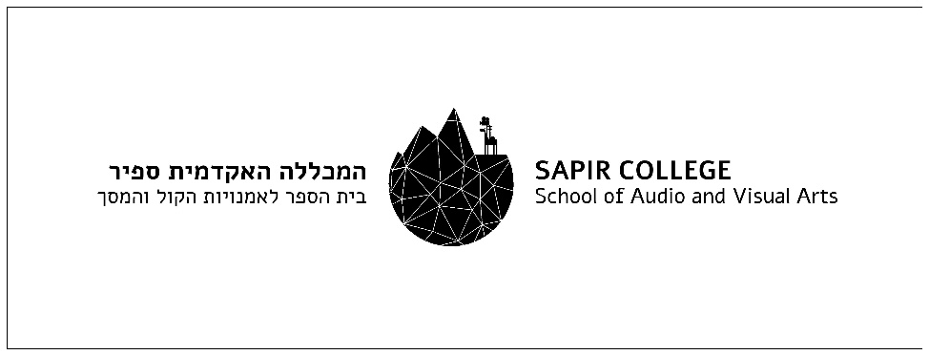

‏09/10/2022

Proof of student status

To whom this may concern,
I hereby declare that the film "Let's talk" by Elad Mukades, i.d. 304899990, is produced as a graduate film as a part of the studies at the School of Audio and Visual Arts, Sapir College, Israel.
We confirm the full support of the college in the project.
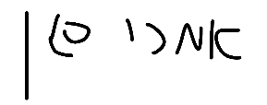
Best regards,
Imri Kagan,
Productions Coordinator,
School of Audio & Visual Arts
Sapir College,
+972-77-9802361
imrik@sapir.ac.il

