



THE INFORMATION CONTAINED IN THE FOLLOWING PAGES SHOULD BE PASSED ONTO THE NECESSARY PEOPLE IN YOUR COMPANY AND TO THE VENUE TO ENSURE THE SMOOTH RUNNING OF THE SHOW.

SHOULD THERE BE PROBLEMS OR YOU WISH TO DISCUESS ANY ASPECT OF THE SHOW PLEASE CONTACT THE PRODUCTION MANAGER AS SOON AS POSSIBLE. THANK YOU FOR YOUR HELP.

Creative Director
Philip Rachid
philip@soultrotter.com
+971 54 319 9777

PLEASE ENSRUE THAT THE CREATIVE DIRECTOR / PM IS THE INITIAL CONTACT FOR ALL ADVANCE AND/OR QUESTIONS.

TIMINGS
To be assigned with PM. We will send a preferred Run of Day ASAP after looking at your venue specs. Please provide ASAP.

REHEARSAL & SOUNDCHECK
We will need a quiet, closed off room for Rehearsal & Sound check. Please ensure that no one, unless they are working, has access to the auditorium.

NOISE RESTRICTIONS
Please advise of any noise restrictions – e.g. levels as well as any curfews.

VEHICLES/PARKING
We will not be traveling with vehicles. However please ensure close parking spots as required for ground transport and/or runner vehicles.

RUNNER
We will need a runner with a vehicle. On days that we need the runner to move the touring party from hotel to venue, the runner should have a 15-passenger van with the back seat taken out, creating luggage space. This will be advanced by the PM directly for each show.

GROUND TRANSPORT
We will need you to provide ground transportation from: AIRPORT – HOTEL – VENUE – HOTEL – AIRPORT. These may involve more than 1 journey at separate times. We will need to transport Ten (10) persons + luggage. Please ensure this is in a comfortable air-conditioned vehicle(s). This will be advanced directly with you directly.

PROMOTER’S REPRESENTATIVE
Please provide an experienced, English speaking representative that is onsite from Load-in until Load-out. This person must have full decision-making capability.

PASSES
We will have our own laminates. We will provide working, guest and photo passes. Please liaise with the Production Manager about numbers, restrictions and distribution.

SECURITY
The Safety & Security of “The Main Circle’s” touring party and audience is very important to us! Purchaser shall provide and pay for adequate security personal, equipment and facilities for the protection of the Artist, their employees, agents, contractors and respective equipment and/or instruments, also for the protection of all patrons and/or other persons at the event. The Purchaser shall be solely liable for any damage, loss or injury resulting from its failure to provide the same. Notwithstanding the foregoing, in the event the Production Manager and/or the Artist determine in their sole discretion that the Artist, any of Artists’ employees or any patron is subject to any threat of bodily injury or Artists’ equipment’s has any potential for property damage then the Production Manager shall have the right to cancel the event, without liability or further obligation to Purchaser, Purchaser shall remain liable to Artist for the FULL contract price and/or percentage money’s due. Without limiting the foregoing, Purchaser shall provide and pay for the following for the duration of the event, at times determined by the Production Manager.

SECURITY (continued)

Security will be controlled, but not restrictive. All security personnel must be at least 18 years of age and must be hired specifically as security. Absolutely NO volunteers of any kind shall perform the duties of security. No stagehands, housekeeping staff, etc… shall work as security and all security personnel must be paid employees engaged by or at the direction of PURCHASER. Venue personnel and/or ushers are not to be considered part of the security personnel either.

PURCHASER shall provide clearly identifiable and responsible security from the arrival of ARTIST’S first personnel or equipment on site through the departure of the ARTIST. Amount of staff should be large enough in number to supply all functional security needs to Venue and ARTIST.

Areas to be secured include, but are not limited to: parking and loading areas, dressing rooms and hallways, Tour Production / Management areas, stage, front of stage, stage stairs, sides and back of stage, ALL backstage entrance/exit areas, loading ramps, main entrance to venue and line control of patrons entering facility, VIP entrances/exit, employee entrance/exit areas, lobbies, front of house/mix area, toilets/restrooms, and all concourses / lobbies and patron parking areas.

It is especially important for the Artist’s safety that we have security on all entrances leading to the backstage (from in & outside venue), the dressing room, and FOH.

At all times from the arrival of the Artist/Artist equipment, the security personnel will be advised and directed by the Artist’s PM.

** A security meeting will need to take place with the following people no later than 1 hour prior to doors: Production Manager, Promoter Rep, Venue Manager/Rep and Head of Security. The Doors should not be opened without approval from the Artist’s Production Manager. **

AUDIENCE RESTRICTIONS
- No Large backpacks or bags of the like.
- Please ensure that there is no audio or visual recording of the show.
- We would prefer there is no photography. We will allow non-professional cameras, but we would like to avoid the use of flash and overzealous use.

MERCHANDISE
We have a selection of merchandise available for sale at our shows. We may need you to provide a house merchandise seller for this.

We require a dedicated merchandise area with lighting, power, display area for merchandise. If the venue does not have a dedicated merchandise area, we will require an 8-foot table with tablecloth, two clip lights and power at load-in.

TOWELS
Please provide us with Seven (7) clean bath towels. We will also need Eight (8) hand towels. If new, these should be prewashed. Dark coloured preferred. It is important we have the full number of requested towels as the full touring party will be showering at the venue.

SHOWERS
Please ensure we have access to Two (2) fully working showers from Load-in until Thirty (30) minutes after Load-out. Please ensure these showers are clean and have hot water. If no showers at the venue, we will need a hotel room very close by. This will be advanced with you directly.

DRESSING ROOMS
We will need at least Two (2) Dressing Rooms.
- Female Dressing Room
- Male Dressing Room

Each Dressing Room should be furnished with the following:
Chips, Snickers / Twix /Bounty Bars, Bananas, Oranges, assorted juices, room temp water, Red Bull energy drinks

These should be comfortably furnished and ideally have en-suite bathroom facilities with hot and cold running water. Please make sure there is soap in the bathroom. Both rooms should have a full-length mirror, a Two (2) clothes rails with hangers.

The rooms should be adequately heated/ventilated preferably with a fan, not air-conditioning, trash cans and working electrical outlets, have internet connection with posted Internet WIFI codes, and should have furniture to seat 10 persons.

DAY ROOMS
If you do not have any showers or the dressing rooms are particularly dire, we will need you to provide Two (2) day rooms available from Load in until load out as a show cost. PM will liaise directly on this.

PRODUCTION OFFICE
Please have a separate room available for the TM/PM. This room should have a phone (without international dialling restrictions) and internet – Ethernet or Wireless and a printer. Please pass any codes to the touring party prior to arrival.

MEALS
We would prefer in-house catering for the touring party. If we are to have catering, then we require good quality healthy hot meals:

LUNCH – Timing & Menu to be Advanced

DINNER – At 5pm. Dinner should be 3 courses. There should be, at least but not limited to, Meat options, Fish options, Vegetarian options, plus vegetable and salad side dishes.

BUYOUT
If in-house catering is not possible, we will take buyouts per member of the touring party.

LUNCH - $15 USD per person (or equivalent in local currency)

DINNER - $25 USD per person (or equivalent in local currency)
Buyout should be paid to the Production Manager on arrival.
Will confirm touring party number in advance.

HOUSE ENGINEERS/STAFF
We will require from Load-in:
- House PA Technician who can assist with the set-up, operation and load out.
- House Lighting Technician
- Video Technician who can assist with the set-up, operation and load out.
- Rigging Staff if Required
- One (1) Person Lift (For Lighting Focus / Projector Access)

CREW
PM will advance
We will require from Load-in:
- Two (2) Crew for Load-in / Load-out
- One (1) Wardrobe personnel to take care of costume cleaning and show running repairs.
- One (1) Female Crew Member & One (1) Male Crew Member for assisting with Show Call in conjunction with the Wardrobe personnel.
ARTIST’S Production Manager may vary this schedule and or manpower requirements, as it is necessary for production needs.
(“Departmentalized” I.A.T.S.E. union members may require different number.)
STAGING & RIGGING

PLEASE SUPPLY THE PM WITH A COPY OF ALL RELEVANT FLOOR PLANS, LIGHTING AND RIGGING PLANS FOR YOUR VENUE.

EXAMPLE PLANS AT END OF DOCUMENT

- Minimum Dance (Acting) Area: 11m wide by 7m deep (Dimensions may be changed with prior agreement). Flooring suitable for break dancing. Floor must be level with no joins and free from screws and nails.
- End On seating preferred. No Wing or Side Stage Seating.
- Required minimum height for projectors to be above 5m.
- Three (3) white projection screens
  - Screen 1 – The Upstage screen to be 16:9 ratio (approx. 8m wide x 4.5m high)
  - Screen 2 & 3 are positioned 1m Downstage and orientated vertically 9:16 ratio (approx. 4.5m high x 2.5m wide)
- One (1) Super 55 Microphone is suspended through a pulley system to be dropped in as close to downstage center as possible without being in the projection beam.

RISERS

We need the following risers provided locally.
Two (2) 8’ x 8’ x 1’ risers. (Percussion & Oud)
Risers to include set of stairs for access.

To be placed either side of the dance area at the front of the stage for musicians.

BACKDROP/DRAPE/FIRE CURTIAN
Venue to supply and install before Artist arrival per approved plan

- Please ensure there is a BLACK backdrop that spans the full width of the stage in the most upstage position.
- Three (3) sets of black masking legs.
- Please advise if your venue has a DS Fire curtain installed that we need to be aware of.

VIDEO REQUIREMENTS
Venue to supply and install before Artist arrival per approved plan

PLEASE ADVANCE WITH PRODUCTION MANAGER

- Two (2) MacBook Pro running Q Lab with installed video license.
  - One (1) Q lab output + Camera output both fed to a vision mixer
output signal to center projector

  - Second Q lab runs Two (2) outputs to the outer screens’ projectors

- Three (3) Full HD projectors flown above the audience to cover the screens, one projector per screen, with minimal actor shadowing (Rigging & Position to be agreed before ARTIST arrival or to be allowed time within schedule)

- One (1) HD Camera, rigged Center Stage pointing down with preview monitor

- One (1) Stream Deck programmed to trigger both Q Lab laptops simultaneously

- Cable Package with spares for the full set up

- Enough power in the right locations to accommodate the above list of gear.

COMPANY WILL PROVIDE:

- Bundled Q Lab show file & content file can be supplied before arrival to allow for setup and testing.

ADDITIONAL REQUIREMENTS

- Access equipment and trained personnel to access projector positions
- One (1) Q Lab operator
- One (1) House video technician with full working knowledge and experience of equipment
- Proper power to supply the Video & Control System – Should not be shared with any other department.

AUDIO REQUIREMENTS
Venue to supply and install before Artist arrival per approved plan
PLEASE ADVANCE
Stereo system that is capable of providing 120dB at F.O.H. mix position is needed for a good performance. This high number is to ensure that the system has enough headroom to sound good when playing at 100dB (A).
INPUT LIST AT END OF DOCUMENT
PA:
- Venue to supply a professional stereo sound system consisting of Left, Right and Sub fed independently (L’Acoustics, d&b, Nexo)
- Subs are to be placed clear of the performance area.
- PA should be placed no further upstage than the front of the stage.
- All elements should be time and phase aligned and must deliver 100dB, 20Hz-20kHz evenly throughout the venue with no more than a 6db variation between the front of stage and FOH mix position. No more than 3db variations between audience blocks to maintain homogeneity.
- Front Fills and Delays to be implemented where necessary to maintain audience coverage and homogeneity.
- Double 18” Subwoofers that can drive 30Hz-60Hz/80Hz to be placed under the seating riser fed from a separate send, to act as a Frequency extension for special effects (Not to be tied to the Main PA Sub) – If Possible, To be advanced.
- Any & All Cable package requirements.

Monitoring:
  - Four (4) full Range Stage monitors & Four (4) Single 18” subs, Two (2) on each side of SR & SL all on separate sends (mixes) for Artists.
  - One (1) Stage monitor on each musician platform

Control:
  - Control position centred to the PA , to be as close to audience position as possible.
  - Preferred console: Yamaha CL/QL series or above with minimum 16 IN, 8 OUT IO capabilities (not including archive). Reverb and distortion effect required in places.
  - Playback from Three (3) x Q Lab stereo DI inputs

Microphones:
  - One (1) Countryman WCB6B lavalier microphone or Similar
  - One (1) Super 55 hanging mic
  - Two (2) DI input or Neuman 184 / SM57
  - One (1) Beta91 for Cajon
  - Two (2) Beyer dynamic M88 for Bongos
  - One (1) God Mic for Rehearsals

AUDIO REQUIREMENTS (continued)

  - Venue to supply Sound Operator with full working knowledge of equipment and console for show operation.
  - Please ensure that proper RF coordination is done before arrival. Actors interact in close proximity to each other. In the case of ULXD or above, please allow access to control network for additional coordination
  - Full P.A and Line check to have been installed and checked before Artist arrival
  - Will require Clear-Com between, Backstage, Video, Lightings, Audio & FOH
  - Proper power to supply the Audio & Control System – Should not be shared with any other department.

LIGHTING REQUIREMENTS

PLEASE ADVANCE

Lighting varies in all situations, the below is a guideline. Use LX Plot example attached as a good general reference of what is required. Please advance placements, fixture types and Fixture brands with PM. Please provide your Venue Plot prior to advacne.

VENUE TO SUPPLY AND WHEN POSSIBLE INSTALL BEFORE ARTIST ARRIVAL

Proper power to supply the Lighting & Control System – Should not be shared with any other department.

Any & All Cable package requirements.

EXAMPLE PLANS AT END OF DOCUMENT

CONSOLES
- We do not travel with consoles, preferred consoles in order of preference:
    - ETC Eos Family Console: Gio, Gio@5, Ti (Running Software v3.1.2)
    - GrandMA 2 Lite
*If your venue has a MA3, Mode 2 will be used please provide the Ver. In Use.

FIXTURE COUNT

Lustr Series 2 LED - Total: 26
Booms: Lustr2: 20
Over Head Lustr2: 6*
*(These can also be movers – marked in RED on Plot example)

Intelligent Moving Head Profiles – Total: 22
*(NOT including possible Six (6) Lustr2 Swaps)

Intelligent Moving Head Washes – Total: 9

CS MARK
- One (1) Intelligent Moving PROFILE Fixture to be hung on a bar between DS & MID Stage Truss to ensure fixture at open beam lands straight down on the CS Mark of the ACTING AREA. This is also where the HD Camera can be hung for the CS shot required for the show mentioned above in the Video Section.

LIGHTING REQUIREMENTS (continued)

FOH POSITION
- Four (4) Lustr Series 2 Source 4 with 36 Degree Lenses with Gel Frame*
*(If is easier – these fixtures can also be movers with framing to save on focus time)
- Three (3) Intelligent Moving PROFILE Fixtures with framing
- Five (5) Intelligent Moving WASH Fixtures with Framing

US TRUSS
- Four (4) Intelligent Moving PROFILE Fixtures
- Four (4) Intelligent Moving WASH Fixtures with framing if possible

MID TRUSS
- Eight (8) Intelligent Moving PROFILE Fixtures

DS TRUSS
- Two (2) Lustr Series 2 Source 4 with 36 Degree Lenses with Gel Frame*
*(If is easier – these fixtures can also be movers with framing to save on focus time)
- Six (6) Moving Light PROFILE Fixtures

ON STAGE BOOMS
- Eight (8) Lighting Booms
    - Four (4) Booms on each side of SR & SL
    - Four (4) Booms US should consist of Three (3) ETC Lustr Series 2 with 26 Degree Lenses installed with Gel Frame
    - Four (4) Booms DS should consist of Two (2) ETC Lustr Series 2 with 26 Degree Lenses installed with Gel Frame
- Two (2) Hazers; one (1) on Stage Right & Left with - DMX Control
- Two (2) Quiet Fans if Hazers do not have internal blowers - with DMX Contro

All Moving Light PROFILE Fixtures on the MID & DS Truss’ and CS Mark Fixture should have the following CONE GOBO installed in Slot 1 of the rotating GOBO wheel where possible.


PLEASE NOTE
- We will need one Professional Audio / Lighting Rig as suggested above. The technicians must speak English. Please consult with the Production Manager with any questions regarding this.
- Associated access equipment and trained personnel to be supplied by venue.
- All fixtures to be installed and tested prior to arrival when possible.
- The ARTIST Production Manager must approve all Lighting & Video specifications.
- The above list is a guide. But understand that this is the type of package we will need.

STAGE PLAN EXAMPLE
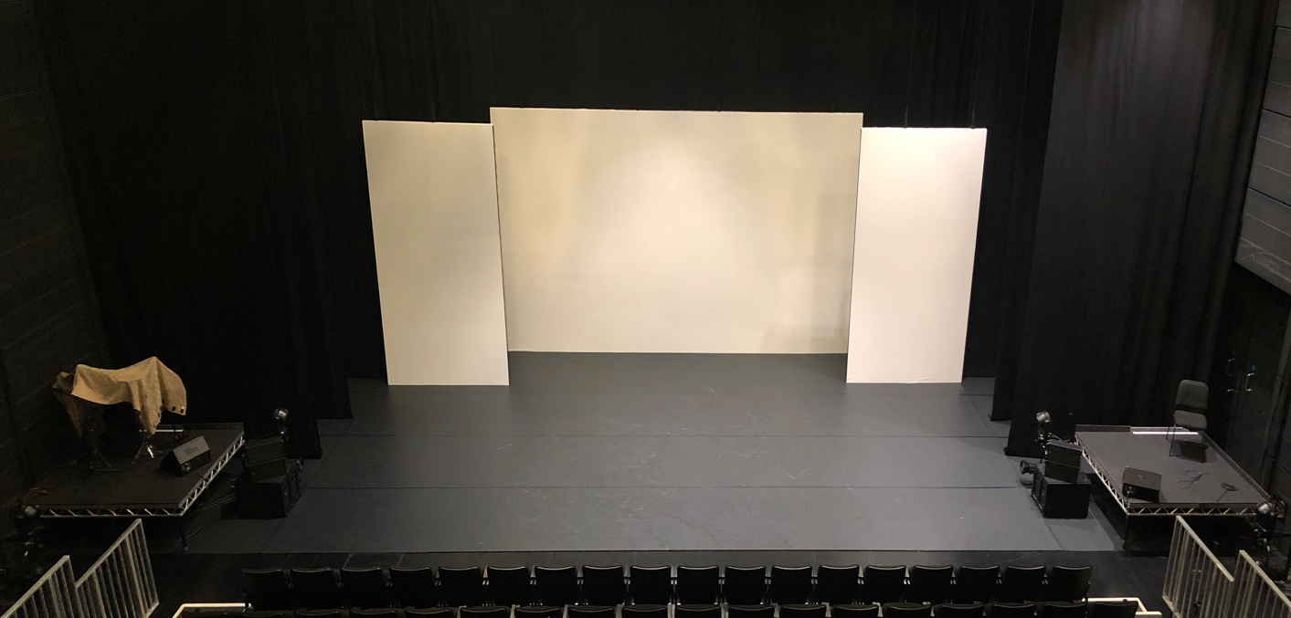

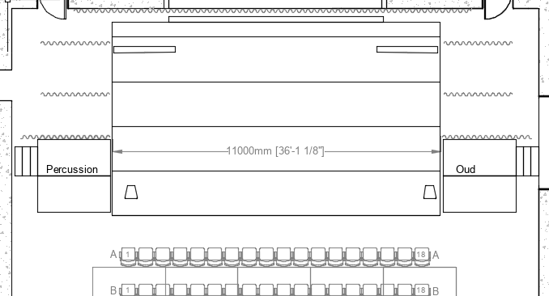

INPUT LIST
CH | Instrument | MICROPHONE / AMPLIFICATION | OUTPUT | MONITORS
1 | AV Media Server Computer Audio Que L | Focusrite Scarlett 18i8 3rd Gen - OUT 1 (MAIN PA L) | MAIN PA L | ALL
2 | AV Media Server Computer Audio Que R | Focusrite Scarlett 18i8 3rd Gen - OUT 2 (MAIN PA R) | MAIN PA R | ALL
3 | AV Media Server Computer Audio Que SUB FX | Focusrite Scarlett 18i8 3rd Gen - OUT 3 ( FX SUBS) | FX SUB Matrix 1 | NONE
4 | AV Media Server Computer Video L | Focusrite Scarlett 18i8 3rd Gen - OUT 1 (MAIN PA L) | MAIN PA L | ALL
5 | AV Media Server Computer Video R | Focusrite Scarlett 18i8 3rd Gen - OUT 2 (MAIN PA R) | MAIN PA R | ALL
6 | OUD | RADIAL DI | MAIN PA | MUSICIANS ONLY / AS NEEDED
7 | Cajun | Beta 91 inside / DPA 4099 w. Clip | MAIN PA | ALL
8 | Bongos | Beyerdynamic M88/ SM57 (Tall Mic Stand) | MAIN PA | MUSICIANS ONLY
9 | Conga 1 | DPA 4099 w. Clip /or SM57 on Stand | MAIN PA | MUSICIANS ONLY
10 | Conga 2 | DPA 4099 w. Clip /or SM57 on Stand | MAIN PA | MUSICIANS ONLY
11 | Hi-Hats/ Cymbal | Neumann KM185 / Equivalent Super Cardiod Condenser | MAIN PA | DS Monitors & Musicians Only if needed
12 | OH Toys/ Shakers/ Chimes | Neumann KM184 / Equivalent Cardiod Condenser | MAIN PA | As Needed/ Only for Musicians
13 | Philip Vocals | Wireless DPA 4080 Cradiod | MAIN PA | As needed
14 | FX Corded Mic Drop | Shure SH55 Series II Cardiod Dynamic | MAIN PA | DS Monitors
15 | Philip Vocals SPARE | Wireless DPA 4080 Cradiod | MAIN PA | As needed
16 | FX SPARE HH (If FX Mic Fails) | Wireless Beta58 | MAIN PA | DS Monitors
17 | Director TalkbBack Mic | Wireless Beta58 | MAIN PA | ALL AS NEEDED
18 | LX TalkBack Mic | Wireless Beta58 | MAIN PA | ALL AS NEEDED
 | NOTES
 | Large Wireless Pack Strap
 | Pully System for FX Shure SH55 Microphone
 | All Transmitters / Receivers
 | All MC Microphones needed as per event

LIGHTING PLAN EXAMPLE
