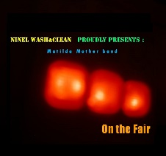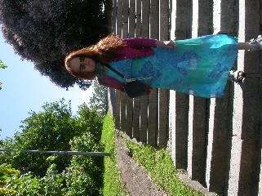
On the Fair Ninel Grönholm Tomi Christiansson
Press kit – On the Fair https://filmfreeway.com/OntheFair

This short film/music video criticizises capitalism and commercialized world, where you can sell even the old granny as well. It doesn´t seek to draw laughter, but there is still parody. The project started from poem, which was the things Ninel Grönholm and Tomi Christiansson were discussing: the daily issues from television and newspapers. The music was written around that and the filming happed the same day by one take. Music track is from main film track, no added sounds or effects. The song is Composed by Tomi Christiansson and is performed by Matilda Mother band.
Some themes Tomi Christiansson played beforehand and wrote the lyrics. The idea for film is based on this song and music; the final editing accomodates music.
The guitar sound pays hommage to the grinding sound of a pump organ. Accompanging the constant blabbering of the master of ceremonies blowing the tent top off in town after town. Making a spectacular entrance and exiting just in time before the novelty wears off and the uselessness of the ointments and magic potions becomes clear. Just in time before tar and feathers.
The main filmtrack is filmed by one shot and the soundtrack is the same. Directing, filming, editing is done by Matilda Mother band. This song is planned to be in LP called On the Fair.
Matilda Mother band has digital sound material in Bandcamp. Sähkö, 700Napa-38, Sun, Fluttering Reflection, Aamuun on pitkä matka and Pim ja Pom, Amfibioraketti. https://matildamotherband.bandcamp.com/follow_me
https://www.facebook.com/MatildaMotherband
https://www.instagram.com/matildamotherband/
https://twitter.com/BandMatilda
https://www.youtube.com/channel/UCHa0PerB3-BX8OKu0_XQqPg
https://holvi.com/shop/RubyLipsSound

