Aliquam II – Content

Introduction to Aliquam

Giving a gift of the ocean to the next generation is more than just an ideology.

It is also more than passing on the turbulence created by generations past.

What it is about is simply making a start to give them the gift of knowledge and ability.

To provide them an extremely rare opportunity to experience their first breath beneath the surface.

FILM 1:
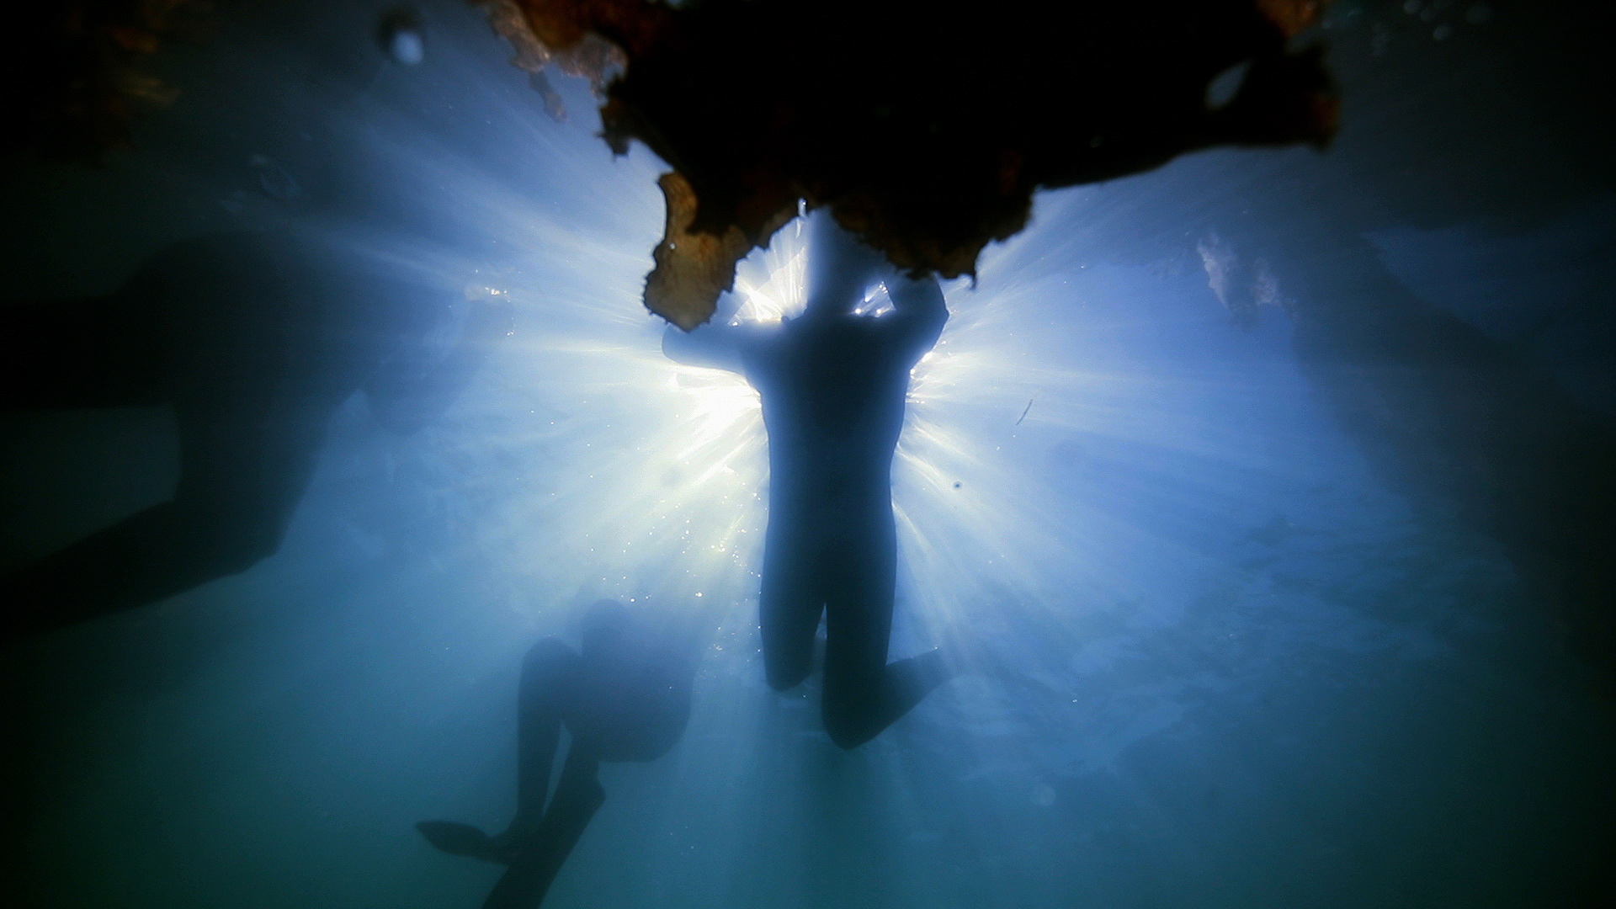

Kohia 12

When I went in and looked around it was like entering an amazing new underwater world that I didn’t realise existed so close to the seashore, there were beautiful plants growing on the net, like an underwater forest and schools of small fish swimming around us as well as a few lone medium fish, and I wonder how many more big fish would we have seen if we didn’t overfish? During the snorkel I realised the gold flex on the seagrass and thought it was beautiful I never knew that sea grass would look like that underwater!

I am usually a verry anxious person and sometimes I even have trouble having a consistent swim at the beach because I am too scared to stay in the water (I often hop in and out constantly), but when I went out diving and snorkelling, I found it so peaceful and magical. I think if I could hop in and discover that beautiful world any one can. I hope we all try much harder to protect the ocean, because if we lost it, it would be a catastrophe.

Zac 16

The diving experience opened a whole new world to me.

Being able to dive down to the bottom and look at the amazing environment I couldn’t see from the surface. It was truly incredible to see the marine life around me, watching the various fish and string rays move past me.

I think every kid should have the opportunity to go diving and see how different it looks from the bottom. And how cool and amazing the ocean can be.

To start your dive journey visit
https://www.diveraid.com/adventure/

SUUNTO Australia
https://www.suunto.com/en-au/?epslanguage=en-GB&CMPID=google%7Csearch-b%7Cperformance%7Capac%7Cau%7Csuunto%7Ce%7C571256147516%7Cc%7C%7Cwinter-sales&gclid=CjwKCAiAl-6PBhBCEiwAc2GOVF-FnGOrkSETG5aP0Ib5gqYpOM9gtTBuDSCLFna4TA6bXhnaWMUwZhoCLHMQAvD_BwE

SUUNTO New Zealand
https://www.suunto.com/en-nz/?epslanguage=en-GB&CMPID=google%7Csearch-b%7Cperformance%7Capac%7Cau%7Csuunto%7Ce%7C571256147516%7Cc%7C%7Cwinter-sales&gclid=CjwKCAiAl-6PBhBCEiwAc2GOVF-FnGOrkSETG5aP0Ib5gqYpOM9gtTBuDSCLFna4TA6bXhnaWMUwZhoCLHMQAvD_BwE

Partner Tags:
https://www.instagram.com/mercedesbenzgbrothers/
https://www.instagram.com/suunto_anz/
https://www.instagram.com/prodivemanly/
https://www.instagram.com/scubadivermagazine/

https://www.instagram.com/diveraid_international/
https://www.instagram.com/zoomaustralia/
https://www.instagram.com/sharkskin_watersports/

FILM 2:
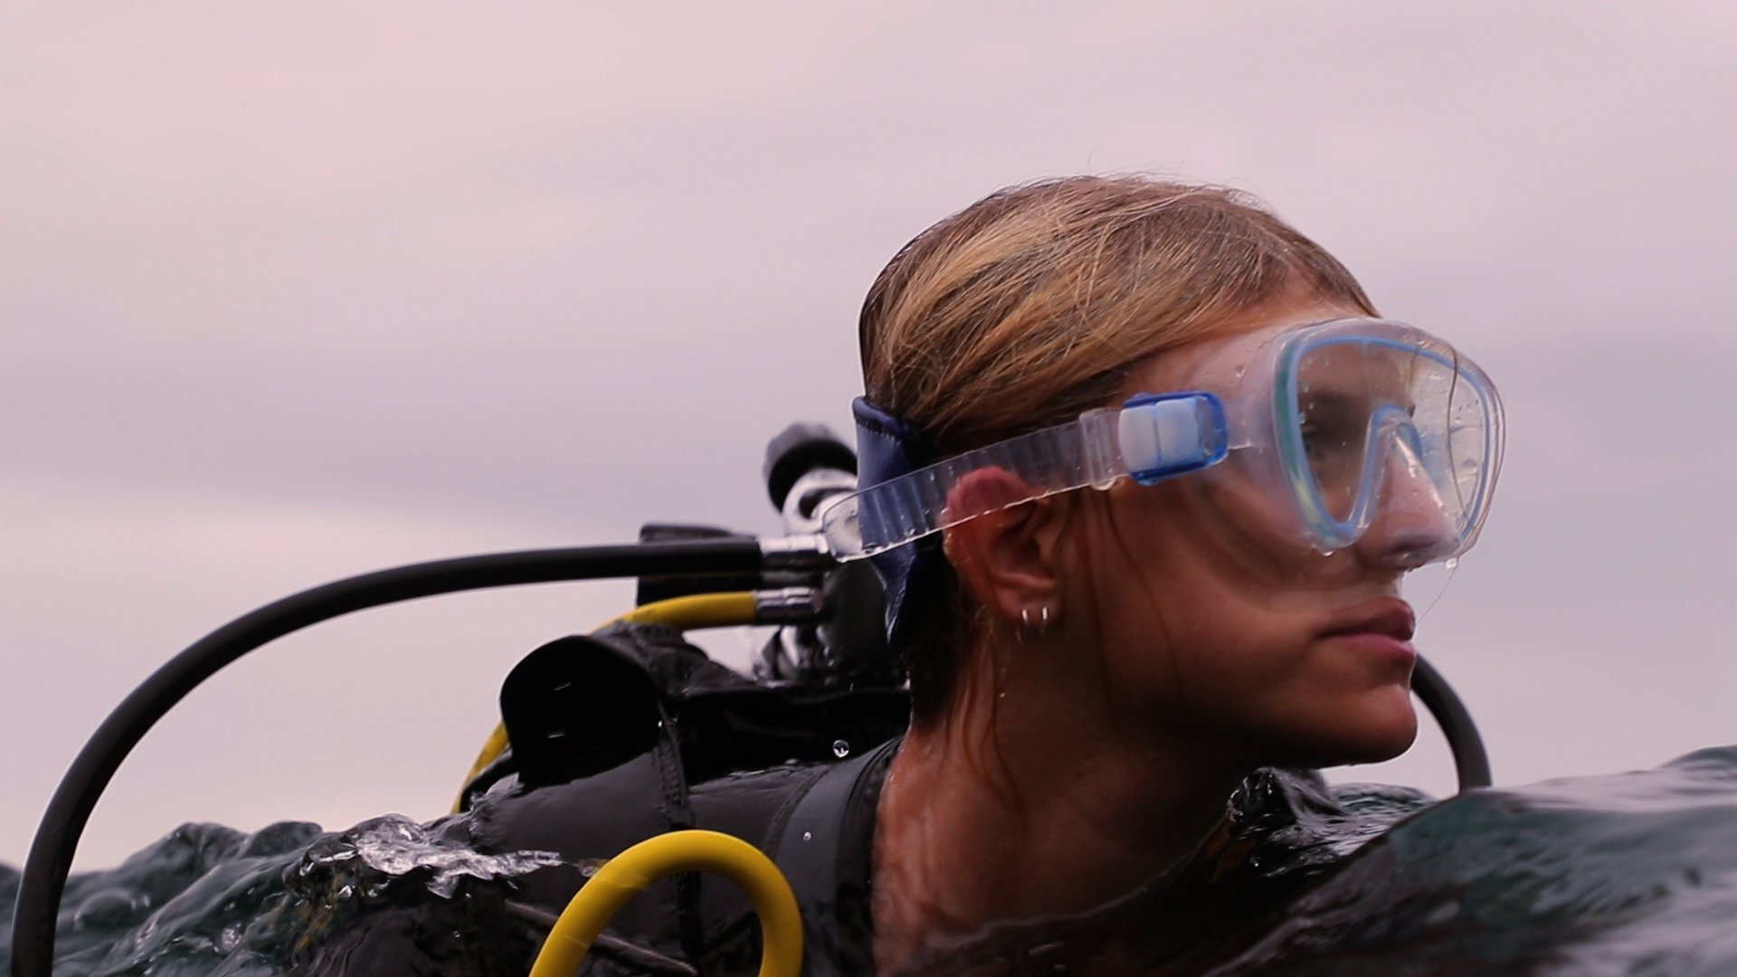

Ashley 16

Scuba diving is an amazing experience that few people have the opportunity to experience; being able to immerse yourself completely underwater for long periods of time is a gift.

Scuba diving teaches the sensation of relaxing and slowing down life as you begin to notice all the small details in the ocean and stay alert to those aspects of life we take for granted, such as breathing and moving.

Diving is definitely an activity I would recommend to anyone of any age but it does help to start young. Like any sport, young minds seem to catch onto what is being taught and their attention is much more devoted to the more enjoyable aspects of Scuba.

Personally, diving has been a way to clear my mind and it has helped me to find my happy place, as well as seeing marine animals such as sharks and rays, I find myself only thinking about the ocean, and nothing else seems to bother me when I am underwater.

To start your dive journey visit
https://www.diveraid.com/adventure/

SUUNTO Australia
https://www.suunto.com/en-au/?epslanguage=en-GB&CMPID=google%7Csearch-b%7Cperformance%7Capac%7Cau%7Csuunto%7Ce%7C571256147516%7Cc%7C%7Cwinter-sales&gclid=CjwKCAiAl-6PBhBCEiwAc2GOVF-FnGOrkSETG5aP0Ib5gqYpOM9gtTBuDSCLFna4TA6bXhnaWMUwZhoCLHMQAvD_BwE

SUUNTO New Zealand
https://www.suunto.com/en-nz/?epslanguage=en-GB&CMPID=google%7Csearch-b%7Cperformance%7Capac%7Cau%7Csuunto%7Ce%7C571256147516%7Cc%7C%7Cwinter-sales&gclid=CjwKCAiAl-6PBhBCEiwAc2GOVF-FnGOrkSETG5aP0Ib5gqYpOM9gtTBuDSCLFna4TA6bXhnaWMUwZhoCLHMQAvD_BwE

Partner Tags:
https://www.instagram.com/mercedesbenzgbrothers/
https://www.instagram.com/suunto_anz/
https://www.instagram.com/prodivemanly/
https://www.instagram.com/scubadivermagazine/

https://www.instagram.com/diveraid_international/
https://www.instagram.com/zoomaustralia/
https://www.instagram.com/sharkskin_watersports/

FILM 3:
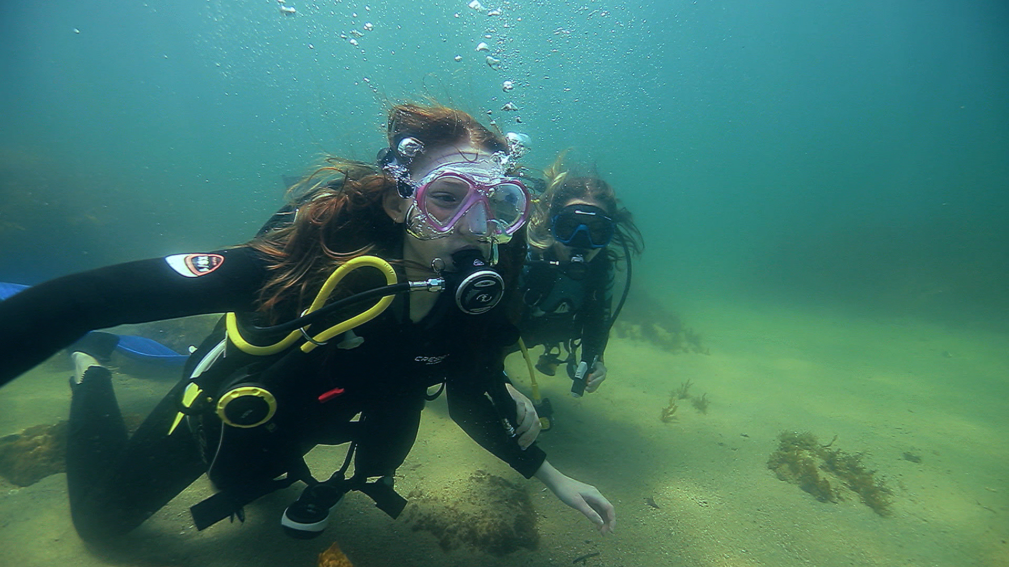

Eden 14

Scuba diving for the first time was an incredible dreamlike experience.

Taking that first breath under the water is such an unbelievable feeling, the joy from being under the surface and seeing all these amazing sea creatures can not be replicated anywhere else.

As soon as you hit the water you immediately become weightless, floating along the sand, watching the sun peak through the water in golden streams was the most remarkable and calming sight.

I would highly recommend scuba diving to all adults and kids, no matter how scared you feel as soon as you open your eyes under the water it all immediately becomes worth it.

Scuba Diving was such a uniquely special experience, no camera can really do it justice.

Absolutely add it to your bucket list! It was an eye-opening adventure that gave me a whole new perspective on the environment and why we need to care for it.

If you haven’t scuba dived in your life, you haven’t yet lived.

To start your dive journey visit
https://www.diveraid.com/adventure/

SUUNTO Australia
https://www.suunto.com/en-au/?epslanguage=en-GB&CMPID=google%7Csearch-b%7Cperformance%7Capac%7Cau%7Csuunto%7Ce%7C571256147516%7Cc%7C%7Cwinter-sales&gclid=CjwKCAiAl-6PBhBCEiwAc2GOVF-FnGOrkSETG5aP0Ib5gqYpOM9gtTBuDSCLFna4TA6bXhnaWMUwZhoCLHMQAvD_BwE

SUUNTO New Zealand
https://www.suunto.com/en-nz/?epslanguage=en-GB&CMPID=google%7Csearch-b%7Cperformance%7Capac%7Cau%7Csuunto%7Ce%7C571256147516%7Cc%7C%7Cwinter-sales&gclid=CjwKCAiAl-6PBhBCEiwAc2GOVF-FnGOrkSETG5aP0Ib5gqYpOM9gtTBuDSCLFna4TA6bXhnaWMUwZhoCLHMQAvD_BwE

Partner Tags:
https://www.instagram.com/mercedesbenzgbrothers/
https://www.instagram.com/suunto_anz/
https://www.instagram.com/prodivemanly/
https://www.instagram.com/scubadivermagazine/

https://www.instagram.com/diveraid_international/
https://www.instagram.com/zoomaustralia/
https://www.instagram.com/sharkskin_watersports/

FILM 4:
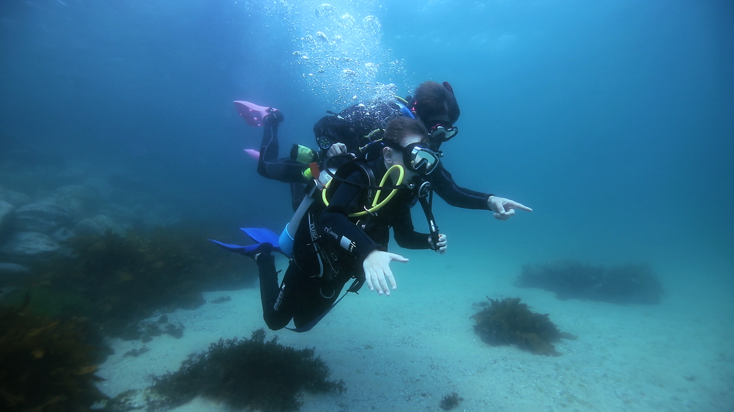

Forest 10

I love freediving when I go to the beach and try to touch the bottom rock, but to be able to breathe underwater was amazing! Peaceful, fun, and quiet.

At first when I was invited to dive, I didn't know what to expect and was a little bit scared, but that did last long. I loved being beneath the surface, observing the sea life, coral, crustaceans and how the fish behaved around me.

If any kid is lucky enough to be asked to spend some time under the sea, scuba diving
I would tell them it is an awesome life-changing encounter.

This was definitely one of the best experiences of my life so far...

To start your dive journey visit
https://www.diveraid.com/adventure/

SUUNTO Australia
https://www.suunto.com/en-au/?epslanguage=en-GB&CMPID=google%7Csearch-b%7Cperformance%7Capac%7Cau%7Csuunto%7Ce%7C571256147516%7Cc%7C%7Cwinter-sales&gclid=CjwKCAiAl-6PBhBCEiwAc2GOVF-FnGOrkSETG5aP0Ib5gqYpOM9gtTBuDSCLFna4TA6bXhnaWMUwZhoCLHMQAvD_BwE

SUUNTO New Zealand
https://www.suunto.com/en-nz/?epslanguage=en-GB&CMPID=google%7Csearch-b%7Cperformance%7Capac%7Cau%7Csuunto%7Ce%7C571256147516%7Cc%7C%7Cwinter-sales&gclid=CjwKCAiAl-6PBhBCEiwAc2GOVF-FnGOrkSETG5aP0Ib5gqYpOM9gtTBuDSCLFna4TA6bXhnaWMUwZhoCLHMQAvD_BwE

Partner Tags:
https://www.instagram.com/mercedesbenzgbrothers/
https://www.instagram.com/suunto_anz/
https://www.instagram.com/prodivemanly/
https://www.instagram.com/scubadivermagazine/

https://www.instagram.com/diveraid_international/
https://www.instagram.com/zoomaustralia/
https://www.instagram.com/sharkskin_watersports/

FILM 5:
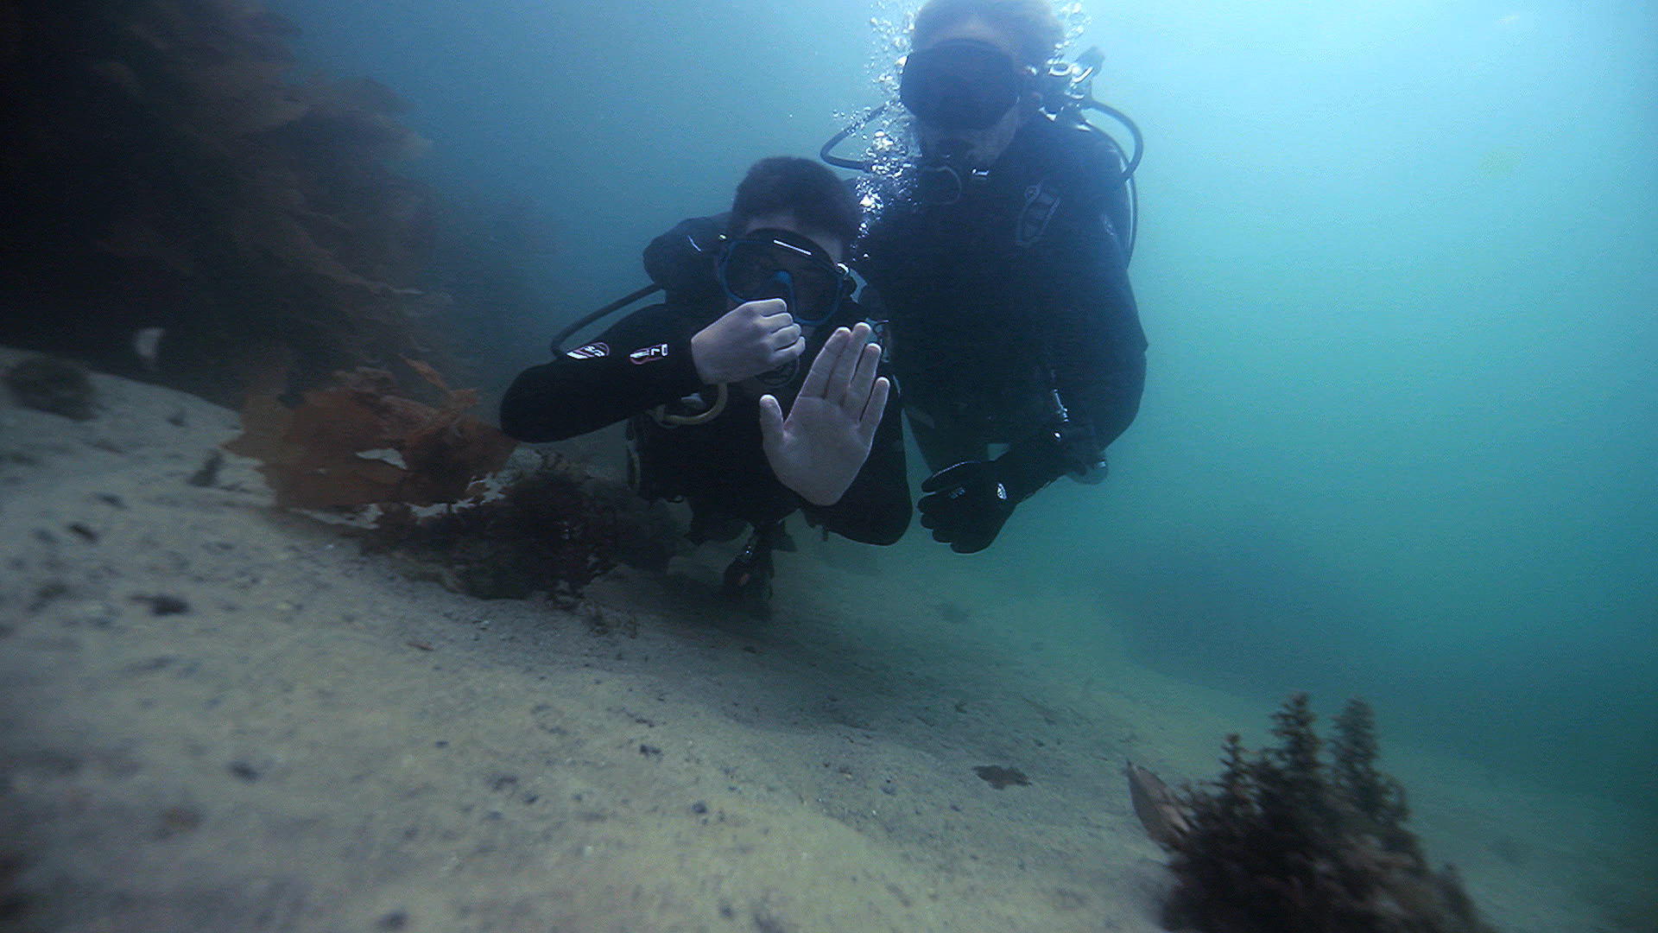
Lewis 15

When I went diving I felt excited to do it for the first time. Seeing all the fish up close was so cool. It was a different world down there.
I think young people should do it because they haven’t experienced it before, only if they’ve snorkelled which isn’t as good.

I felt safe doing it when Arthur showed me what to do. I can’t wait to do it again one day.

To start your dive journey visit
https://www.diveraid.com/adventure/

SUUNTO Australia
https://www.suunto.com/en-au/?epslanguage=en-GB&CMPID=google%7Csearch-b%7Cperformance%7Capac%7Cau%7Csuunto%7Ce%7C571256147516%7Cc%7C%7Cwinter-sales&gclid=CjwKCAiAl-6PBhBCEiwAc2GOVF-FnGOrkSETG5aP0Ib5gqYpOM9gtTBuDSCLFna4TA6bXhnaWMUwZhoCLHMQAvD_BwE

SUUNTO New Zealand
https://www.suunto.com/en-nz/?epslanguage=en-GB&CMPID=google%7Csearch-b%7Cperformance%7Capac%7Cau%7Csuunto%7Ce%7C571256147516%7Cc%7C%7Cwinter-sales&gclid=CjwKCAiAl-6PBhBCEiwAc2GOVF-FnGOrkSETG5aP0Ib5gqYpOM9gtTBuDSCLFna4TA6bXhnaWMUwZhoCLHMQAvD_BwE

Partner Tags:
https://www.instagram.com/mercedesbenzgbrothers/
https://www.instagram.com/suunto_anz/
https://www.instagram.com/prodivemanly/
https://www.instagram.com/scubadivermagazine/

https://www.instagram.com/diveraid_international/
https://www.instagram.com/zoomaustralia/
https://www.instagram.com/sharkskin_watersports/

FILM 6:
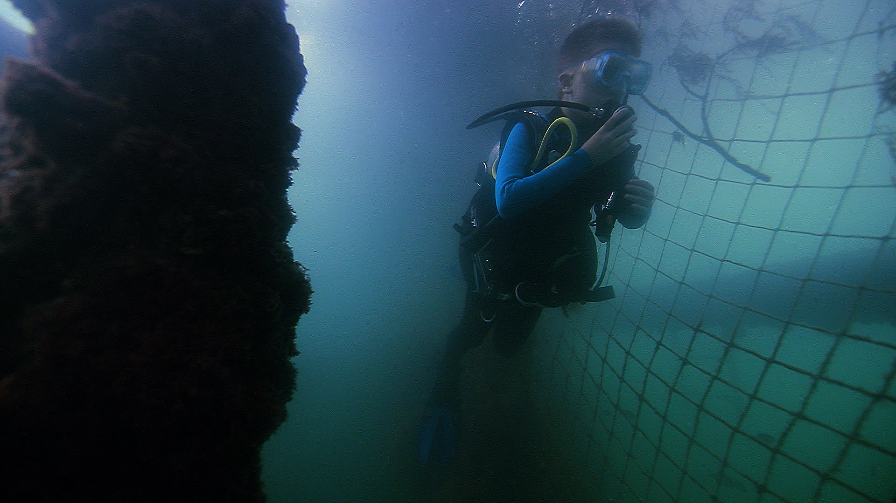
William 10

My first dive was amazing. I loved being able to swim underwater and see everything at the same level, rather than when I snorkel and all the marine life is below me.

It was the coolest thing I have ever done. I saw so many different species of marine life such as the clown nudibranch that I had never seen before and lots of other colourful fish.

I’ve been on several dives since at Little Beach and Fly Point in Nelson Bay with my dad.

On those dives I’ve seen so much awesome marine life such as lionfish, octopus, wobbegong sharks and so much more.

I’m really excited about doing my junior open water course when I turn 12 in march.

To start your dive journey visit
https://www.diveraid.com/adventure/

SUUNTO Australia
https://www.suunto.com/en-au/?epslanguage=en-GB&CMPID=google%7Csearch-b%7Cperformance%7Capac%7Cau%7Csuunto%7Ce%7C571256147516%7Cc%7C%7Cwinter-sales&gclid=CjwKCAiAl-6PBhBCEiwAc2GOVF-FnGOrkSETG5aP0Ib5gqYpOM9gtTBuDSCLFna4TA6bXhnaWMUwZhoCLHMQAvD_BwE

SUUNTO New Zealand
https://www.suunto.com/en-nz/?epslanguage=en-GB&CMPID=google%7Csearch-b%7Cperformance%7Capac%7Cau%7Csuunto%7Ce%7C571256147516%7Cc%7C%7Cwinter-sales&gclid=CjwKCAiAl-6PBhBCEiwAc2GOVF-FnGOrkSETG5aP0Ib5gqYpOM9gtTBuDSCLFna4TA6bXhnaWMUwZhoCLHMQAvD_BwE

Partner Tags:
https://www.instagram.com/mercedesbenzgbrothers/
https://www.instagram.com/suunto_anz/
https://www.instagram.com/prodivemanly/
https://www.instagram.com/scubadivermagazine/

https://www.instagram.com/diveraid_international/
https://www.instagram.com/zoomaustralia/
https://www.instagram.com/sharkskin_watersports/

FILM 7:
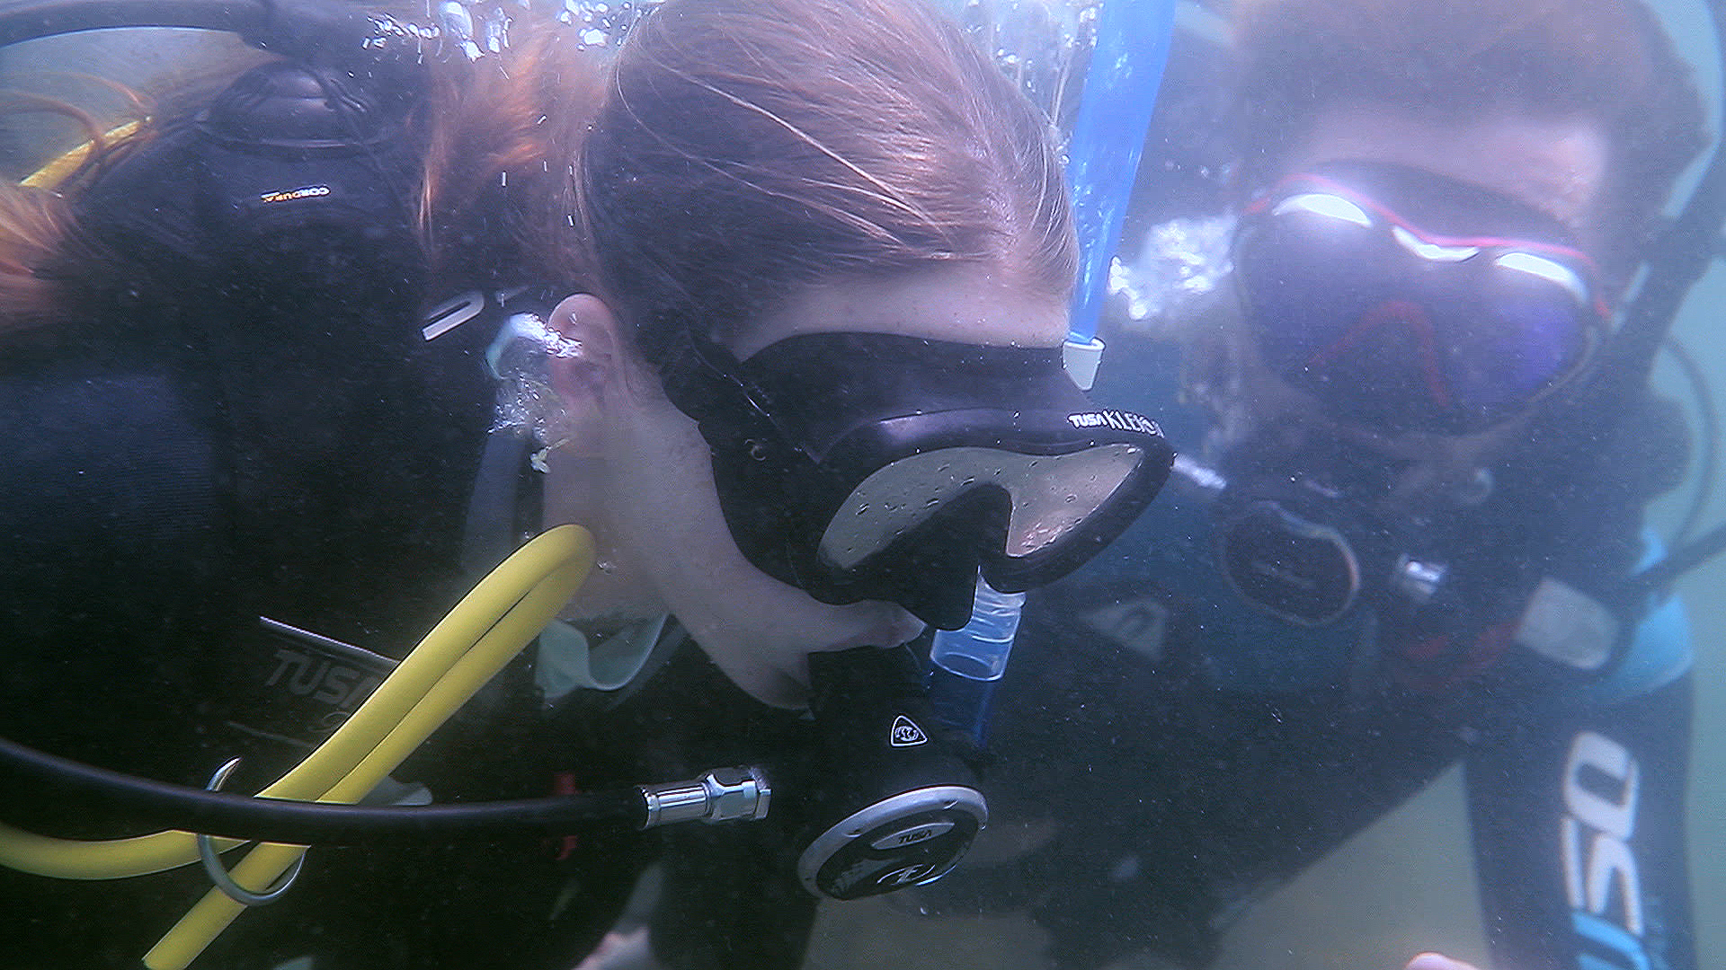
Cara 14

When I first found out about the opportunity to go scuba diving, I was so excited and a little bit nervous. I had always been intrigued by the ocean and sea creature’s so there was no way I could say no.

When we arrived at Little Manly Boat Ramp my nerves were growing but I was still super excited.

We got ready, first snorkeling, a cool experience where we saw a few fish, but it was nothing compared to scuba diving.

We put on all the gear and jumped in the water. I have never experienced anything like scuba diving, it was amazing! It was so calm and peaceful, you couldn’t hear anything, it was just you and the ocean.

It’s a little bit daunting when you’re going under, but once you’re at the ocean floor it’s fine.

I saw a lot of cool sea-life like; a stingray, an octopus and a wobbegong.

I recommend it for anyone who loves the ocean, I’m sure they would love the experience.

To start your dive journey visit
https://www.diveraid.com/adventure/

SUUNTO Australia
https://www.suunto.com/en-au/?epslanguage=en-GB&CMPID=google%7Csearch-b%7Cperformance%7Capac%7Cau%7Csuunto%7Ce%7C571256147516%7Cc%7C%7Cwinter-sales&gclid=CjwKCAiAl-6PBhBCEiwAc2GOVF-FnGOrkSETG5aP0Ib5gqYpOM9gtTBuDSCLFna4TA6bXhnaWMUwZhoCLHMQAvD_BwE

SUUNTO New Zealand
https://www.suunto.com/en-nz/?epslanguage=en-GB&CMPID=google%7Csearch-b%7Cperformance%7Capac%7Cau%7Csuunto%7Ce%7C571256147516%7Cc%7C%7Cwinter-sales&gclid=CjwKCAiAl-6PBhBCEiwAc2GOVF-FnGOrkSETG5aP0Ib5gqYpOM9gtTBuDSCLFna4TA6bXhnaWMUwZhoCLHMQAvD_BwE

Partner Tags:
https://www.instagram.com/mercedesbenzgbrothers/
https://www.instagram.com/suunto_anz/
https://www.instagram.com/prodivemanly/
https://www.instagram.com/scubadivermagazine/

https://www.instagram.com/diveraid_international/
https://www.instagram.com/zoomaustralia/
https://www.instagram.com/sharkskin_watersports/

FILM 8:
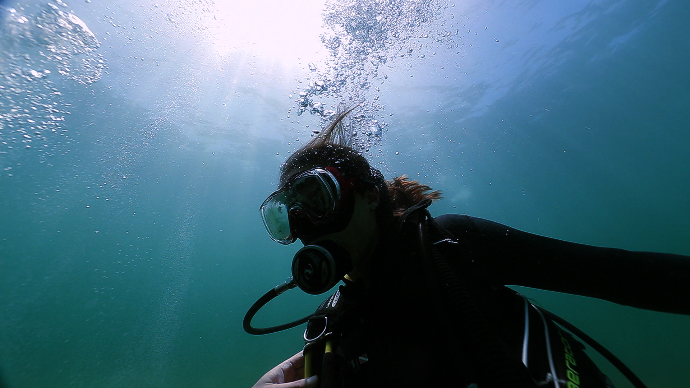
Jess 14

It was like this... It’s kind of like... It’s different than like breathing, ‘cause like you’re breathe and it’s all the noise is going and then you can just see all the bubbles. Yeah, it’s quite cool.

It’s very satisfying in a way. Yeah, well it’s like when you breathe out you can see like your breath going. We saw an octopus, which was quite cool because we watch the show called My Octopus Teacher, and so that was kind of cool to see.

Oh, it was incredibly good to see all the fish around you and like all the coral.

I love the water. It’s just a different world really underwater.

So it’s just a place where you go and it’s all calm and nice and you can just be at peace.

To start your dive journey visit
https://www.diveraid.com/adventure/

SUUNTO Australia
https://www.suunto.com/en-au/?epslanguage=en-GB&CMPID=google%7Csearch-b%7Cperformance%7Capac%7Cau%7Csuunto%7Ce%7C571256147516%7Cc%7C%7Cwinter-sales&gclid=CjwKCAiAl-6PBhBCEiwAc2GOVF-FnGOrkSETG5aP0Ib5gqYpOM9gtTBuDSCLFna4TA6bXhnaWMUwZhoCLHMQAvD_BwE

SUUNTO New Zealand
https://www.suunto.com/en-nz/?epslanguage=en-GB&CMPID=google%7Csearch-b%7Cperformance%7Capac%7Cau%7Csuunto%7Ce%7C571256147516%7Cc%7C%7Cwinter-sales&gclid=CjwKCAiAl-6PBhBCEiwAc2GOVF-FnGOrkSETG5aP0Ib5gqYpOM9gtTBuDSCLFna4TA6bXhnaWMUwZhoCLHMQAvD_BwE

Partner Tags:
https://www.instagram.com/mercedesbenzgbrothers/
https://www.instagram.com/suunto_anz/
https://www.instagram.com/prodivemanly/
https://www.instagram.com/scubadivermagazine/

https://www.instagram.com/diveraid_international/
https://www.instagram.com/zoomaustralia/
https://www.instagram.com/sharkskin_watersports/

