LX SETH PTY LTD
AFRICAN RENAISSANCE MOVIES
PRESENTS
THE CASTLE
A Film by Arish Sirkissoon

FILM INFORMATION
Character Actor/ Actress
Catherine Rio Notra SEGAL
Michael Arish Sirkissoon
Dr John DR Raj Singh
Alicia Sibongiseni Shezi
Kim Khushi Parekh
Terry Tevin Kunene
Ed Edwin Chetty

Directed by: Running Time: 80 Minutes
Arish Sirkissoon Closed Captioning- Yes
Genre- Horror/ Psychological Thriller
Executive Producer:
Arish Sirkissoon
Dr Raj Singh
Written by: Tagline: Trust Nobody
Arish Sirkissoon
Additional Contribution by: DR Raj Singh
Produced by: Film Type- Feature Film
Arish Sirkissoon
Sinesipho Makaula
Cinematography: Camera: Sony
Nick Bartlett Aspect Ratio: 3840*2160 (4k)
Location: Sound: Stereo/5.1 Surround Mix
Durban, South Africa Language: English
Ownership:
The Film is owned by LX SETH (PTY) LTD and ARM (PTY) LTD.
Copyright © 2022
LX SETH- The Director of this company is Arish Sirkissoon.
ARM- The Director of this company is Dr Raj Singh.
Synopsis
On their wedding day Michael and Catherine break down in the middle of nowhere. They walk for several kilometres when they discover an old castle. Against her better judgement Catherine is convinced by Michael to spend the night. Once she enters the castle she feels like something is watching her. What she discovers in the castle will change her life forever.
Tagline
Trust Nobody
Logline
Catherine and her new groom Michael ecstatically travel to their honeymoon destination when a bad engine derails their plans.
Dramatic Issue
Will Catherine escape the castle alive?
Controlling idea
Sometimes it’s better to trust your intuition

DIRECTORS STATEMENT- Arish Sirkissoon (AKA Lx Seth)
“It’s always been important to me to write deep psychological thrillers that are borderline horror. In my personal view there is nothing better than a great feature with a worthy twist. I wrote this film with many ideas in mind and it came together beautifully in one swift stroke. I know audiences are going to appreciate the attention to detail I have put into this film both on paper and on the screen. This is my directorial debut so I always wanted something special and I think I have achieved this in many forms. The movie itself is a play on frameworks that lead to an intriguing crescendo that leaves you wanting more.”

DIRECTORS/LEAD ACTOR BIOGRAPHY
Arish Sirkissoon (37) AKA LX SETH is a Durban based Movie/Music Executive/Academic and entrepreneur.
Sirkissoon was signed to T-SERIES INDIA at the tender age of 21, T-SERIES is India's largest Movie and recording label. Sirkissoon has had several number one singles and has produced several movies locally.
- THE CURSE OF HIGHWAY SHEILA – 2013 (Distributed by VIDEOVISION ENTERTAINMENT)
- BROKEN PROMISES 4- 2018 (Distributed by Indigenous Films)
- TOKOLOSHE THE CALLING – 2020 (Distributed by VIDEOVISION ENTERTAINMENT)-
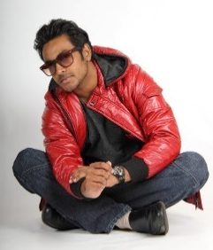
Nominated for 6 Simon Sabela Awards:
Best Feature Film – Arish Sirkissoon and Richard Green- Tokoloshe THE CALLING
Best supporting actor – Sir Roelof Twijnstra
Best Actor- Arish Sirkissoon
Best Actress –Sibongiseni Shezi
Best Director-Richard Green
Best newcomer actress- Lwandile Xaba
Sirkissoon is currently the HEAD of Business Innovation and Technology at AFDA.
He has a Bachelor of Social Science, Honours in Psychology and a MBA.
He is also the Director of LX SETH PTY LTD.

EXECUTIVE PRODUCERS STATEMENT- Dr Raj Singh
“It has always been my dream to be a part of the movie industry. I have always had a passion and love for the art form and when Lx Seth presented this idea to me I jumped at the opportunity. What I love about this film is that it is so unconventional for a South Africa movie. The ideas on display are higher grade with a touch of genius. I have loved being a part of this project and I cannot wait to start the sequel. I come from the medical industry and watching something like this come together is simply incredible.”
EXECUTIVE PRODUCERS/LEAD ACTOR- BIOGRAPHY
Dr Raj Singh was born in Durban South Africa and matriculated at Isipingo Secondary, South Africa. He studied B.Sc at the University of Durban – Westville, South Africa. He then went on to study for his MBBS degree (Bachelor of Medicine and Bachelor of Surgery) in Mysore, India.
He was awarded both the Commonwealth and United Nations scholarship during his undergraduate training. He completed his internship at RK Khan Hospital and worked at Prince Mshiyeni Hospital, South Africa, as a medical officer in Obstetrics and Gynaecology.
He started private practice as a General Practitioner in 1994, and was also a pathology lecturer at the Durban University of Technology, South Africa. He decided to specialise in Dermatology and served as a registrar in both the Department of Medicine and the Department of Dermatology at King Edward Hospital, affiliated to the N.R Mandela School of Medicine, South Africa.
He qualified as a dermatologist in 2004 and has been in private practice since then. His special interest is Cosmetic Dermatology, and he has introduced various unique procedures to Kwazulu Natal and South Africa, such as Laser Liposuction, Ematrix for Acne scarring, Snore Lase for snoring, Intimalase for vaginal tightening, Incontilase for Urinary incontinence and the Velashape iii for cellulite. He is a qualified dermatological surgeon.
He has also introduced his own range known as the DR RS SKINCARE RANGE, formulated for the South African Skin by a South African Dermatologist.
Dr Singh has served as a faculty member and as a speaker in various international congresses such as DASIL (The Dermatologic & Aesthetic Surgery International League) in Malta, Sun City, Bangkok, Vietnam , Dubai and Shanghai, and his posters were accepted at the World Congress of Dermatology in Vancouver in 2015. He also spoke at the World congress of dermatology in Bangalore in 2017 and chaired the South African session, and the Spring continental congress of dermatology in 2018
He is also a published author and has written his first novel “Love has no Boundaries”.
He is a fellow of the College of Dermatology of South Africa, and a fellow of the American Academy of Dermatology (AAD). He is a member of the Dermatological Society of South Africa, the EADV (European Academy of Dermatology and Venereology) and DASIL (The Dermatologic & Aesthetic Surgery International League). He is also a member of the International Society of Dermatology
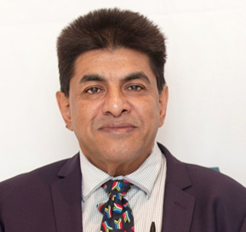

Rio Notra Segal (Lead Actress)
Rio Notra Segal is young talented actress, singer, dancer and model who is constantly trying to improve her craft. Born into a dynamic family, mother an American and father a South African from Johannesburg. She grew up in Durban, Kwazulu-Natal. At the early age of three Rio discovered her passion for arts, and with the support of her family started attending dancing, acting, and singing classes, which led to her performing in productions.
For over twenty years, Rio has garnered wealth of experience in the entertainment industry from her direct involvement in stage plays and media projects. Some of the projects Rio has had the privilege of working on consist of The Young Performers project of Legally Blonde, Gail Smith School of Dance shows, and Dancers Love Dogs and most recently Save our stages SA.
Since returning to South Africa, Rio has been involved in numerous productions such as commercials, films and passion projects:
- TOKOLOSHE THE CALLING (2021)
- KINGS SHAFT’S (2020)
- THE UNEXPTECTED (2021)
- A FISH TALE (2022)
Rio's inherent passion about her craft and the determination to carve out a niche for herself serves as her biggest motivation. Rio has stated that she has "so much to bring to the table and is open to working with anyone or any media production company out there on projects. I have that strong drive in me and I believe I have what it takes to excel."



Sibongiseni Shezi (Supporting Actress)
Sibongiseni Shezi has strutted into 2019 with what can only be described as a BANG! Directly after graduating from AFDA with a Bachelor of Arts degree in Live Performance Cum Laude, Sibongiseni (Hleziphi) is a supporting role on the number one South African television soapie Uzalo SABC 1 (over 9 million viewers daily). "I got given the role after I was seen at a “mock audition” done by Afda," motivates Sibongiseni.
The Simon Sabela Awards came up next. Sibongiseni won the Best Actress in a Feature Film for her stand out performance in the AFDA Durban 2018 experimental short film Run, This was a remarkable achievement considering she was competing against seasoned actresses in professional feature film category.
In 2021 she was nominated for two Simon Sabela Awards including best actress in Tokoloshe the Calling.
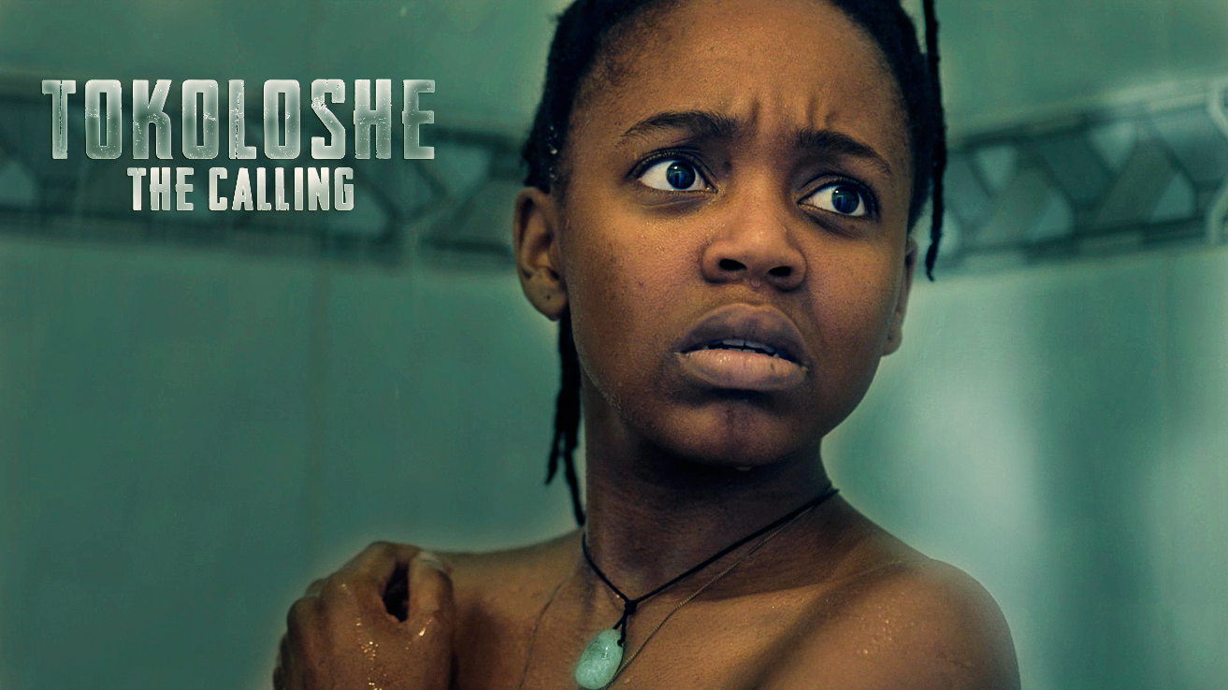

Edwin Cole- Supporting Actor

Edwin Cole is a qualified lecturer, facilitator, program director, producer, professional host and actor. Being a multifaceted individual, Edwin graduated with a Business Commerce degree in Business Innovation and Entrepreneurship at AFDA: The School for the Creative Economy where he also gained the opportunity of acquiring skills, experience and expertise in filmmaking with regards to sound, production design, as well as directing and post production. This enabled him to co-host a radio show, “Innovation and the Future” on MegaZone Hit Radio, direct and coordinate auditions for “Broken Promises 4”, assist in production of, and star in “Tokoloshe: The Calling”, to name a few. Edwin possesses an immense passion for the arts, entertainment, as well as education. With this drive and zeal, he has also had the pleasure of assistant producing and acting in “The Castle” directed by Arish Sirkissoon (aka LX Seth). As a rolling stone gathers no moss, Edwin Cole believes any opportunity in life missed, counts as a loss.

Poster

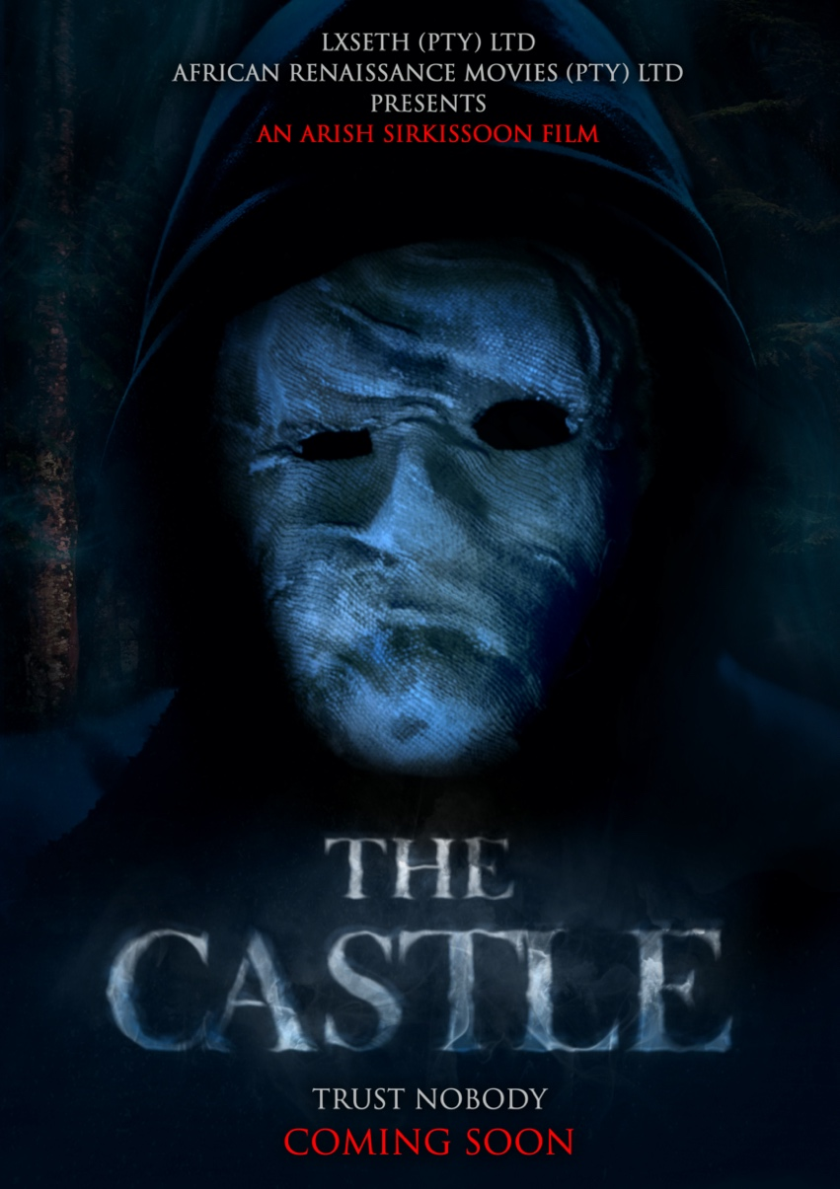

Contact :
mrseth@mweb.co.za
(+27) 828222989
Facebook : https://www.facebook.com/thecastlefeaturefilm
Twitter: @lxseth
Instagram : @lxseth
Tik Tok @lxseth
IMDB: https://www.imdb.com/title/tt14760292/?ref_=ext_shr_lnk

Trailer:

https://youtu.be/GZ7ZN3iIa88

Password: 2130

