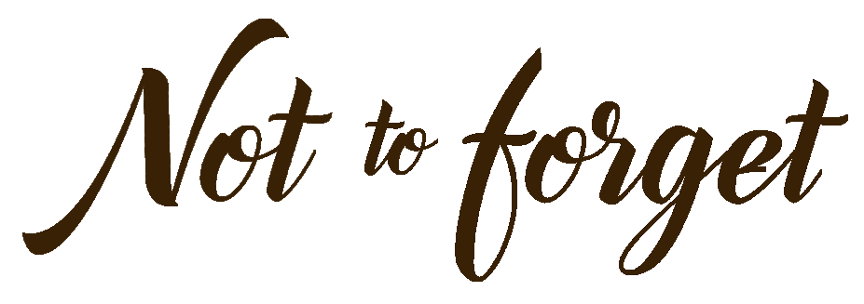

“HEARTFELT AND MOVING”
Women’s Alzheimer’s Movement

KAREN GRASSLE – Melody
LOUIS GOSSETT JR. - Pastor John
TATUM O’NEAL - Doctor
CLORIS LEACHMAN - Donna
GEORGE CHAKIRIS - Bank Manager
OLYMPIA DUKAKIS - Judge
KEVIN HARDESTY - Joe
TATE DEWEY - Chris
JARED EGUSA - Jerry
TAYLOR HOOK - Kim
EBEN FRENCH MASTIN - George
SUSAN DUDLEY - Hairdresser
CLARK DAVIS - District Attorney
PEDRO LUCERO - Security Guard
DANIEL HALL KUHN - Hospital Guard
JESSA DELUCA - Hospital Worker

Chris is a self-centered millennial who has grown up to become a con artist. After one of his scams goes wrong, he is sentenced to take care of his grandmother, who is affected by Alzheimer’s. As he realizes the extent of the elderly woman’s wealth, Chris decides to get his friends involved in their ultimate heist. However, things don’t go as planned… and he finds himself struggling between his painful past and newly found family values.

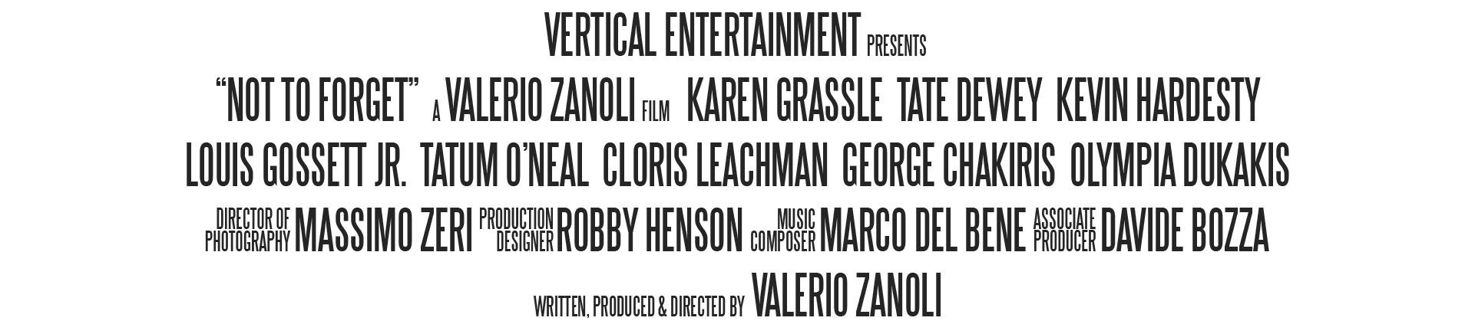

FILMMAKER’S STATEMENT

I started developing the film Not to Forget in 2018, after learning about the terrifying numbers related to Alzheimer’s – a form of dementia that has been called a “plague of the XXI century”.

Every 65 seconds, a new brain develops Alzheimer’s. 2/3 of them belong to women. African Americans are twice as likely as whites to develop the disease.

My intent was clear from the very beginning: Giving life to a film that could have a social impact and become a tool to raise awareness for the fight against Alzheimer’s. I wanted to entertain audiences around the world while informing them about this terrible disease and, above all, about the ways everyone can prevent it.

One-third of Alzheimer's cases may be preventable by addressing lifestyle factors. It's never too early to start.

From the beginning, I wanted to create a different kind of “Alzheimer’s film”. I was determined to make a film with the right compromise of light situations and dramatic moments. Instead of focusing on an elderly person, I decided to take the perspective of a young caregiver. So, I wrote the story of a millennial who doesn’t know anything about Alzheimer’s and finds himself taking care of Grandma.

In the movie, Grandma forgets names and events, but she remembers love. On the contrary, her grandson and caregiver Chris remembers everything (to the point he made a “career” out of counting cards)… but he forgot the value and importance of family. In this perspective, NOT TO FORGET becomes a journey about finding faith and, above all, home.
Dementia affects approximately 50 million people around the world, with nearly 10 million new patients every year. However, this terrible disease also affects the caregivers – the unsung heroes, often family members willing to sacrifice themselves to take care of their loved ones.

There are 6 million Americans living with Alzheimer's. There are 11.2 million Americans providing unpaid care to someone with Alzheimer's or dementia. And, also in this case, two-thirds of them are women.

All the above-mentioned data and useful resources for patients and caregivers are available at TheWomensAlzheimersMovement.org – a nonprofit organization founded by Maria Shriver that raises awareness about women’s increased risk for Alzheimer’s, educates the public about brain health and prevention, and raises funds to support women-based research.

During pre-production, Alzheimer’s patients and caregivers read the screenplay and provided invaluable feedback. After several revisions, I reached out to my dream cast and I convinced Karen Grassle and 5 Oscar winning actors to join me in Kentucky for an incredible experience. I had the honor and pleasure of working with talented professionals, of directing Cloris Leachman and Olympia Dukakis in their final performances, and of bringing to the big screen a sweet story that needs to be told.

I am very pleased with all my cast and crew members, who gave their best and were highly motivated by our common goal of helping the fight against Alzheimer’s. I am grateful to the Commonwealth of Kentucky, which welcomed us with open arms. And I’ll be eternally thankful to Vertical Entertainment, which believed in me and this film.

Not to Forget is a tribute to believing, working hard, and never giving up. It is part of the project Letsmakeadifference.info and is an invitation for everyone to serve, find purpose, and have an impact. As mentioned in the end credits, I dedicate this film to:

All the Alzheimer’s patients, their families, and caregivers.
All the cast and crew members, especially the ones who passed away too soon.
My parents, who will always inspire me and live through me.

CAST

KAREN GRASSLE

Karen Grassle is the beloved actress who played Caroline Ingalls (Ma) in the NBC television drama series Little House on the Prairie.

“Working on the film Not to Forget was an unforgettable experience. After writer and director Valerio Zanoli approached me for the role of Melody, I read the screenplay and I immediately accepted to be part of this sweet and charming story. Valerio is gifted as well as dedicated to his field. He has been specializing in films with important social messages: From leukemia to child obesity, from bullying to homelessness. Our film dealt with dementia and was produced as an attempt to further educate and draw funds to this issue. Valerio is a humble individual, who is always open to suggestions. At first, we had slightly different visions about my character, but he enthusiastically accepted my notes and allowed me to make it my own. Valerio is constructive, attentive, and open-minded. Alzheimer’s Disease has been called a “21st century plague”. It progressively destroys memory and other important mental functions, as is well known. This film reminds the audience we need to strive to make a difference and support the fight against this terrible disease, which affects millions of people and their families. I am pleased and proud our film Not to Forget will soon be released. I truly hope it can be used to inspire and move people to action.”

CLORIS LEACHMAN

Cloris Leachman was an American actress and comedienne whose career spanned more than seven decades. She won an Academy Award for The Last Picture Show, a Golden Globe Award, and a Daytime Emmy Award. She also won eight Primetime Emmy Awards from 22 nominations, making her the most nominated and, along with Julia Louis-Dreyfus, most awarded actress in Emmy history.

Dinah Englund: “As the daughter of two film legends, I’ve always been involved with the entertainment industry. My late mother Cloris Leachman starred in countless films and TV shows and won several accolades. My late father George Englund was an accomplished film editor, director, producer and actor. Over the past few years, I have assisted my late mother on the several films she starred in. When Valerio offered her a role in his movie, which turned out to be her final film role, I was thrilled to accompany her in this endeavor. From my privileged position on set, I was happy to see that Valerio was taking his time with my mom. Though her age and health didn’t make it easy, Valerio was very patient, worked around her needs, and was determined to make her shine. He went so far to create a character carved from her personality. Spending time with her also off set, he made sure to listen to her voice and treasure her advice. [I watched the movie and] I thought it was sweet and charming and quite amazing.”

OLYMPIA DUKAKIS

Olympia Dukakis performed in more than 130 stage productions, more than 60 films and in 50 television series. She won an Academy Award and a Golden Globe, among other accolades, for her performance in Moonstruck.

“Throughout my career, I worked with many directors and producers, but I must praise and recommend Valerio for his extraordinary ability and passion. When he approached me, Valerio wanted to create a movie to raise awareness and funds for the fight against Alzheimer’s, and I wanted to be part of it. I believed in his ambition and capabilities, and I am very happy I did. Valerio created a sweet film, which I enjoyed watching. It is going into distribution later in 2021 and is part of a bigger project, which he envisioned and gave life to: Let’s Make a Difference (www.letsmakeadifference.info). Valerio was eager to have me in his film, and he was able to move the entire production to New York City just to film with me. He respected the limitations imposed by my age, and he calmy and professionally helped me feel at ease, before and during filming. I was glad that Valerio kept in touch with me for the holidays and for my birthday, kept me updated about the status of the film, and asked for my feedback. He’s an exquisite person, not just an outstanding director. Thank you! A total pleasure!!”

TATUM O’NEAL

Tatum O'Neal is the youngest person ever to win a competitive Academy Award, which she won at age 10 for her performance as Addie Loggins in Paper Moon opposite her father, Ryan O'Neal.

“Not to Forget Me – Please – I love you & hope we work together again. With love”

LOUIS GOSSETT JR

Louis Gossett Jr. is best known for his role as Gunnery Sergeant Emil Foley in the film An Officer and a Gentleman, winning him the Academy Award for Best Supporting Actor. His acting career spans over five decades.

“Have peace always”

GEORGE CHAKIRIS

George Chakiris is best known for his performance as Bernardo in the 1961 film version of West Side Story, for which he won both the Academy Award and the Golden Globe Award.

“When Not to Forget came about, I was really pleased to take part in a film about a very important subject. I worked a whole day on that, so if you blink you could miss me, but I was happy to be involved because of the very important subject matter. I was eager to help make a difference by supporting this sweet / charming film and the fight against Alzheimer’s. Another reason was to be in anything that included Olympia Dukakis, someone I admire, not just because she’s Greek, but because she’s such a beautiful actress and presence on the screen.”

TATE DEWEY

Tate Dewey trained at the London Academy of Music & Dramatic Arts (LAMDA) and had several mentors and teachers, including Craig Robert Young, John Ruby, and Desean Terry.

“When I first got the audition for Not to Forget and I had the chance to read the script, I knew right away that not only was it a great opportunity to work on a great film, but it was something I could really grasp onto and connect with. The film deals with one of the most destructive diseases in the world, but it focuses less on the specifics of the disease itself and more on how families can come together in the midst of it. One of the main themes is growing up, as Chris does in the film. That journey and the challenges that came with it were very interesting. I couldn’t have dreamed of a better character to portray in my first lead role, and at the same time I was well aware of the amount of work and commitment I’d have to put into it. In that sense, both Chris and I got to grow up, and I’d say the experience really helped me not only as an actor, but also as a person. Getting the chance to work on a deep, layered role on a film whose message centers around an issue so critical and important in today’s world meant a lot to me. On set I was surrounded by literal legends and true professionals who’ve achieved the pinnacle of their fields. Working with Valerio Zanoli was an awesome experience. He gave me the tools to explore my own emotions and drive my own performance, while giving me the notes and feedback to keep me on the right road. To this day, he’s a good friend of mine, and I feel beyond grateful to have had him as my director.”

KEVIN HARDESTY

Kevin Hardesty is a veteran actor who has worked professionally in theatre, film, and television. His credits include co-starring roles in Heathers, Happy Together, 100 Proof, The Cavanaughs, TV 101 and Family of Spies.

“I was thrilled to be a part of this film. Not only to work with Valerio and an incredibly talented cast and crew, but to also help make a difference in the fight against Alzheimer’s. This disease has touched the lives of so many people I care about. Giving life to a creative experience that furthers awareness of such an important topic is the highest purpose of what we do as actors and artists.”

FILMMAKER’S BIO

Valerio Zanoli graduated from the prestigious School of Cinematic Arts at the University of Southern California, with a Presidential Scholarship and a Dean’s Scholarship.

A few years later, Valerio produced and directed the film The Minis, starring NBA legend Dennis Rodman. The movie was distributed in approximately 20 territories, was used for a Happy Meal campaign in Europe, and had an official videogame.

Valerio later produced and directed the film Hopeful Notes, which was awarded the first prize at the International Social Commitment Awards and 5 out of 5 doves by The Dove Foundation. The film is in distribution all over the world through Pure Flix Entertainment.

Valerio is the director and producer of the film All You Can Dream, starring international singer Anastacia. The movie had its world premiere at the Giffoni Film Festival and its U.S. premiere at the Chinese Theatre in Hollywood. It later received support letters from the Office of the First Lady and UNESCO’s Education for Children in Need.

Valerio is the director of the Spanish-language film Fiebre Salsera, with a Grammy winner and several world-champion salsa dancers.

Valerio is the director of the Italian film W gli Sposi – Just Married, which features a cast of numerous celebrities and is the final performance of comedy icon Paolo Villaggio.

Valerio’s latest film is Not to Forget, which he produced and directed with a cast that includes Karen Grassle and 5 Academy Award winners: Louis Gossett Jr., Olympia Dukakis, Cloris Leachman, Tatum O'Neal, and George Chakiris.

Valerio is currently in post-production on the documentary Homeless.

CREW

Among the crew members of the film Not to Forget, associate producer Davide Bozza is worthy of a special mention. Davide has worked with producer and director Valerio Zanoli on all his films. He is both an asset and a point of reference in the production office, which he supervises with enthusiasm, knowledge, and professionalism.

This film is the result of the work of many professionals, ranging from David di Donatello winner Marco Biscarini (sound designer) to Academy Award winner Matthew W. Mungle (prosthetic designer).

The look of the movie was achieved through the invaluable contribution of production designer Robby Henson, director of photography Massimo Zeri, and colorist Walter Cavatoi.

A very important element of the film is the score, composed by Marco Del Bene, who also wrote the original song Take Care of Me together with Pierluigi Fabi, Davide Bozza, and Valerio Zanoli. The song is performed by Sherol Dos Santos, arranged and produced by Marco Del Bene and Simone Sello, and mastered by Studio DMI’s Luca Pretolesi.

