灰 GREY
THE MOVIE

The Topic of this MOVIE is the oppression of society and big CITY.
But also the metaphor of our inner self.

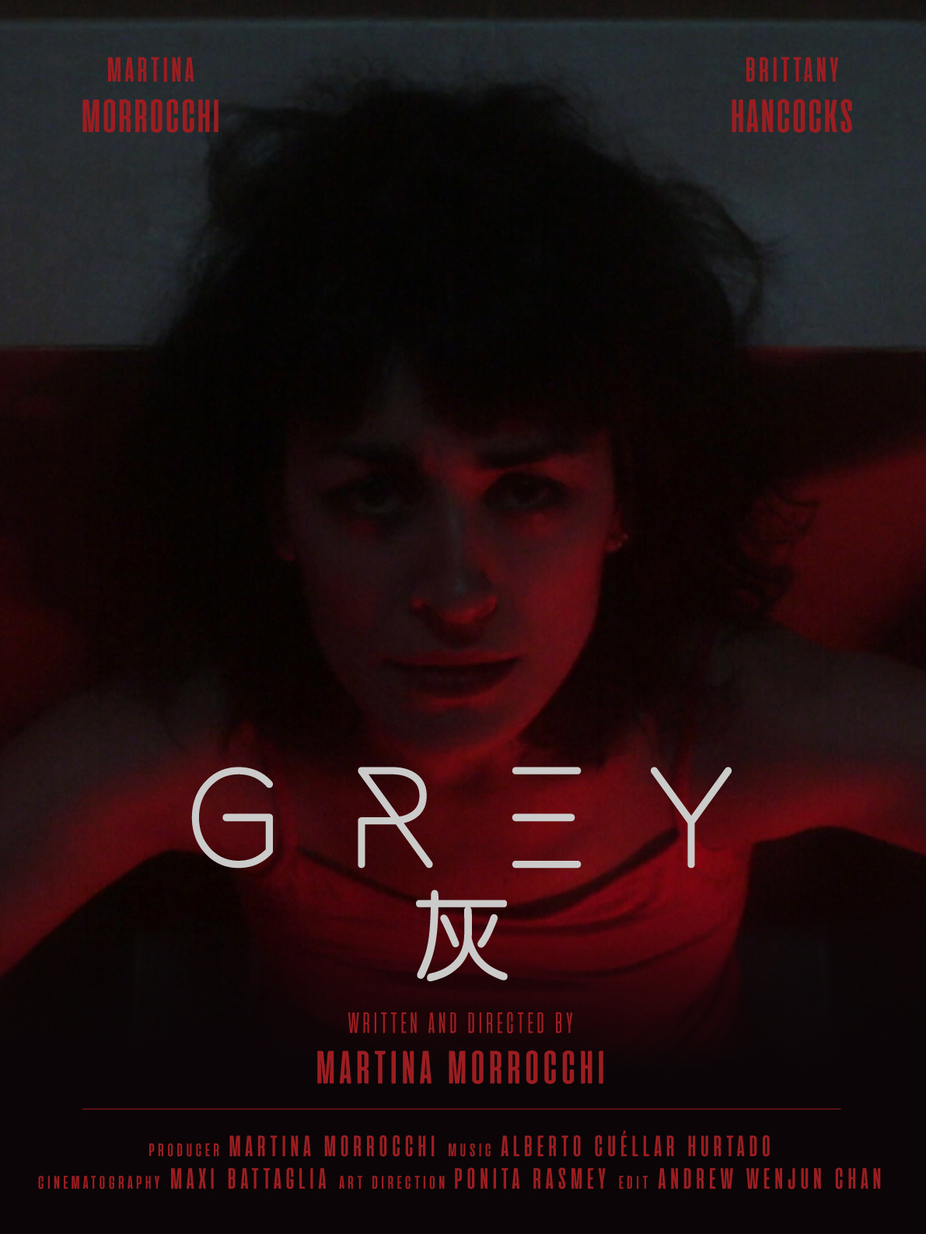

When you live a chaotic life in a chaotic city, where everything is supposed to be perfect but it
is not perfect at all.
Where is the point? Does perfection exists?

Our modern world is now a mix of contaminated environments where most of the time our
emotions are not considered and where we feel obliged to avoid any outgoing.
We live in an appearance society where everything must be perfect and we are losing the concept of the person as individual human.
We often cannot even identify the problem, because there is not only one, is a chain of problems… and our emotions and irrational reactions become our ghosts to keep hidden…

She is representing all of us…and the loop of our modern life, get ready, go to work, go for shopping, meet friends, over and over,…
We hide so many emotions that are already too strong to be expressed but our inner self is pushing us to get rid of it.

We are all supposed to be perfect workers, have the time to train and be fit, be socially active, have a perfect family, be connected 24h, be always happy and funny, …
Is that possible?
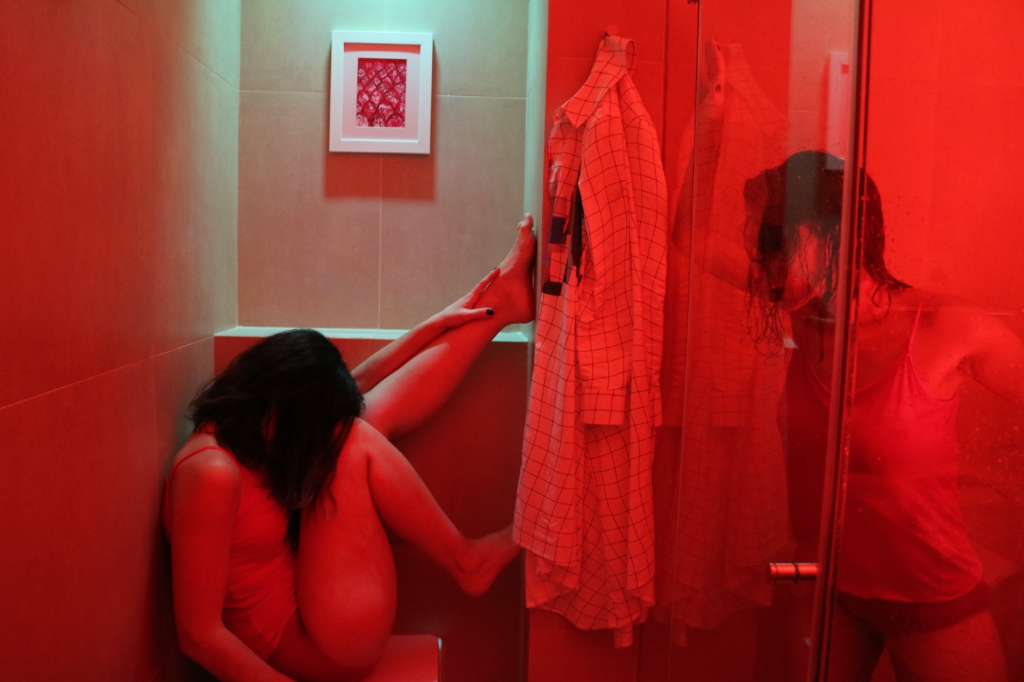

灰GREY
THE INDIPENDET & LOW BUDGET MOVIE

“灰Grey” has been all shoot in Beijing even if the mission N.1 was to do not let people recognize it.
Has been really challenging make this movie, first of all there was no budget at all, the troupe was young and everyone with their job, so even to arrange the schedule sometimes was just impossible to find the time to meet up and have enough time to work on it.
On the top you would always have a last minute problem or unforeseen difficulty.
Was amazing see how people loved the idea and the concept behind the movie, and this is when things got easier and faster, because we got few sponsors for the locations and not only.
Later on at the beginning of 2020 due of the Covid-19 we had to stop again but thanks to our team flexibility we managed to keep on going.
At the end the cost has been more than reasonable and we managed to finish everything within one year and half, now is the time to spread the movie around the world….
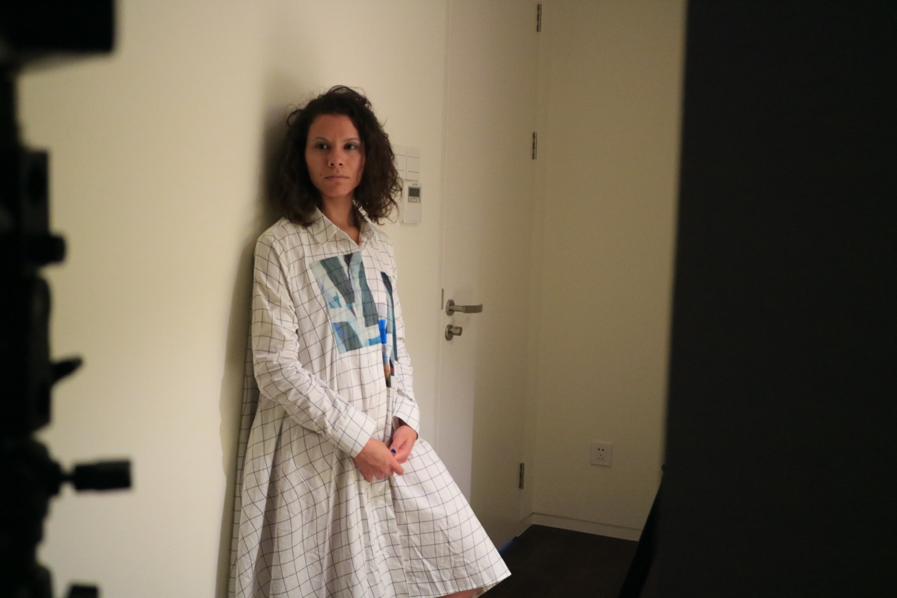
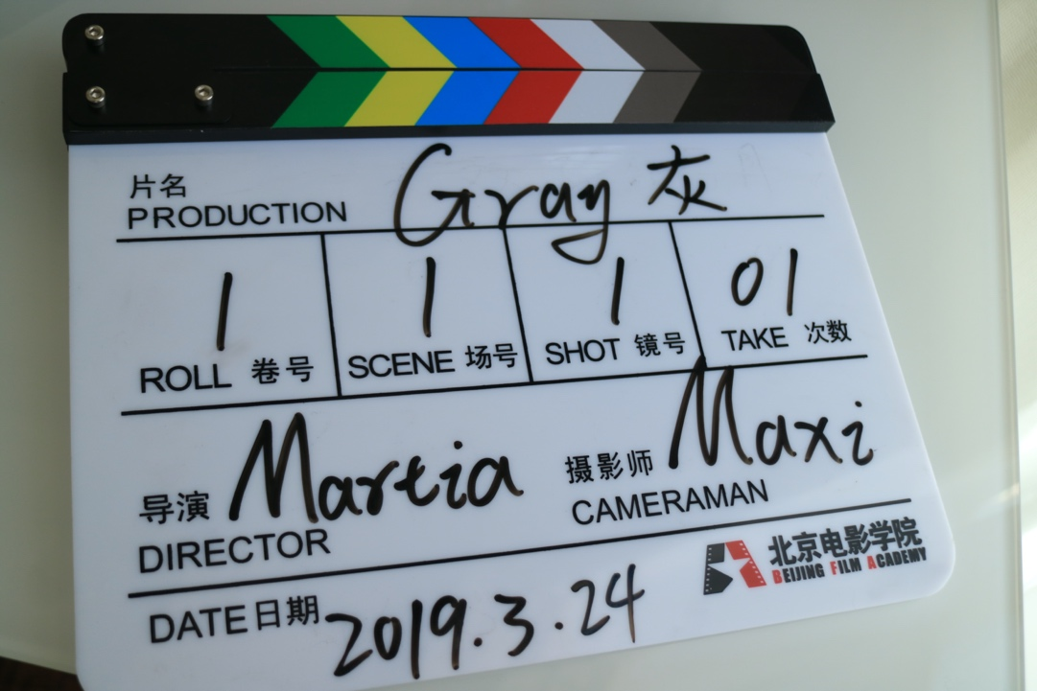

STARRING
Martina Morrocchi
Brittany Hancocks

WRITTEN – DIRECTED – PRODUCED
Martina Morrocchi
MUSIC COMPOSER
Alberto Cuéllar Hurtado

ART DIRECTOR
Ponita Rasmey

CINEMATOGRAPHER
Maxi Battaglia

EDITOR
Andrew Wenjun Chan

Cast:
Martina Morrocchi
Brittany Hancocks
Niu Jie 牛洁 (dancer)
Sylvain Torres
Lucia Rampanti
Scarlett
Peter King
Sandra
Juan Carlos Rodriguez Santos
Elena Zamora Monreal
Sunny
Hannah
Ted Yan
Moeun Kannika
Cheath Chennika
Chenni Zhang
Jessica Abad Martinez
Elizabeth Martínez
Bedyael Gomez Pahuara
Meng Lyhuor
Son Borey
Chhay Vathana
Raul Estrano
Grace Xiaoshun Wei
Moss
潘宜佳
张伟
张强强
刘秋驿
张鹤至
彭睿

Special thanks:
TERRAZZA MARTINI
THE BELL
THE BULK HOUSE 零浪费生活
WHITE NOISE
Juan Carlos Rodriguez Santos
Elena Zamora Monreal
Yi Jia 議嘉 (singer)
SENMIAO 森淼学校
KSIEZYC 孟月明
Tiinlab 耳一号
陈超
焉雨蒙

Camera Operator:
Maxi Battaglia
Andrew Wenjun Chan
Ponita Keo

Hair Stylist:
Pamela Tirza

Assistant of Production:
Queenie Zhang
Swan
Lansang
Shorty
Nana Wei

Graphic Designer:
Razi Salah
Marcela Arzuza
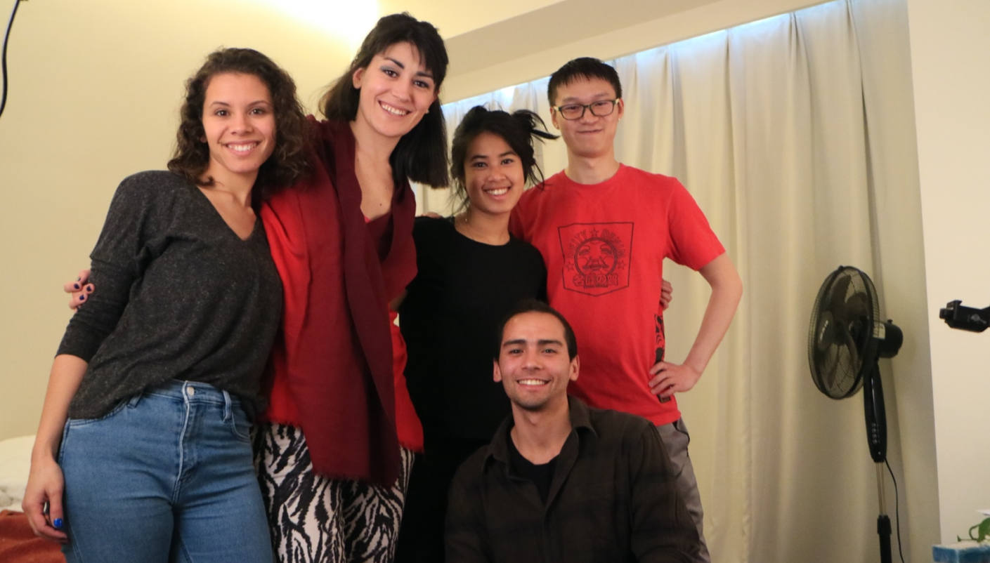

Why Martina Morrocchi decided to make a movie?

“Grey”/ “灰” has borne as an Improve Immersive Physical Theatre Performance “The Grey Life”, performed in the 2017 in Beijing.
After the great success we decided to do the related Docufilm about the show that we showcased at the Fringe Festival in Edinburgh and at the TPAM Festival in Yokohama the following years.
After an attentive brainstorming we thought that the grey life was something deeper and more connected to everyone more than what we thought, we decided that to create a Short movie and would go deeper in to peoples life and less individualistic, connected more to our feelings and our afraidness of every days life.

THE GREY LIFE
The docufilm
The video is a documentation of “ THE GRAY LIFE “ show, has been recorded for many days, during the rehearsal and during the show, we will have many points of view … from the audience, from the actors and some reactions…is somethings that has been experimented for the first time.
The Gray Life as IMPROVE-IMMERSIVE THEATRE-DANCE Show has been performed at first at YUGONGYISHAN with an international troupe from: Italy, Spain, China, South Africa, America...
What is improve-immersive theatre-dance?
Is a new way of express art through motions, using only body languages with any fixed choreography , just few points are fixed but besides these all the emotions are free to fly. Improve because is improvised and immersive because there is a high interaction between the act/dancers and the audience.

MAMONAHI’S SIGNATURE
When come out the need to speak about a topic..the script come out. What is really strong in MAMONAHI is the need to keep the emotions high, to tough the audience to be able to feel how further you can go, how deep you can push to let them emotions come out. is because of this that the shows has a big margin of freedom because the actors need to be able to understand how is the audience and because of it…be able to go deeper if the audience is open or stay more quiet if the audience would not allow them.
Since the beginning of its artistic activities, across avant-garde stimulant and international borders, MAMONAHI’s logic has dealt with mixtures of artistic techniques and artists from all over the world in order to create a very unique project in Beijing. Since our shows are a great mix of dance theatre, classical and modern live music, MAMONAHI’s audiences are then stimulated on various levels. In addition, we do not prefer theatres as our ‘stages’, many of our performances happened also in concert halls, art galleries and museums, hotels, restaurants, squares across many cities in China, for many events and festivals. For this peculiar and wide range of different genres and locations, our shows can deeply satisfy and attract many social and cultural types.

SPONSORS:
