CONTACT TRACE
A mysterious message from the future finds its way to the present, a warning of what may come and what has been. Blending dystopian science fiction with the anguish of real-life, narrated by First Nations actor, Uncle Jack Charles.
Provocatively weaving photographs of the impact of the pandemic with an imagined tale from the future.
Inviting reflection, the work draws on some of John Janson-Moore's thousands of photographs since the pandemic was declared in March 2020. CONTACT TRACE is hybrid and genre-hopping, defying categorisation and challenging audiences to consider the pandemic as a metaphor for psychology, power and colonisation.
Completed and installed at Australia’s first colonial hospital, the World premiere in May 2021 took place just before the third wave of Covid with such difficult impacts on Australians.
Supported by a City of Sydney creative fellowship. Director John-Janson Moore, producer Jacqui North, composer/sound design Andrée Greenwell. #art #film covid #future #firstnations
Contact Producer Jacqui North now for international screenings and gallery installations.
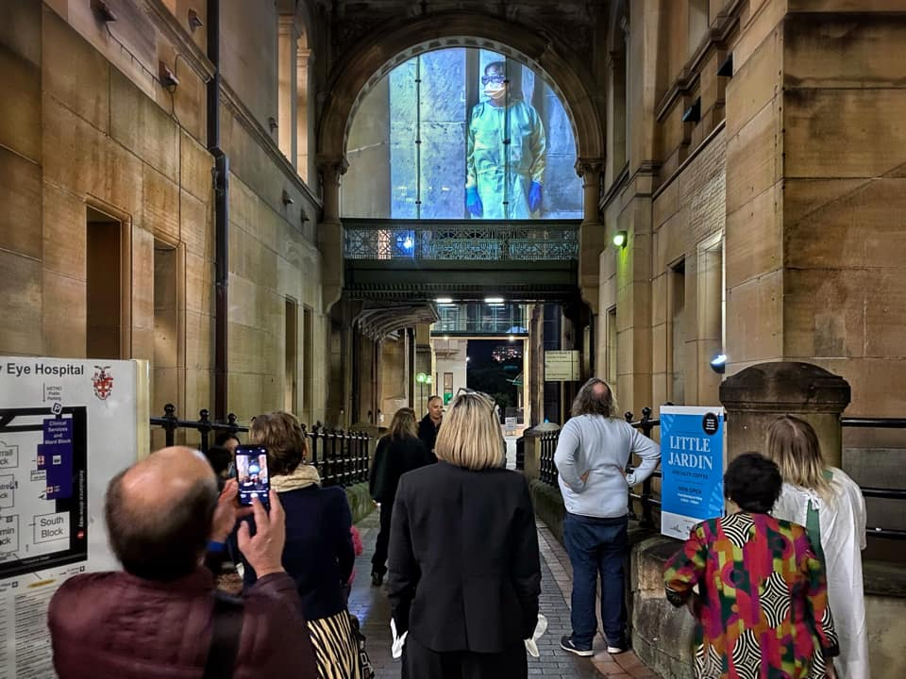

Director, John Janson-Moore is an award-winning multi-disciplinary visual artist, photographer and filmmaker, working across a broad spectrum of media.
Jacqui North is a producer of events, video and art, with transformative activations to engage diverse communities.
Jacqui initiated and produced ‘Contact Trace’ and ‘Curated Stories in Light’ Warrane/Sydney’s first independent light-art show in many years. 655 shows of 3 light-artworks were made available to over 3,000 site visitors.
Composer/Sound Designer: Andrée Greenwell is a highly versatile composer, songwriter and performer, who works across the Australian performing arts, screen and radio.
Full Bio John Janson-Moore
John’s artistic work traverses a precarious line between documentary and fiction, exploring the notion of 'truth' in people's personal, social and public lives. His practice is located within the media arts, situated media and photomedia contexts. John was a collaborative artist in the Biennale of Sydney in 2020, and lead artist and director of ‘Contact Trace’, a site specific video installation at Sydney Hospital in 2021, as part of the ‘Curated Stories in Light’ festival. His multi-screen installation, ‘Duplicity’ was a major work which was showcased in the Bon Marche Studio at the University of Technology Sydney.
John’s photographic work is diverse, operating across portraiture, documentary and contemporary art. 2021 saw John selected as a finalist in the National Photographic Portrait Prize at the National Portrait Gallery in Canberra. In that same year, his work was selected for Head On’s touring exhibition, 2020 Vision. In 2013, John was awarded the Moran Prize for Contemporary Photography, one of Australia’s most significant arts prizes. He was a finalist in the 2016 Head On Portrait Prize, and a triple finalist in the Percival Photographic Portrait Prize.
John is also a highly experienced director, producer and writer of documentaries, drama and short films. His work has seen him produce a range of creative media content, from broadcast television to the web. His films have screened at numerous international film festivals, including in competition for the prestigious Silver Wolf Award at the International Documentary Festival Amsterdam (IDFA) in the Netherlands. In 2005, John received support from the Sundance Documentary Fund (USA) and the Japan Foundation (Japan) for his documentary, ‘Kidnapped!’, which sold extensively worldwide, across Europe, America and Asia. In 2012, he wrote and directed ‘Not In My House’, a series of short dramatized films, which won an ATOM Award. John has worked widely in broadcast television, including with the ABC and SBS in Australia.
John’s photographic, film and art works have been exhibited extensively throughout Australia and internationally. His work is currently held at the Australian Museum, the Australian Parliamentary Library and the State Library of NSW. He holds a Doctorate of Creative Arts from the University of Technology Sydney.

Poster for the premiere installation.
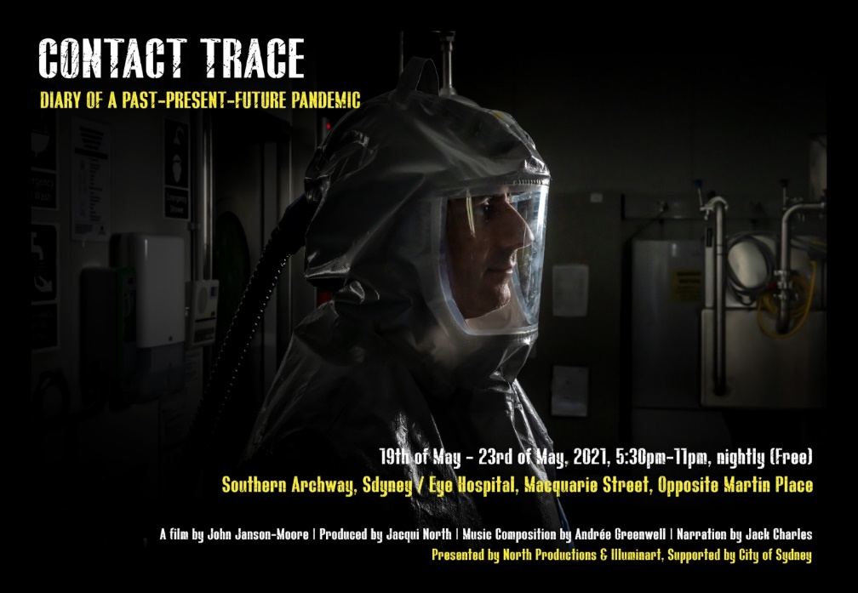
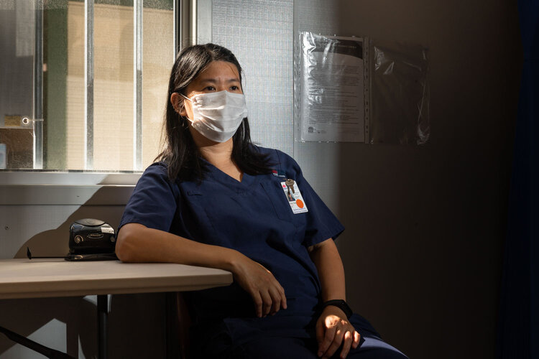
Ruby, who conducts COVID-19 tests at the clinic at the Sydney/Sydney Eye Hospital, takes a well-earned rest. Image © John Janson-Moore

Contact:
Jacqui North
Producer, North Productions
Mb: (61) 0414 490 048
North.jacqui@gmail.com

