The Caretakers
CREW LIST | NFTS 2021

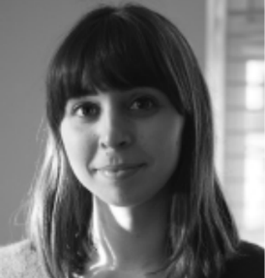
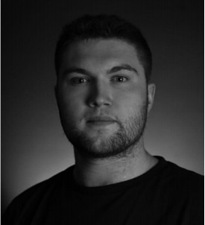
Editor
GIORGIA ZARANTONELLO
zarantonello@msn.com
+44 7476 226652
Director & Cinematographer
TOM HANNER
tomhanner@hotmail.com
+44 7919 200234
www.tomhanner.com
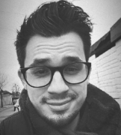
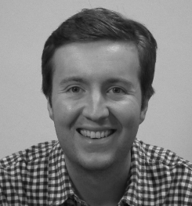
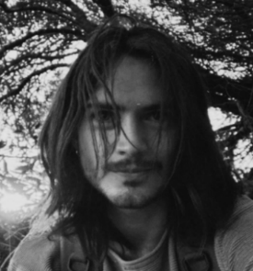
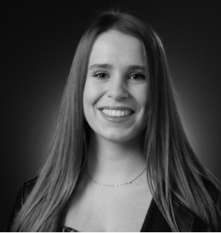
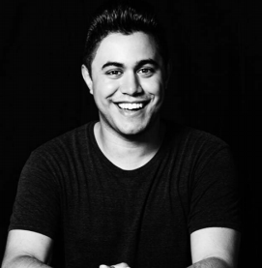
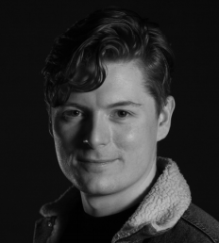
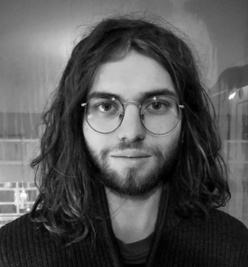
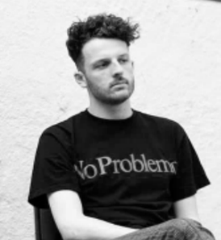
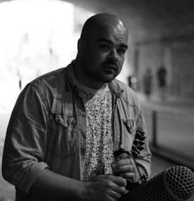
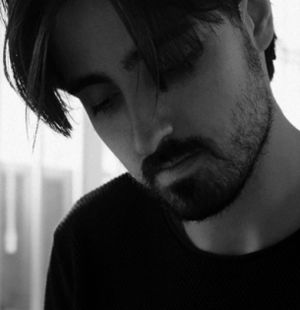
Animation
BEN CRESSWELL
bensartbin@gmail.com
+44 7568 317316
VFX Compositor
SAM PEARSON
sam.pearson3@btinternet.com
Music Recording Engineer
SAMUEL MORRIS
samuel_george@outlook.com
+44 7804 159096
Sound Designer
RUANTH CHRISLEY THYSSEN
ruanth@yahoo.com
www.ruanth.com
ADR Mixer
DOMINIKA LATUSEK
dominika.latusek@icloud.com
+44 7727 801180
VFX Producer
JAKE CALCUTT
jacalcutt@outlook.com
Graphics
DIEGO PRANDO
diegoprando96@gmail.com
www.diegoprando.net
Colourist
FRANCIS QURESHI
fq@francisqureshi.com
+44 7808 812364
www.francisqureshi.com
Dubbing Mixer
HARRY J.N. PARSONS
harryjnparsons@gmail.com
www.harryjnparsons.com
Composer
MORITZ WANGER
moritz.wanger@gmail.com
www.moritzwanger.com

