FOR IMMEDIATE RELEASE:

Jahan Nostra, Tahmell & Reks Bring “Dedication” To Film Festivals with Director Kay The Kreator

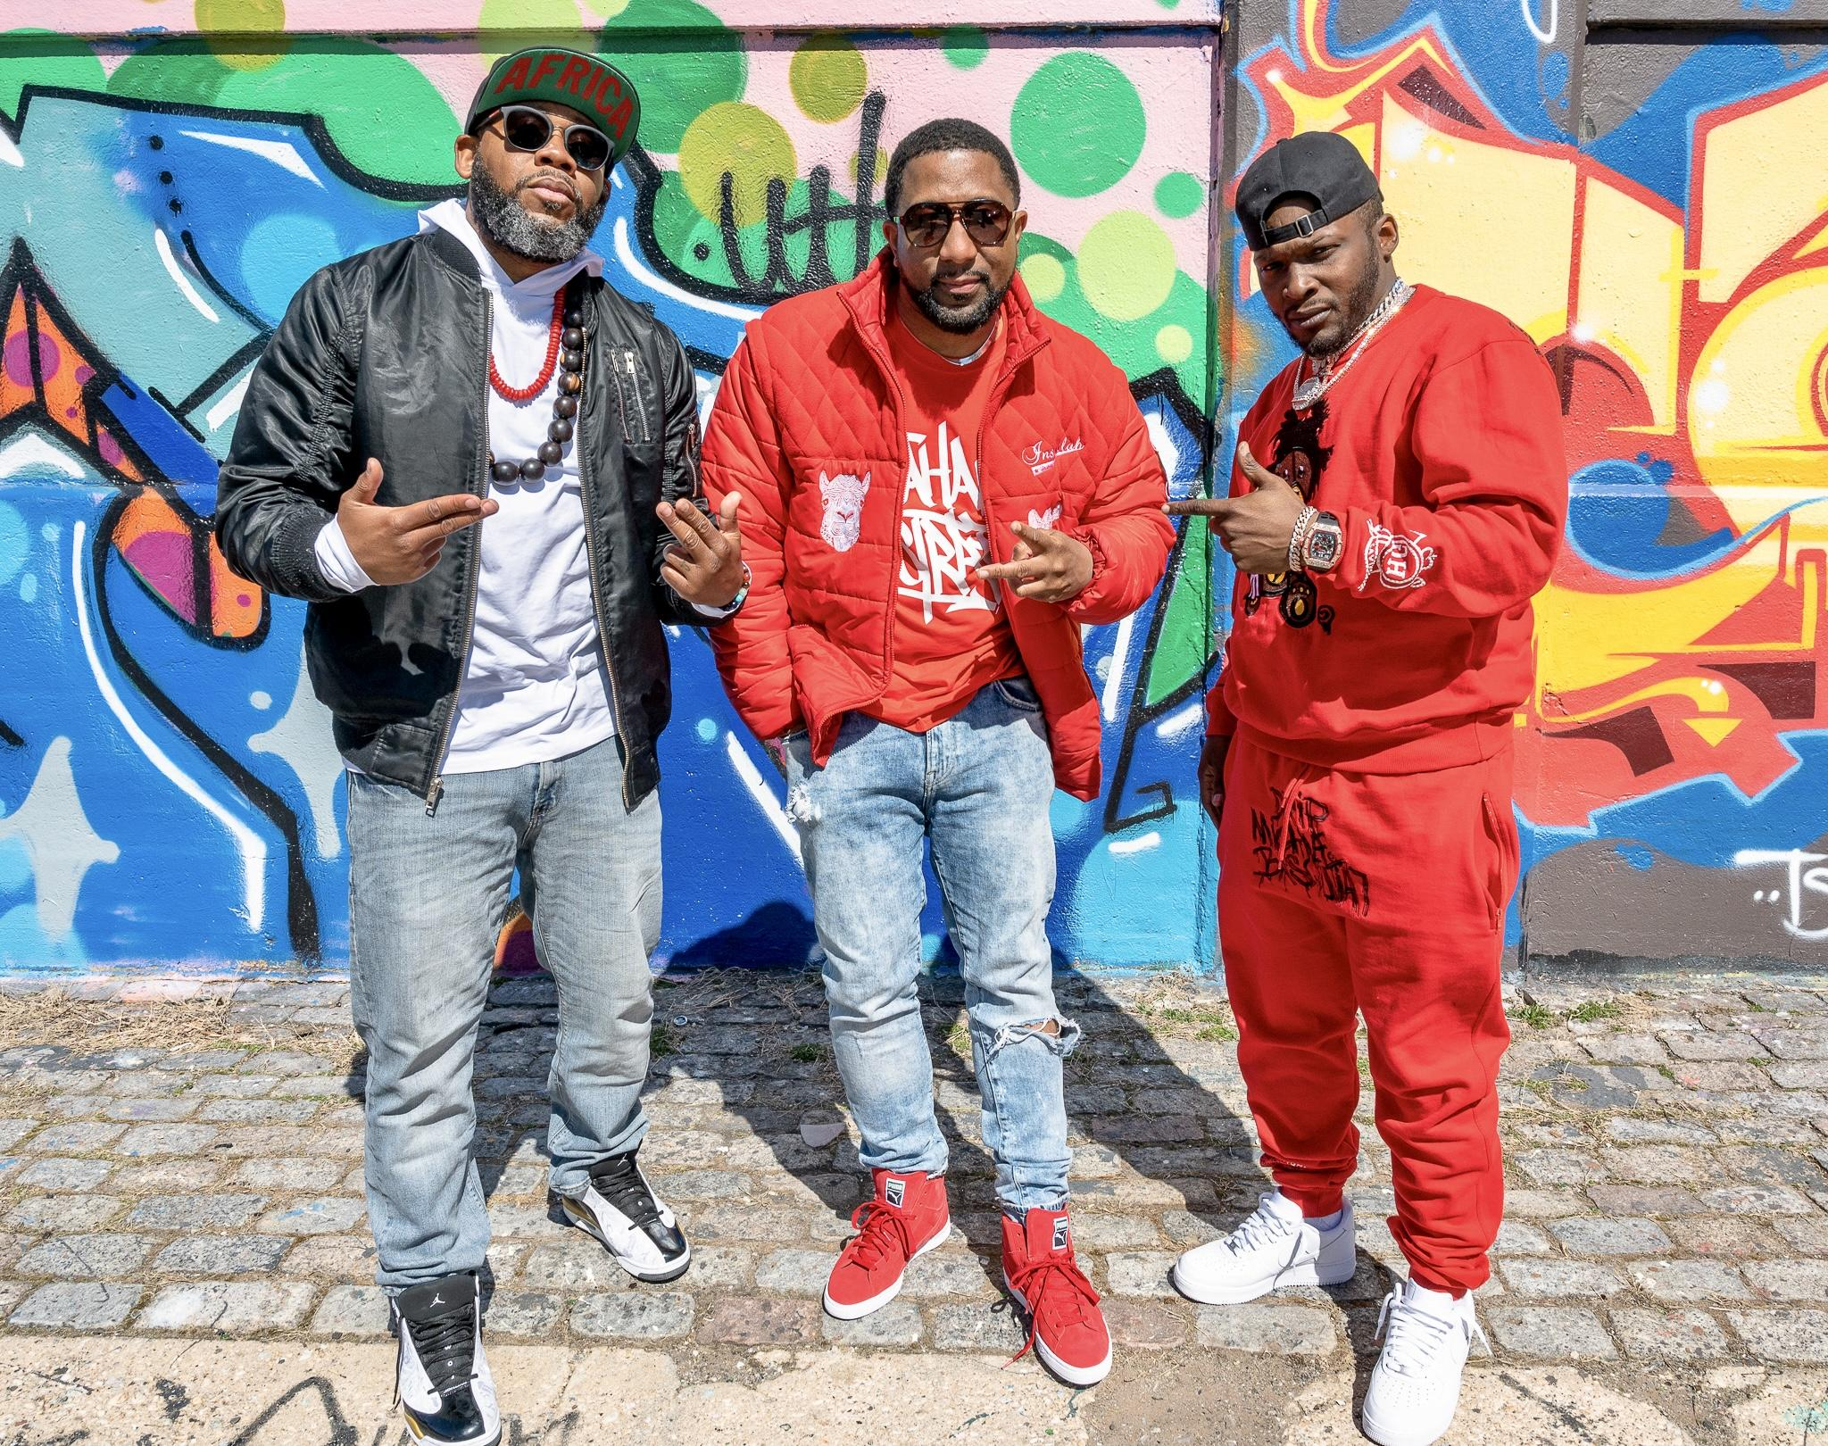

Reks, Jahan Nostra, and Tahmell at video shoot for “Dedication” Directed by Kay The Kreator

Photo Credit: Andrew Binger | R.O.C. Photography

June 7th, 2021 (Newark, NJ) - East Coast-based independent artist Jahan Nostra is a person who believes in being as authentic as possible with his craft. A student of Hip Hop, Jahan has seen the rise of Hip Hop from a regional movement, to becoming a global phenomenon that has made a dent in pop culture. With a new project on the way, he looks to take it back to the old school. To get the ball rolling, he eyes the release of the first single, “Dedication”.

Produced by Australian born/Chicago-based producer Buda Bap Beats, Jahan Nostra pays homage to the 1990s boom bap hip hop that has been a huge influence in his career. The track is given a lot of support with features from Massachusetts emcee Reks, and NY/CT based rapper Tahmell, who is the son of legendary Hip Hop artist Rakim.

The track displays some of the artists’ superb storytelling and lyricism throughout, and it is inclined to bring listeners back to a time when hip hop was about rushing to hit the record store to get music from your favorite rapper, listening to it over and over, and aspiring to becoming a great rapper. The jazz influenced production does a great job of supporting the verses laid, and makes for a more enjoyable listen. The track will be featured on Jahan’s upcoming “Violet Skies”, a three part EP series which will feature appearances from Ché Noir, Blu, and Masta Ace who appears on a remix to “Dedication”.
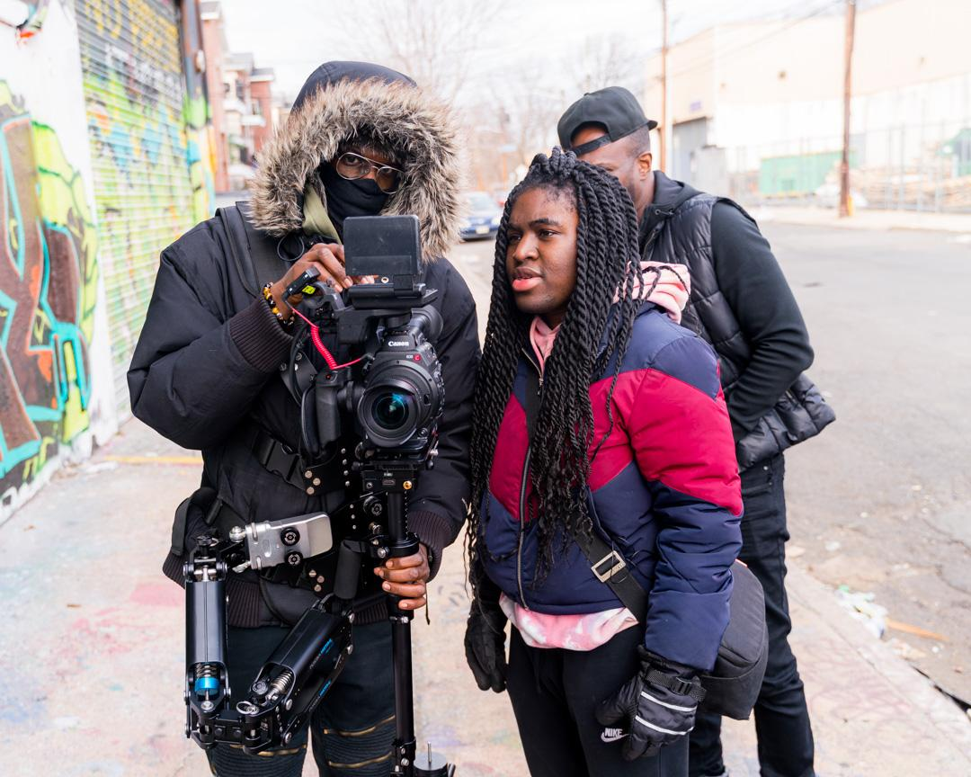
Kay The Kreator, Director of “Dedication” on set in Newark
with Lionel Djaowe (Director of Photography) and Actor, Stan J. Adams
Photo Credit: Andrew Rose

Accompanying the “Dedication” single, is a music video directed by highly sought after New Jersey based director, Kay The Kreator. Shot in Newark, the video features not only the “Dedication” single, but 40 seconds of Jahan Nostra’s 1994 single, “The Ultimate”, which was recorded in his early teens, and released through Brooklyn based independent label, BMX Entertainment.

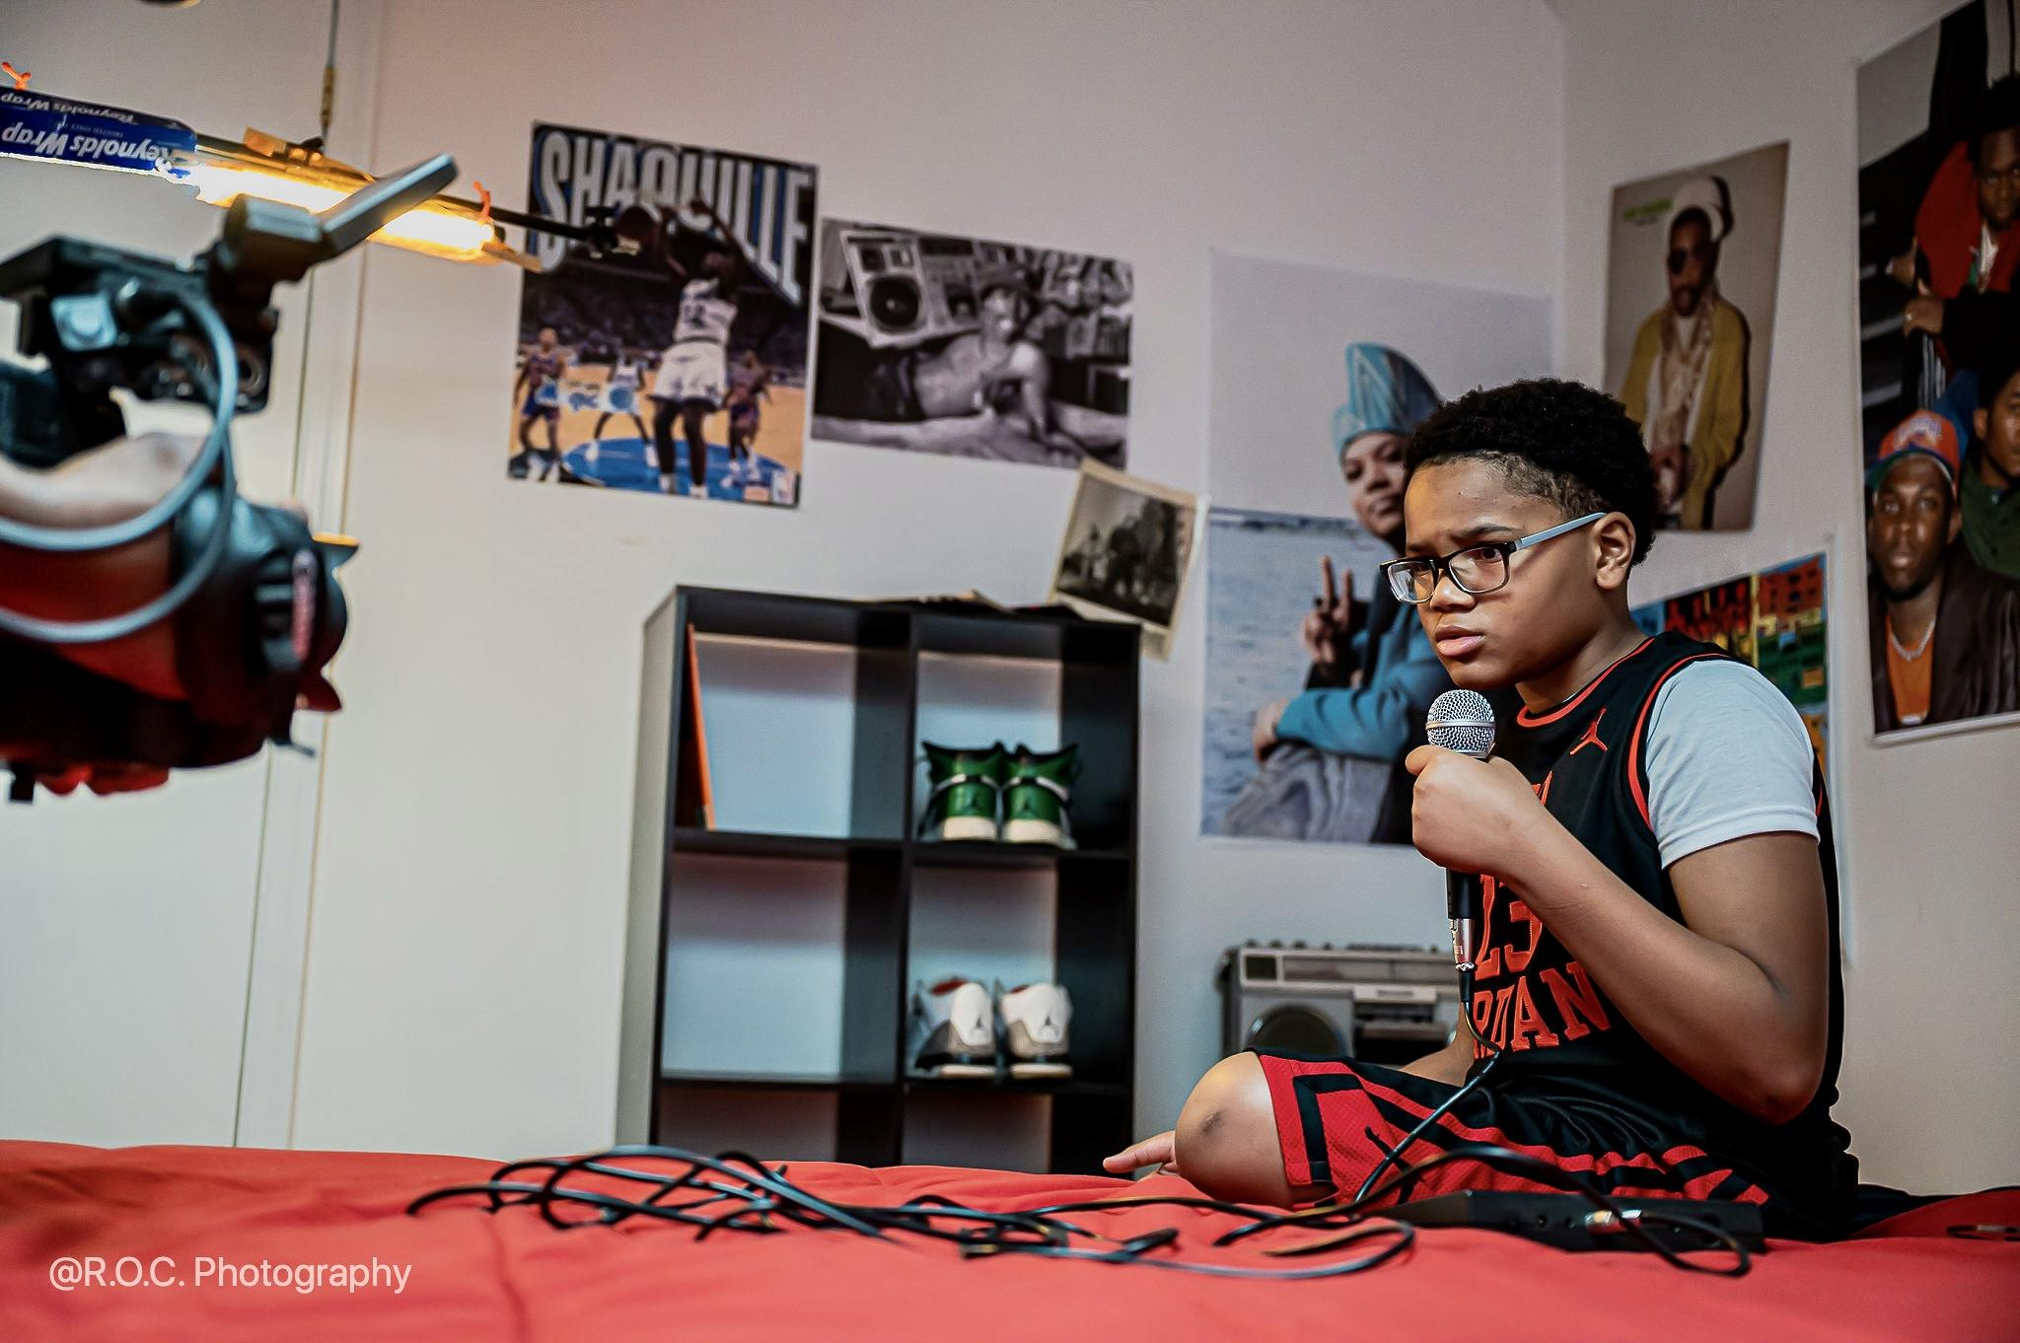
Jeremiah Worilds On Set in Newark and ready to perform his verse as an emcee in the 1990’s
Photo Credit: Andrew Binger | R.O.C. Photography

The video shows Jahan discovering his passion for music in the 90s and becoming a rapper, and while he finds himself building his music collection and becoming a student of Hip Hop, he witnessed his friends not being like-minded, and chose to go down different paths in life. Jahan continued honing his craft well into adulthood, and shares his passion with others through a record shop he runs. Reks and Tahmell join the visual by performing their respective verses, and Kay plays the role of a customer in the record store called Spina Records (located in New Brunswick, NJ). The Providence, RI-based “Hustlepreneur” Victor “Divine” Lombard also makes a cameo appearance at the record store adding some excitement and adrenaline at the end! Jahan Nostra has plans to premiere the video for “Dedication” at film festivals, and opening different avenues for his career.
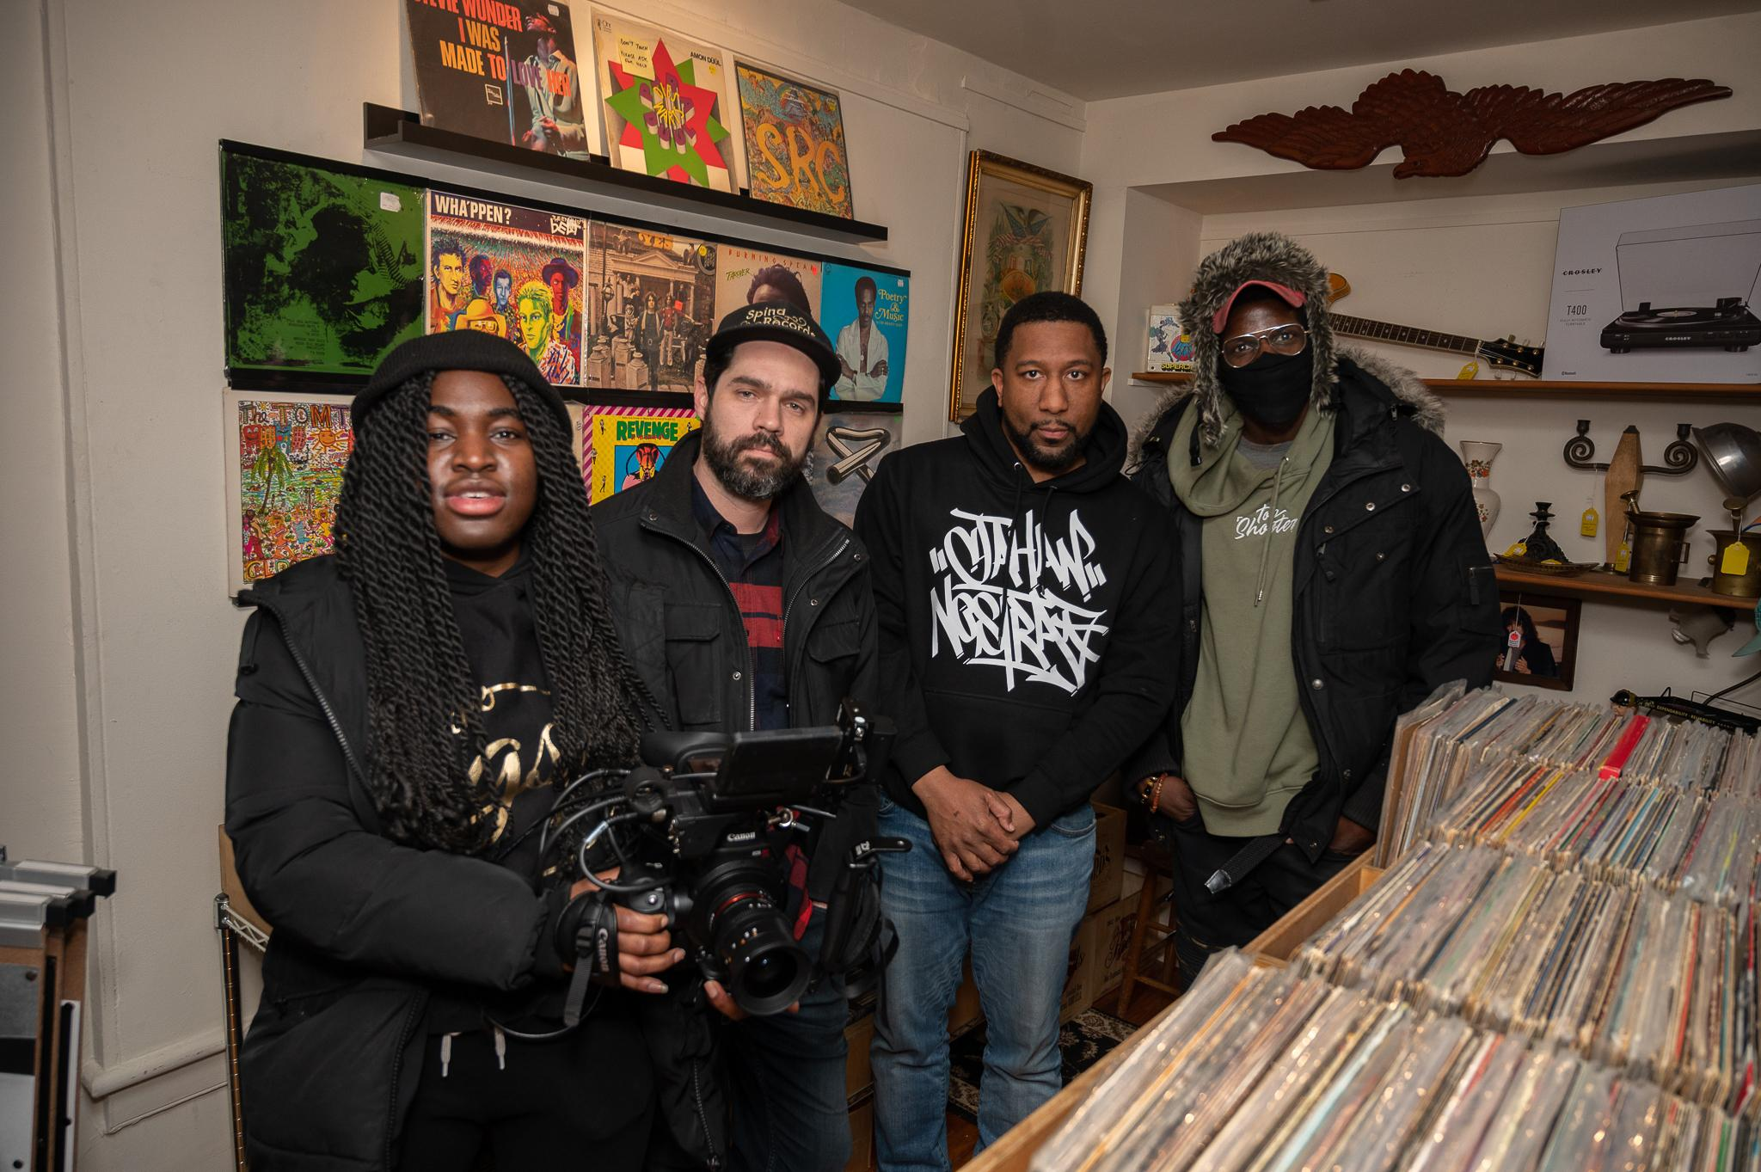
Director, Kay The Kreator with Andrew Spina (Owner of Spina Records), Jahan Nostra
and Lionel Djaowe (Director of Photography) at Spina Records (New Brunswick, NJ)
Photo Credit: Andrew Binger | R.O.C. Photography

Growing up between Connecticut and New York, Jahan Nostra developed a love for music from a young age. With the inspiration from hometown heroes Sean “Diddy” Combs, Heavy D, and Pete Rock, he pursued a career as a recording artist in his teens. At the age of 13, he signed with BMX Entertainment, and started his independent grind with collaborative partner, Ray Kyro while in high school. Since 2012, he has released 3 albums, collaborated with the likes of Smif-N-Wessun and Tone Trump, and has won several awards from the likes of the Hip Hop Film Festival, Urban Mediamakers Festival, and the Golden Door International Film Festival.

Jahan Nostra’s “Dedication” single will be available in summer/fall 2021. The music video will be premiered at film festivals summer 2021, but the visuals will not be available on any major networks or streaming platforms until 2022. For updates on Jahan Nostra’s music and more, follow him on Twitter and Instagram at @JahanNostra, on Facebook at JahanNostraMusic, and visit JahanNostra.com.
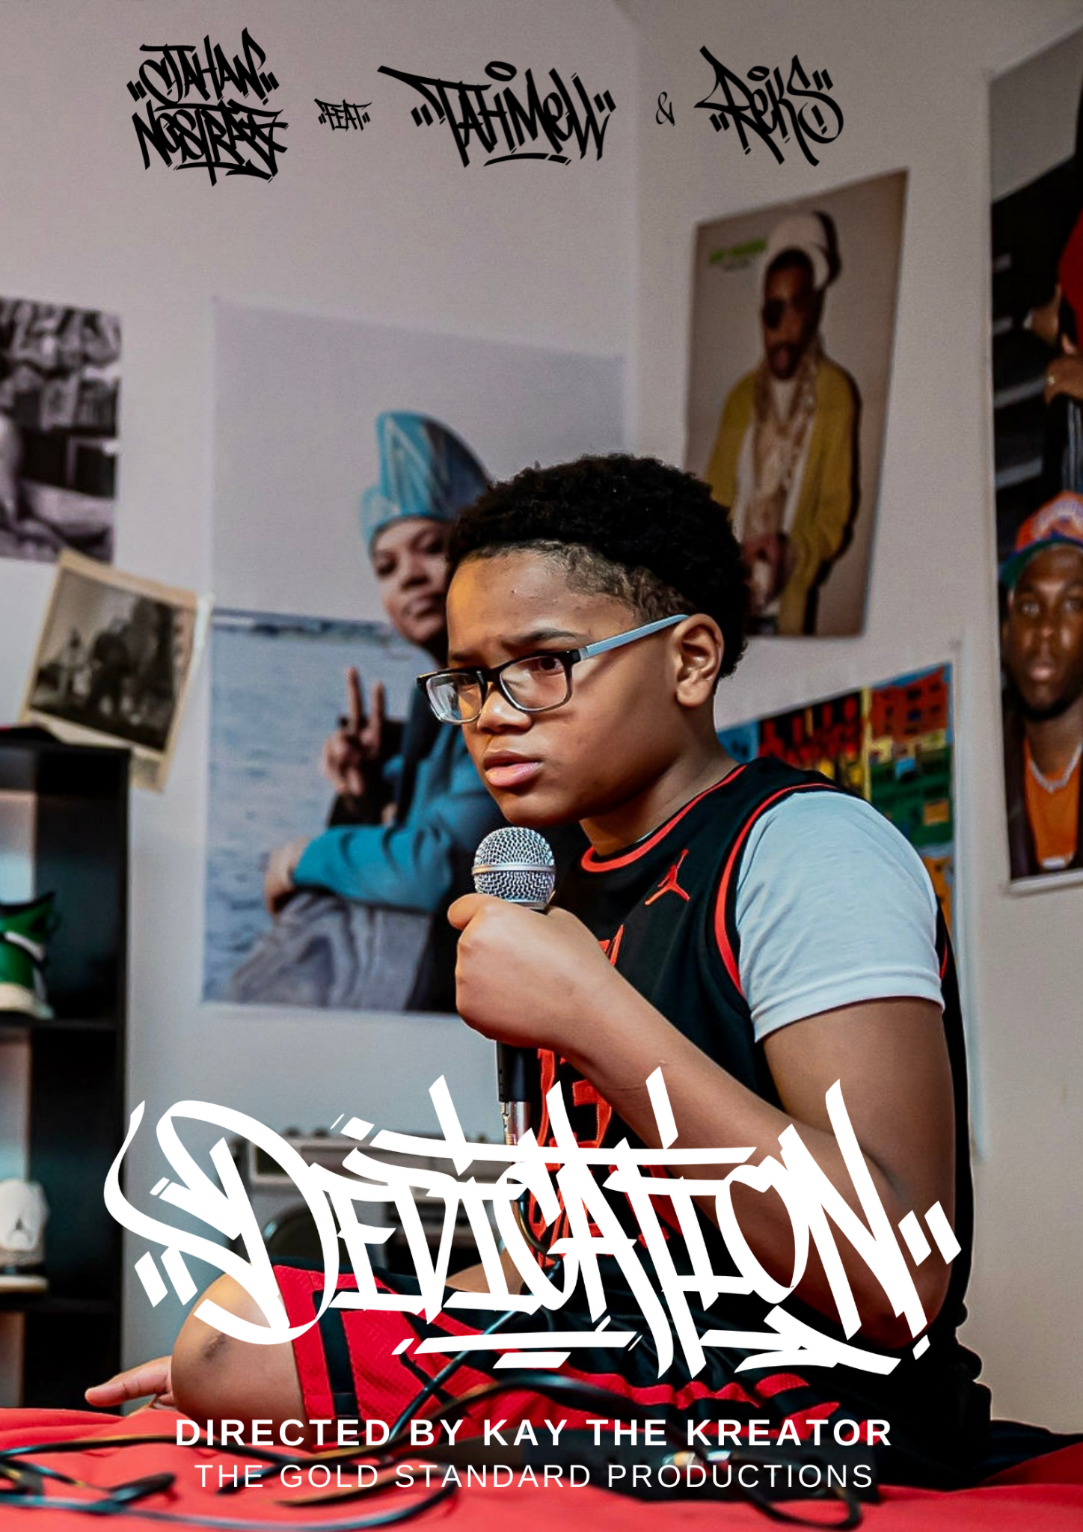
"Dedication" on IMDB

