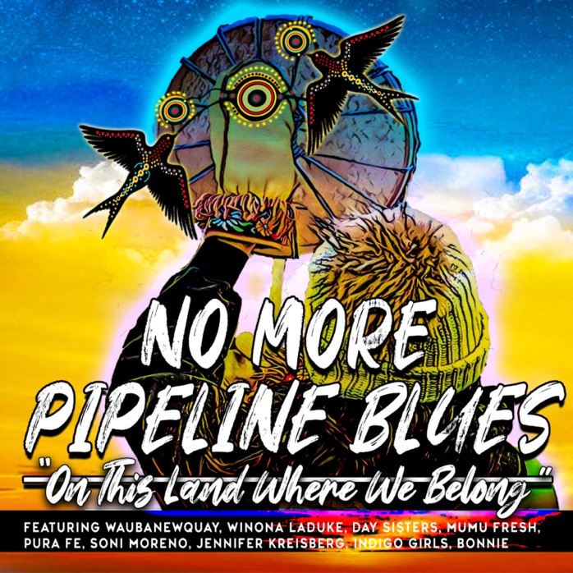

NO MORE PIPELINE BLUES
(ON THIS LAND WHERE WE BELONG)

MUSIC PRODUCTION CREDITS

PRODUCER & COMPOSER
LARRY LONG

MASTER AUDIO & MIXING ENGINEER
BRETT HUUS

MASTERING ENGINEER
STEVE WIESE

FEATURED ARTISTS

Waubanewquay (Anishinaabe Ojibwe Nation)
Winona LaDuke (Anishinaabe Ojibwe Nation)
Pura Fe (Tuscarora & Taíno Nations)
Soni Moreno (Mayan, Apache & Yaqui Nations)
Jennifer Kreisberg (Tuscarora Nation)
Day Sisters (Sharon Day, Julia Uleberg, Charlene Day-Castro, Dorene Day - Anishinaabe Ojibwe Nation)
Mumu Fresh (Maimouna Youssef - Creek & Choctaw Nations)
Indigo Girls (Amy Ray & Emily Saliers)
Bonnie Raitt
Joy Harjo (Muscogee Creek Nation): 23rd Poet Laureate of the United States
No More Pipeline Blues Band
Larry Long (Acoustic Guitar)
Dakota Dave Hull (Acoustic Baritone Guitar)
George Parrish (Electric Guitar)
Larry Dalton (Upright Bass)
Petar Janjic (Traps)
Pura Fe: Tuscarora & Taíno Nations (Hand Drum)
Jennifer Kreisberg: Tuscarora Nation (Hand Drum)

No More Pipeline Blues (On This Land Where We Belong)
Music: Larry Long | Words: Larry Long, Winona LaDuke, Keri Pickett, Buffy Sainte Marie, Keith Secola, Pura Fe, Dorene Day Waubanewquay, Marian Moore, Pam Mahling
Copyright Larry Long Publishing 2021 | BMI

Master Audio & Mixing Engineer: Brett Huus, Sound Strations Studio, La Crosse, Wisconsin
Mastering Engineer: Steve Wiese, Creation Audio, Studio A, Minneapolis, Minnesota

Special thanks to Keith Secola and Max Gail for their advice and support.

The material contributions below are excluded from the copyright of the underlying composition of No More Pipeline Blues (On This Land Where We Belong):

Pura Fe (Chants sung throughout No More Pipeline Blues "On This Land Where We Belong"):

Dorene Day Waubanewquay (Opening and closing Anishinaabe Prayer for the Water)
Winona LaDuke (Spoken words recorded by Keri Pickett)
Joy Harjo (Spoken word poem; Copyright Joy Harjo, Poet Warrior, (a memoir) W.W. Norton)

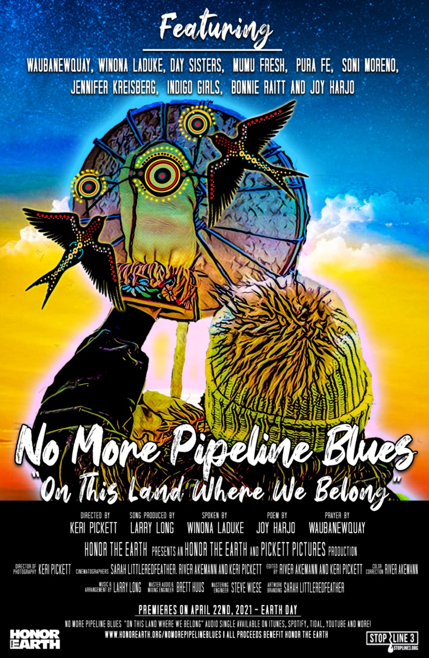
FILM PRODUCTION CREDITS
VIDEO PRODUCERS
HONOR THE EARTH & PICKETT PICTURES

DIRECTOR
KERI PICKETT

EDITORS
RIVER AKEMANN AND KERI PICKETT

CINEMATOGRAPHERS
SARAH LITTLEREDFEATHER, RIVER AKEMANN AND KERI PICKETT

COLORIST
RIVER AKEMANN

NO MORE PIPELINE BLUES
(ON THIS LAND WHERE WE BELONG)
PRODUCTION NOTES
Intro: .30
Waubanewquay opens with Anishinaabe prayer for the water. (Sound of the water)
Winona speaks the following words above Ulali singing a traditional song:
“This is the same water that was here when dinosaurs were here. There is no new water. This is the only water we will ever know. This is the same water my great ancestors drank from and harvested our wild rice upon.”
Song: 3:55
Verse 1: Pura Fé, Soni Moreno, Jennifer Kreisberg
On this land where we belong
Surrounded by the northern lights
On this land where we belong
Beneath a starlit night

Verse 2: Day Sisters (Sharon Day, Julia Uleberg, Charlene Castro, Dorene Day Waubanewquay)
On this land where we belong
Wild Mahnomen grows
Our blood runs red through the watershed
Of Nimaamaa Aki
Verse 3: Mumu Fresh
On this land where we belong
Rivers, lakes and streams
Flows through the heartland
Of the sacred Mississippi
Instrumental Break:
Traditional vocal track from Pura Fé, Soni Moreno, Jennifer Kreisberg mixed within instrumental track.
Winona speaks, “This water is sacred, because without water there’s no life. You cannot drink oil.”

Verse 4: Indigo Girls (Amy Ray & Emily Saliers)
On this land, to which we belong
From the Canadian Tar Sands
One million barrels of oil a day
To come through these sacred lands

Verse 5: Indigo Girls (Amy Ray & Emily Saliers)
On this land, to which we belong
With oil thicker than crude
Four-thousand workers coming our way
Got them pandemic pipeline blues

Instrumental Break:
Ulali: Traditional vocal track mixed within instrumental track
Winona LaDuke: “This moment is that moment in where we face that oil. This is the moment when we face Line 3 and say no. You will not take our water”

Verse 6: Bonnie Raitt
On this land where we belong
With pipelines that corrode
When they break it will be too late
It will kill this river road

Verse 7: Pura Fé, Soni Moreno, Jennifer Kreisberg
On this land where we belong
Don’t let that pipeline through
No more drill pads on Native Land
No more pipeline blues

(Pura Fé, Soni Moreno, Jennifer Kreisberg , Bonnie Raitt)
No more drill pads on public land
No more pipeline blues

(Pura Fé, Soni Moreno, Jennifer Kreisberg , Bonnie Raitt)
No more drill pads on sacred land
No more pipeline blues

Instrumental 8 Count:
((Pura Fé, Soni Moreno, Jennifer Kreisberg , Bonnie Raitt)
Don’t let Line 3 come through

Instrumental Out:
Ulali: Traditional vocal track mixed within instrumental track
Joy Harjo Saxophone mixed withing instrumental track speaking:
“You are a story fed by the generations. You carry songs, grief, triumph, thankfulness and joy. Feel their power as they ascend within you. As you walk run swiftly, even flying to infinite possibilities. Let go of that which burdens you. Let go of any acts of unkindness or brutality. Let go of that which has burdened your family, your community, your nation, or disturbed your soul. Let go one breath into another. Pray thankfulness for this earth. We are. Pray thankfulness for this becoming. We are. For this sunlight touching skin. We are. For this cooling of the water. We are. Listen now as earth sheds her skin. Listen as the generations move one against the other the other to make power. We are bringing in a new story. We will be accompanied by ancient and new songs and will celebrate together.”
Waubanewquay closes with Anishinaabe prayer for the water. (Sound of the water)
Total Length: 4:41

