"The pursuit of music is basically the pursuit of oneself...a very spiritual undertaking." — Rick Kilburn
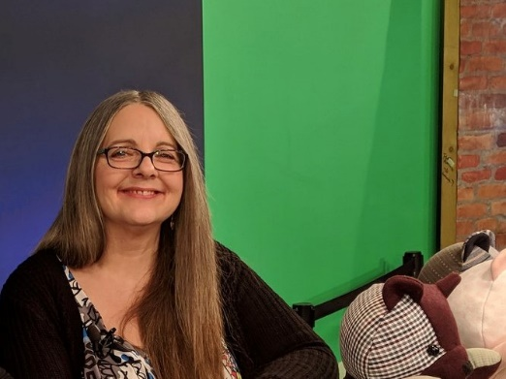
US award-winning Nanaimo former radio host/producer and global Rhythm’a’ning jazz podcast host Kerilie McDowall is a writer and has been a music critic/writer contributor for the American jazz magazine DownBeat (2016-2020). As a former volunteer live radio host, producer/on-air engineer, she listened to thousands of creative, jazz and improvised Canadian, US and global recordings during her 18 years in the radio industry. As a #1 globally ranked jazz podcast radio host on Player FM, McDowall interviewed Canada’s elite jazz and creative music artists including JUNO winners and Order of Canada recipients.
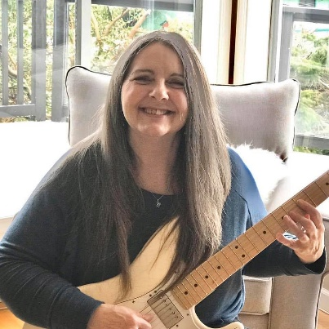
A professional jazz guitarist, instructor and music composer in the 90’s in Vancouver, McDowall is a York University Bachelor of Fine Arts music graduate. Her area of study was New Music Composition and Classical and Jazz Guitar Performance. A current guitar instructor, McDowall has 17 years of guitar instruction experience and 34 years of music industry expertise and currently instructs privately at Oceanview Guitar Studio.
McDowall sits on the Polaris Music Prize jury, judged the JUNO Awards from 2016-18 and judged the annual DownBeat Critics Poll for several years.
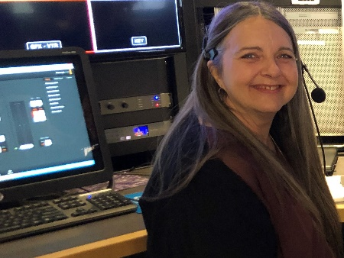
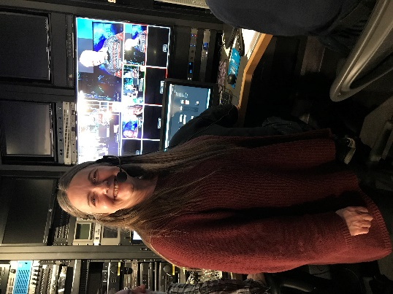
McDowall wrote the Nanaimo Conservatory of Music’s newsletter Chordial Notes in past years. As a freelance writer she has written for the Canadian Antique Phonograph Society, the Vancouver Island Symphony, Festival Nanaimo, Nanaimo Magazine, Nanaimo’s Bethlehem Centre, INSPIRED 55+ Lifestyle Magazine, and others. As a publicist currently McDowall works with musicians and arts and music/events organizations. Clients have included the Friends of Nanaimo Jazz Society and Nanaimo Musicians Association and McDowall was the publicist for Nanaimo’s multi-faith hub, the Bethlehem Centre (pre-COVID) and the Victoria Jazz Orchestra. Additionally McDowall hosts workshops with arts organizations. Past clients have included Nanaimo Opera and Bard to Broadway Theatre.
With her Nanaimo business in past years McDowall conducted PR, media liaison, publicity and writing work for jazz musicians Dan Brubeck, Mike Allen, Marianne Trudel with Ingrid Jensen, Monik Nordine and others. McDowall has produced Nanaimo jazz and art music concerts with Dan Brubeck, France’s award-winning pianist Benoit Delbecq, the island’s Roger Baird and Vancouver jazz saxophonist Mike Allen.
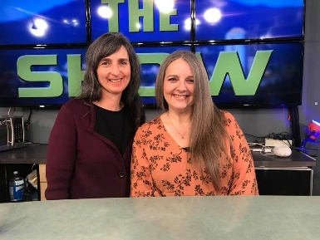
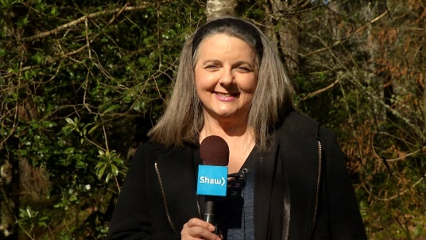
In 2016 McDowall won the Atlanta, Georgia Black Women & The Arts Awards Stiletto Woman of Distinction Award and was Nanaimo Magazine’s Celebrity of the Month. She volunteer hosts and directs television shows at SHAW Spotlight. A past host of Community Producers, currently McDowall hosts as a volunteer on SHAW Spotlight Nanaimo, Canada’s The Show. As a volunteer television director McDowall has directed SHAW TV’s Coast Connections since October 2016, as well as other SHAW Spotlight television productions like Change the World. Kerilie just released her first short mini-documentary film for television/YouTube during COVID-19 on March 17, 2020 as a SHAW volunteer with the assistance of Todd Jones, Jocelyn Matwe and the SHAW Spotlight team.
The film is titled, “In the Zone: Rick Kilburn,” Vancouver Island Bassist and Producer. The film has been selected by the Montreal Independent Film Festival. The short was invited to and is now a finalist at the jellyFEST Film Festival in Hollywood, USA, and is a selection after receiving an Honorable Mention for Best Web and New Media at the Independent Shorts Awards, Hollywood.
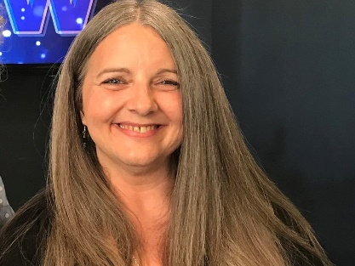
More from Facebook: https://www.facebook.com/kerilie
Watch the mini-doc film “In the Zone: Rick Kilburn,” Vancouver Island Bassist and Producer:
https://www.youtube.com/watch?v=koV7F42KO0U&feature=youtu.be

Video of Kerilie McDowall from Community Producers:
https://www.youtube.com/watch?time_continue=13&v=H5laNfuahPU

