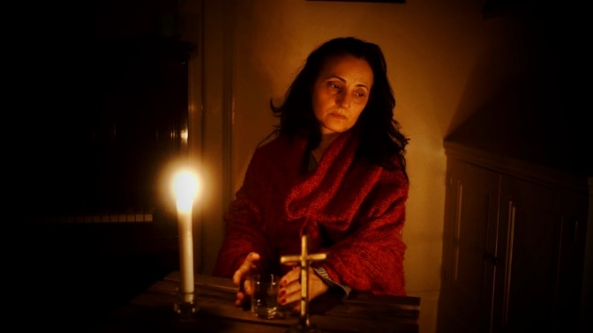 | Where are you Boutros?  A feature film, drama, a visual thriller  85 minutes
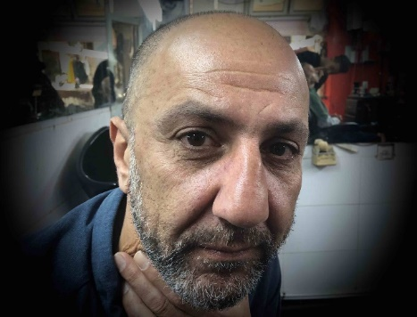
Writer/director/producer: Koutaiba Al-Janabi

Betrayal fear and faith in the cellar of an old church in Baghdad
Journey into the Middle Eastern Christians fate

The events we see are between reality and phantasy, with elements of magic realism, the film is about guilt and forgiveness, pain, deceit, faith and hope.

“Where are you Boutros” is about a woman, Maryam. She is over 45 a teacher, a virgin, she was waiting for real love, with Christian values. She wakes up one morning, hears voices, shooting, she opens the curtain and sees a black flags flying all over her town.

Maryam’s town is occupied by extremist militias. She knows she would have to leave the town, her younger brother, Boutros is to help her. Maryam trusts him, but Boutros betrays her to those who brutally persecute the Christians. When Maryam is interrogated by a masked man she recognises in him her old student who fuelled by the evil powers he is working for, rapes her.

She escapes and hides in the cellar of the church, that she feels is her duty to protect, it houses the church’s historical documents and treasures. She is alone with her faith and she contemplates all the sins committed against her and her community. Boutros calls her, urges her to give up her faith so that she can leave the city but she refuses and stays.

With her strong belief, her unshaken honesty. -will she find the strength to forgive her brother, the rapist when they beg for her forgiveness? What does she feel towards the man who took her virginity - anger, or also attraction, liberation? The church bells ring again above Baghdad while they reunite in the cellar.

DIRECTOR’S INTENTION

- Why this film? The idea was developed with a limited budget and location available in mind. The new circumstances caused by the corona virus strengthened my belief that this was a realistic way to proceed to be able to realise this film.
My intention with making this film is presenting evil powers without showing them, only being present as shadows and animation as there have been numerous films directly presenting the anti-hero. Although the main characters are persecuted because of their faith, because they are Christian, the film is not about ISIS, not putting Islam as an opponent and oppressor of Christianity.
I am not of a Christian background but I feel an obligation to present their fate. Iraq, and generally the Middle East lost the Jewish community a generation ago and now I am witnessing losing the Christian community. I feel my artistic, political and personal obligation towards my friends, neighbours, comrades, lovers, teachers to speak up. We are still carrying the guilt of the previous generations.

- Characters: The film is an internal journey of a 50 year old lady, who feels like Maryam, the holy Mary, living by her Christian values. She is still a virgin after her love was torn from her in their youth by wars, and she is still waiting for him. Now she is raped by her old student as a result of her own brother’s betrayal under the power of the occupying forces. How does she experience the violation of her body, of her beliefs? Can she also feel liberated, feel attraction to her rapist? A woman who was raised in strict faith, in a male dominated society, to serve the church to serve the family, can she experience this brutal event as freeing? How does her faith and her moral pureness give her the strength to forgive? Her calling is stronger and feels she has to act as witness to the events around her, she stands up for her beliefs by staying in her hiding place, the cellar under her church. She is not hiding to escape but hiding to protect and preserve what she inherited. It will be a challenge to present her in the one location and the relationship she has to the only living being around, a hedgehog - that brings relief to her and to the viewers.

The three main characters - Maryam, her brother Boutros who deceives her and Jamal, her student who rapes her have to come together to be stronger in the face of evil. My focus is the betrayal, sin, shame and ultimately the forgiveness. The performers are cast because of their personal beliefs, experiences and their own stories they can bring to the film.
My intended message is to call upon my Christian brothers and sisters not to leave us.

- Technical realisation The events are happening between reality and phantasy, using elements of magic realism, in a world split into two: The lower world, the cellar lit by candles, being warm and protecting, while the upper world, the area around the church, the compound is created as seen through a camera obscura, with shadows dominating, as animation. In my film the brutal forces, torture scenes do not need to be seen, but indicated through shadows, lighting. The external images reflect the barbarism of the occupying group, while the cellar is warm, comforting, a refuge from the ruthless world raging outside. The story telling is not linear, past and present are intercut.
Very careful camerawork and editing through close collaboration between director, the DoP and editor will be essential to create this special visual world under challenging conditions.

MOOD PICTURES FROM THE LOCATION

