francisco, el hombre convoca "MATILHA" para resistência cultural em novo clipe
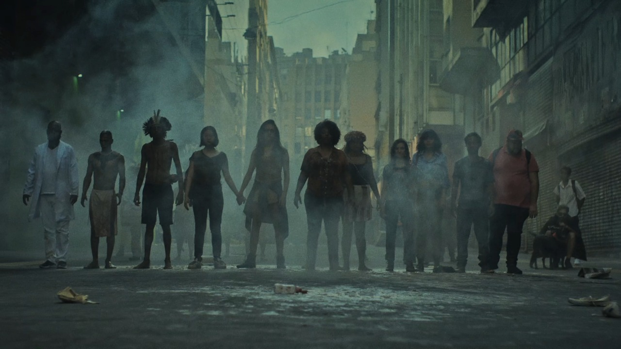

Sao Paolo-based directing duo Los Pibes are commercial directors who have also regularly made music videos for the Brazilian rock band Francisco, El Hombre. And this new video for their song Matilha is a passionate and powerful expression of resistance to the first year of Brazil's 'new politics' – Jair Bolsanaro's far-right Presidency.
Through the allegory of a big demonstration, the film features metaphors of key events that have interfered and regressed public, social and ecological policies since 2018. The enemy are three conservative personas that prevail in the history of the country: the ruralist, the entrepreneur and the military. And representing the key groups affected by this old way of governing, the clip shows the strength of these minorities when fighting collectively.
"This film was independently made with the support of almost 400 people who believed and were part of this pack," say Los Pibes. "Thanks."

