United Community Action Network (UCAN)
www.ucannz.org.nz
13/1/2020
To the World Health Organisation Film Festival Organisers

Tēnā koe to Whom it May Concern,
As Chair of UCAN I humbly submit a film for the Film Festival. UCAN has ​grown as an advocacy voice for New Zealanders with poor access to health and mental health services. We are a coalition of community organizations, health and social service providers and human rights organizations, such as the Child Poverty Action Group, the New Zealand Nurses Organisation and Equality Network, who see upfront on a daily basis the inequity perpetuated by our current system in New Zealand.
We call for a Human Rights Framework for understanding and addressing the issues people with mental health, chronic health and addiction issues face, because many of the drivers are not health-based but economic. As New Zealand’s service infrastructure modernises, those most vulnerable and in need of services are left without equal and fair access to them, because of financial barriers to transportation and internet, while their general health is affected by the financial barriers to warm dry housing and healthy food.
We developed a Health Charter to promote and prioritise the human rights of New Zealand’s most vulnerable citizens. In 2018 we presented our Health Charter to the Expert Advisory Panels that presided over New Zealand’s Inquiry into Mental Health and Addictions, and its Reform of Social Welfare. We brought with us stories from our members, to reiterate the points we made in our submission, with their own voices and true stories. Our Charter was received well by each panel and was also shared widely by our network of stakeholders. We have new opportunities to meet with members of parliament, to advocate their implementation of the Charter’s measures and ensure equal rights for New Zealanders living in material hardship and poor mental health.
We present UCAN’s Charter to the World Health Organisation, in the hope that its human rights framework can support the global health promotion efforts made by this institution worldwide. It is critical that as every nation’s health system is supported to modernise with new technology and knowledge, we take every measure to ensure no citizen is left behind and marginalised because of either their mental illness, addiction, material hardship, or the combination of all three.
I would be happy to discuss our Charter and UCAN’s success in engaging stakeholders across labour unions, academic institutions, public health and child well-being networks within New Zealand. We believe the Charter’s framework is universal and could serve the interests of people with mental health and addictions issues, particularly those in material hardship, everywhere. It is with this in mind that we share it with the World Health Organisation, asking for you to endorse and promote worldwide.

Yours Sincerely,
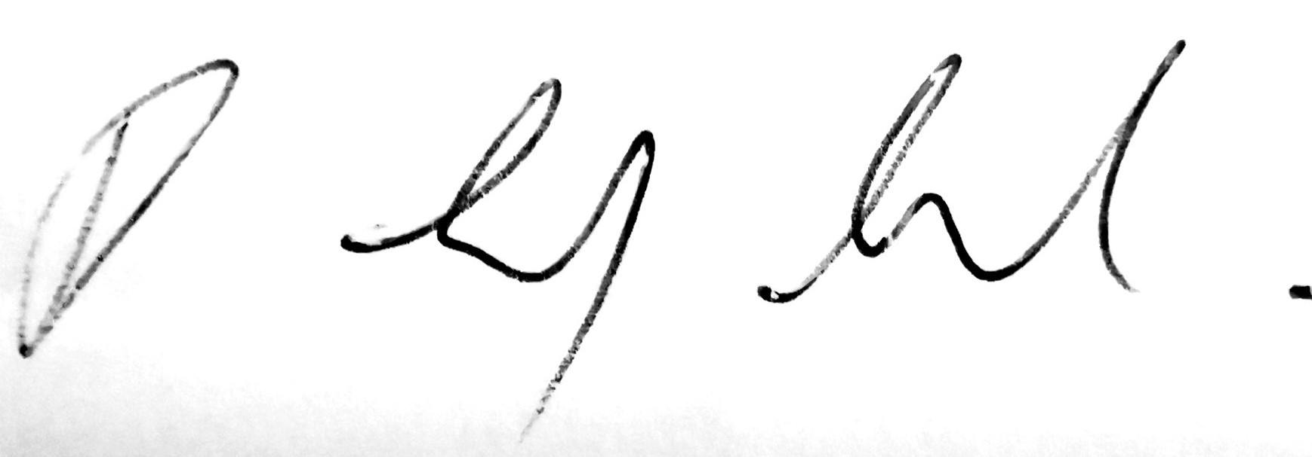
Debbie Leyland
Chair, UCAN

