Becoming Masina
Electronic Press Kit
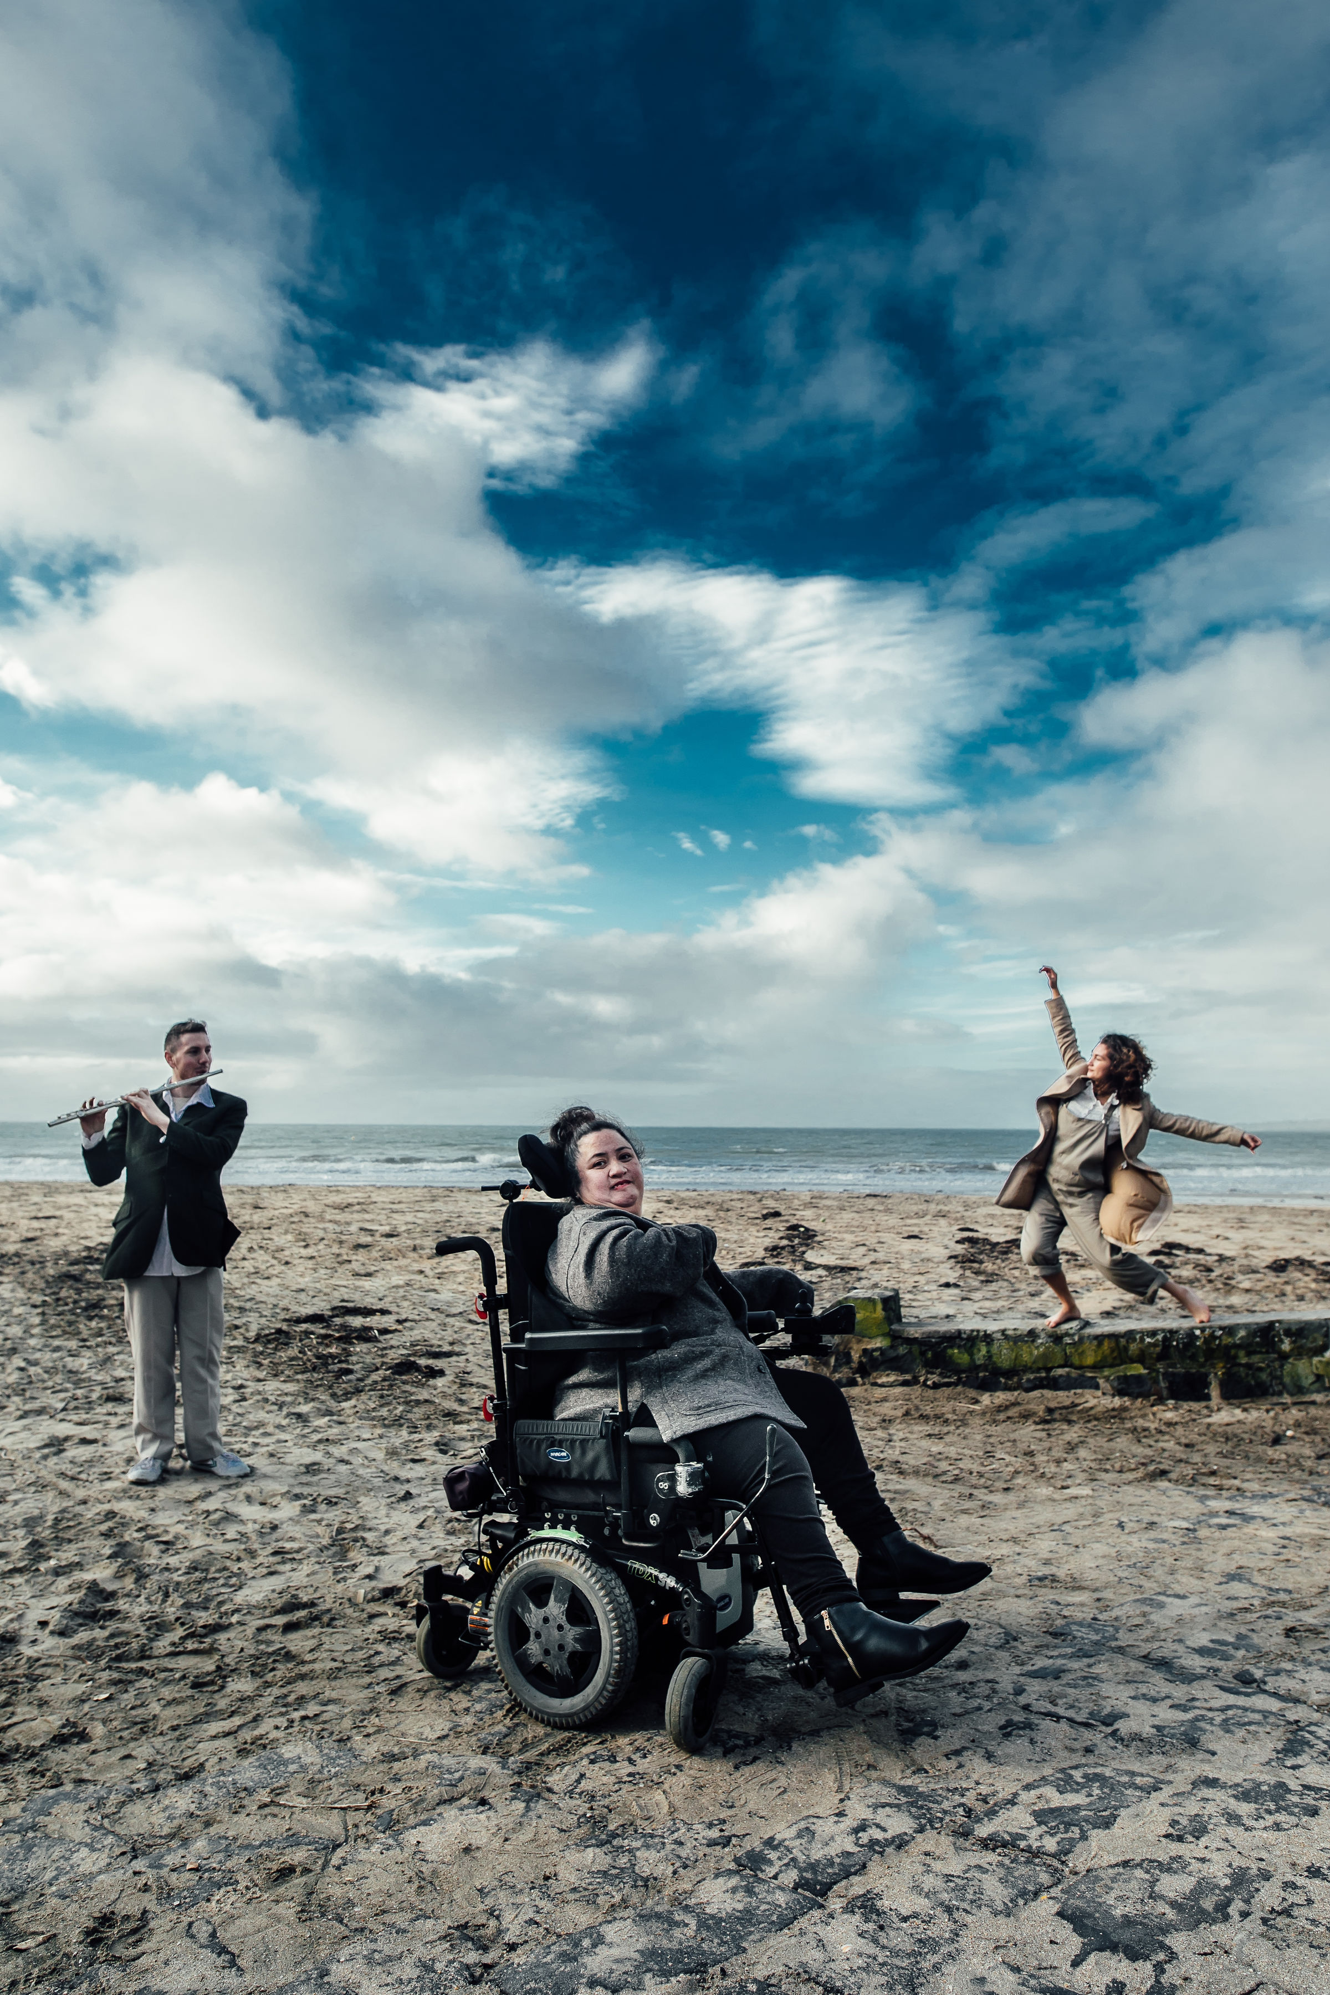

Synopsis
It takes bravery and guts to perform on stage to an audience… but Lusi does it all the time. Despite growing up with a disability, Lusi has been breaking boundaries as a loud and proud Samoan dancer and actor in the theatrical world.
Becoming Masina is a documentary that takes us behind the scenes into the creation of her latest project ‘Masina Returning Home’ and highlights the crazy characters that have stepped beyond their comfort zone to take part in a type of theatre that truly makes a difference.

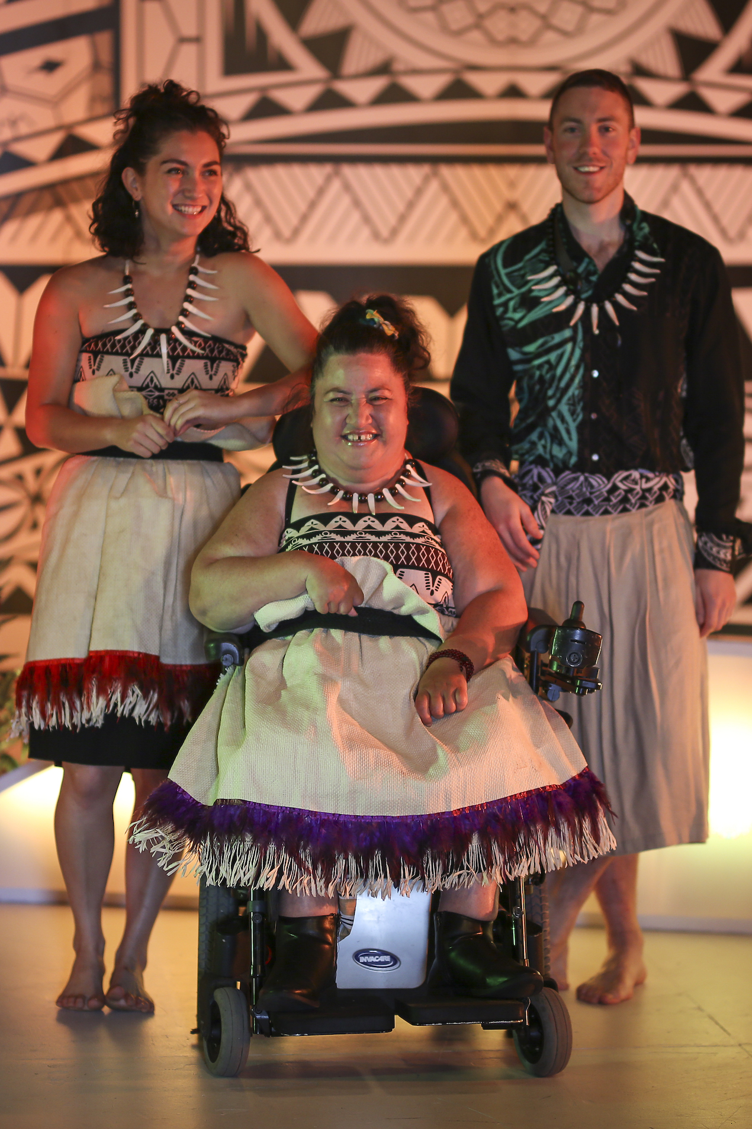

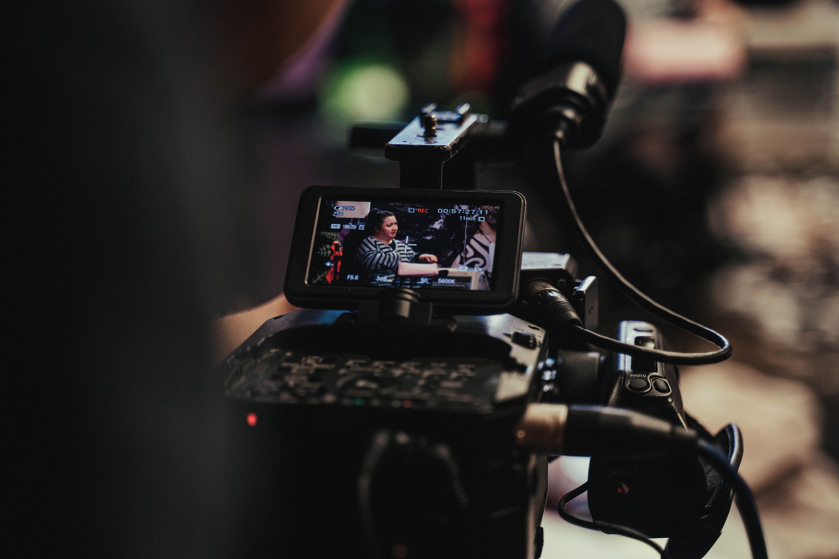
Directors Statement
Becoming Masina is a short documentary that gives us a glimpse into Lusi Faiva’s experience as a dancer and actor and goes behind-the-scenes into the creation and progression of her latest project; the sensory-immersive theatre production called Masina Returing Home.
As a former dance teacher for children and teenagers with physical and intellectual disability, I have witnessed the difficulties experienced by the dancers, their families and support persons in regards to access to creative platforms. When I discovered Touch Compass, I was excited to see a platform in Auckland that provides training, development and paid work for mixed ability performers but, more than that, they were creating theatre pieces for mixed ability audience members as well. Furthermore, when I saw Lusi performing, I knew that she was someone who I wanted to know more about as she was clearly someone living beyond her disability.
This documentary is more than just getting to know the team behind ‘Masina Returning Home’. It plays at much bigger themes of people and companies that proactively strive for accessibility and inclusivity in today’s modern society and is set to challenge common misconceptions that people have others living with disabilities.
I hope that the documentary inspires audience members to think a little more broadly about their own expectations as to who can be performers but more importantly, I hope that it encourages audiences to look beyond differences and realise that deep down, we are all leaves from the same tree experiencing similar feelings, troubles and triumphs.
Meet the Cast

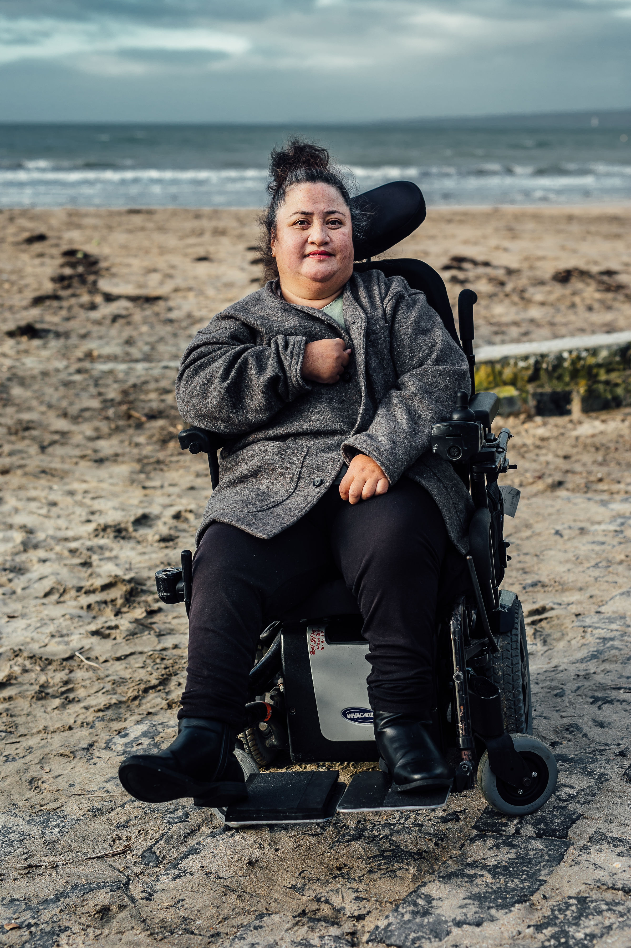
Lusi Faiva
Lusi is an actor and dancer of Samoan descent and plays Masina In the play ‘Masina Returning Home’. She has been interested in theatre since her teens, and joined Touch Compass Dance Company as a founding member in 1996 after attending an introductory workshop and then an audition. Within months, she was doing her first solo performance at The University of Auckland’s now-demolished Maidment Theatre and has been touring around New Zealand and Australia in the company’s major shows ever since. She states that “As a performer with a disability, I have had to overcome barriers, with people saying that I can’t talk or dance. But it seems that I have proved them wrong. I believe it is possible for anyone who has a disability to achieve their dreams in this able-bodied world!"

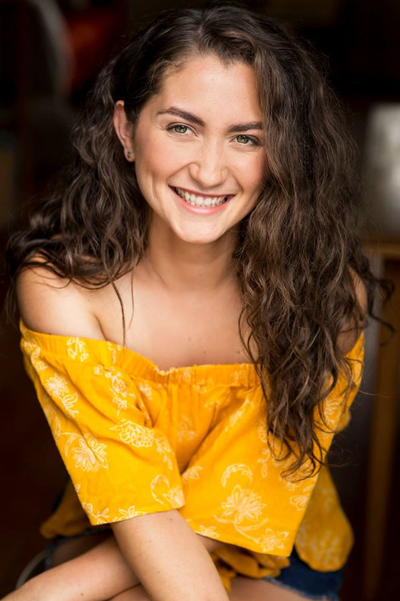
Katrina George
Katrina started dancing before she was able to properly walk and hasn’t stopped since. She studied acting at Toi Whakaari and has a passion for visual and dynamic story telling as well as the intricate in’s and out’s of the creative process. She describes her experience of performing in the interactive theatre show – Masina Returning Home, as a “life altering and profound experience”. Katrina shares a particularly special bond with fellow performer Lusi Faiva as they both share the common thread of being of Samoan descent. Since graduating, Katrina has performed all over the world and states that “I am blessed to have the best job in the world”.
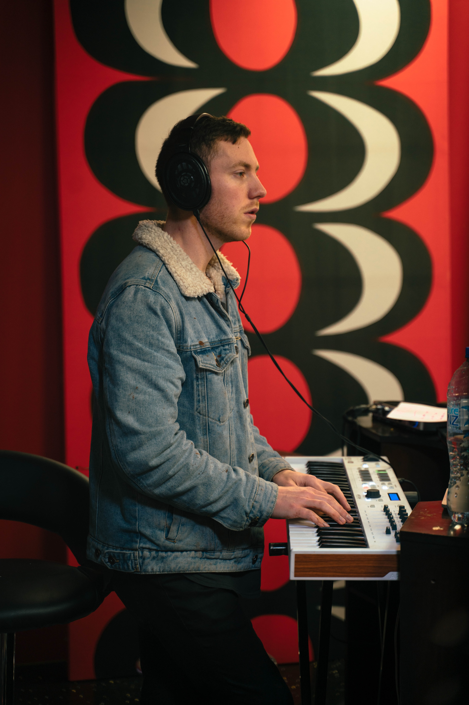
Sam Jones
Sam is a composer and musical director based in Auckland, New Zealand. He studied classical performance at the New Zealand School of Music, and got his first theatre job as the drummer for a NZ tour of “The Great Gatsby”. He continued with this company for several years, working as associate musical director for “Sound of Music” and “Cats”, and will be musical directing the company’s next show in 2020. Aside from theatre, Sam works with a range of artists in studio and on stage including Laughton Kora, Bailey Wiley, Ashley Alexander and the Sweet Mix Kids.


Charlotte Nightingale
Charlotte is the general manager of Touch Compass—the company behind the production Masina Returning Home. Hailing from the UK, Charlotte trained in London at the Central School of Speech and Drama. As an actor she has worked in television, film and theatre both in the UK and New Zealand, most recently as character Linda Burgen in Shortland Street in 2016. Over the past two years, Charlotte has looked into how the productions that Touch Compass create can be more inclusive and accessible for audiences with ranging abilities. She says - “my passion is for diversity and equality in the arts and I believe that by delivering engaging performance that reflects the society we live in we can change people’s perceptions of what art is and who can do it”.

Meet The Crew

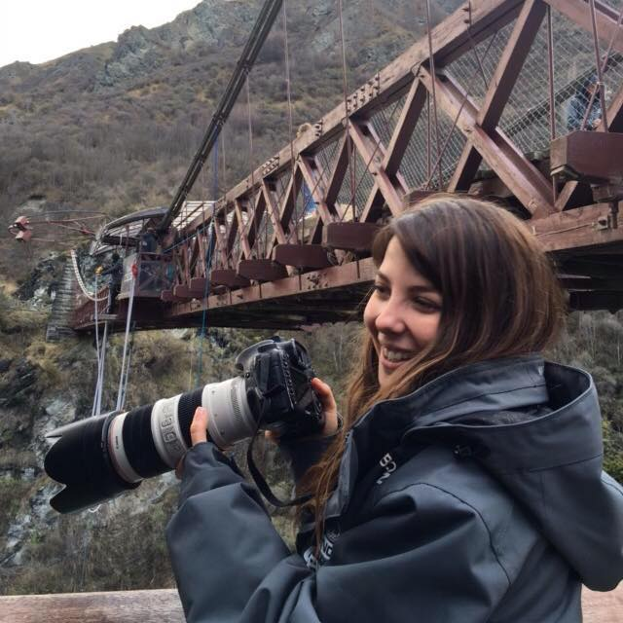
Veronica Maitre | Director Producer
Veronica is an enthusiastic, aspiring filmmaker with a passion for factual, personable and intimate storytelling. Moving from Australia to study Documentary Directing and Research at Yoobee South Seas Film school, Veronica plans to use her natural curiosity to further understand the human process and the world around us, in a creative and visual medium. She was previously an Occupational Therapist working in the disability and mental health sector giving her a particular passion for working with those who have experienced disadvantages or adversities in their lives. With her ability to connect with people young and old, Veronica hopes to share the unique and authentic stories of others to a wide range of audiences throughout her career.

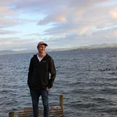
Matt Kitson | Editor
Born and raised in Auckland, New Zealand, Matt Kitson has had a passion for film since the early age of 10 years old. He grew up filming and editing homemade action movies with his friends, developing and improving as time went by. Coupling this skillset with his love of sports, Matt began to compile sport montages of snowboarding and water-skiing. Upon completing high school, he decided to turn his passion into a career and began to freelance as an editor and videographer, where he’s had great success and attracted clients such as Air New Zealand, World Vision, Microsoft, Oxfam and AUT, to name a few. In 2019, to heighten his skillset and hone his craft, Matt studied at Yoobee College’s South Seas Film School, specialising in Post-Production Editing. Returning to the industry with newfound vigour, Matt aims to continue his passion and find his place within the post production industry where he can continue to learn and experience everything it has to offer.
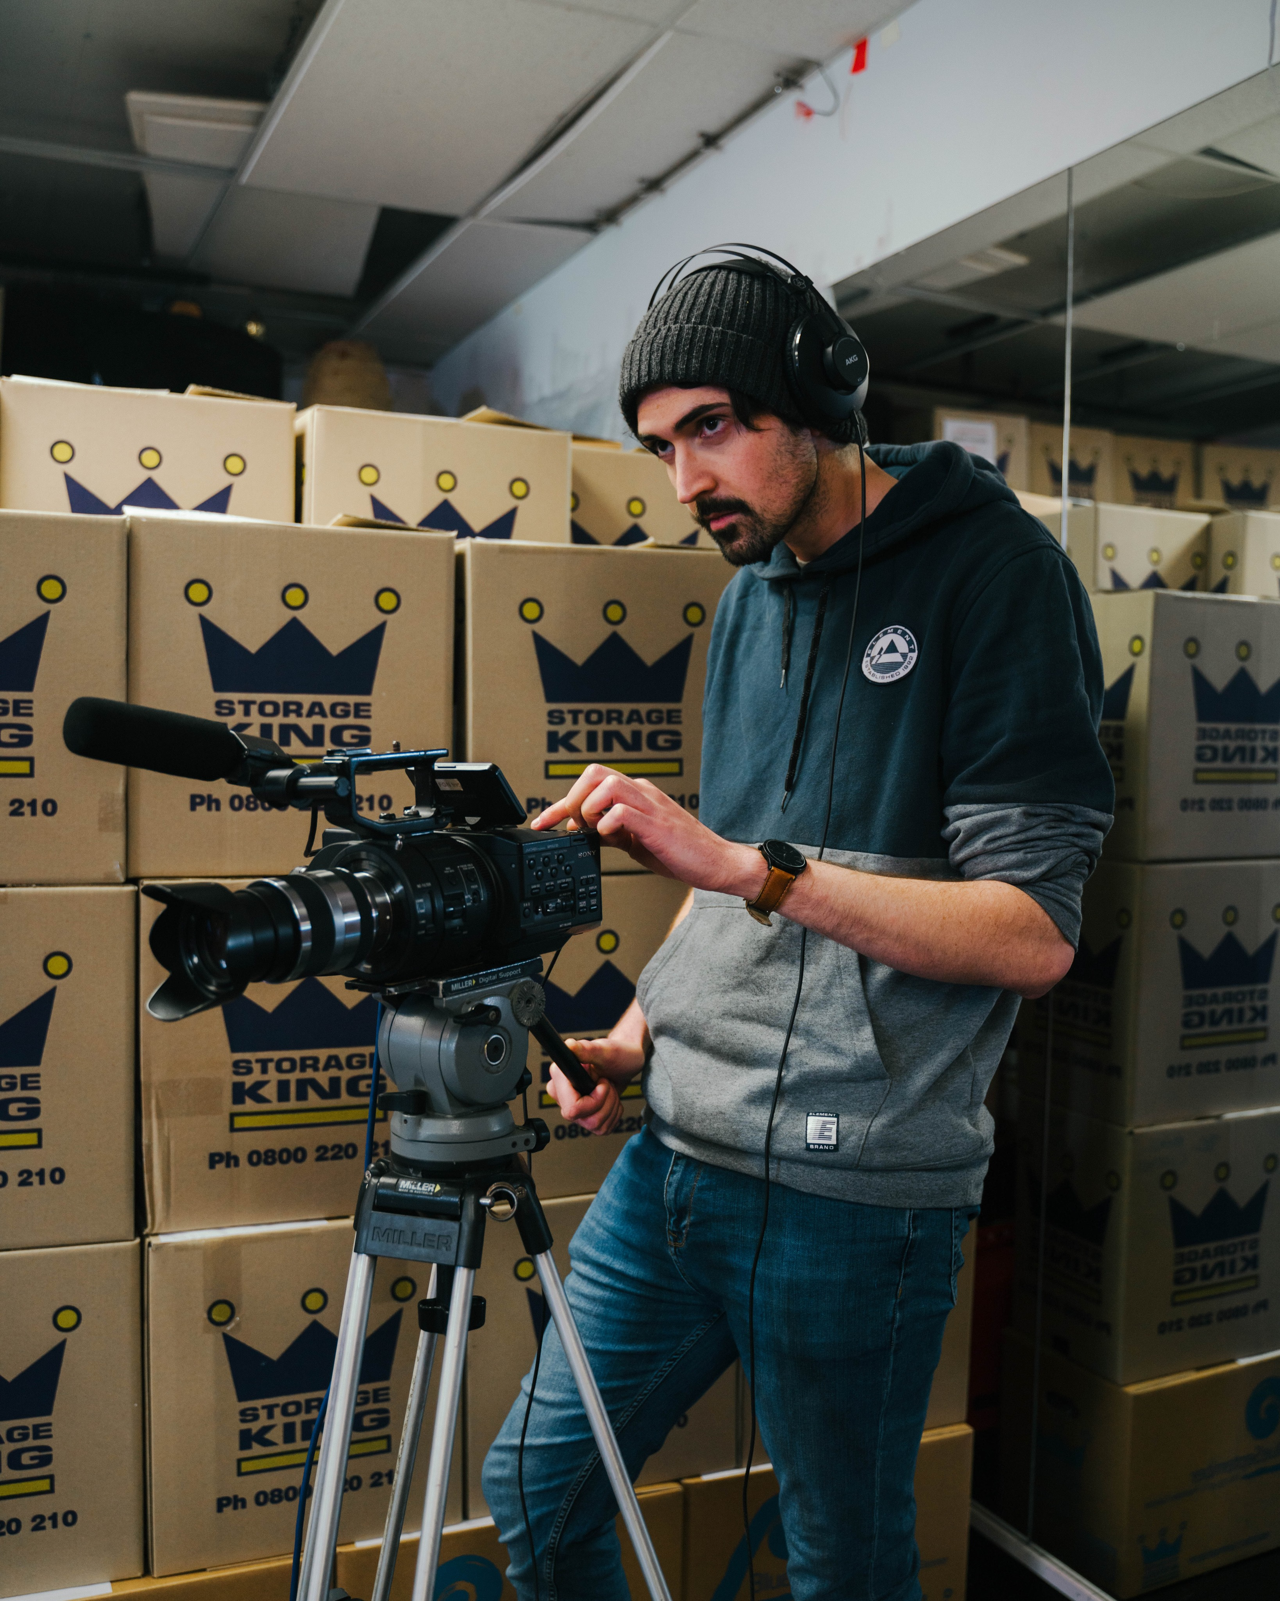
Bradley Mentor | Camera Operator
Bradley Mentor first picked up a camera at the age of 10 and has been hooked ever since. He shot his first short films in 2011 and 2012 for his Media Studies class at Mahurangi College in his hometown of Warkworth. Captivated by the science and art of moving pictures, Bradley decided to pursue a career behind the scenes of film and television, studying for the New Zealand Diploma in Screen Production at South Seas Film and Television School. As the technology progresses, so do Bradley’s skills as he develops his expertise and artistry in camera, lighting and audio specialisations. Having had work experience on TVNZ’s Fair Go and independent music videos, Bradley has been fortunate to witness industry professionals at work, further fueling his fascination and love of the screen industry. Hoping to climb the ranks within film and television crews, Bradley has major feature-films in his sights and continues to work towards his goals.

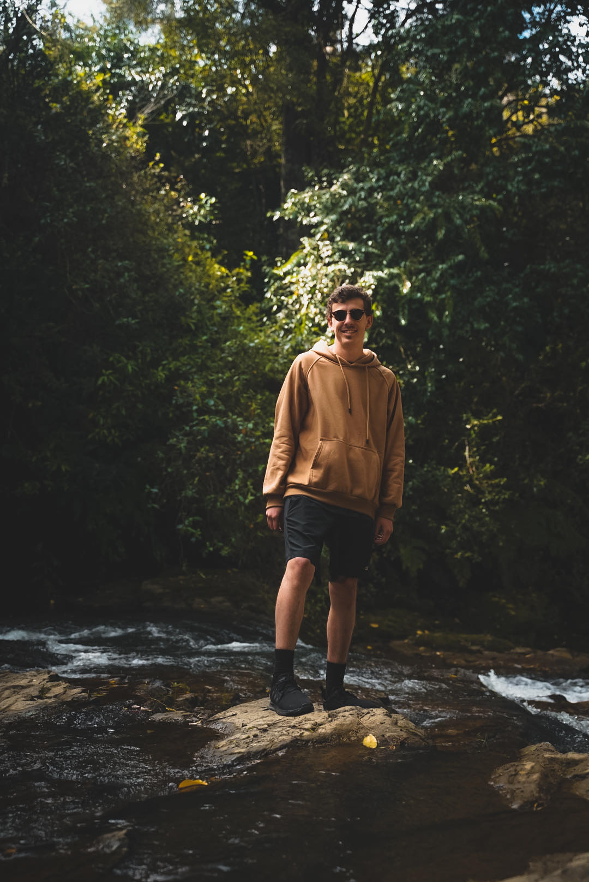
Cameron Webb | Audio Operator
Cameron was born in Waitakere City, Auckland. From a young age, Cameron was always interested in photography and camera work. He studied photography in college but found his passions for film making during his gap year and decided to pursue it. He is currently studying at South Seas Film & television School specializing in Camera, Lighting and audio. Although he chose this field to study, he has always found the other departments within the film industry interesting. Cameron is an eager learner and finds himself putting his best foot forward when it comes to work. He is his biggest critic and is determined to improve his abilities
Technical Specifications

Aspect Ratio: 16:9
Shooting Format: 1080p 25
Exhibition Format: 1080p 25
Sound: Stereo
Running Time: 13min 59sec
Country of Production: New Zealand
Date of Completion: December 2019
Language: English
Genre: Documentary

Any Enquires Contract:
Veronica Maitre
Director/Producer
Ph: +6427 862 4873
maitre.veronica@gmail.com

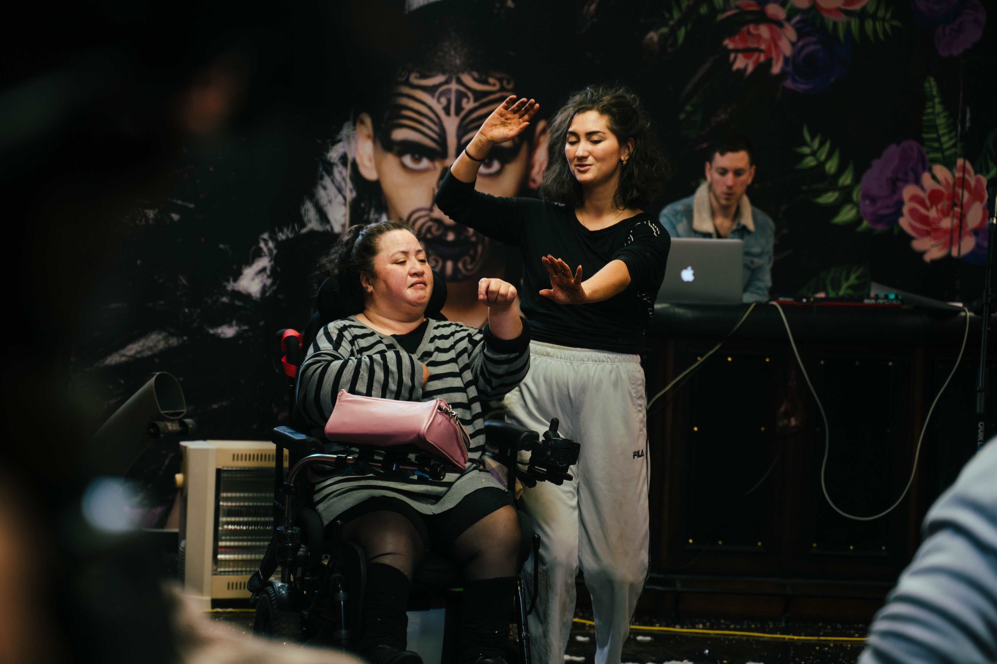

Frequently Asked Questions

What is Becoming Masina About?
Becoming Masina is a short documentary that takes us behind-the-scenes into the creation and progression of sensory-immersive theatre production—Masina Returning Home. We learn about the creative and crazy characters that have been the driving forces behind this unique show created for people with profound and multiple learning disabilities (PMLD). It shows the ups and downs of the creative process in bringing theatre like this together and most importantly, it shows that people with varying abilities can achieve their dreams in this abled bodied world, no matter the adversities!

What is the meaning behind the Title—Becoming Masina?
A large part of the documentary is following Lusi’s journey from the start of her dancing and acting career to where she is now and her latest role as Masina in the stage production Masina Returning Home. It is a play on words (double entendre) as within the theatre show, Masina literally goes on a journey to learn about herself through discovering her land and her Samoan culture—another theme that is displayed throughout the documentary.

Who will enjoy it?
This is an inspirational documentary that is enjoyed by all ages from 10 years and above.

Why should I watch it?
It takes a brave person to get out in front of an audience and perform on stage. It takes an even braver person to do it when they have a physical disability. This documentary pays homage to Lusi who has been an actor and dancer since her teenage years despite being in a wheelchair with limited mobility. If that’s not enough, there are many universal themes throughout this documentary that speak to pretty much everyone who is interested in humanity and equality, the importance of inclusion and accessibility, discovering of ones spiritual identity and culture and the struggles and triumphs of the creative process.

What challenges were faced in the making of this documentary?
One of the biggest challenges throughout the creation of this documentary was finding the best angle for the story and shortening the documentary to be 15 minutes long – we had hours of interview footage and it was a very difficult process to choose what information to put in and what to leave out!

Frequently Asked Questions

What is the theatre production that this documentary is about?
The production that this doco is based on is called Masina Returning Home. It’s about a young girl called Sina who awakes to be on a mystical, ancient beach and she has no idea how she got there. How will she find her way back? What is her connection to Masina? Using words, song, music and dance including multi-sensory props and experiences, the show follows Sina and Masina’s exploration into reconnecting back to the land, their history and their future.

What is profound and multiple learning disabilities (PMLD)?
There is no accepted definition of PMLD but people with PMLD often have developmental delay with significant physical and ranging sensory impairments. People with PMLD usually engage with others and their environment through the use of their senses such as smell, taste, touch, hearing and seeing rather than verbally. Masina Returning Home promotes and enhances this engagement by having multiple parts of the show as ranging sensory
experiences.

How does Lusi dance on stage?
Lusi dances on stage with the use of her upper body mobility and controlling her powered wheelchair, however, Lusi is most known for her aerial stunts in which she is attached to special ropes and literally fly’s through the air!

Is this the only theatre show by Touch Compass Dance Company or are there others?
Yes – Touch Compass boasts multiple shows and productions each year! Head to Touchcompass.org.nz to see a list of the upcoming productions that they are working on.

What was your mission in making this documentary?
With this documentary, my mission is to enlightening audience on the beauty and importance of having inclusive spaces in theatre and to pay homage to Lusi who is an inspirational human and who has spent years actively working towards her dreams despite all of the challenges that come along the way and as she puts it “being a disabled person in this able-bodied world”. Lastly, I wanted to also pay homage to a company that actively creates experiences for mixed ability performers and that challenges perceptions about what performance is and who can do it.

Press Release
It takes bravery and guts to perform on stage to an audience… but Lusi does it all the time. Despite growing up with a disability, Lusi has been breaking boundaries as a loud and proud Samoan dancer and actor in the theatrical world. Becoming Masina is a documentary that takes us behind the scenes into the creation of her latest project ‘Masina Returning Home’ and highlights the crazy characters that have stepped beyond their comfort zone to take part in a type of theatre that truly makes a difference.

Aspiring documentary director, Veronica has a strong passion for theatre and dancing and envisions a world in which everybody has equal access to engage in it. As a former dance teacher for children with disabilities, Veronica is using her past experience mixed with her natural knack for storytelling to share the experiences and lives of the people who have been pushing boundaries and living beyond the constraints of their disabilities… and what a better way to start than Masina Returning Home.

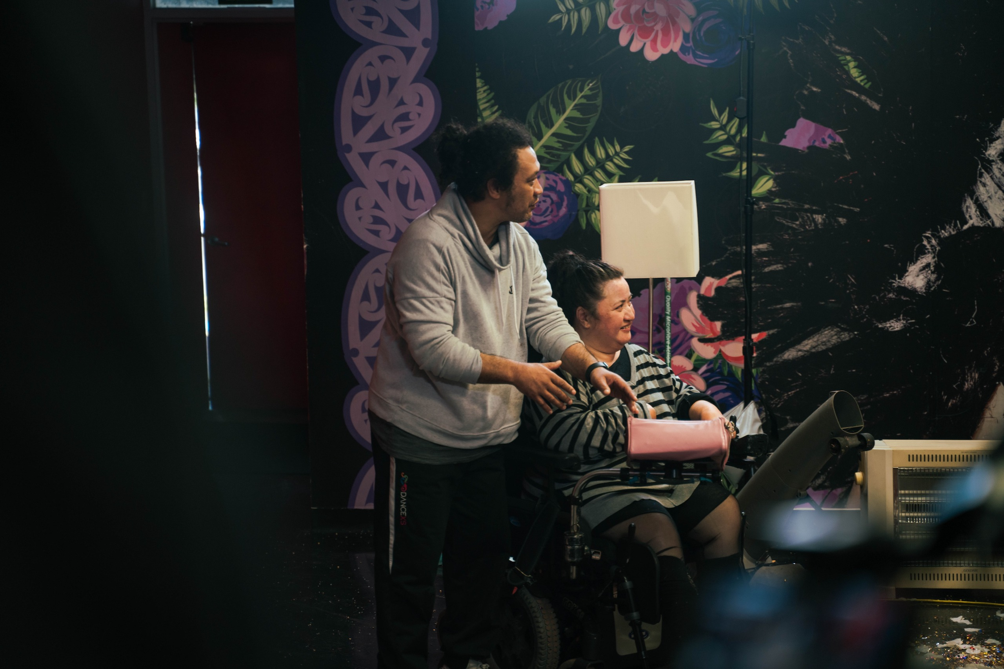

Credits

Special Thanks To
Lusi Faiva
Katrina George
Sam Jones
Charlotte Nightingale
Laughton Kora

Director/Producer – Veronica Maitre
Editor – Matt Kitson
Camera – Bradley Mentor
Audio – Cameron Webb
Drone – Joe Leonard
Photographer (Poster) – Andi Crown

With Thanks To
Touch Compass Dance Company
Diane Eaglesome
Mika Haka Studio
The Rose Centre

Made in Association with South Seas Film and Television School

