EWA PONIŃSKA-KONOPACKA, pseudonym „Ewa”

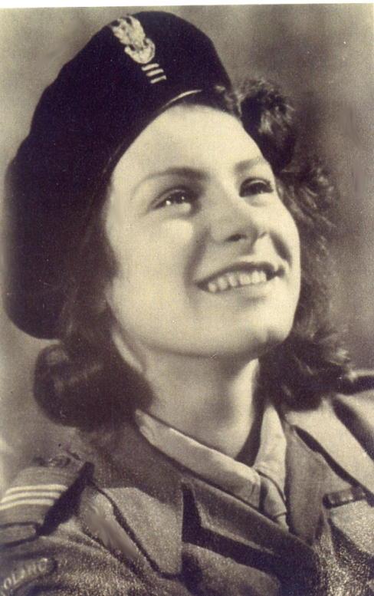

Eva Ponińska was born on the 4th May 1926 in Paris the only child of the Polish diplomat Alfred Poniński. From the fourth year of her life she lived with her mother in Poland. In 1931 after the first sign of the tuberculosis was discovered in her lung she was sent to Rabka, a mountainous region of Poland, where she attended elementary school run by the Sisters of Nazareth. In 1938 she continued her education at the Sisters of Immaculate Conception High School at Novy Sacz.
In 1939, the war broke out and Eva with her mother left for Lwow. In February of 1940 they tried to reach Eva’s father stationed as a diplomat in Bucharest, Romania. They were arrested by Soviet border guards on the Polish territory, crossing the border illegally. They found themselves in the prison, first in Kolomyja, later in Stanislavov. Prisons were overcrowded with the political prisoners, mainly Polish officers and their families. Walls were covered with names and addresses of those who were sent to unknown places. In the prison, men wore heavy chains on their legs and hands. In Stanislavov, Eva and her mother were placed in a cell originally meant for one person but there were already 8 women sitting on the floor. After spending one month in prison, Eva was released but her mother was sent to Kiev prison as a spy and later to a gulag. After her release Eva reached Lvow and having nowhere to go she knocked at the door of casual friends and was warmly received. For one year Eva continued to attend High School studies at Lvow. When the occupational forces of Lvow changed hands Soviets left and German army took over the city in July 1941, Eva left for Warsaw to join her aunt. She left with terrible memories of unspeakable crimes committed by the Soviet secret police NKWD on political prisoners. Before Germans entered, Lvow, for one day the city was free. The moment Soviets left, people rushed to two prisons to liberate the prisoners. What they found were the tortured bodies some of them with heads covered in tar to make the recognition difficult. In one cell on Łącki Street, a Catholic priest was found crucified on the wall.
In Warsaw, Eva continued High School studies, although officially it was called a gardening school. Germans abolished Polish universities and higher education including high schools. Only trade schools were allowed. Soon Eva found out about the secret organizations and joined Girl Guides who were also illegal. In February 1943 she was accepted as a member of the Polish Home Army. She finished courses as telephone operator and general courses in street fighting.
During the Uprising of 1944, she was member of a platoon 228 in telecommunication for division called “Żywiciel”. In the second month of the uprising she was moved to the group called “Żyrafa”. At first, Eva served as telephone operator then she repaired telephone lines broken by shrapnel, finally as a courier passing orders. During a concentrated attack of the German forces connection was lost with an important fortified building where the insurgents were under heavy attack, Eva volunteered to make connection. For this act she received the Polish highest war decoration for bravery the Virtuti Militari. After capitulation she became the prisoner of war and was sent to Stalag XIA Gross Lubars, then to Stalag VIC Oberlangen in Germany.
Stalag XIC Oberlangen was freed by the division of gen. S. Maczek on the 12th of April 1945. Eva left for Italy to become member of the 2 Corps of gen. Anders whose Corps was occupying Italy. She was able to finish the last year of high school in 1946. With the 2nd Corps she travelled to England where she was demobilized. Soon after she was offered a scholarship by the Polish Government in Exile and was sent to the National University of Ireland in Cork. After three years she received the B.A. degree in history and sociology. After one more year at London University, she obtained the Diploma in Education. For three years Eva taught in a Catholic high school in Port-of-Spain, Trinidad, and an English colony. In February 1954 she left for Canada, the same year she met her future husband Thaddeus Konopacki, whom she married in the fall of the same year. They lived in Montreal, Toronto and finally in Ottawa. For the first nine years Eva looked after their four daughters. In 1964 at the request of dr. Żurowski, she became one of the founders of the Polish Women Federation in Ottawa.
In 1964 she went back to teaching career and for 20 years she taught at the Catholic schools for the Separate School Board of Ottawa. She also took classes of painting at the Ottawa School of Art and developed an artistic career. Her paintings found their way to private collections in Canada and Poland. Four religious paintings can be found at the Catholic Church of St. Hyacinth in Ottawa. She is member of the Polish Combatants’ Association in Canada and works for the Polish Missions “Z Pomocą”. Eva and Thaddeus have four daughters who speak Polish and seven grandchildren.

EWA PONIŃSKA – KONOPACKA ps. „Ewa” was decorated with Silver Order Virtuti Militari by commander 8 DP ppłk. M. Niedzielski „Żywiciel” on 30 IX 1044 and advanced to the rank of sergeant. After the war, in 1989 she received Silver Scout Cross with Two Swords. In 1994 r. Ewa received the Cross of Home Army Members, the Cross for Warsaw Uprising and many others. In 2000 she was advanced by the Polish President to the rank of the Second Lieutenant; in 2005 to the Lieutenant and in 2010 to the rank of Captain. In 2010 Ewa was decorated by President of the Republic of Poland Lech Kaczyński with the Officer’s Order of Polonia Restituta. On May 20, 2013 r. Ewa received Medal „Pro Patria” and in 2018 in Waraw Medal „Pro Boniae Polonia”.

