PRESS KIT
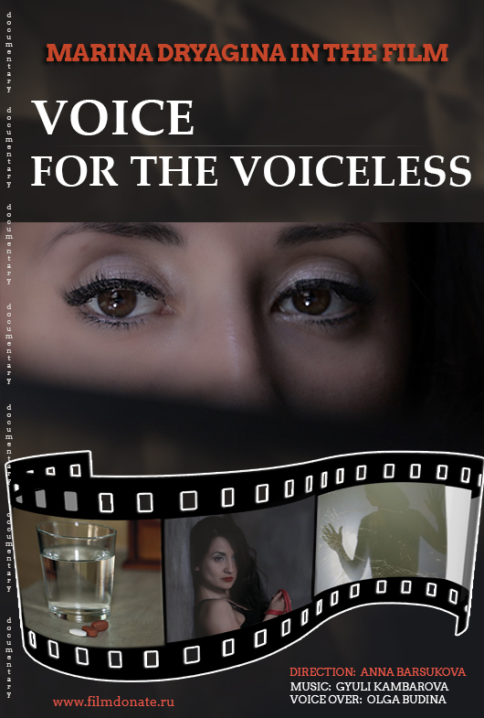
VOICE FOR THE VOICELESS
(Голос за безгласных) Documentary
The documentary Voice For The Voiceless touches on a highly relevant topic. In recent years, there has been a significant increase in the dissemination of information about HIV. However, despite the public outreach, the majority of the Russian people continue to misinterpret this disease, considering it to be extremely deadly and those infected extremely dangerous for the society. Many do not know how they should act around people with HIV, nor how to act if they themselves were found HIV-positive. People are facing a lot of questions and have the right to hear the answers.
The film aims to overcome the stigma and discrimination against people with HIV, break stereotypes and misconceptions. The success of any film lies in the apt choice of a character. If the character has an interesting, versatile, and true personality, viewers will want to identify with them!
Considering the stigmatization of HIV and tuberculosis, it’s natural that one would expect the film to follow someone who is socially disadvantaged and has a repulsive appearance. Contrary to common expectations, the film follows someone else, highlighting the contradiction between reality and viewers’ perception of it. The strong character stands as a role model for other TB and HIV patients to look up to and for the society to overcome the stigma and fear of these two diseases. The film follows a young girl named Marina, a native of Ekaterinburg (The film is not tied to any specific Russian region; the shooting took place in Rostov-on-Don, Moscow, Chelyabinsk, and Kopeysk). She’s an insightful, intelligent and beautiful person, a creative thinker and spiritual type with her own perception of things. Marina works a permanent job and has a 5-year-old daughter. The idea is to show how strong and determined she is as a person. The message we are trying to get across is that anyone can be at risk regardless of sex, nationality, occupation and social status. Living with HIV does not prevent Marina from achieving success in life. She’s a real-life example of building belief in yourself. By showing her emotional state, the film wants to break the stigma and change the public perception of HIV patients.
It wasn’t until Marina’s diagnosis went public without her consent that this film became possible. She feels confused as the story unfolds. The mixed feelings she trusted to her diary became a leitmotif of the film. First, Marina is angry about her diagnosis having been disclosed and wants revenge on the one who disclosed it. But, as she explores her disease and questions herself about where the stigma and fears come from, she changes her mind. To learn what happens next you need to see the film. The life situation Marina finds herself shows clearly that disclosing one’s diagnosis is unlawful (illegal) and that discrimination against people living with HIV is immoral.

SPECIFICATIONS | 12+; 2019; documentary short; running time: 33 mins; color; DSLR Full HD; stereo.
YEAR, CATEGORY, GENRE, FORMAT;

SCENES | Locations:  1. Shopping Centre SLAVA in Kopeysk (campaign in support of PLWH)  2. Ural Research Institute of Phthisiopulmonology – Branch of Ministry of Health’s National Research Institute of Phthisiopulmonology and Infectious Diseases  3. Legal Firm “Belyansky & Partners”  4. Boris Yeltsin Presidential Center  - Exhibition of paintings by Polina Siniatkina.  5-8. Character’s personal space (home, workplace, habitual places of rest and leisure).  9. Federal State-Financed Research Organization “Rostov Institute for Epidemiological and Microbiological Research”
Pos. | Description | Quantity
1. | SEASON | SUMMER, FALL
2 | LOCATIONS | 9
3. | EXT. SVERDLOVSK REGION | 2 (01.15)
4. | EXT. CHELYABINSK REGION | 2 (01.15)
5. | INT. YEKATERINBURG | 4 (16:00)
6. | INT. ROSTOV-ON-DON | 1 (01:45)
 | TOTAL: | (32 min 45 s)

ИСПОЛНИТЕЛИ | Crew:  1. Script, direction, cinematography:  Anna Barsukova  2. Aerial cinematography:  Ruslan Sharafutdinov  3. Sound:  Ilya Pucheglazov  --------------------------  4. Music, arrangement:  Gyuli Kambarova  5. Voice-over:  Actress Olga Budina
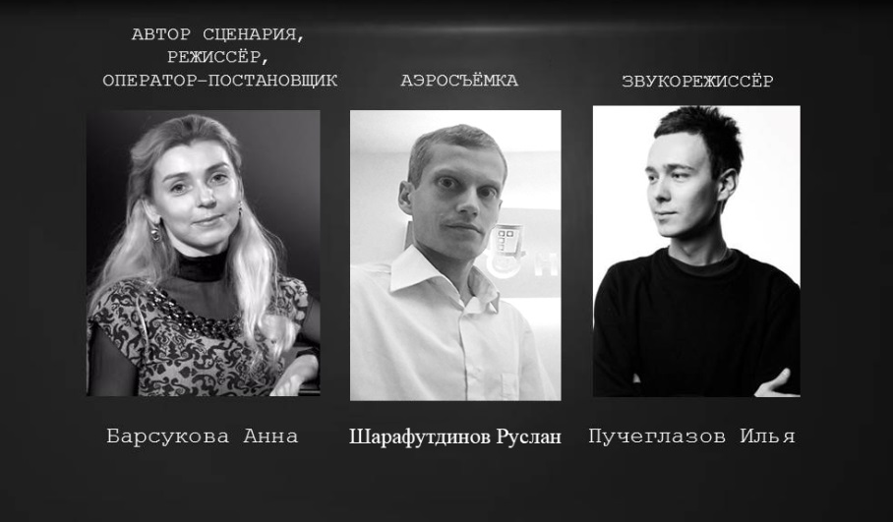
RELEASE & DISTRIBUTION | 1.International film festivals  2.Television  3.Internet
Screening channels | 1.International film festivals  2.Television  3.Internet

ABBREVIATED SYNOPSIS:
After learning about her diagnosis Marina begins to search for answers to her questions. Fearing disclosure and condemnation, she chooses to trust her thoughts to her diary. But nothing stays hidden for long…

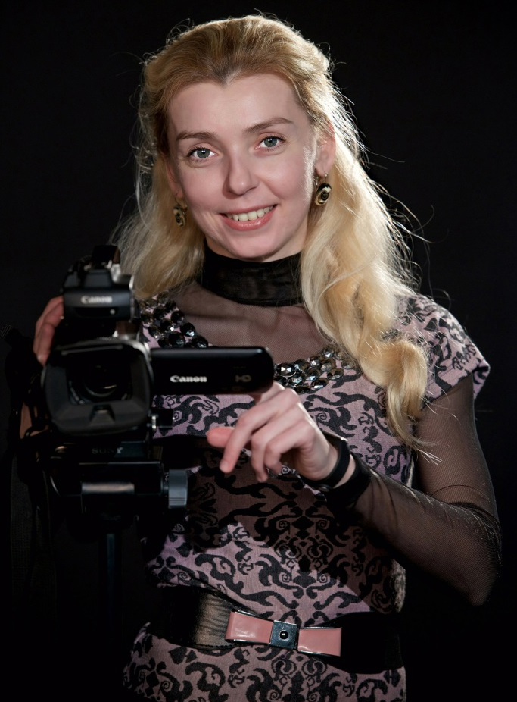
FILM DIRECTOR’S BIO:
Anna Barsukova has been doing sports and played music since she was a child. She would compete for prizes in rhythmic gymnastics competitions and win first prizes in regional violin competitions. After completing, in 2001, her studies at the Academy of Music as a violinist and symphony orchestra conductor, Anna earned a higher degree from Rachmaninov State Conservatoire in Rostov, in 2006, and played together with many accomplished composers and musicians of our times including Yuriy Bashmet, Sergey Yakovenko, and Giya Kancheli. In 2016, Anna retrained to become a film director. She graduated with honors.
Web: http://annabarsukova.com/

Filmography
Broken Path (2016), short feature film
You Are Not Alone (2017), documentary short film
http://tineodin.zermir.ru/ (media, awards, feedback)
Voice For The Voiceless (2019), documentary short film
http://www.filmdonate.ru/

PREVIEW SCREENING TOOK PLACE IN ROSTOV-ON-DON ON MARCH 1, 2019
1. Media feedback on preview screening (articles, TV & radio): http://www.filmdonate.ru/pressa/
2. Coverage in the press of Yekaterinburg: https://ura.news/news/1052344474
VOICE FOR THE VOICELESS PREMIERES ON MARCH 30 IN YEKATERINBURG
3. Announcement on Boris Yeltsin Presidential Center’s webpage: https://yeltsin.ru/affair/pokaz-dokumentalnogo-filma-golos-za-bezglasnyh/
TRAILER: https://youtu.be/NAK6Hl9toJs

PRESS RELEASES:

- The documentary Voice For The Voiceless touches on a highly relevant topic. In recent years, there has been a significant increase in the dissemination of information about HIV. However, despite the public outreach, the majority of the Russian people continue to misinterpret this disease, considering it to be extremely deadly and those infected extremely dangerous for the society. Many people do not know how they should act around people with HIV, nor how to act if they themselves were found HIV-positive. People are facing a lot of questions and have the right to hear the answers. This film aims to overcome the stigma and discrimination against people with HIV, break stereotypes and misconceptions. The success of any film lies in the apt choice of character. If the character has an interesting, versatile, and true personality, viewers will want to identify with them. Considering the stigmatization of HIV and tuberculosis, it’s natural that one would expect the film to follow someone who is socially disadvantaged and has a repulsive appearance. Contrary to common expectations, the film follows someone else, highlighting the contradiction between reality and viewers’ perception of it. The strong character stands as a role model for other TB and HIV patients to look up to and for the society to overcome the stigma and fear of these two diseases. The film follows a young girl named Marina, a native of Ekaterinburg. She’s an insightful, intelligent and beautiful person, a creative thinker and spiritual type with her own perception of things. Marina belongs to socially prosperous class, works a permanent job and has 5-year-old daughter. The idea is to show how strong and determined she is as a person. The message we are trying to get across is that anyone can be at risk regardless of sex, nationality, occupation and social status. Living with HIV does not prevent Marina from achieving success in life. She’s a real-life example of building belief in yourself. By showing her emotional state, the film wants to break the stigma and change the public perception of HIV patients.

- Rationale for film project Voice For The Voiceless:
Despite the multitude of films focusing on HIV, Russian people still tend to discriminate against people with HIV. The ignorance and poor awareness are leading the Russian society away from the truth. Voice For The Voiceless is meant to tell a story and to educate. Its footage highly motivating and intended to build a strong emotional response among the audience, the film wants viewers to realize that anyone can be at risk, regardless of sex, occupation and social status, and that he who keeps on struggling won’t sink into despair. Living with HIV does not prevent the heroine from achieving success in life. As her story unfolds, she learns more about her disease by conversing with legal advisers, medical specialists and lab scientists like journalists do.
By receiving competent answers to her questions, the heroine introduces viewers to a lot of valuable details about HIV. It is health awareness that the film uses as a means to change the public perception of this disease.

PRODUCTION STILLS:

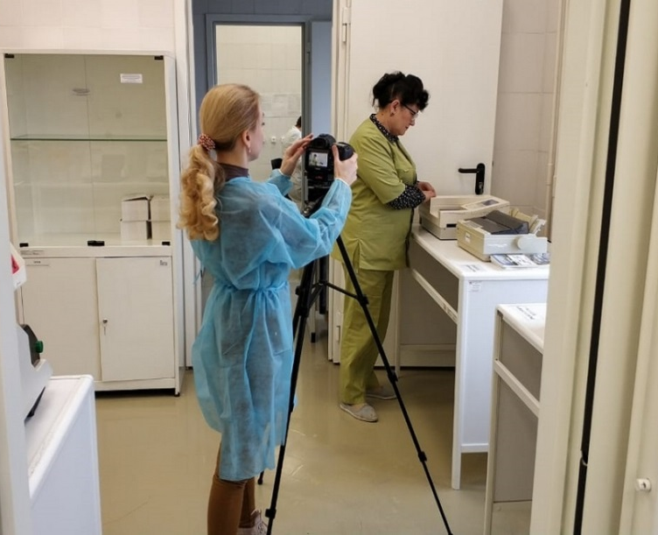
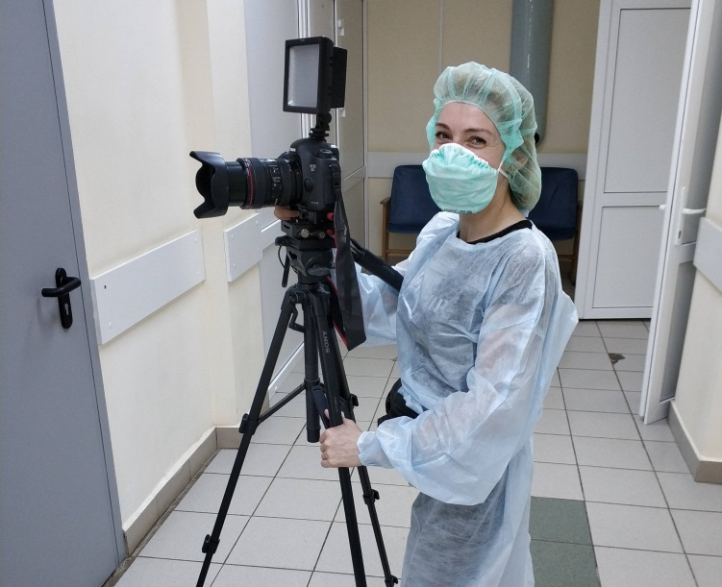
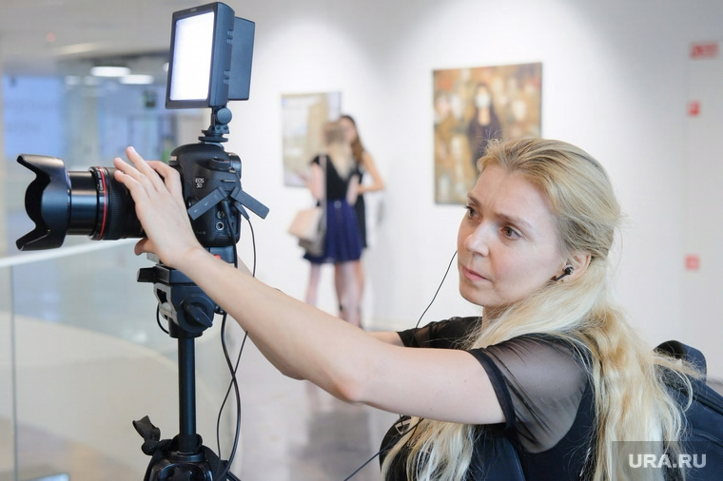
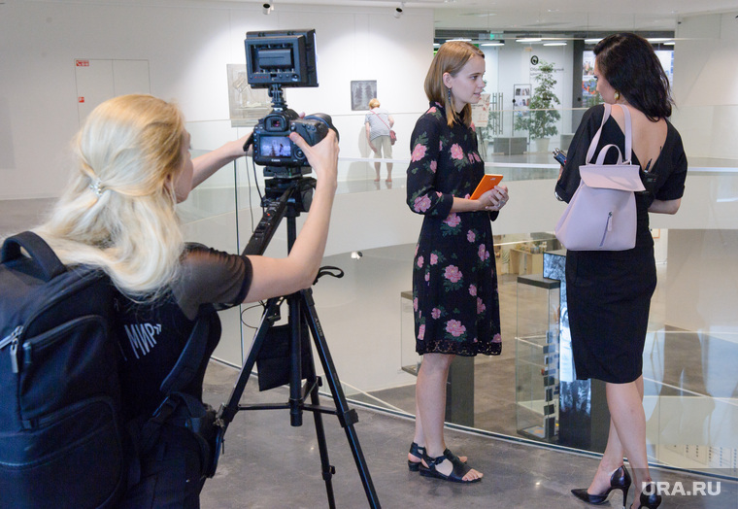

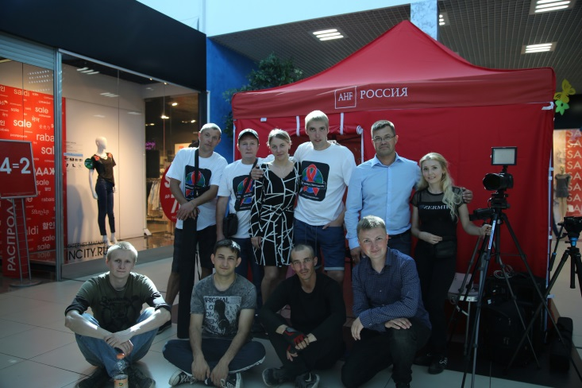
Contacts:

Anna Barsukova, film director, screenwriter, cinematographer:
Cell: 8(904) 505-12-30
WWW:_annabarsukova.com,
http://tineodin.zermir.ru
http://www.filmdonate.ru/

Email: kosinka1981@mail.ru ;
annabarsukova.com@yandex.ru

FILM FRAMES
