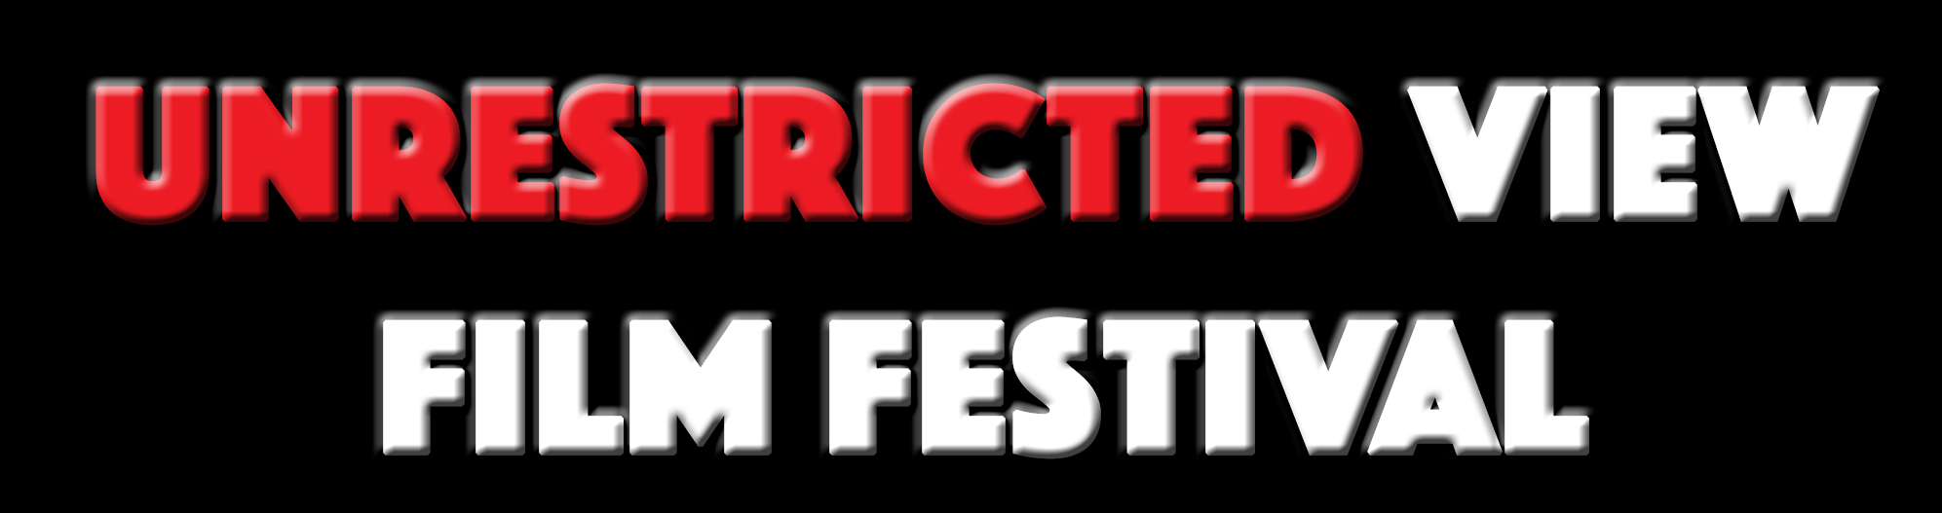

Certificate

Nomination for Best Cinematography

PARALYSIS

At

Unrestricted View Horror Film Festival 2018

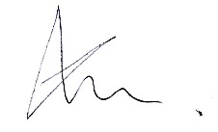
James Wren
Festival Director

