Cléa van der Grijn
JUMP
26 min 40 seconds
Aspect:16:9
Sound: 2 channel stereo
PRIVATE VIMEO LINK

https://vimeo.com/ciarancarty/jump

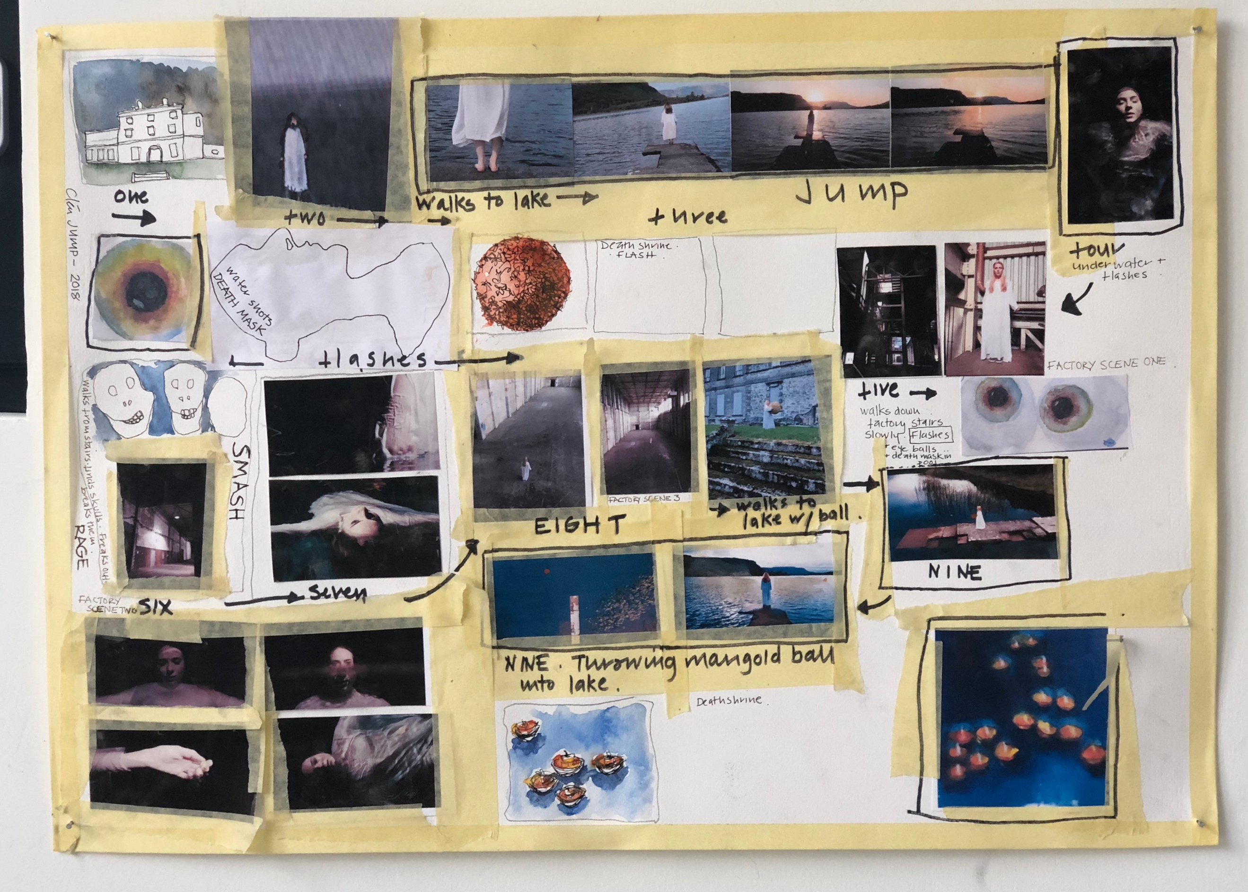

JUMP story board. Cléa van der Grijn

