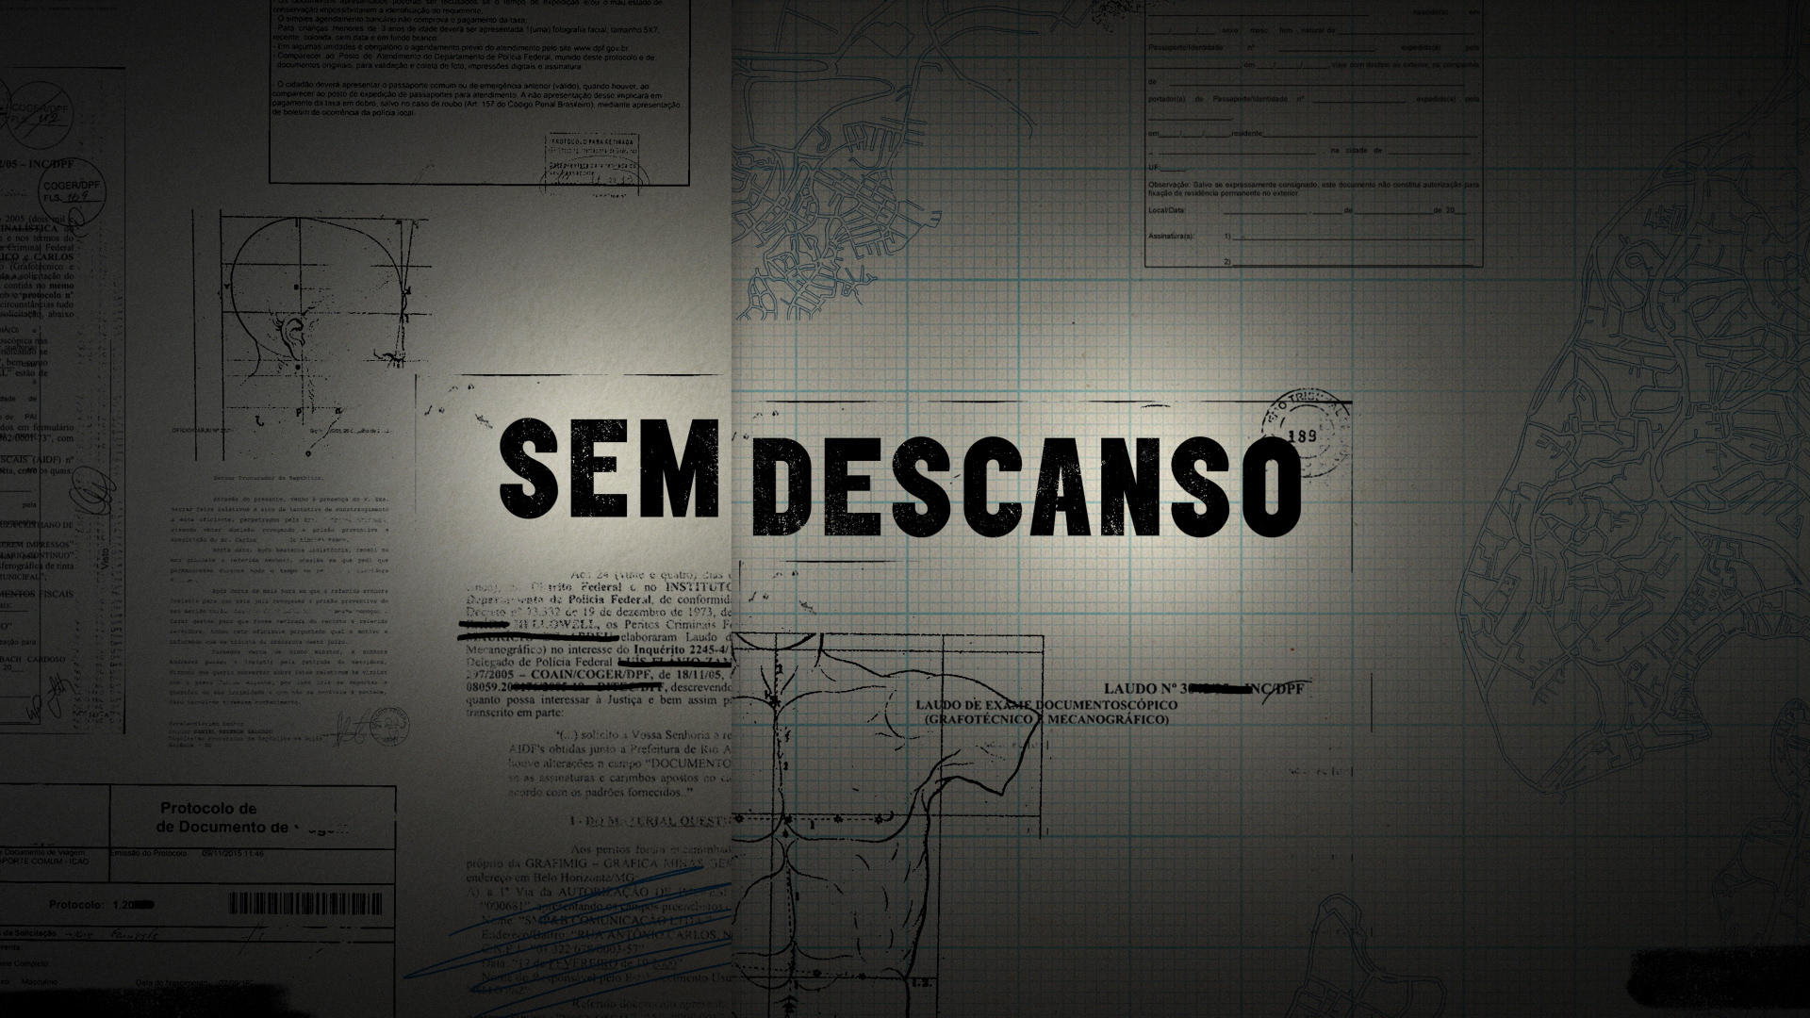

LOG LINE
In 2014, Geovane, a young man from a poor neighborhood in Brazil, was arrested by the military police and never seen again. His dad would not rest until he found the whereabouts of his son.

SHORT SYNOPSIS
In 2014, Geovane, a young man from a poor neighborhood in Brazil, was arrested by the military police and never seen again. Assisted by the local newspaper, his dad conducted an investigation that led to the indictment of seven policemen. “Restless” tells the relentless pursuit of the truth by a simple man who wanted to bury his son with dignity.

LONG SYNOPSIS
In 2014, Geovane, a young man from a poor neighborhood in Brazil, was arrested by the military police and never seen again. Assisted by the local newspaper, his dad conducted an investigation that led to the indictment of several policemen. According to recent statistics, the Brazilian police is one of the most violent in the world. The victims are mostly the young black men from the suburbs of the large cities. The cases are rarely investigated and many parents are left to live in ignorance and distress about the fate of their child after an encounter with the military police. But Geovane's father would not rest until he found the whereabouts of his son and could bury him with dignity. The documentary weaves the investigation of the case with a debate about the historic and social roots of police brutality.

CREDITOS

Direção: Bernard Attal
Roteiro: Bernard Attal, Fabiola Aquino
Produtora Executiva: Gel Santana e Fabiola Aquino
Diretor de Fotografia: Matheus Rocha
Montagem: Marcos Lé

Direção de arte: Carol Tanajura

Música: Silvain Vanot
Desenho de som: Pedro Garcia e Eduardo Ayrosa

BIO OF THE DIRECTOR
Bernard Attal, a former child actor, studied filmmaking at the New School in New York City. He has been living in Brazil since 2005. He directed three short films (29 Inches, Rat Island, and A Bike Ride) and a documentary for the Brazilian Public TV, The Magnificent. All of these films participated and won awards in festivals throughout the world, including Palm Springs, Chicago, London-BFI and Clermont-Ferrand. Bernard’s first fiction feature, The Invisible Collection, based on a short story by Stefan Zweig, was released in the movie theaters in 2014, won fifteen awards on the international film festival circuit (Nashville, Bogota, Newport Beach, Paris) and was later sold to several TV channels, including HBO and In-flight Entertainment. Bernard recently completed a feature film for television, the comedy “My late mother-in-law” and a short film ("DELA") that opened the encounter of the BRICS's countries in South Africa for the centenary of Nelson Mandela's birth.

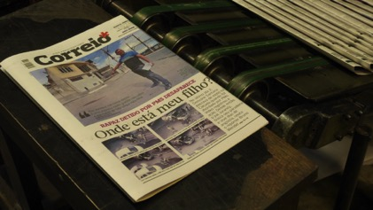
“Where is my son?”

