Hands of Thunder
14 yr. old Ty Harden is an Avalanche waitin’ on an Echo.

They shot his dog, burned their home and smashed his father’s skull. 4 years later, 14yr. old Ty Harden has 2 Lemat revolvers and can shoot the shingles off a housefly. His Pa left Ty 2 dying requests. Take the family to Utah. Ty will have to tangle with the robbers who sent them into Indian country to be slaughtered, avoid the cavalry, rescue his mother and sisters from the Sioux, once again face the gang that killed his father…Without killin’ anyone – Ever.

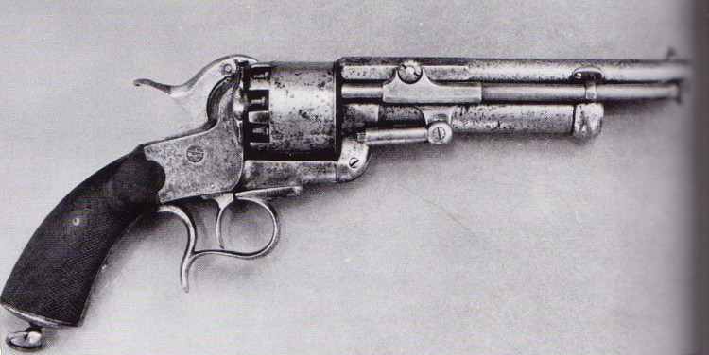
Lemat Revolver: Black powder gun. 2 Barrels. 1 shoots 9-44 caliber balls.
The other is a single shot 20-gauge shotgun. Sometimes if fires, other times…
you wish it did.

Winner “*Best Original Screenplay” LA Short Film Festival 2018 – Currently a Finalist Austin Revolution Film Festival 2018 – Winner Gloria Int. Film
Festival
A “Lethal Weapon/ Shanghai Noon” buddy film for the family.

10yr. old Ty’s life dream is to be a warrior, a hero, someone to be depended upon. His failure to take action results in his father’s death, their home burned, his mother and sisters tormented, livestock killed and his dog Commander shot.
As Ty buries Commander he makes him a promise. “I’ll never start a fight. But Harden’s ain’t never gonna be driven, picked on, pushed, mobbed or harassed ever again. Not ever! An anyone who tries is gonna wished he’d thought better!”
Ty spends the next three years freighting with his Uncle Jim and learning to shoot and waiting and hoping his father will get better.
With the aid of a very deviously clever, clairvoyant horse, sporting a triangle mark around his left eye named “Bermuda” and a Cherokee brave “Falling Rock” with a gift for tossing stones, Ty is determined to honor his father’s dying requests and set his world in order… no matter the cost.
Carl Gundestrup 801-450-2515 carlshootsfilms@gmail.com
38 yrs. experience in award winning audio, video & film production.
www.theilluminator.biz www.talesofdavyjones.com
Carl’s audio adventure “Tales of Davy Jones Series episode 1- Quetzalcoatl”
Is currently in-flight entertainment on Air Canada – American Airlines -Cathay Pacific – Delta - Lufthansa airlines – Swiss Air.

