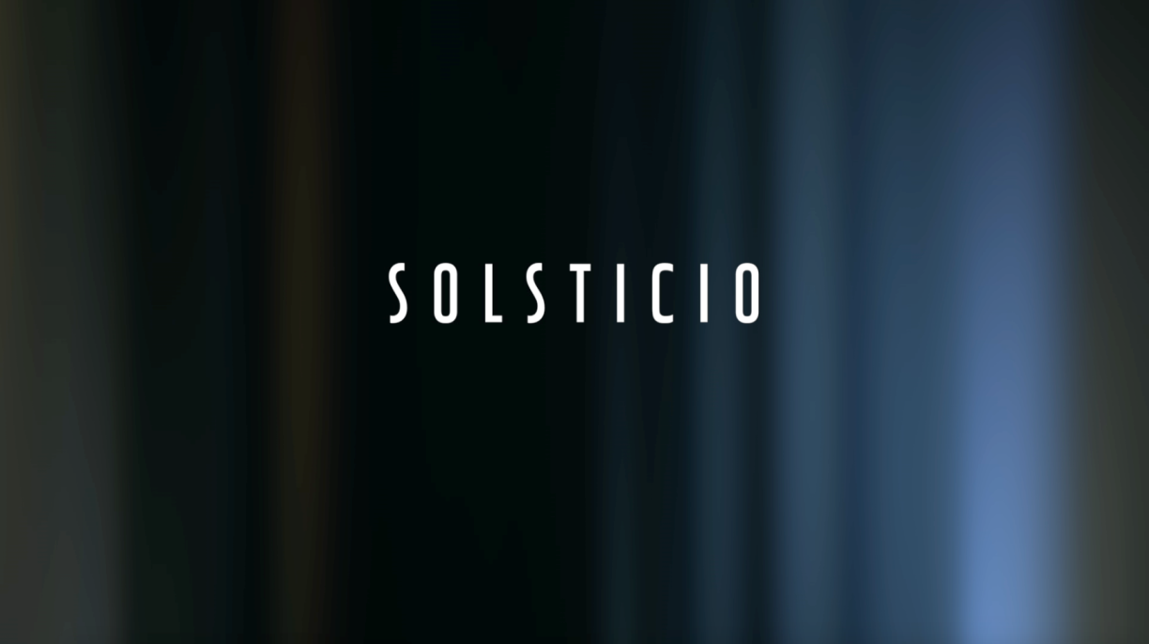

LINK VIDEO DOWNLOAD:
https://www.dropbox.com/s/0iuhjs67oh09bzh/Solsticio%20Anthony%20Xavier%20Gonzalez%20CWh5%20proxy.mov?dl=0

LINK VIEW:
https://vimeo.com/223714612 Password: solsticiotr2

LINK FULL PACK (Subtitle and more):
https://drive.google.com/open?id=1cxuuULPGT94oivKOCvV1kqSRn9UKAW0K

