MAYFLY

A Film By AKHILESH TRIPATHI

Its a story of a strange boy whose life is only depend on 24 hours.

CAST
- DEVKANT GUPTA
ROBIN
- MAMTA SHARMA
PAYAL
- ASHOK MISHRA
SETH (DON)
- VIKAS
LOCAL GANGSTER
- SHIKHAR
HOTEL OWNER
- ROHIT RAJ YADAV
LOCAL GANGSTER
- RAHIM
CHILD WORKER
- ASHISH PAL
BEGGER

PRODUCTION TEAM

Production Manager- ABHISHESK MISHRA

Execute/Line Producer - RAJNEESH MISHRA

Director of photography- AKHILESH TRIPATHI

Edited by – AKHILESH TRIPATHI

Music by- AKHILESH TRIPATHI

Assistant Directors – Bobby Raj Yadav

Rohit Raj Yadav

AKASH

SHIKHAR

Sound Mixing – AKHILESH TRIPATHI

Director Biography
AKHILESH TRIPATHI
Versatile and young performer with many creative hands, innovative and imaginative writer / director / actor and designer.
His film work-
- WHATNEXT (2011)
- Maha Kumbh Mela (THE HUGE PITCHER) (2012)
- UNKNOWN (2014)
- DOGS FATE (2015)
- MAYFLY (2017)

MAYFLY STILLS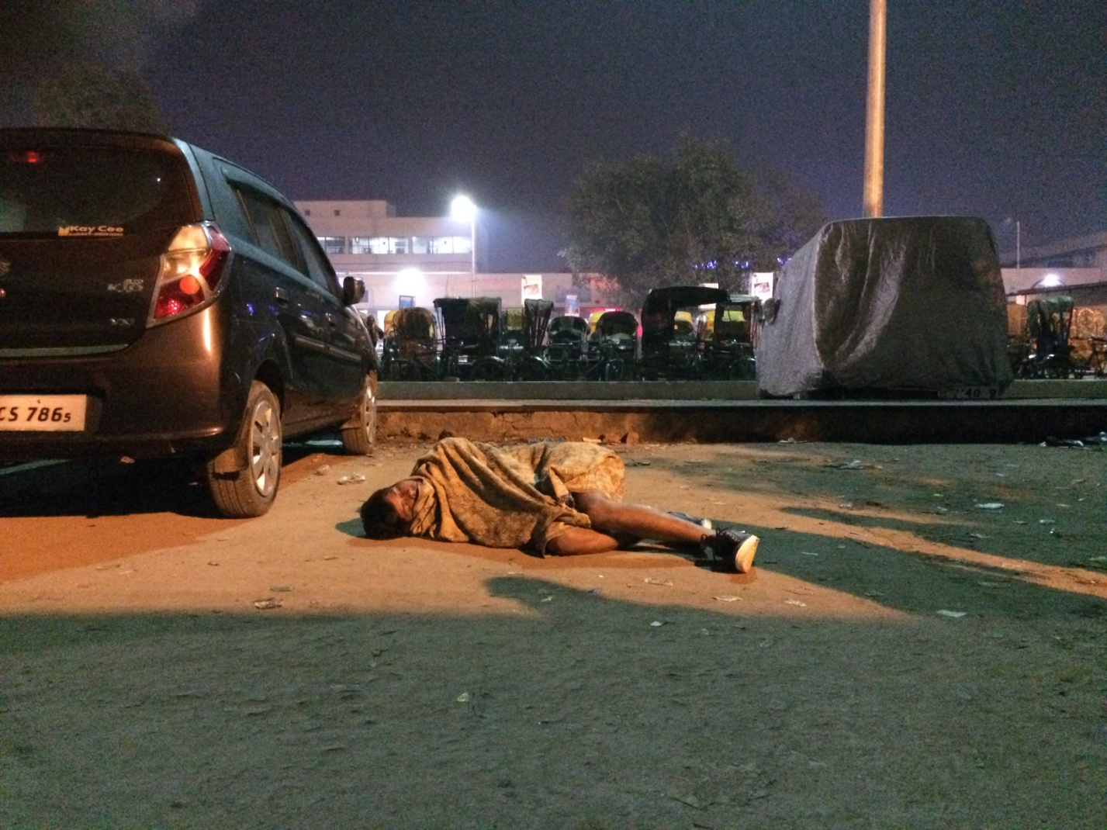

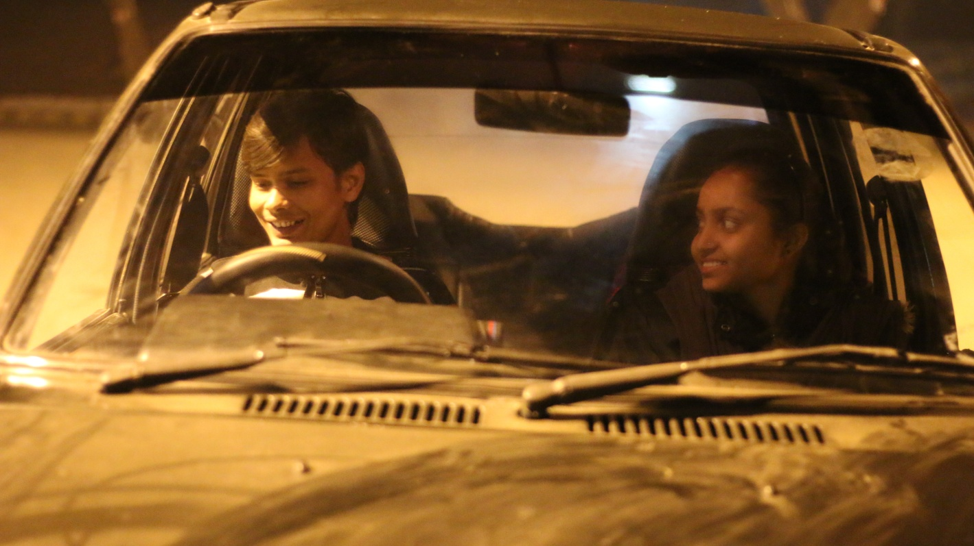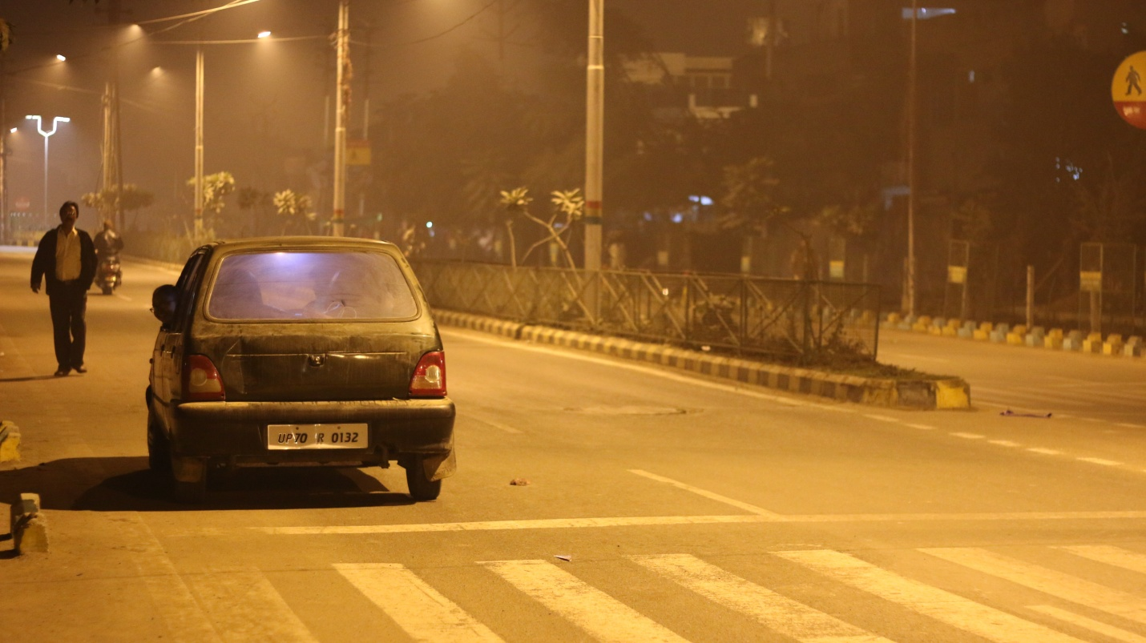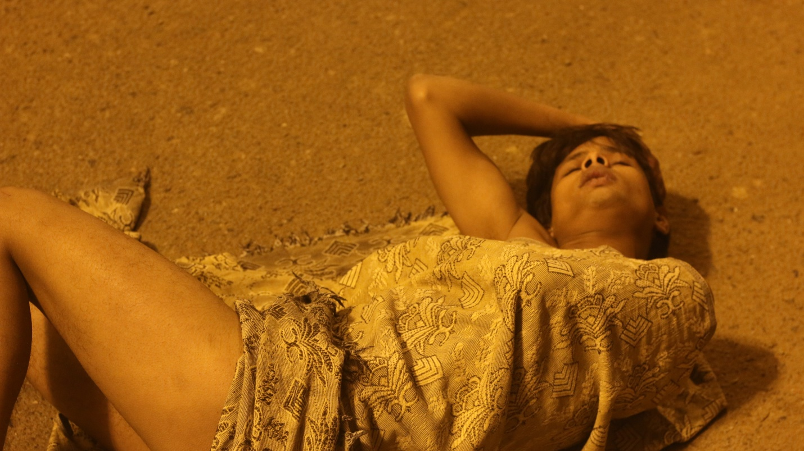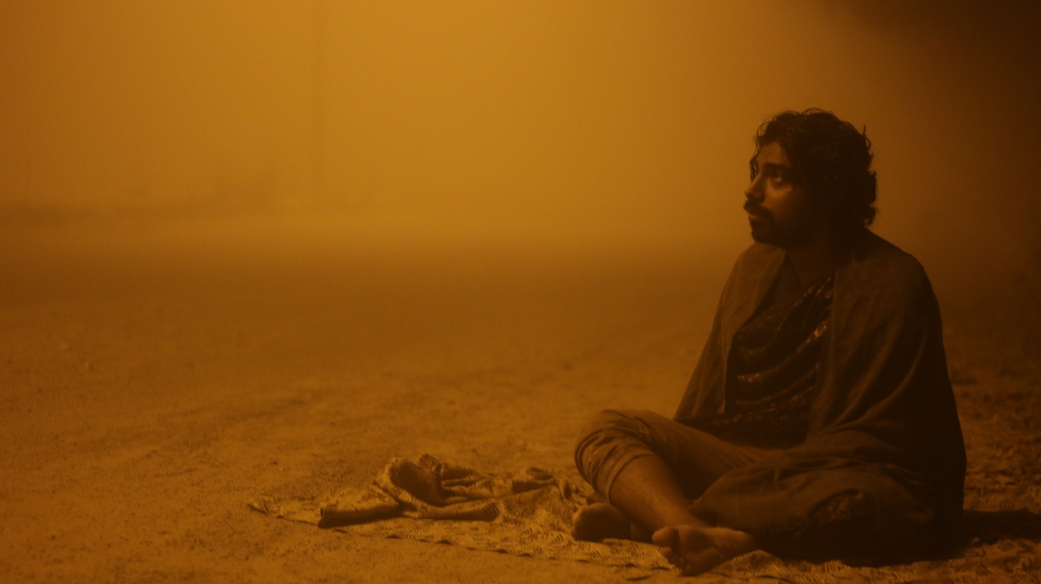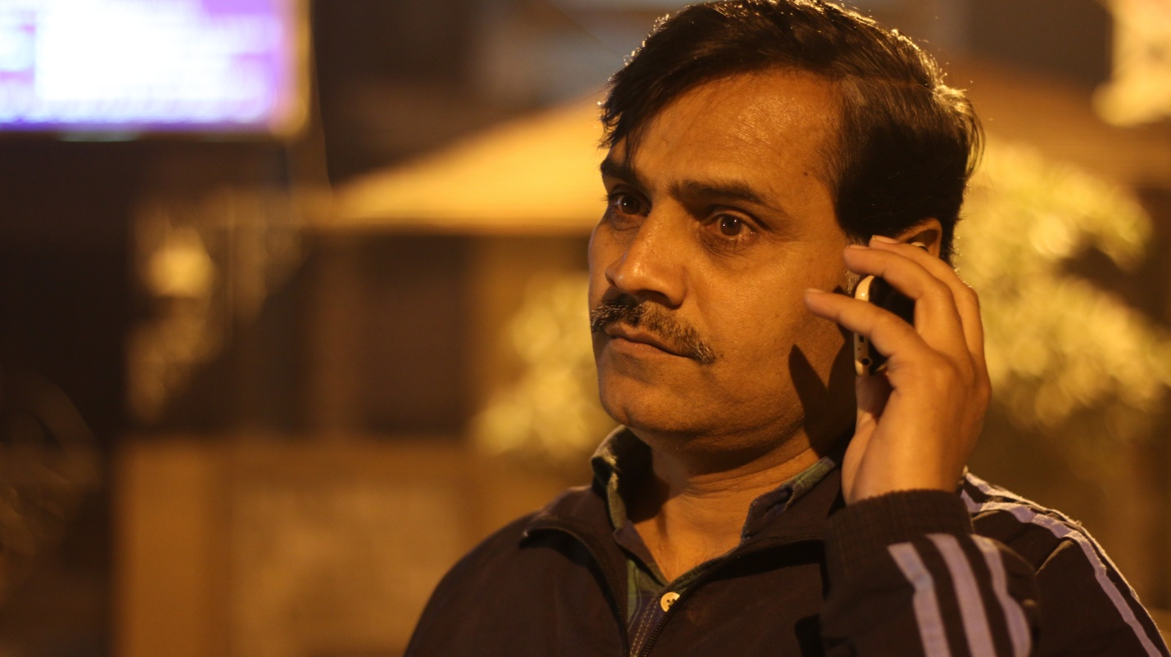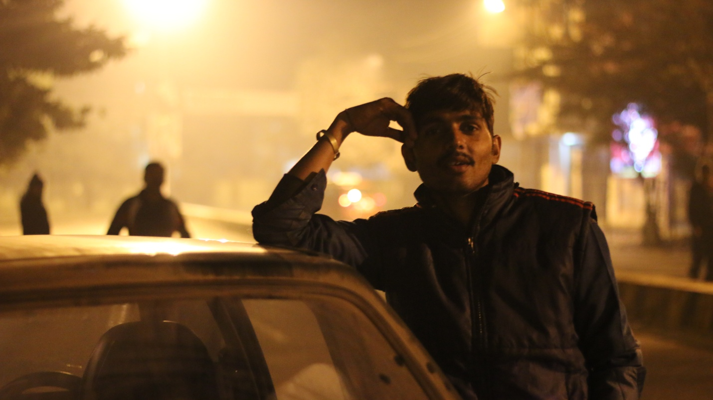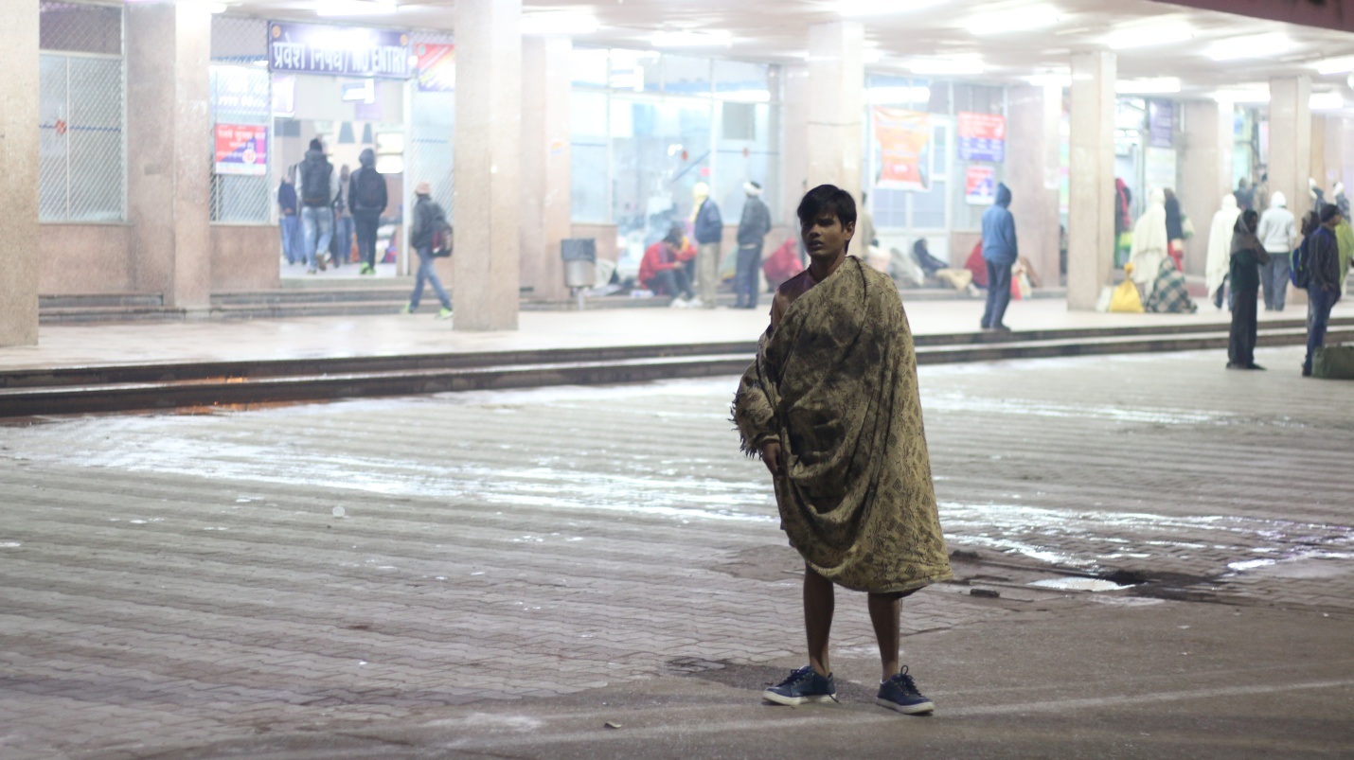

DIRECTOR – AKHILESH TRIPATHI

