WHO’S WATCHING OLIVER

Synopsis

Who's watching Oliver tells the story of a mentally unstable loner lost in a life forced upon him. By night Oliver aimlessly wanders the streets and bars on what can only be described as a truly shocking and humiliating killing spree. His only savior and possible way out of a life he is desperate to escape comes in the form of the beautiful Sophia with her sweet eccentricity and naivety to the danger she has put herself in.

Director - Richie Moore

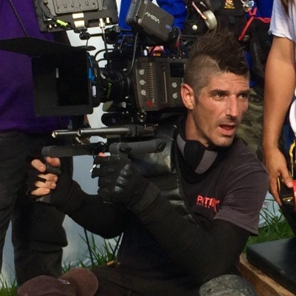

Richie Moore was born in Portland Oregon USA and grew up between Los Angeles and Portland where he began working first on his father’s crew in 1991. Richie has continued to work as full time film crew for the past 27 years in the camera department with some of his latest credits including:

"Gold" starring Matthew McConaughey
"Marco Polo" Netflix original TV series
"No Escape"
"Mission Impossible: Ghost Protocol"
"The Hangover Parts II and III"

http://www.imdb.com/name/nm0600853/?ref_=fn_al_nm_1

Richie has just completed his first feature film “Who’s watching Oliver” as Director.

Producer – Raimund Huber

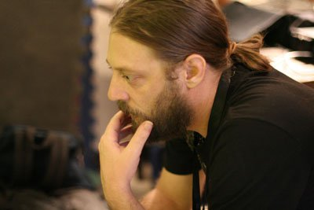

Raimund Huber is a German/Austrian, Writer/Director/Producer born in Munich. He produced titles such as:

“Cam2Cam” and “Buffalo Rider”

http://www.imdb.com/name/nm3450267/?ref_=fn_al_nm_1

Producer – Aki Komine

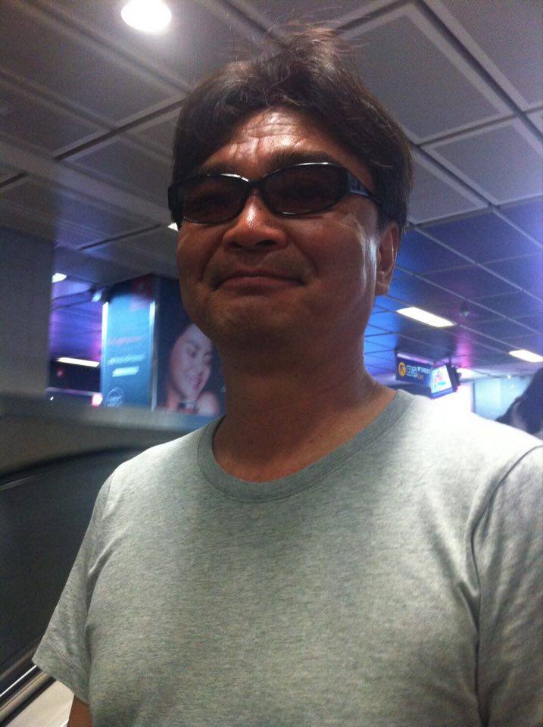

Aki Komine was born in Japan and started out producing movies in the early 90’s with titles such as:

“Guyver 1991”
“Necronomicon 1993”
“Fist of the north star 1995”
“Crying Freeman 1995”
“No way back 1995” – Russell Crowe

And his latest the “Kamen Rider TV Series”.

http://www.imdb.com/name/nm0464634/?ref_=fn_al_nm_1

Actor - Russell Geoffrey Banks (Oliver)

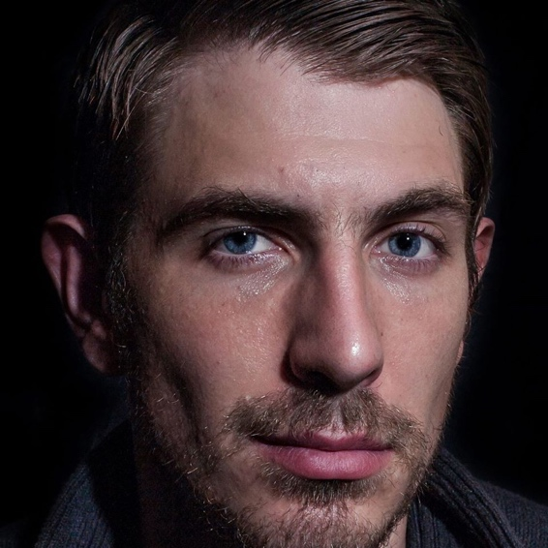

Russell Geoffrey Banks an English actor born November 13 1981. His career path wasn’t smooth and had many different jobs from construction to barman to market trader, to door to door sales to pay for his acting classes. Eventually he found his calling and has been lucky enough to work on different movies.

“Cam2Cam 2014”
“Pernicious 2014”
“Ghost house 2016”
“Knights 2017”

http://www.imdb.com/name/nm3086789/?ref_=fn_al_nm_1

Actress – Sara Malakul Lane (Sophia)

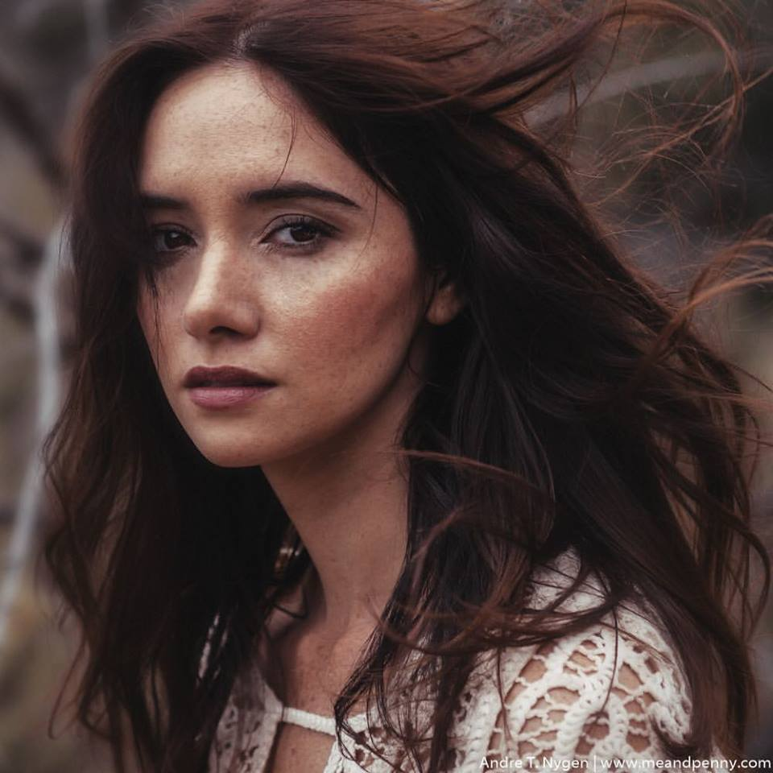

Sara Malakul Lane is a successful Thai model and actress. She began modeling at the age of 14, and has also been in a number of big screen movies.Sara is a model of Thai-English descent. Her father is an English businessman named Alistair Lane. Her mother is named Madam Tuptim Malakul Na Ayuthaya. Some of her latest titles include:

“12/12/12 2012”
“Jail Bait 2014”
“Sun Choke 2015”
“Kickboxer: Vengeance 2016”
“Kickboxer Retaliation 2017”

http://www.imdb.com/name/nm1523899/?ref_=nv_sr_1

