Galli (The Lane)
Marathi/19 Min /HDV/ Colour /2015/ India

Directed By - Santosh Ram
Produced By – Ramchandra Pundlikrao Marewad ,
Santosh Ram

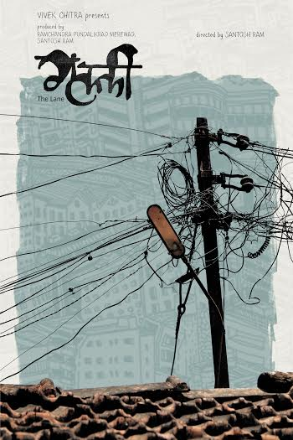
Synopsis-

Galli (The Lane) is about the people and the Life in the Lane . The Lane in the times of a modern small town India which is restless and wants to break free from its shackles of convention, moral and existential crisis and the rigid socio-cultural structure. The Film tries to explore the incidents happening in Seven days time . It highlights the contrasts, similarities , paradoxes , randomness and abstractness of contemporary human life with the universal themes of Birth, Trust , loneliness , Frustration , Friendship , Happiness and Death. There are Fifteen stories in two forms which try to define LIFE and The Lane connects them.

Official Selection

Galli (The Lane), has been pre-selected during the session of screenings of Venice International Film Festival held in Mumbai by Paolo Bertolin , but in the finals it could not be selected .

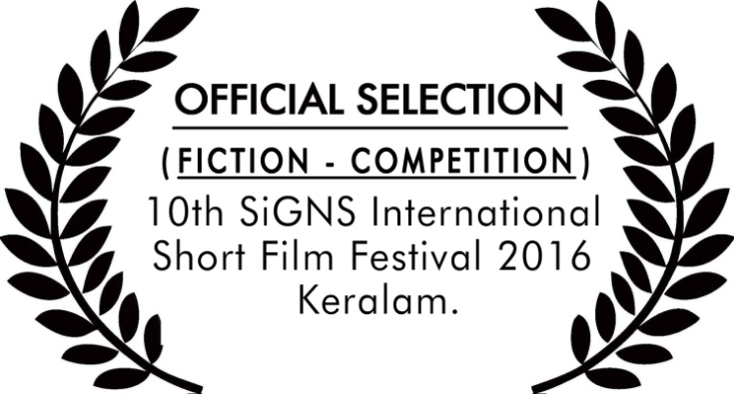

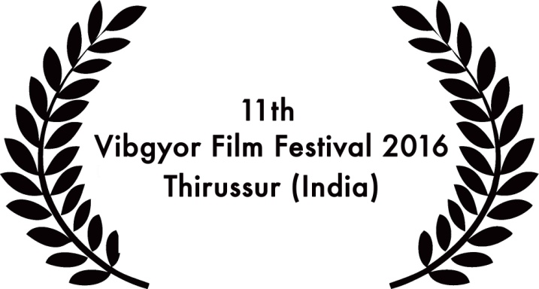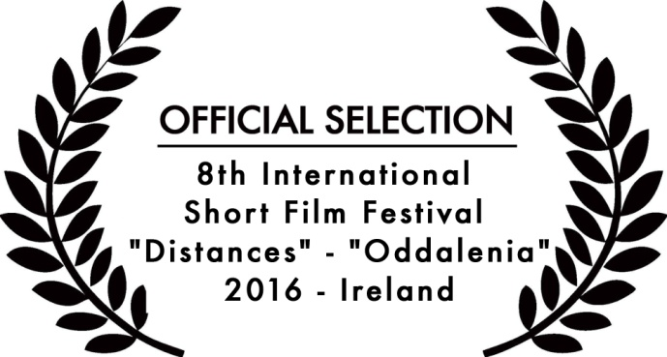

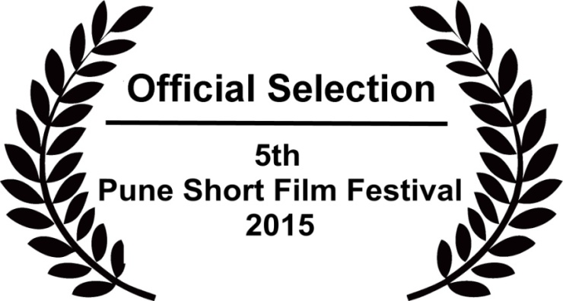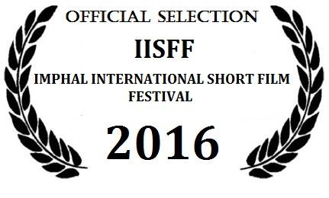

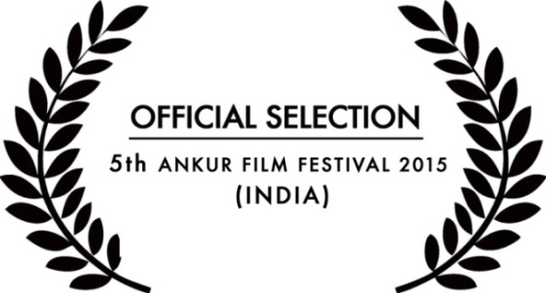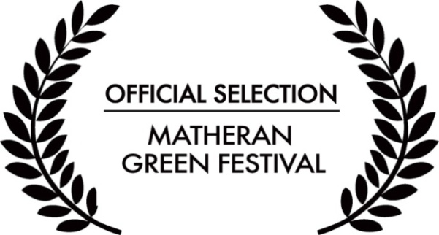

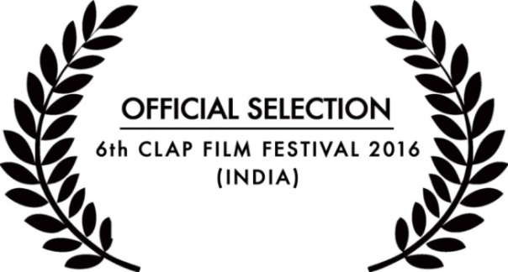



Film stills –

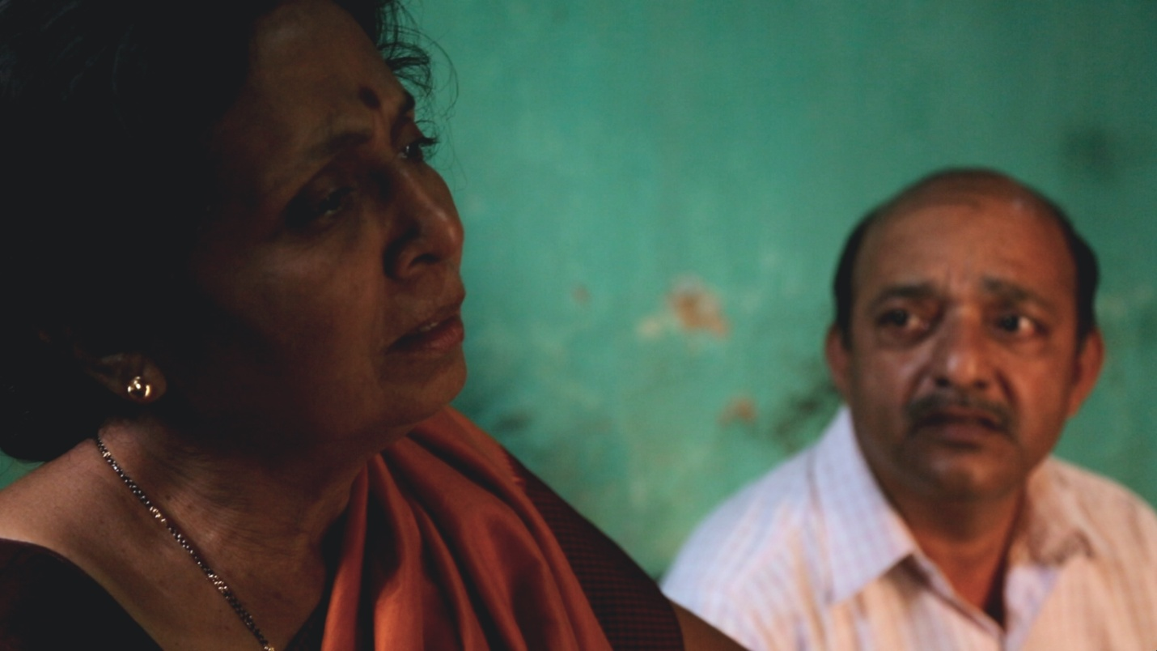

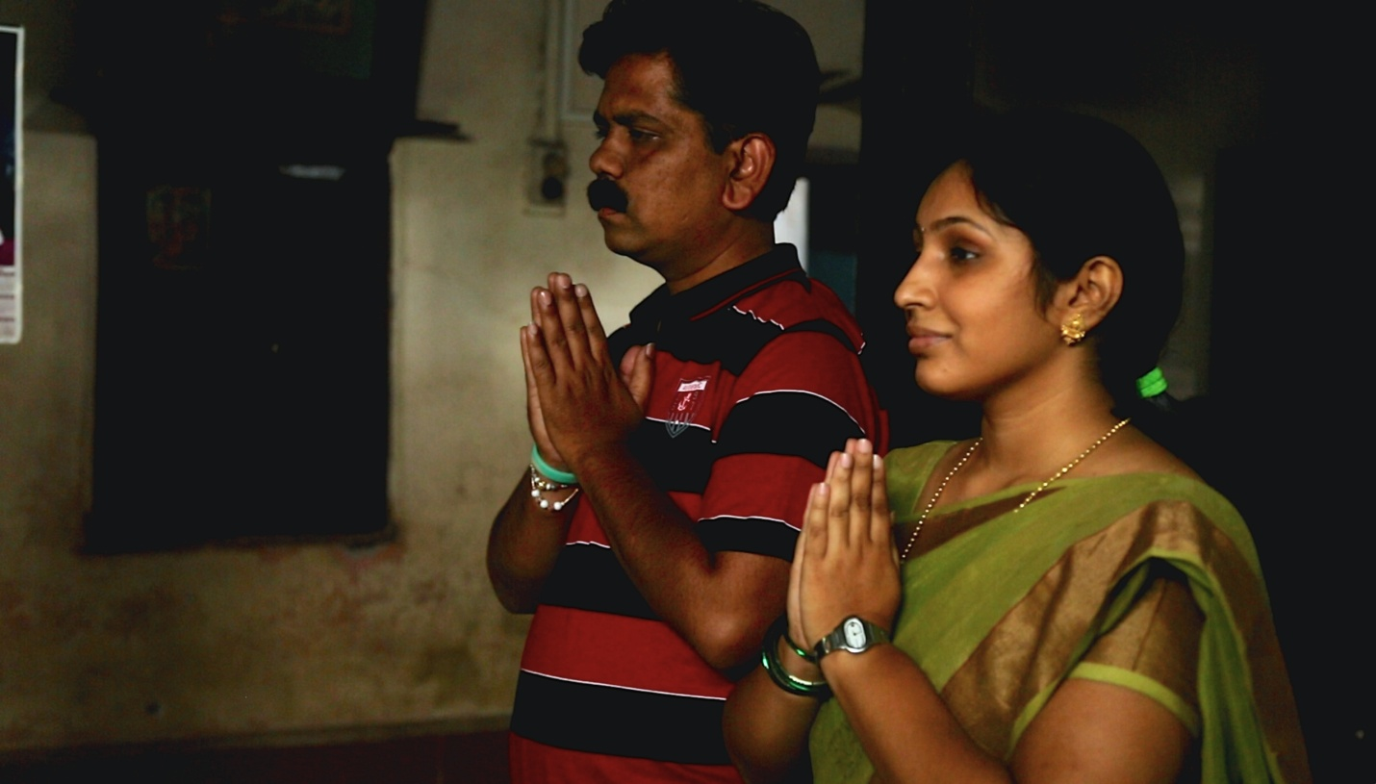

Director’s Biography -

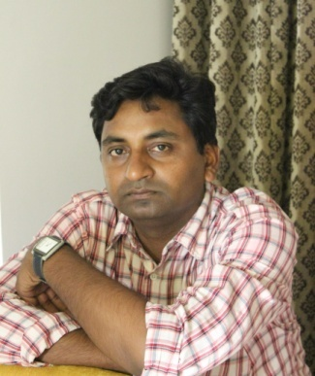
Santosh Ram born in the historical town of Udgir, Maharashtra . He has done his Post Graduation in English Literature from Modern College, Pune . He developed an appreciation for cinema while studying Literature .He has participated in Film Appreciation Course conducted by NFAI & FTII 2006 .He Participated in a six month Film making course conducted by Cinefusion ,Pune . He was selected for a Six Month course in City Narratives In Cinema and Literature conducted by Maajlis and Maxmullar Bhavan , Mumbai . His Short Film Vartul (Circle) travelled to over Fifty Six Film Festivals across the world including 11th Osian’s Cinefan Film Festival , New Delhi (India) , International Documentary and Short Film Festival Of Kerala, 17th Toronto Reel Asian International Film Festival (Caneda ) and 5th National Show of Independent Cinema "Otros Cines", San Nicolas (Argentina) , Winning Thirteen Awards . Santosh Ram is one of the Advisory Board – Filmmakers for tiNai Eco film festival (TEFF) Goa ,India. He started Vivek Chitra Productions with Ramchandra Pundlikrao Marewad in 2008 . He is one of the Curators For 11th Vibgyor Film Festival 2016 Thirussur (India }
Currently He is working on “Santosh Ram Project “ , a series of 15 Short Films And His Full length Debut Marathi Film “ China Mobile “.

Director’s Filmography –
Vartul (Short) (2009) - winner of 13 Awards – Selection in over Fifty Six Film Festivals across the world
Galli (Short) (2015)- Selection in over Twelve Film Festivals across the world
Cast & Crew–
Concept , Screenplay & Directed By – Santosh Ram
Produced By – Ramchandra Pundlikrao Marewad , Santosh Ram
Executive Producer – Balaji Ramchandra Marewad
Editor – Vivekanand Daakhore
Cinematography- Benjamin Burghartz
Music - Pranav Ghodnadikar
Sound - Sameer Thorat
Cast –
Sanghsen Jagatkar , Seva More ,Uma Namjoshi ,Shraddha Patil ,
Vinay Joshi ,Narendra Patwardhan , Sagar Khurd ,Raja Babhulkar , Mala Inamdar ,Pranavi Patil ,Sangram Desai ,Vardan Patole , Tanishka Patole
Contact-
Santosh Ram
Vivek Chitra Productions
C/o R. P.MAREWAD , REDDY NIVAS,
VIKAS NAGAR , DEGLOOR ROAD ,
UDGIR-413517
MAHARASHTRA
(INDIA )
Mobile No -+ 91 9822827277
Email- mrsantoshram1@gmail.com
www.santoshram.in.

