B H ū M ī

PRESS KIT

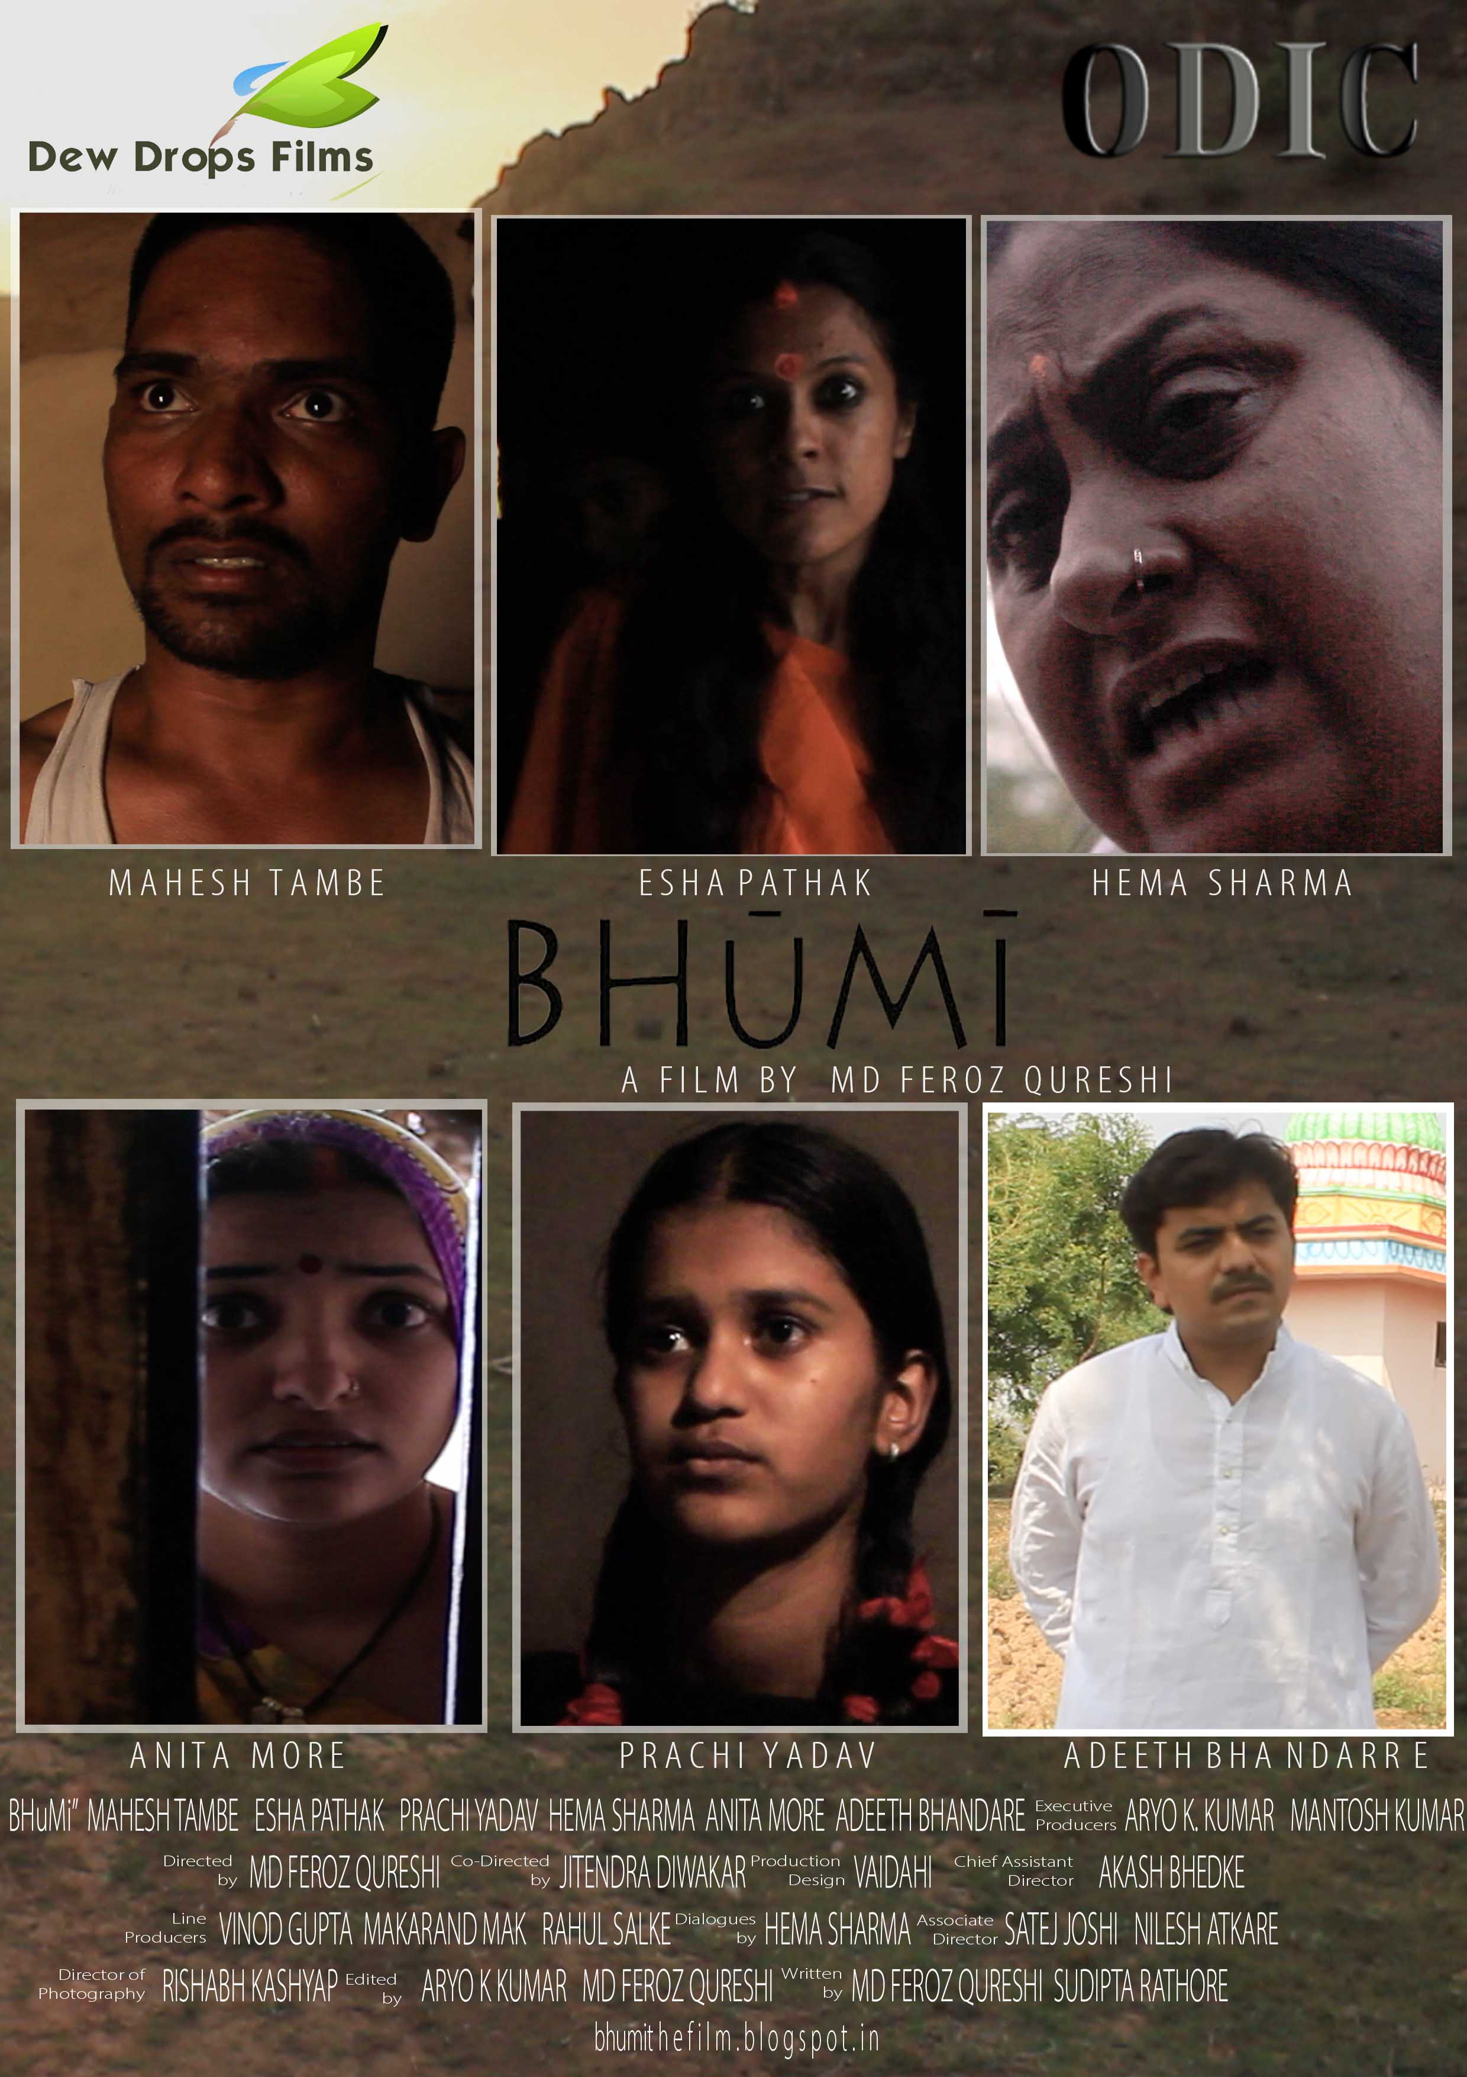

WRITER – DIRECTOR - PRODUCER
MD FEROZ QURESHI

B H ū M ī
PRESS KIT

CONTENTS

SYNOPSIS | 5
SCREENING DETAILS | 6
PRODUCTION NOTE | 7
CAST AND CREW’S BIOGRAPHIES
-MD FEROZ QURESHI (WRITER DIRECTOR PRODUCER) | 8
-SUDIPTA RATHORE (WRITER)  -HEMA SHARMA (DAILOGUE WRITER) | 9  9
-ARYO KUMAR (EXECUTIVE PRODUCER/EDITOR) | 10
-JITENDRA DIWARKAR (CO DIRECTOR) | 10
-RISHUBH KASHYAP (DOP) | 11
-MAKARAND MAK (LINE PRODUCER) | 11
-VINOD GUPTA (LINE PRODUCER) | 12
-RAHUL SHELKE (LINE PRODUCER) | 12
-MANTOSH KUMAR (EXECUTIVE PRODUCER) | 13
-AKASH BHEDKE (CHIEF ASSISTANT DIRECTOR)  -SATEJ JOSHI (ASSOCIATE DIRECTOR)  -NILESH ATKARE (ASSOCIATE DIRECTOR) | 13  14  14
CAST  -MAHESH TAMBE (KALLU SAHARIYA)  -ESHA PATHAK (MANAGALA SAHARIYA)  -PRACHI YADAV (BHUMI SAHARIYA)  -HEMA SHARMA (PARVATI SAHARIYA)  -ADEETH BHANDAREE (PARMESHWAR)  -ANITA MORE (RINA)  CONTACT DETAIL | 15  15  16  16  17  17  18
STILLS
-MD FEROZ QURESHI (WRITER DIRECTOR PRODUCER) | 19
-POSTER OF THE FILM | 20
-PRODUCTION STILLS OF THE FILM | 21
-STILL PHOTOGRAPHs OF THE FILM | 22
FILM TRAILER | 23

SYNOPSIS
DESCRIPTION
India – The country of many belief’s and superstitions which not only add positive elements to it but also a disgrace for the society. The film “BHUMI” speaks about the various superstitions and dis-belief which affect the life of an India Women. In this Story the Protagonist BHUMI Seheriya lead actress, been saved by the MANGLA Seheriya , her mother in the supporting cast from the antagonist PARVATI Seheriya and KALLU Majumdar her son, The story speaks about Parvati a superstitious, a belief in a DEVI MATA and kill her own granddaughter in need of getting a male child.
SYNOPSIS
The story of the film begins with the murder of a new born baby girl from Mangala Seheriya(Kallu Seheriya ’s Wife) by the Parvati Seheriya(Kallu’s mother) of the family supported by the villagers and the (Kallu) Father of the baby girl in the name of Goddess i.e. Devi mata. In the urge of getting a male child, Kallu tried again with Mangala and they had twins - a boy (Raghu) and a Girl (Bhumi). Because of birth of Raghu, Parvati didn’t give much importance to kill Bhumi as she is happy to get a male child. Everything is going fine till the day when Raghu died and from that day the sufferings of Bhumi started. As the time passes, Parvati died at her old age and Kallu became physiologically ill. The village started suffers from the drought. Now Kallu become a big problem for the Mangala and Bhumi. He beat them and drinks allot and also he didn’t work anymore. When they have nothing to eat, Mangala and Bhumi started working at a distance school and earn their living. Bhumi got chance to study at that school and Mangala supported her allot. One day, Kallu wants to sell Bhumi in the hand of few people for money but Mangala saved her and helped her to run away somewhere far and study allot, live her life. This action results into the death of Mangala been killed by Kallu. Kallu sells the field for money to his neighbor and then died drinking poisonous liquor.
Bhumi gets success in her life. She struggled allot and got a good job in the bank. One day she is coming back to the village to meet her mother and she kept knocking the door. But no one answers.

SCREENING DETAILS
TITLE : BHūMī
YEAR OF PRODUCTION : 2015
DURATION : 1:44:00
COUNTRY OF PRODUCTION : INDIA
GENRE : DRAMA
VIDEO FORMAT : 1920 1080 HD
SOUND FORMAT : STERIO SOUND 48KHZ
ASPECT RATIO : 1.85:1
LANGUAGE : HINDI (ENGLISH SUBTITLE)

PRODUCTION NOTE
From the Director MD FEROZ QURESHI brings the story that discuss about the Superstitions and its effect prevails in various parts in India. The story revolves around the central character of the film BHuMi [portrayed by Prachi Yadav], a 15 year old, girl who survives against the deadly superstitions in her life. With the little support of her mother and capabilities in her she proves that girl is worth living for and they have an important role in the Indian Economy.

To select the suitable characters for the film the director MD FEROZ QURESHI visited various Theatres, Dance group and slums. After years of casting finally MAHESH TAMBE, PRACHI YADAV, ESHA PATHAK, HEMA SHARMA, ADEETH BHANDARE and ANITA MORE were selected for the Lead and other supporting roles.
We use the cameras Canon 5D handled by DOP RISHUBH KASHYAP. Mostly the gorilla and hidden camera shots were added in the film.

Shooting were generally took place in original location with original people involved in it. Shooting location were LONIKAND [Village in Pune District]and PUNE CITY.

The character introduced in the film where:-

KALLU SAHARIYA – is a negative character of the film. He is a farmer and a superstitions man. He works on the words of his mother Parvati. After the death of his mother he turns out to be a psychological dis-balance.

BHUMI SAHARIYA – is a Central character of the film. She is the daughter of Mangala Sahariya and Kallu sahariya. She is saved by the fortune as she has a twin brother Raghu. The films runs around her life and speaks about the success and sacrifices of her.

MANGALA SAHARIYA – is the mother of Bhumi and she helps her is all instances. She is the one who sacrifices herself for the life of bhumi and her career.
PARVATI SAHARIYA – she is the negative character of the film. She believes in superstitions and killing girl child in front of god for the male child. She has a good reputation and a powerful lady in the village.
PARMESHVAR – He is a farmer and a “Choudhari” in the village having a good wealth and status in the village. He is the neighbour of kallu and helps him whenever he is in need.
RINA – is the wife of parmeshwar and she is a best friend of Mangala. She guides her and supports her in her up’s and down’s of life.

CAST AND CREW’S BIOGRAPHIES
- MD FEROZ QURESHI (WRITER DIRECTOR PRODUCER)
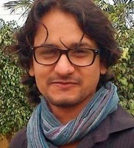

MD FEROZ QURESHI from BILASPUR C.G learned Film-Making by making Short Film for the Festivals. After his graduation is started WRITING/ DIRECTING and PRODUCING several Short Films for the Film Festivals and also he assisted the Filmmaker TRILOK MALIK.

His Filmography includes:-

DAD'S BLESSINGS, GIVING A NEW LIFE, KHUSIYAAN, COLOUR BLUE, RIGHT TO LIVE Part 1 and 2, 3 PORTRAITS OF MOTHER INDIA, KALEIDOSCOPIC SHADES DOCUMENTARY, VARIOUS AD FILMS and CORPORATE FILMS,

Website - mdferozqureshi.blogspot.in

- SUDIPTA RATHORE (WRITER)


SUDIPTA RATHORE from Jodhpur, Rajasthan is into writing Poems and Stories and Lyrics from 4 years. She wrote for various bands, Ad films Concepts, Short Films etc. She wrote an award winning short film - 3 PORTRAITS OF MOTHER INDIA with MD FEROZ QURESHI. Currently she is working in a Script of Feature Film and also a Novel.

Website: - sudiptarathore.in

- HEMA SHARMA (DAILOGUE WRITER)

HEMA SHARMA is from PUNE, Maharashtra. She is a dancer and actress been trained from Bhavana Dance Academy. This is her first feature film as an actress.
- ARYO KUMAR (EXECUTIVE PRODUCER/ EDITOR)
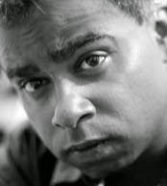

ARYO KUMAR is an Indian Film Producer/Writer and Director. He is working on his Short Film for the International Film Festival. He is associated with Dir. MD FEROZ QURESHI for the production of Films. He has edited few short films and this is his first film as an Editor.

- JITENDRA DIWAKAR (CO- DIRECTOR)


JITENDRA DIWAKAR is an artistic painter and fine artist honoured by the President Mr. Atal Bihari Vajpayee for his works and painting. He is also an actor. Currently he is associated with the production ODIC films as a production designer and an actor.
He has successfully completed few short films and feature films as an actor and assistant director. This is his debut film as a CO- Director.

- RISHUBH KASHYAP (DOP)
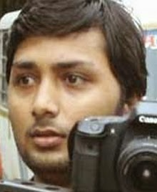

RISHUBH KASHYAP is an actor and photographer. He has photographed models and actors portfolios for the various productions. This is his first film as an DOP.
- MAKARAND MAK (LINE PRODUCER)
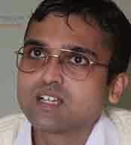
By profession MAKARAND MAK is an engineer. Passion for cinema drags him into this industry. He has also Produced, Written and Directed a short film. MD FEROZ QURESHI appreciated the work and offered the job as a line producer for his latest venture HARD TO CHANGE THE WORLD. My job description contains location hunting, resources supplying, rest room, travel, food, junior artist and e.t.c as needed for the film.

- VINOD GUPTA (LINE PRODUCER)
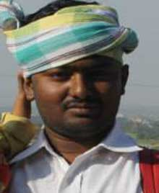
By profession VINOD GUPTA is an electrician. Passion for cinema drags him into this industry. He worked as a side artist and production co-ordinator for various films and short films. Now he is working as a line producer for MD FEROZ QURESHI form his last 2 feature film.
- RAHUL SHELKE (LINE PRODUCER)
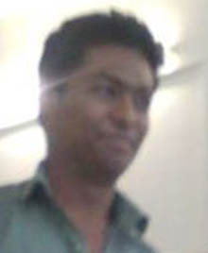
RAHUL SHELKE is a student of pune university and also he is a event co ordinator. He worked for theatre production as a part time in backstage. This is his first film as a line producer.

- MANTOSH KUMAR (EXECUTIVE PRODUCER)
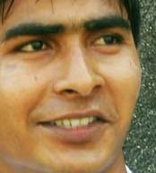
MANTOSH KUMAR from Delhi has worked in various Feature Films and Short Films. He worked as an ACTOR and PRODUCTION CONTROLLER for a feature film HARD TO CHANGE THE WORLD. This is his second film where he is working as a Executive Producer.
- AKASH BHEDKE (CHIEF ASSISTANT DIRECTOR)
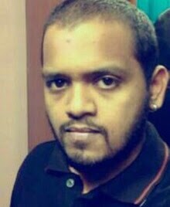
AKASH BHEDKE is a business man in pune and alumni of Film Institute. He has completed his short films as a Writer and Producer and this is his first feature film as a chief assistant director.

- SATEJ JOSHI (ASSOCIATE DIRECTOR)
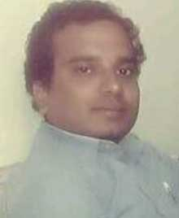
SATEJ JOSHI is an assistant director for various marathi short and feature films. He work in pune.

- NILESH ATKARE (ASSOSIATE DIRECTOR)
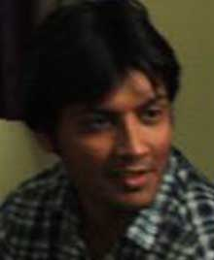
NILESH ATKARE is an assistant director OF Reputed Marathi Film Director – Adeeth Bhadaree. This is his 3rd feature film as an assistant director.

- MAHESH TAMBE (CHARACTER – KALLU SAHARIYA)


MAHESH TAMBE from Sindhudurg M.H and his passion for acting drives him to work in theatre of VASANTRAO ACHREKAR SANSKRIT PRATISTHAN and did 37 shows of the play named as MEE MAJHYASHI directed by ATUL PETHE. This show is also selected for the NATIONAL FESTIVAL 2010 of Bharat Rang Mahotsav.
website:- http://maheshtambe.blogspot.in/

- ESHA PATHAK (CHARACTER – MANGALA SAHARIYA)
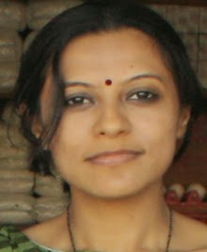
ESHA PATHAK from Surat has been passionately associated with theaters for 3 years and did plays at National Level and at International Level. She's also honored by various outstanding characters in one play.
Her Acting performances includes :- RED ALERT, NAVARATNA PENDENT AD FILM, CORPORATE FILMS.

- PRACHI YADAV (CHARACTER – BHUMI SAHARIYA)

PRACHI YADAV is from PUNE MAHARASHTRA. Her passion for acting makes her to join Adeeth Bhandaree acting and theatre group and she works in various short films with hi. This is her first feature film as a lead actress.

- HEMA SHARMA (CHARACTER – PARVATI SAHARIYA)

HEMA SHARMA is from PUNE, Maharashtra. She is a dancer and actress been trained from Bhavana Dance Academy. This is her first feature film as an actress.

- ADEETH BHANDAREE (CHARACTER – PARMESHWAR)
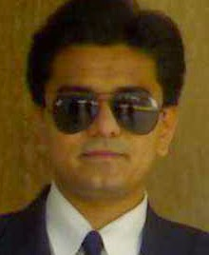

ADEETH BHANDAREE is a well knon Writer, Director in Pune. He is also the CEO and Founder of Adeeth Acting Acadmey. He has acted and director various short films, feature films and TVC’s. He is associated as an actor for the film.

- ANITA MORE (CHARACTER – RINA)


ANITA MORE is from PUNE, Maharashtra. She is a dancer and actress been trained from Bhavana Dance Academy. This is her first feature film as an actress.

CONTACT DETAIL
PRODUCTION COMPANY
INDIA SALES
DEW DROPS FILMS
MD FEROZ QURESHI
FLAT NO 25, 3TH FLOOR
KUMAR SAMRUDHDHI SOCIETY
TINGRE NAGAR
VISHRANTVADI
PUNE
INDIA
PIN NO :- 411015
MOB NO :- 7030378630
EMAIL :- ferozqureshimohd@yahoo.co.in

STILLS
- MD FEROZ QURESHI (WRITER DIRECTOR PRODUCER)
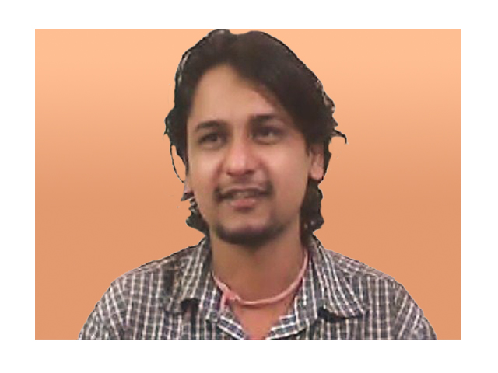
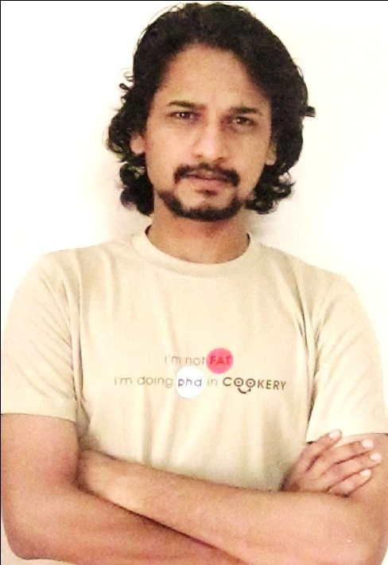

- POSTER OF THE FILM

- PRODUCTION STILLS OF THE FILM
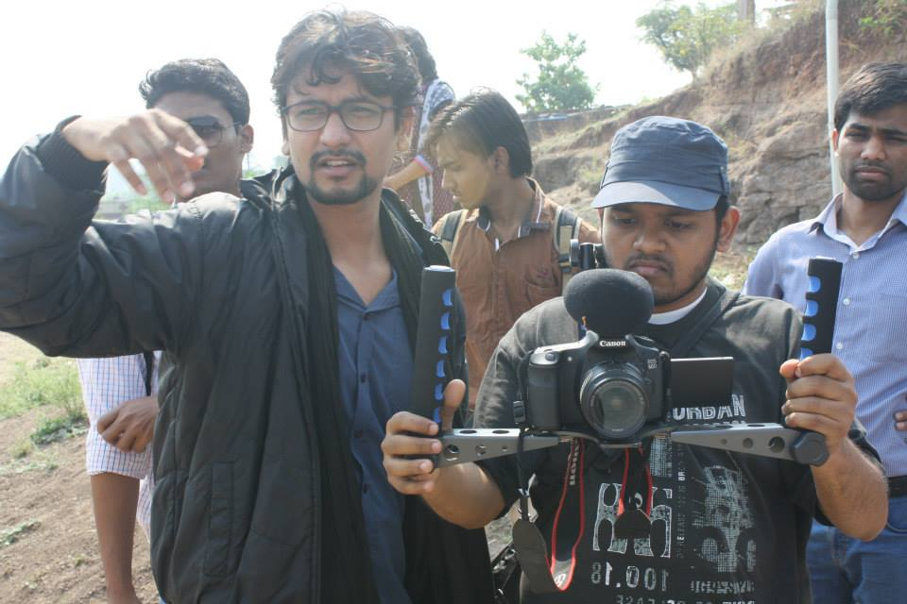
-(FROM RIGHT TO LEFT)
AKASH BHEDKE (CHIEF ASSISTANT DIRECTOR) , GIRISH GAWALE (AD) MD FEROZ QURESHI (DIRECTOR) , RAHUL SALKE (LINE PRODUCER)
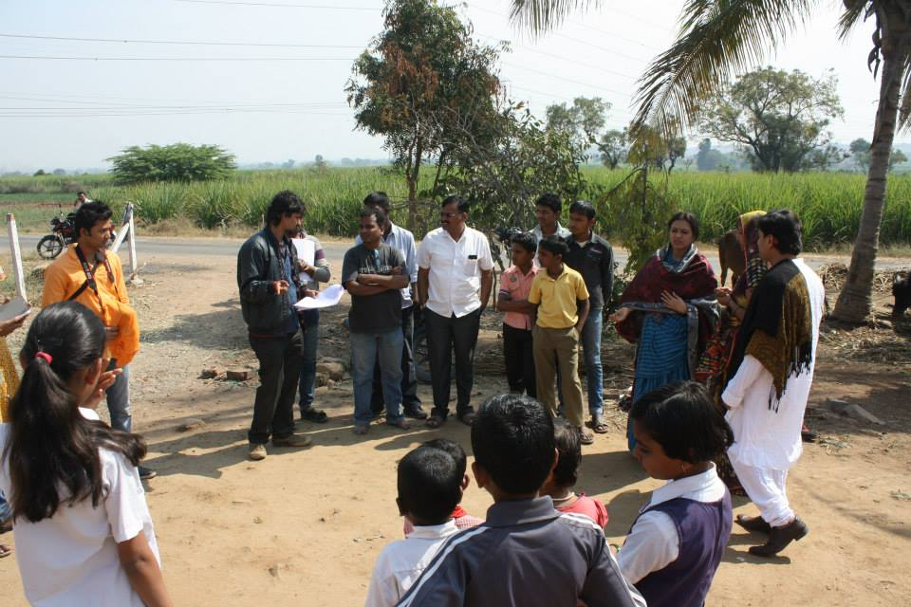
-(FROM LEFT TO RIGHT)
RISHUBH KASHYAP (DOP) , MD FEROZ QURESHI (DIRECTOR) , SATEJ JOSHI (ASSOCIATE DIRECTOR) , ESHA PATHAK (ACTRESS) , ANITA MORE (ACTRESS) , ADEETH BHANDAREE (ACTOR)
- STILL PHOTOGRAPHS OF THE FILM
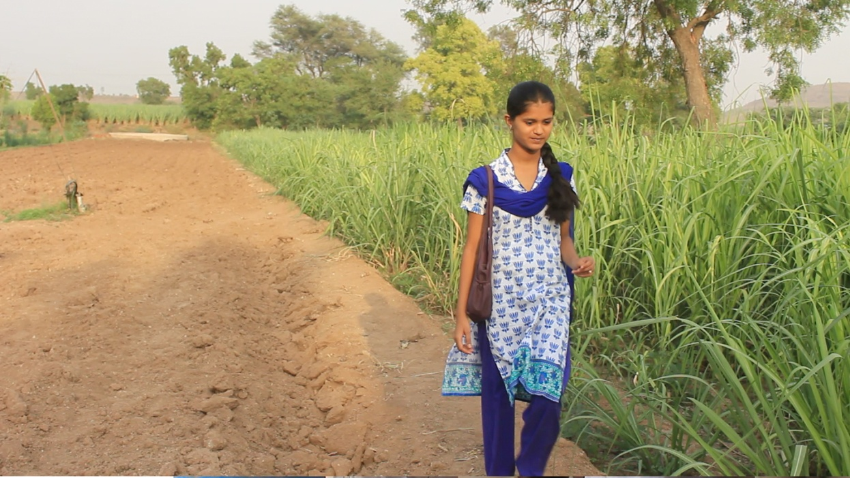
PRACHI YADAV (LEAD ACTORESS)

MAHESH TAMBE (LEAD ACTOR)

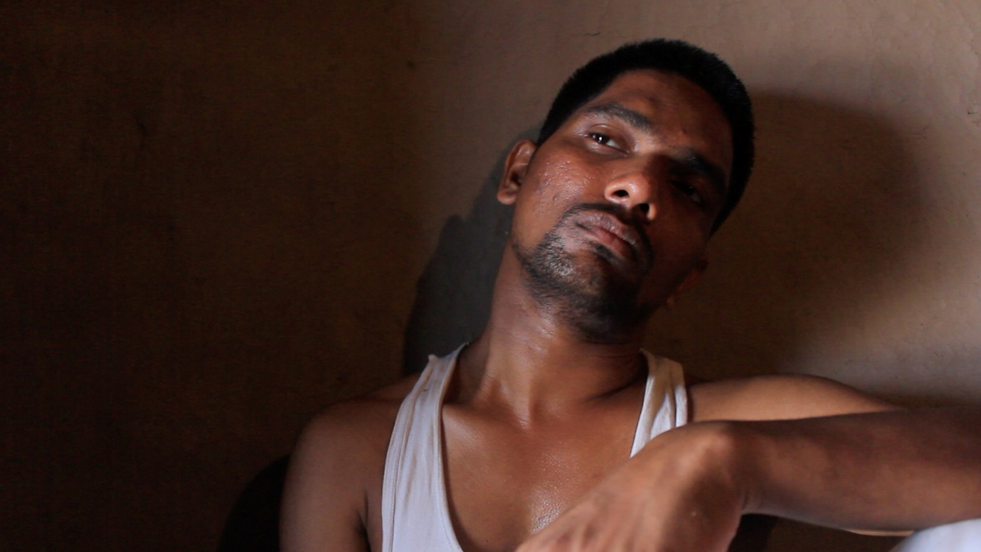

- TRAILER OF THE FILM

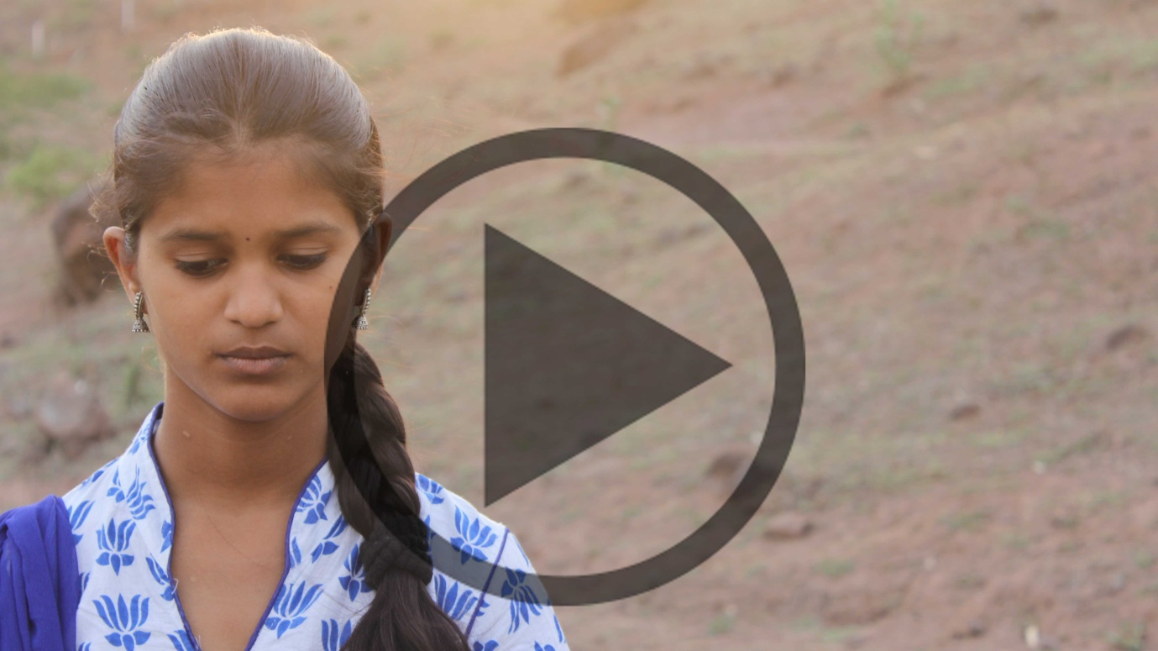

Visit the following Link –

© MD FEROZ QURESHI

