

TAGLINE: Everybody’s Got a Story.

LOGLINE: After a run-in with a New York City councilman, a former mobster turned NYPD detective takes over his uncle's bail bonds business in Fort Worth, Texas; but with the mafia on his tail, will escaping the rat race be as smooth as he hopes?

SYNOPSIS: Bail Out is a zany, TV comedy series about one larger-than-life NYPD detective's attempt to take "Cow-town" Fort Worth, Texas, and turn it into "Little New York." His first few escapades as a bounty hunter include going undercover as a hotel maid, dressing as a clown and getting lost in the Texas backwoods, where even animals fear him. This is a fish out of water odyssey. This is, Walker, Texas Ranger, meets the Sopranos, meets Seinfeld.

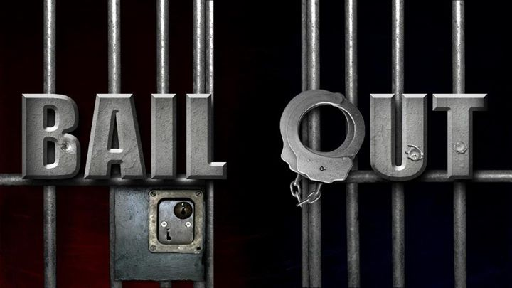

Bail Out, LLC, PO Box 33003, Fort Worth, TX 76162 817.307.7546

BAIL OUT FUTURE EPISODES

01 – PILOT: NYPD Detective, Jimmy O’Neill, changes jobs and location amidst controversy with the New York mob. Leaving behind his police partner of 20 years, he has inherited his uncles failing bail bonds business and surprised to find enjoyment in Fort Worth, TX, being a fish out of water.

02 – CLEANING LADIES: Marty visits Jimmy in Texas. They go undercover as hotel housekeepers, to find out why mobster Bobby “The Nose” is in town.

03 – STRANGER FROM BROOKLYN: Jimmy thought he left the past behind, in New York, when a mobster pops up in Fort Worth with a strong warning.

04 – JIMMY & THE KID: Jimmy is investigating a teenager involved in drug related crimes. When Jimmy is emotional, he reveals a dark secret from his past.

05 – KATY: Jimmy is forced to care for a grand champion teacup Yorkie that is left as collateral at Uncle Charlie’s bail bonds office. This thorn-in-the-flesh may likely turn out to be one of the sweetest relationships Jimmy has ever had.

06 – THE GREATER GOOD: A missing woman’s family hires Jimmy to check the alibi and whereabouts of her ex-boss. Meanwhile, the D.A., Renee Simmons bends the rules as she handles this case, putting herself in extreme danger, which infuriates Jimmy.

07 – MISTAKEN IDENTITY: While playing a round of golf, Jimmy and his NYPD partner, Marty show up uninvited at the Country Club to investigate a gambling ring. A hilarious but serious investigation takes place during a crazy round of golf.

08 – DEFEND YOURSELF: Jimmy sets up a self-defense class for women at Paulie Ayala’s boxing gym after a rash of purse snatchings and thefts.

09 – WHOA, MAN! : Jimmy does not know how to break it to his Uncle Charlie that Victoria, his live-in rehab nurse, is actually a male nurse in the witness protection program.

10 – SNEAKING AROUND: Jimmy asks Susan Perry a vivacious, female, mechanic, for her assistance in an investigation at a black tie affair.

11 – BLAST FROM THE PAST: Jimmy is awaiting the arrival of Katherine, his ex girlfriend, whose uncle, Carmine Cappelletti, is the Don of the five NY mob families.

