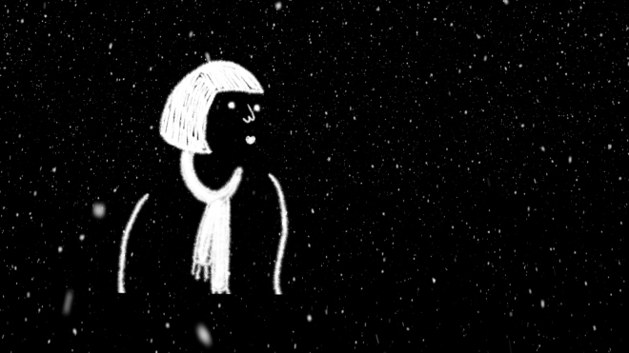

“The evening her mind jumped out of her head"

A short animated film by Mew Lab

“One cold winters evening, a serious woman is forced to lighten up when her mind jumps out of her head”

Written by Sarah Woolner

Directed and Animated by Kim Noce & Shaun Clark

2015

Funded by Watford Burroughs Council"

Title “The evening her mind jumped out of her head"
Credits
Voices by Penelope McGhie & Paul Mundell
Produced, Directed and Animated by Kim Noce & Shaun Clark
Written by Sarah Woolner
Music by Alex Harwood
Edit by Fiona De Souza
Sound by David Pringle
Funded by Watford Burroughs Council
A Mew Lab Production
Synopsis One cold winters evening, a serious woman is forced to lighten up when her mind jumps out of her head

Website www.theeveninghermindjumpedoutofherhead.mewlab.com
Contact Hello@Mewlab.com
Contact details and social media are as follow: Twitter: @MewTweets @LoveWatford @KimNoce @Shaundclark @FilmClubProd
Facebook: MewLab (https://www.facebook.com/MewLab)
Instagram @Mewlab
Main Hashtags are: #MewLab #WatfordBC

Title translations
EnglishThe evening her mind jumped out of her head
Italian: La sera la sua mente scappo dalla sua testa
French: Dans la soirée, son esprit se enfuir de sa tête
Spanish:La noche su mente huir de la cabeza
Synopsis translation
English “One cold winters evening, a serious woman is forced to lighten up when her mind jumps out of her head”
Italian: "Un fredda notte d’inverno, una donna molto seria fu costretta a riconsidera se stessa quando il suo cervello scappo dalla sua testa".
French" Un des hivers froids soir, une femme sérieuse est forcée d'alléger son esprit lorsqu'il saute hors de sa tête "
Spanish "Una fría noche de invierno , una mujer muy grave fue constretta reconsiderar sí misma cuando su cerebro huir de la cabeza"

Stills images Click on the image and right click to download 300DPI
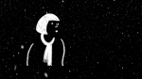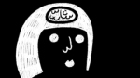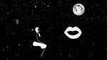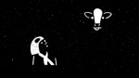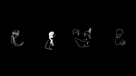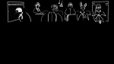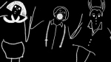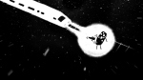

Directors Biography as MewLab
MewLab www.mewlab.com
We are MEW LAB: the collective talent of Shaun Clark and Kim Noce award winning London based animation directors. We are both author animators with filmmaking and art background.
Directors Filmography as Mewlab
2014 The Key
2012 High Above The Sky
2010 The Magic Fish
2009 Anansi
2008 Frau Holle

Biography Shaun Clark www.shaunclark.org
1979, Beverley, Uk
Shaun Clark has directed an eclectic array of award winning animated films since the early 90′s. His films have been BAFTA nominated and has earned him praise for his use of different techniques and styles of storytelling most recently in Clermont Ferrand (2012). Shaun graduated with a first degree honours in animation before studying for a MA at The National Film School for two years. He resides in London where he works at Mew Lab as a animation director.
Education
2005 The National Film and Television School M.A. in Animation Direction
2001 Hull School of Art and Design B.A. in Animation
1998 Beverley College BTEC Art Foundation 1997-1998
Filmography
2014 The Key
2012 High Above the Sky
2012 Lady and the tooth
2010 The Magic Fish
2010 LIAF Idents ,Four Idents, LIAF
2009 Anansi
2008 Frau Holle
2007 home?
2006 Philophobia
2005Lightman
2001 Lost property

Biography Kim Noce www.kimnoce.com
1973, Mendrisio, Switzerland
I am an Animator Director with a BA in Fine Art from BRERA and an MA in Animation Direction from the NATIONAL FILM AND TELEVISION SCHOOL. My graduation film “After” was nominated for a ROYAL TELEVISION SOCIETY AWARD.In 2006 I was awarded the Channel 4 AIR Scheme where I made a short film called “Forget Me Not”.
Alongside my personal films I work as a freelance animator for the commercials industry for company such as BBC, Channel 4 and TATE. My films and my animation work have won many awards around the globe, including a BAFTA nomination for an TV series.
Education
2005 MA Animation Direction National Film Television School (UK)
2002 HND Photography Westminster College (UK)
1998 DIPLOMA PITTURA (BA + MA Fine Art &Illustration) Accademia di Belle Arti 1992 DIPLOMA ARTISTICO Architecture, Istituto Orsoline di San Carlo
Filmography
2014 Nest of Stone
2014 The Key (short film)
2012 High Above the Sky (short film)
2012 Museum at Night Animated Installation, Culture 24, Funder, Silhouettes (in post production)
2012 High Above the Sky, Short film, BFI & FILM COUNCIL Commission,
2011 Museum at Night Animated Projection, Culture 24, Commission, Silhouettes,
2010 LIAF Idents ,Three Idents, LIAF ,
2010 Magic Fish Short film, BBC Commission, Cut Out Collage
2008 Frau Holle Short film, BBC Commission, Cut Out Collage
2007 Anansi and the Turtle Short film, BBC Commission, Cut Out Collage
2006”Forget Me Not”,Short film, CH4 Funder, Cut Out Collage and Embroidery,
2005 “After” Graduation animation, Sculpture, Painted clay, Paint on glass,
2004 MTV Idents , MTV Commission, Sand on glass, Stop Motion puppet Flash, 2D

Dialogue list

KISSING COUPLE
My darling
MUSIC MAN
Figaro
OLD LADY
New Game
Smash
Manic
KNITTING MAN
Knit one
Pearl one
Knit one
Pearl one
Ok
PUNK
When all at once I saw a crowd, A host, of golden daffodils
RABBIT GIRL
So I said to him: “Whatever I am gonna do what I want!”
Oh that’s gonna be sick man
SERIOUS WOMAN
Oh, how boring!
TRAIN CARRIAGE
Noise of voices talking
TRAIN CARRIAGE
OLD WOMAN
Smash. Manic. Nervous. Noise. Repetition
SERIOUS WOMAN
What!?!
TRAIN CARRIAGE PEOPLE MOANING
What’s happening?
There is no light
You are stepping on my ear
This trains: never a journey without a problem
SERIOUS WOMAN
Ah! Good
RABBIT GIRL
Thank you
SERIOUS WOMAN
Charming!
RABBIT GIRL
Australia is being hit by a bunny invasion and these marauders aren't the chocolate kind…
MIND (O.S.)
Hello?
SERIOUS WOMAN
What was that?
Mhh you? No.
Mhh, maybe..
Don’t think…
Yes?
OLD WOMAN
Can I help you?
SERIOUS WOMAN
Sorry!
TANNOY (O.S.)
We are sorry to announce a delay to this service. This is due to a cow on the track.
SERIOUS WOMAN (thinking)
A cow?!?
OLD WOMAN
Smash
Manic
Journey
OLD COUPLE
My darling…
PUNK
I wandered lonely as a cloud. That floats on high o'er vales and hills
MIND (O.S.)
Can you let me out?
MIND (O.S.)
Please.
SERIOUS WOMAN (thinking)
No, I know its not you!
MIND
You can’t keep me locked up forever.
SERIOUS WOMAN (thinking)
Where is this voice coming from?!?
SERIOUS WOMAN
Ssshhhhhhh!
CAGE (Many voices)
OLD LADY
Fear
Anger
Repression
MIND
You can’t lock me up forever!
Let me out!
MIND
Let me out, pleaseeeee!
OLD WOMAN
How dare you!
MIND
Yes I am freeeee
SERIOUS WOMAN
Where do you think you are going!
Come back!
MIND
Off I go..
SERIOUS WOMAN
Come on! I know you are in there!
Open the door!
MIND
Outside…
Outside…
I am free…
Imagine…
Anything is possible out here
MIND
Oh! Home again!
SERIOUS WOMAN
Moooooo.
COMMUTERS
Sssshhhhhh!

