Producer/ Director’s Profile- (page 1 of 2)
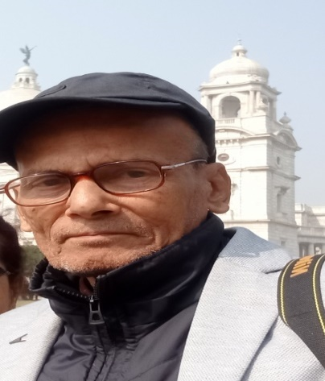
Producer/Director Name- Sri Aparup Agarwala, (D.O.B.-30/07/1954)
S/O Late Bibekananda Agarwala, younger brother of Rupkonwar Jyoti Prasad Agarwala, pioneer of Assamese Film Industry. Jyoti Prasad produced the first Assamese feature sound film way back in 1935, entitled “JOYMOTI”35mm.B/W.& “Indramaloti”(1939)
Banner—Sri Haribilash Movies. Address- “Dipti- Nivas” Sankar Mandir Road, Kumergaon,Tezpur.Pin-784001.Assam.India.Propietor Sri Aparup Agarwala.
Academic qualification- B.A. (Cotton College, Guwahati University-1975)
-Experience in the field of film production, television serials and documentaries & in the capacity as an empanelled producer of Doordarshan Kendra Guwahati-784021.Assam.India-
.- Producer, Director, script writer, Music director, and consultant Editor of the following documentary films, and Television Serials---
While as a final year B.A. student of Cotton College, Guwahati University, Aparup Agarwala, and as a secretary, along with the members of the Cotton College Film Society in the year 1975, scripted directed and scored the music of the documentary film ‘Cotton College’, covering the 75 years of glorious history of the College. Voice –over rendered by Bharat Ratna Dr. Bhupen Hazarika,an ex-Cottonian.Due to financial problems, completed & released in the year 1982. This is the only documentary film to receive a CBFC in the 100years of the College glorious history till date (January 2025). CBFC, Kolkata, No.101526/Date-28.12.1982
1.-Cotton College : Documentary/W, Length 487.68 metres, 35 mm. Released in the Year 1982 (Assamese) 2 reels. Telecast through DDK, Guwahati and in the Cinema Halls.
2.- Borhomputror Lohor Aru Bhongima: East men color, 16mm. Length 236.00 metres. Year 1988 (Assamese) 2 reels. Telecast through PPC North- East.
3.-Echoes of Brahmaputra: colour Length 236.00mm, year 1994 (English) 2 reels.
4.-Cotton College: English, B/W, 16mm, Length 197.07 metres, year 1994. Reels-2. Telecast through North-East.
5.-T.V. serial of 13 episodes – “Rupahi Aru Soontara”. (Year- 1995). (Continue page-2)
6.-Musical Feature- “Memorable Melody” based on the life and musical composition of Rupkonwar Jyoti Prasad Agarwala with English commentary. Telecast through PPC, North-East on 16/01/1998. (23 minutes).
7.-Musical Feature “Siro-Xondor Sanskriti”, 24 minutes Telecast on 18/01/1999 through DDK, Guwahati.
8.-Commission Project: LAKHYA- STHAN-AXOM. Documentary of 28 minutes based on infiltration from Bangladesh. Its impact on State Economy (2000-2001). Telecast through Doordarshan Kendra, Guwahati.
9.-Commission Project: XOMONNOYOR – BAGHJORI. Documentary of 25 minutes based on communal harmony and national integration (2001-2002). Telecast through Prasar Bharati, Doordarshan Kendra, Guwahati.
10.-Commission Project: XOMONNOYOR- AENAJORI. (2002-2003). The thread of integration based on ‘communal harmony’: 2 episodes of 30 minutes each.
11.-Empanellment Director of Doordarshan Kendra, Guwahati. (EMP No.34)
12.-Commission Project: (2004-2005) on Pioneer of Assamese Film Industry Jyoti Prasad- A Genius of North-East, 3 episodes of 28 minutes each.
13.-Commissioned Project: 2010-2011. Serial in 5 Episodes- Title ‘Phulmoni Baganor Kahini’ of duration 22 minutes: 30 seconds each. Story based on a sort story ‘Kuri Bosor Jail’, written by Kolaguru Bishnu Prasad Rava.
14.-On 17th January 2023 released the first video Album on the first Assamese modern song ‘Gose Gose’ of the drama ‘Sonit Kunwari’(1917) and a patriotic song ‘Ur Ur Ur’ (1947)both composed by trend setter of Assamese Modern Music Rupkonwar Jyoti Prasad Agarwala of Tezpur,Assam,India.
15. As a debut director,- Produced, scripted,directed and scored the music of the feature film “KEYO”? (WHY?) based on a classic play”KEYO”written by the famous dramatist,Actor,Natasurjya Phani Sarma of Tezpur,Assam,India.
CBFC date-27/12/24.Certification no.-DIL/1/42/2024-GUW.Category-Universal.Duration-100.54 min.sec. Language-Assamese with English sub-titles. ( color) (2D)
- As publisher:-The Bhatkhande style of notation book “ Jyoti Sangeetor Swarlipi: By Late Mahesh Saikia (M. Music). First published on 17th January, 1984.
- ‘KOLIGAI’ a play written by renowned dramatist Late Hiren Choudhury of Tezpur.
- Producer and Music Director of an audio CD of Jyoti Sangeet entitled “ Jyotir Gaan” in 2004, comprising eight original songs of Rupkoonwar Jyoti Prasad Agarwala.
- Engaged in research work on Jyoti Sangeet under famous violinist Late Mahesh Saikia since 1980.
- Published the first Western Staff Notation with the Indian Notation Book entitled Friday, 07 February 202507-02-2025“JYOTI SANGEET” in 2012 by famous musician Mr. Rajeswar Bordoloi, (Bulu da).
- Published in a book form ‘Bibekananda Agarwala Rachanawali’ (2019).
- Published the book- “Aparup Agarwala’s Thoughts and Writings” in the year 2024.

************************************************

