Peter
Solar-Angel
Musician, Classical Concert Pianist, Jazz Pianist, Producer, Film Maker, Audio
Engineer, Video Editor, Camera Man, Lyricist, Composer, Arranger,
Roller Skate Dancer ,Martial Arts Exhibitionist, Author
Summary
Peter Solar-Angel
With 45+ years of diverse experience in music, filmmaking, and creative arts, I currently serve as Director at Film & Entertainment. My work blends a passion for storytelling with technical expertise in sensor arrays and video production, creating compelling narratives that resonate with audiences. I am committed to fostering innovation and artistic excellence, contributing unique perspectives to every project.

At Film & Entertainment, I lead projects that combine advanced editing techniques, audio engineering, and creative direction to produce high-quality content. My hands-on approach integrates skills across video production, music composition, and post-production to deliver impactful visual and auditory experiences.
Generative AI.

Education
Art O level
School St Josephs RC School for Boys Orpington Sept 1975 – Jul 1980
Grades 1,2,3,4,5
Tuition Ido Martin, Private Piano Teacher
Mar 1986 – Dec 1986
I Studied Music Theory 1,2,3,4,5 In 1986 with my Piano Teacher Ido Martin I am currently studying Classical Music studying: Johann Sebastian Bach, The Well Tempered Clavichord and Grades 6,7,8,9,.

Studies Self Educated in Film making, Self Educated in Music Production, Dancing Jul 1978 – Continue
Experience
P&O Ferries

Work experience Ships Pianist Entertainer North Sea Ferries
Oct 2001 – Mar 2004
Pianist/Singer Performing in Piano lounge on Ferry from Hull England to Holland & Belgium.
Inn On The Park Jersey Channel Islands
Position Pianist/Singer Oct 1988 – Feb 1989
Pianist/Singer Performing in Restaurant in The Inn On The Park Complex.
England, France, Holland, Belgium, Germany, Italy, Switzerland, Portugal, USA, Various locations
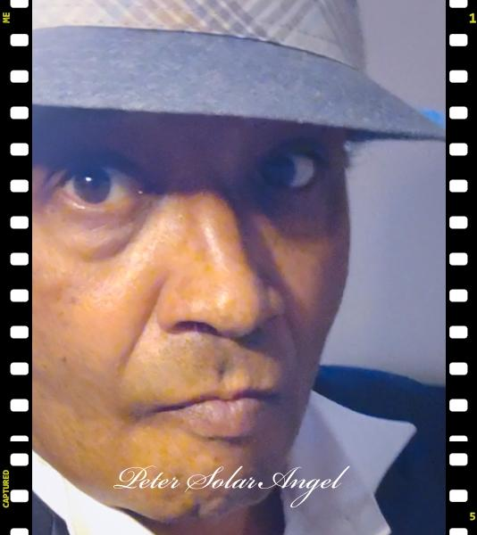
Email:
MixonianMotionPictures@gmail.com

petersolarangel@gmail.com
Phone:
+44(0)7902798459
Date Of Birth : 17/3/1964
Nationality: British
Gender: Male

Websites:
Filmfreeway
http://filmfreeway.com/petersolarangel

Storywrite
http://storywrite.com/petersolarangel

Bandlab
http://bandlab.com/petersolarangel

Facebook
https://www.facebook.com/share/1FPE7fFHUG/

Youtube
http://www.youtube.com/@PeterSolarAngel

Linkedin
https://uk.linkedin.com/in/peter-solar-angel-175255326

Zoom Pixel Photography
https://drive.google.com/drive/folders/1-65GtQpd1OHZ-vcZs-fVZE1gzv4YNAPF

Position:
Musician, Recording Artist, Live Performance, Gigs & Street Performing
^{Jan 1990 – June 2025}
I have Street Performed along Boulevards, in Cities and Town centres in locations such as: Leicester Square Covent Garden London, Liverpool, Manchester, Sheffield, Amsterdam ,Brussels Rome, Stuttgart, Geneva Paris, Lisbon, Seaside Towns :
Ramsgate, Dover, Margate in England, Cote De Azure France ,Algarve Portugal. .
Various Piano Bars Gigs England & Europe
Position Pianist/Singer Dec 1986 – June 2025
I have performed in Piano Bars, Night Clubs, Hotel lounges, Restaurants, Private Parties, Weddings, Birthday Parties, Festivals such as :The North Sea Jazz Festival Holland, .
Home Studio Productions
Position Producer / Audio Engineer/Video Editor
Jan 1983 – Continue
I Mixonian Motion Pictures covers the Mechanical Rights to the following Music Productions: Eyes Of The Sun 5.5.2000 Instrumental Themes Beyond Rads Place Cavemen Humans & Spacemen Thousands Of Years Ahead 1,2,3,4,5,6,7 Soundtracks. Up There Outa Here I,II & III Soundtracks. ARYCRAFT-AGP 1,2,3,4,5,6,7,8,9 Soundtracks. For Portfolio Log onto: http://filmfreeway.com:petersolarangel "My Music" All Songs on the Albums: Eyes Of The Sun 5.5.2000 Instrumental Themes Composed and Produced by Peter Solar-Angel Registered with PRS & MCPS Emissary Craft Records
Ltd Presented at the Midem 1996,1998 (c)(p) Mixonian Motion Pictures 1983-2024 All
Songs On The Albums Beyond Rad’s Place Cavemen Humans & Spacemen
Soundtracks to Thousands Of Years Ahead 1,2,3,4, 5'9 Seven Vegan Food Recipes & Theme For Two Lady Angels (In The Making ) Up There Outa Here I,II & III ARYCRAFT-AGP series Composed and Produced by Peter Solar-Angel (c)(p) Mixonian Motion Pictures 1983-2025 Song : California Witten and Performed By Peter Solar-Angel Recorded At CCa3 Productions In California USA with Producer Conley Abrahams between Feb -March 2001. Adapted From Original Song Francesca Composed by Peter Solar-Angel (c) 1983 -2025 Song: I Got To Know Recorded In Holland In My Home Studio Between 1996-1997 From 5.5.2000 Album Registered With PRS MCPS (c) (p) Mixonian Motion Pictures 1983-2025.
Mixonian Motion Pictures SA Registered December 31/2024
Position Self Employed Sol Trader with company Mixonian Motion Pictures , Film & Entertainment Company
Various Bands, England, Holland, form Band Drummer / Piano /Keyboardist /Singer Jun 1981 – Continue
Mixonian Motion Pictures
Position Film Maker, Director, Actor
Mar 2008 – Continue
For Portfolio Log onto: http://filmfreeway.com:petersolarangel "My Films".
Mixonian Motion Pictures
Position Author Jul 2005 – Continue
For Preview log onto: http://storywrite.com/petersolarangel .
Mixonian Motion Pictures
Position Zoom Pixel Photography Specialist
May 2008 – Continue
I have Pioneered the discovery some people say re-discovery of Zoom Pixel Photography For Examples lo onto : http://filmfreeway.com/petersolarangel.
Band Drummer, Innovation, Impact

Acting, Filming, Audio Editing, Film editing,

Audio Engineering
Bicycle Repair
Design
Digital illustration
Graphic design skills
Jazz Dance

Keyboard Synthesizer
Martial Arts
Position Drummer
^{May 1981 – Continue}
Drums was my first instrument, I started playing Drums soon after I left School in 1980, I had a Drum Teacher named John , I played in three bands between 1980-1982. Then I started playing Piano at Christmas 1982 and on into January 1983 . Dave
Vought a Piano/ Keyboard player and Bass Guitar player who formed our Band :Innovation/ Impact, gave me his old Eurotech Electronic Piano a few months after he had bought himself a Fender Rhodes. I went Solo in 1983 and was self taught for four years until 1986 when I began Piano lessons with Ido Martin the father of Jessica Martin & Mariana Martin. I still play the Piano 41 years later..
Mixonian Motion Pictures
Position Songwriter , Composer, Arranger, Lyricist, Poet.
Jan 1983 – Continue
All Songs on the Albums: Eyes Of The Sun 5.5.2000 Instrumental Themes Composed and Produced by Peter Solar-Angel Registered with PRS & MCPS Emissary Craft Records Ltd Presented at the Midem 1996,1998 (c)(p) Mixonian Motion Pictures 19832024 All Songs On The Albums Beyond Rads Place Cavemen Humans & Spacemen
Soundtracks to Thousands Of Years Ahead 1,2,3,4, 5'9 Seven Vegan Food Recipes & Thousands Of Years Ahead Theme For Two Lady Angels (In The Making ) Up There Outa Here I,II & III ARYCRAFT-AGP series Composed and Produced by Peter Solar-Angel (c)(p) Mixonian Motion Pictures 1983-2025 Song : California Witten and Performed By Peter Solar-Angel Recorded At CCa3 Productions In California USA with Producer Conley Abrahams between Feb -March 2001. Adapted From Original Song : Your The Sweetest Thing” Composed by Peter Solar-Angel (c) 1983 -2025 Song: I Got To Know Recorded In Holland In My Home Studio Between 1996-1997 From 5.5.2000 Album Registered With PRS MCPS (c) (p) Mixonian Motion Pictures 1983-2025.
Meditation
Music composition

Teaching, Song-writing, Poetry, Music-Production, Piano-Playing,
Roller Skate-Dancing, Self-Defence,
Kung Fu, Karate, Kempo Jujitsu ,Boxing,
Sound-Editing, Story-telling, Video- editing
Video-production, Writing, Visual- Effects

