MWAKA GERALD

PROFESSIONAL SUMMARY

A highly skilled Visual Content Producer with nine years of experience in video editing, storytelling, and multimedia production. Adept in video production, scriptwriting, news anchoring, and post-production, with expertise in Adobe Creative Suite. Passionate about using visual media to drive social impact, with experience in training and mentoring young professionals.

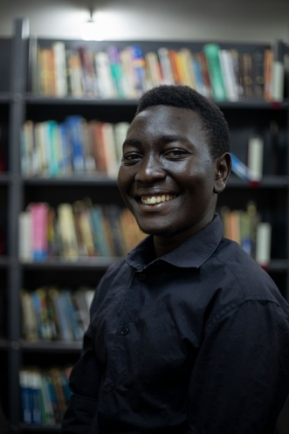

SKILLS
- Video production and editing
- Directing and coordinating film shoots
- Project management and budgeting
- Excellent Communication Skills
- Strong Writing and Editing Skills
- Research and Fact-Checking
- Adaptability and Quick Thinking
- Technical Awareness

PHONE:
0789 277 628

EMAIL:
mwakageraldremmy@gmail.com

EDUCATION

- UMCAT School of Journalism and Mass Communication, National Diploma In Journalism and Mass Communication.
CONTINUING STUDENT.

- Makerere University,
B.A Drama and Film
CGPA. 4.26

- Hope Senior School – Bbira, UACE
12 POINTS

- Opit Secondary School, UCE
47 AGGREGATES

WORK HISTORY
- FREELANCE VIDEO EDITOR & PRODUCER
2016 – PRESENT
Produced and edited documentaries, news stories, and music videos Creating compelling narratives that highlight social issues, including environmental sustainability.
- FOUNDER & FILMMAKER – SHAKERS AND MOVERS (2022 – PRESENT)
I established "Shakers and Movers" to apply my film education, taking on roles in writing, directing, producing, and editing most of the group’s projects.
- CONTENT CREATOR AND NEWS ANCHORING TRAINER – TWINBROOK SCHOOLS (JULY – OCTOBER 2024)
I was responsible for creating engaging digital content for Twinbrook Schools, enhancing their media presence. Taught young learners the basics of news reading, scriptwriting, and confidence building, organized mock bulletins and media activities, collaborated with teachers to integrate journalism into extracurricular activities while inspiring students' interest in communication and public speaking.
- NEWS EDITOR – HOPE BROADCASTING COMPANY (DATE – PRESENT)
I edit my own news stories for my channel, ensuring high-quality and compelling news content.

LANGUAGES

- LEB'ACOLI - Excellent
- ENGLISH – Fluent
- LUGANDA – Elementary
- KISWAHILI - Beginner

INTERNSHIPS AND APPRENTICESHIPS
SOUND ENGINEERING INTERN– July to September 2023.
Assisted in recording, editing, and mixing audio for various media projects, operated studio equipment, supported sound engineers in synchronizing audio with visuals, applied audio processing techniques, ensured sound quality, collaborated with composers and producers, managed audio files, and gained hands-on experience with industry-standard software.

PORTFOLIO

- GOD IS A WOMAN – MICRO FILM
https://youtu.be/C1BDAOiYfo8?si=TLY8QXJhJBESUIbL

- LANGWECH – SMART PHONE FILM
https://youtu.be/XLTZll7WrQA?si=b7_zM_krD8_MwLN0

- THEE THRILLSEEKERS – SHORT FILM
https://youtu.be/xyxlGsgOINs?si=o9QrfTplG1sbMr6l

- CELESTIAL SIRENS – SHORT FILM
https://youtu.be/mQgS937Scp8?si=hXa21Gn8Xo__NpKX

- WALLS – SHORT FILM
https://youtu.be/M_ovFd4IQbs

- NAKIBEMBE EMBAIRE XYLOPHONE TROUPE UGANDA 2024 – DOCUMENTARY
https://youtu.be/gawDNUfugmU?si=kXGCF4MtpwBOQx5m

FINAL DECLARATION
I hereby declare that the information provided in this CV is true and accurate to the best of my knowledge. I understand that any false or misleading information may disqualify me from consideration for the position. I am eager to contribute my skills, experiences, and passion for journalism and media to make a meaningful impact in the industry.
MWAKA GERALD
E-signed.

