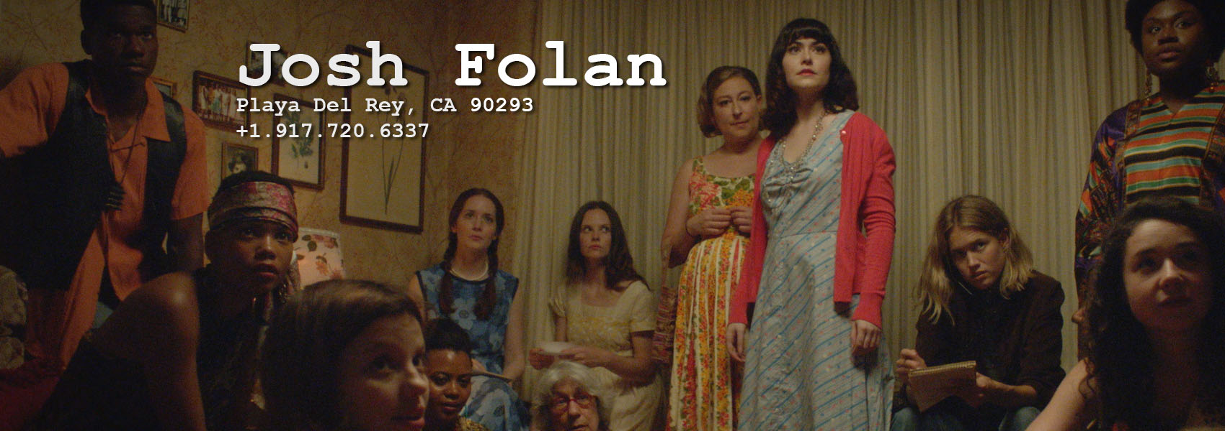
  On the Marquee:  Featured Library Titles:  :: Project Baby (2023) – Feature (RomCom)  Line Producer (LMN)  :: Tales of a Fifth-Grade Robin Hood (2021) – Feature (Family Comedy)  Line Producer (TUBI)  :: Sally Floss: Digital Detective (2021) – Feature (Family/Mystery)  Line Producer  :: CITY (2021) – Feature (Drama)  Producer/UPM/PMD  :: Apache Junction (2021) – Feature (Western)  UPM/Accountant  :: Death Rider in the House of Vampires (2020) – Feature (Horror)  UPM/Accountant | 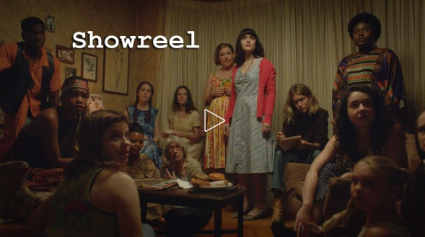  Edu /Software /Awards /Etc:  - Awards List  - MM Budgeting & Scheduling, Final Draft, MS Office, Adobe Creative Suite, Wordpress, Google, HTML  - Author of the Filmmaking, the Hard Way book series, in-depth case studies of the micro-budget filmmaking process  - Finance background, Formerly NASD Series 7 Licensed  - Squaw Valley Screenwriting Workshop Alumnus (2013)  - BSBA (Finance) from The Ohio State University, Fisher College of Business
   | Dance Dads (2022) :: Feature (Comedy)  :: Roles - Producer/Line Producer/PMD  :: Festivals: 2022 Austin Audience Award Winner
  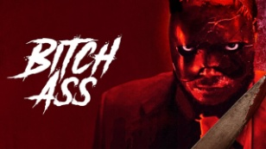 | Bitch Ass (2022) :: Feature (HorCom)  :: Role – Production Supervisor  :: Festivals: 2022 SXSW Selection  :: Released via Signature Ent & Showtime
   | Ask For Jane (2019) :: Feature (Drama)  :: Roles - Producer/UPM/PMD  :: Festivals: 2018 Hamptons/Woodstock/Napa/Athena  :: NA theatrical & VOD release via Level Film
   | The Light of the Moon (2017) :: Feature (Drama)  :: Role – Production Manager  :: Festivals: 2017 SXSW Audience Award Winner  :: NA theatrical & VOD release via Imagination Worldwide
  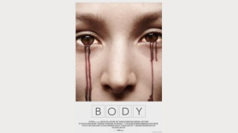 | BODY (2015) :: Feature (Thriller)  :: Role – Co-Producer  :: Festivals: 2015 Slamdance/Oak Cliff  :: NA theatrical and VOD release via Oscilloscope
   | nyehentertainment.com
   | jf@nyehentertainment.com
   | @joshfolan
   | @MYSHIFTKEYISBROKE
   | @nyehentertainment
   | linkedin.com/in/joshfolan
   | imdb.com/name/nm2253666/

