Michael Woods Director, Producer, and Writer
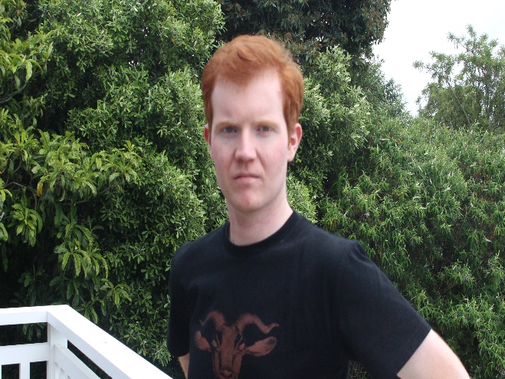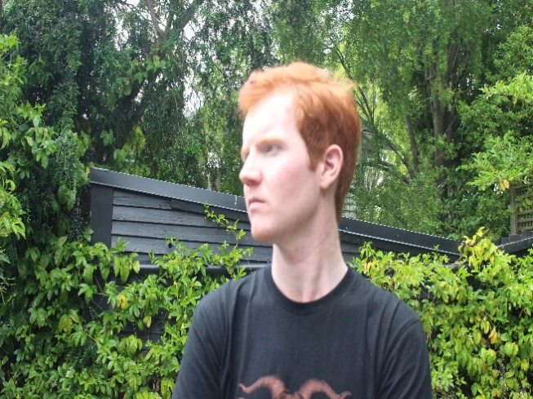

PROFILE
Talented and creative aspiring filmmaker with keen attention to detail. Passionate about filmmaking and the arts in general with a wide knowledge of the history of film and theatre. Filmmaking since 2014 with his own production company Abyssinian Productions.

HIGHLIGHTS
2016 short film The Parcel was screened as part of the 12th Autism Europe International Congress in 2019. 2023 documentary The Craftsmen’s Castle was an official selection for the Tokyo International Short Film Festival in 2024.

EXPERIENCE
Features
2024 The Bostrom Scenario Production Assistant &Featured Extra (Photographer 5) Dir. Richard Townsend Interframe Pictutes
2023 The Craftsmen’s Castle Director, Producer, & Writer Abyssinian Productions
Short Films
2024 Babysitter’s Club Lighting & Production Assistant Dir. Alexander Jones One Dollar Genre
2023 Glitch: The Debugged Cut Director, Producer, & Co-Editor Abyssinian Productions
2022 Archive Co-Director & Co-Producer Co-Dir. Casilda Tudor-Oakley Darkstar Productions & Abyssinian Productions
2021 Tall Poppies Director, Producer, Writer, Co-Editor, Narrator, & Singer Abyssinian Productions
2018 Glitch Co-Director, Producer, Co-Editor, Cameraman, & Actor (Boy in Elevator) Abyssinian Productions
2018 Spiderman & Catwoman vs The Komodosarus Director, Producer, Writer, Cameraman, & Actor (Spiderman) Abyssinian Productions
2016 The Parcel Director, Producer, Writer, & Actor (The Recluse) Abyssinian Productions
Music Videos
2021 Power Up! Director, Producer, Story, Cinematographer, Editor, & Actor (Mega Man) Abyssinian Productions
2019 Baby Blue Actor (Audience Member) Dir. David Duckworth South Island Media

AWARDS
2023 Official Selection for The Craftsmen’s Castle Tokyo International Short Film Festival
2018 Best Sound/Soundtrack for Spiderman & Catwoman vs The Komodosarus The Ed Wood Student Film Competition
2015 Excellence in Acting for Josiah Morgan’s Harakiri: A Portrait Theatrefest

QUALIFICATIONS
2022 Honours in Cinema Studies University of Canterbury
2020 Bachelor of Arts (Double Major in History & Cinema Studies) University of Canterbury

EDUCATION
2017-2021 University of Canterbury
- Achieved a Bachelor of Bachelor of Arts (Double Major in History & Cinema Studies) and Honours in Cinema Studies.
- Participated in clubs and societies such as the Drama Society (Dramasoc) and the Film Society (Filmsoc)
2015-2017 Ao Tawhiti Unlimited Discovery
- Achieved NCEA Level 3 with university entrance.
- Participated in film and theatre clubs.

SKILLS
Directing
Producing
Writing
Acting
Editing (Sony Vegas Pro)

CONTACT
Email: michaelwoods954@gmail.com

