CV
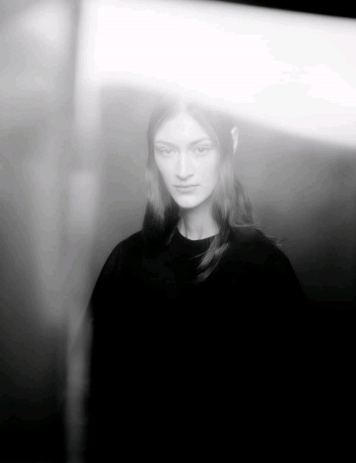

Yevheniia Kolesnykova
Biographical data:
- Date of birth: 23.04.1999
- Place of birth: Konotop, Sumy oblast, Ukraine
Education:
- Kyiv National Linguistic University (KNLU), bachelor's degree in Hungarian philology.
- Transcarpathian Hungarian Institute (ZUI), Master of Hungarian Philology.

Professional activity: linguist, model, filmmaker (self-taught in the field of cinema), director of the Max Sir International Film Festival.
Creative activity:
- Short film ‘History. Love. Modernity’ (2021): Directorial debut, presented at the First All-Ukrainian Khmelnytsky Film Festival, which was the beginning of the cinematic career.
- The documentary The Creation of a Symbolic Painting (2022): Film featuring a chilean artist Max Sir. The film won at 22 international film festivals and was screened during Ukrainian film days in different countries (Ukraine, Hungary, Costa Rica).
- The documentary Sendero Universal (2023): A short film made in Costa Rica about the activities of the country's national parks.
- Max Sir International Film Festival (2023-present): Director and main organiser of the international film festival held in Costa Rica (2023) and Lviv (2024). In two years, the festival has attracted more than 6,000 film crews from 167 countries.
- Charity exhibition ‘Looking for the Mirror’ by Max Sir (2022): Organisation of a charity exhibition in Budapest, which raised 67,000 UAH to help war victims.
- Charity exhibition ‘The creation of a symbolic painting’ (2022): Organisation of a charity exhibition in Budapest, which raised funds to help those affected by the war.
Awards and recognitions:
2022 «The creation of a symbolic paining» – a short documentary about the making series of paintings about war.
- Brno Film Festival (award winner: best mobile short film) Czech Republic
- BlueSky Film&Music Festival (award winner: best short documentary, best short documentary about war) Czech Republic
- Prague International Film Awards (honorable mention: best mobile film, best short documentary) Czech Republic
- Kamianets-Podilskiy International Film Festival “BRUKIVKA” (Finalist: best short documentary) Ukraine
- Kalamata Monthly International Short Documentary Festival (Finalist: best short documentary) Greece
- Scout Film Festival Emerging Filmmakers Grant (Quarter-Finalist: best short documentary) USA
- The Richard Harris International Film Festival (Official selection) Ireland
- Ukrainian Dream Film Festival (Official selection) Ukraine
- Dispatches of War (Official selection) Ukraine
- Black Cat Award International Film Festival (Official selection) Bolivia
- Lift-Off Filmmaker Sessions @PinewoodStudios (Official selection) England
2021 ‘History. Love. Modernity.’ - finalist of the Khmelnytsky Film Festival.
2021 ‘To be routined’ (animation) - selection to the Bardak film festival competition programme, Ukraine

Booklets and event programmes:
https://ngp-ua.info/2021/09/53142
https://khmfilmfest.com.ua/do-konkursnoyi-programy-hmelnyczkogo-kinofestyvalyu-vidibrano-29-kinostrichok/?fbclid=IwY2xjawFr3IFleHRuA2FlbQIxMQABHYxKzZAcENX2ol5Qp92z3xqV464mtY7_iKZSwbRDuu-1mi2MKRCb3cdE8Q_aem_7NEGyXk0a2LcekYuBm3VfQ
https://www.xm-inside.com/news/filmy-hmelnyczkogo-kinofestyvalyu-demonstruvatymut-u-chotyroh-mistah-oblasti-programa/

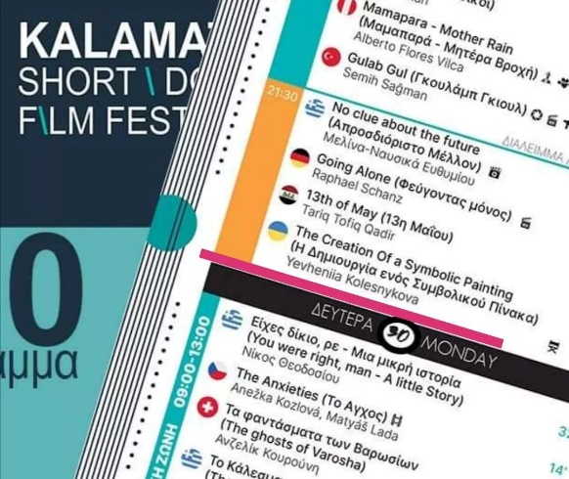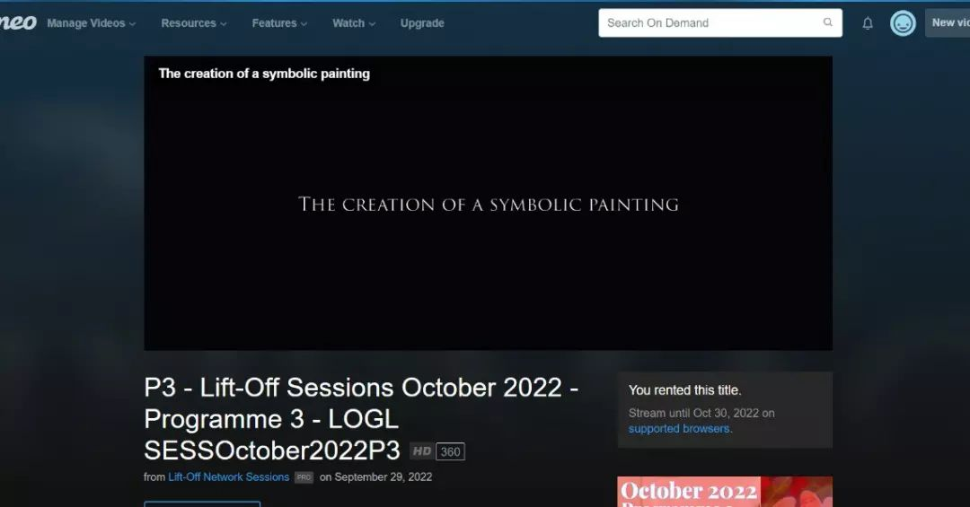
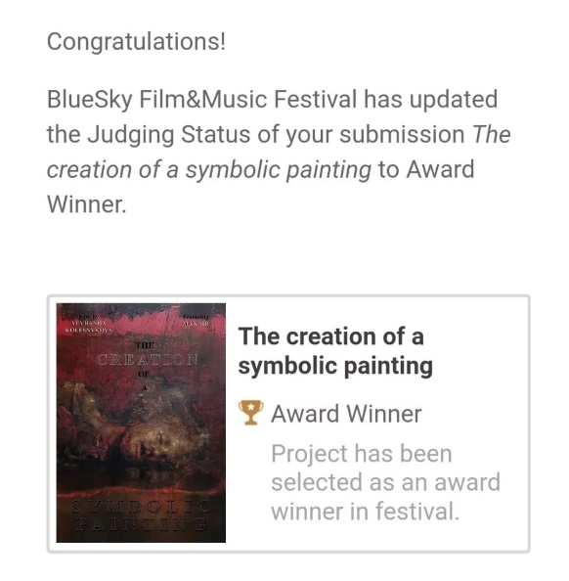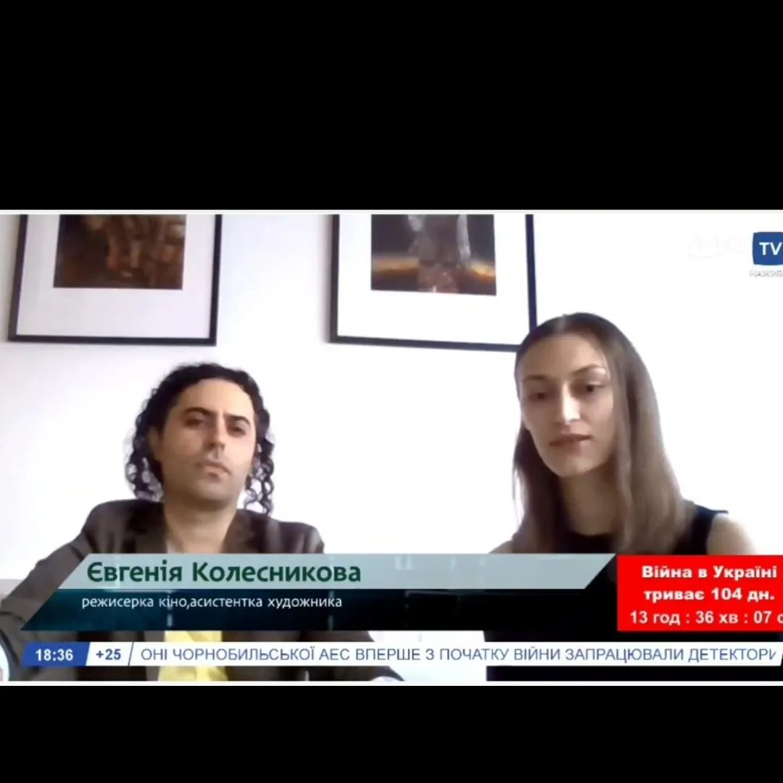
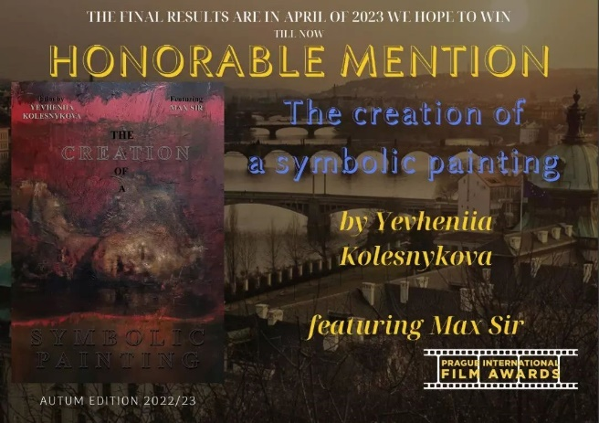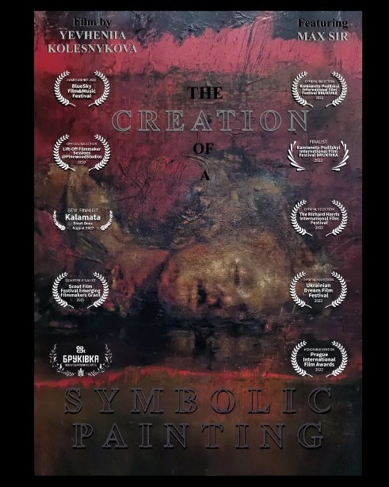

Додаткові матеріали:
https://www.youtube.com/watch?v=-Eg6G4mP05o

Посилання на статті:
https://filmfreeway.com/YevheniiaKolesnykova
https://www.imdb.com/title/tt22756040/?ref_=nm_flmg_knf_c_1
https://shortshorts.org/2023/en/program/smartphone/the-creation-of-a-symbolic-painting/
https://pro.imdb.com/name/nm14134586/
https://peloponnisosdocfestival.com/index.php?option=com_documentaries&view=film&id=384&Itemid=2758&lang=en
https://praguefilmfest.com/winners/20221
https://papageno.hu/intermezzo/2022/09/ukrajnabol-menekult-chilei-muvesz-kepeibol-nyit-jotekonysagi-kiallitast-a-cervantes-intezet/
https://europeanshortawards.com/winners/2021-2022
https://fidelio.hu/vizual/kiallitas-nyilik-az-ukrajnabol-elmenekult-chilei-muvesz-munkaibol-a-cervantes-intezetben-173809.html
https://filmfreeway.com/MaxSirInternationalFilmFestival
https://praguefilmfest.com/winners/202223-autum-edition
https://delfino.cr/2023/09/the-steve-aronson-international-film-festival-premio-a-los-filmes-dedicados-a-la-proteccion-de-la-naturaleza
https://meetdocsfestival.com/en/programma-2022/
https://filmarks.com/movies/109738

