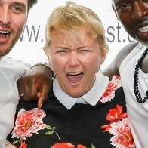
NINA ROMAIN
07936659075 and nromain1@yahoo.co.uk
IMDB page www.girlfright.com
Nina Romain is a London-based organised and experienced writer and producer, whose 16 horror shorts – shot in the UK and LA – have screened or selected in over 165 film festivals globally.

A true “crew allrounder”, she has 10 years’ experience in London features and short films, mainly horror, comedy and drama. She has worked on features as second AD, script supervisor, BTS/videographer, location manager and production manager assistant.

Her work has been screened in the UK's largest International genre film festival, on horror feature: “Are
We Dead Yet?” and Raindance-screened "Love Possibly". She also worked on UK dramedies “Love's Spell” and “On the Other Foot” (as 2nd AD and continuity). She's done some weird and wonderful crew work, including as a camera assistant for the US reality show "The Amazing Race" as well as an SA on Netflix series “The Crown”.

Nina is also an experienced Production Manager Asst, having worked on Sundance-screened feature Love, Possibly, locations manager and script supervisor with strong organisational and prioritisation abilities.

She works as a script reader and film reviewer for Coverfly, Scriptapalooza, industrial Scripts, Golden Scripts, Women in Horror film festival, (US) and London Short Film among others.

She also works in film PR promoting features and shorts (including “The Wick” and has written for Total Film (links available on request).
On the other side of the camera, she has worked in some of London’s biggest immersive theatre experiences, including Punchdrunk, Future Cinema and You Me Bum Bum Train. She has also worked as an SA in features including the respected global success “The Crown”, to UK indie horrors including Dexter Fletcher’s “Dead Cert”, and Jaime Winston’s “Knuckledust”.

EDUCATION

BACHELOR OF COMMUNICATION, AUCKLAND UNIVERSITY OF TECHNOLOGY
Film and TV studied at third year level of degree course, including practical and short docu making.
SUMMER SCHOOL, LAMDA
LAMDA stage management short term course in theatre work: props, direction, costumes.

LONDON ACADEMIC STUDY

FILM STUDY COURSES AT RAINDANCE, CITY LIT, AND FILM OXFORD
RAINDANCE FILM PRODUCERS’ FOUNDATION CERTIFICATE, LONDON.
Weekend and three day courses on all aspects of film making, in front and behind the camera, directing, lighting, production, screenwriting and others. Listed on IMDB as Nina Romain (III).

SKILLS
- Horror short writer and producer
- Feature Asst Production Manager
- Script Supervisor (studied at Raindance)
- Writer for horror zines including Digital Dead, Horror Asylum, and Blazing Minds

ACTIVITIES
- Both academically and practically trained (LAMDA summer school stage management theatre course)
- Feature 2nd AD
- Horror festival script reader and film reviewer for Coverfly, Scriptapalooza, Golden Scripts, industrial Scripts, Women in Horror film festival, (US) and London Short Film

Nina Romain worked in London for over a decade in horrors screening at FrightFest (Dead Cert), and in live theatre productions (such as Top Gear 2009 National Live Tour), and many short films such as “The Wick”. She has worked as script supervisor in Fredi Nwaka's FrightFest 2019 screening "Are We Dead Yet?" and as 3rd AD in Sundance selection “Love, Possibly”.

Nina Romain’s first short "U Never Listen" (2016), a 4-minute short screened in Los Angeles as part of the Hollywood Dead Film Festival in June 2017, and her second Fright Corner (2017) starred Game of Thrones' Rob Callender and screened in Los Angeles’ Hollywood Dead Film Festival and was a semifinalist in the LA Underground Film Festival. She screens regularly at the UK’s largest independent horror festival Horror-on-Sea.
Nina Romain has also worked in live TV in London's ITV, and New Zealand’s TV3 so well versed at helping organize a shoot behind the camera. She has done some weird and wonderful crew work, including as a camera assistant for the US reality show "The Amazing Race".
As a former journalist, she also works as an onset/BTS photographer as well as film premieres, so is adept at taking publicity photos.
She also is a script reviewer for horror, writes film PR and BTS photography, and is a voiceover artist. A Raindance blogger she believes in shooting from the hip in horror as well as shooting it scary.

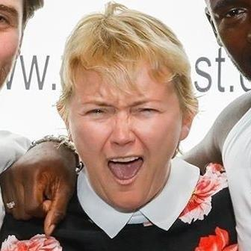2

3

