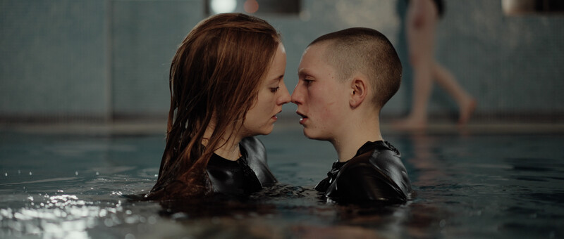Cléa Elisa van der Grijn’s Fever Dream Feature The Disembodied Adventures of Alice screens at the Spring 2024 New Jersey Film Festival on Friday, February 2!

By Evelyn Reese

Adapting a story from one already familiar to most and twisting it into a creation completely unique is a mark of a true creator. The Disembodied Adventures of Alice by Cléa Elisa van der Grijn is an experience unlike the original fairytale. The dissociative nature of the protagonist coupled with the ambiguous and evasive motives of the interacting characters takes the viewer down an equally comforting and eerie descent.

Watching the film feels like a fever dream. This is accomplished through incredible performances as well as outstanding editing. From shot to shot, the camera is filled with murky colors, directly opposing the initial innocence given off by the protagonist. This was a choice perfectly made to set the disingenuous scene. Supporting this was the presence of noise and other times, lack thereof. A loud clang can be just as impactful as a vat of silence filling a room. van der Grijn understands this balance perfectly, as represented throughout the film, blanketing certain shots with subtle music, cascading others in quiet muteness, and contrasting said quiet with loud, sudden sounds. Each choice was beautifully intentional and aided in keeping the audience trapped in the story.

Paramount to a wonderful film is that of a talented cast. The cast of this film is no short of wonder. Each actor perfectly embodied the madness that is laced in each scene. Ranging from despair to rage to pure, unbridled hysteria, the performers were as bold as a shot of whiskey. Their drunken composure in comparison with their seemingly well lived wisdom produces a captivating history that begs to be delved into. Though they experience and express a very wide range of emotions in such little time, if there is one feeling that seems to be left untouched, it is that of shame. No matter the action or behavior, each of the interacting characters emotes unapologetically, adding to their whimsical mystique. This quality helps the audience understand why the protagonist fell so easily into the entrancing trap, perhaps making them want to slip in as well. Part of the allure of the interacting characters are their opaque and clearly articulated styles. While some looks seemed a tad wild or taboo, they were worn with the utmost repose, a true testament to the connection made between performer and character. This sense of self and confidence is intriguing to both the audience and the protagonist, though it also subtly adds to the alienation of the main character.

It is clear through the unraveling of the story that she feels out of place and is in search of a home for herself, not just a bed to sleep in but a people to be a part of. This particular group being so set in their places creates an unsettled air for the protagonist though it is initially sensed as interest, leading her to sit down at the table. When confrontation presents itself, the uneasy tone can be felt clearly by the audience through the combination of presentation of noise, actors’ performances, costuming and lighting. This well put together orchestra of unhinged melody is truly a beautiful accomplishment on van der Grijn’s part.

There is no lull with this film, the ending is as captivating and all consuming as the beginning. It isn’t a surface level creation, in fact it is the opposite. This film provokes deep thought and response from its audience, taking them down a true rabbit hole of struggle, love, pain, learning, healing, consciousness, breaking points and so much more. This eccentric ensemble of bizarre relations derived from classic literature yet so dramatically reimagined by Cléa Elisa van der Grijn is a true escape from reality for 1 hour, 18 minutes and 28 seconds, and a must watch film.

The Disembodied Adventures of Alice screens at the Spring 2024 New Jersey Film Festival on Friday, February 2, 2024 – Online for 24 Hours and In-Person at 7PM! in Voorhees Hall #105/Rutgers University, 71 Hamilton Street, New Brunswick, NJ. The Disembodied Adventures of Alice Director Cléa Elisa van der Grijn and DP Ciaran Carty will be on hand to do a Q+A after the In-Person screening!
For more info and tickets go here:
https://watch.eventive.org/newjerseyfilmfestivalspring2024/play/652487d479250800322948c2

