SHIFT
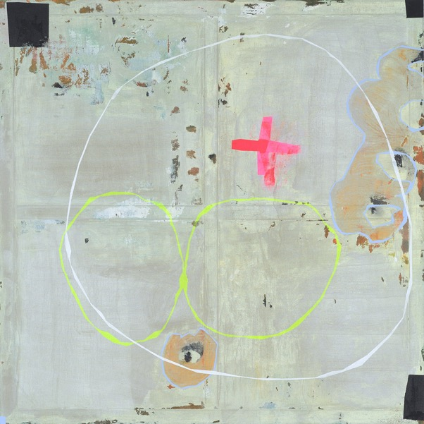
‘How long is forever? Sometimes just one second’ (Lewis Carroll-Alice in Wonderland) Mixed media on Linen 152 cm x 152 cm 2021.

SHIFT comes both in the wake of and the process of FLUX—like the climax of a tsunami, FLUX leaves behind an altered landscape. Nothing is the same. With SHIFT, van der Grijn explores this landscape, going to the outer edges of emotions and depicting emotional dysregulation, but as a means of disinterested exploration of what it is to be human rather than just with a focus on the discomfort and challenges it brings. She sails close to the wind rather than on an even keel, leaves the well-trodden path with its clear destination to instead build the way as she goes, both in content and form, genuine authentic exploration with openness to being surprised by the destination.
When Ernest Shackleton was looking for companions to join his expedition to explore the physical outer reaches of the time, he advertised for men for a “hazardous journey, small wages, bitter cold, long months of complete darkness, constant danger, safe return doubtful, honour and recognition in case of success”. What kind of person would respond to this today? Perhaps, in these days of celebrities, the promise of recognition might be a motivation; but celebrity status is about notoriety for notoriety’s sake, and this can be earned in much less strenuous ways. Also, a person driven by fame for fame’s sake would be unlikely to go looking for it so far from the source of validation, so-called ‘civilisation’. No, this type of call will be answered by those seeking validation in the act itself, explorers moving towards the source of validation: the call of the wild? But what does wild say? What is wild: untamed, nature, naturalism?
As always, van der Grijn is contemporary, not because she is on-trend, but because universal themes are timeless, and so always contemporary. The wild, untamed, is what that call is to. Back to the world before words, without words, back to nameless and uncalled, unknown, that world every individual is beckoned out of in the early days of their lives with calls to ‘use your words’ and ‘contain yourself’. Some find it harder than others to fit within the limits of tameness (society) and can feel like imposters, alien. But none of us is alien, instead, some have a balance of wildness that is greater than tame. They are subject to ‘the call of the wild’, and while van der Grijn may not venture to the poles or into outer space, she does venture to the edges of human experience and emotional, psychological and mental endurance and brings back stories without words, stories of the landscape in maps.
SHIFT evokes maps and topography: islands and mountains and wide open oceans, journeys of discovery, new discovery without a certain destination. SHIFT is not a call to anywhere; instead, it is a call to remember and bear witness to what is more to our nature. Just as the explorer of the poles brings back evidence, charts new lands, van der Grijn charts outer edges of ontological extremes, the highs and the lows and the tools, the grappling hook that both hooks and is used to hook, crosses (death) letting go, rebirth, skin-shedding along the way.
The edges are hellish, and often we don’t return; whether it is the edges of endurance at the actual edge of the world or the edges of psychological endurance of extreme emotional dysregulation. These are hellish, but only tragic if not embraced, if rejected. Hell takes us to edges, the precipice; and it is only here that an unqualified and unconditional ‘yes’ to life is possible—no ‘ifs’ or ‘buts’. How many ask that question? To be pushed to the edge of endurance and still say yes is to be asked: “Do you really want this?” It is ultimately to be pushed to the point of enabling consciousness. Arguably, living without knowledge of whether we would choose to stay no matter what is but a provisional existence. Without the ‘dark night of the soul’, there can be no dawn (dawning). It is to remain in the waiting room. Grace calls us forth, if we are lucky, pulling us there where the limits of endurance are presented, and we are faced with the question, the simple question: do you want to live? Regardless? This is a question that can only be answered absolutely (you do or you don’t); and the answer can only be known in an absolute sense when it is given from a position of being ‘on our knees’.
Dialectics are at play in much of van der Grijn’s work in terms of a holding of opposites in tension to frame a window to what is more. Dialectics, not just of content or context, but also of means of representation. Brechtian calling attention to the means of production of the creation of the art is not new for van der Grijn either. In FLUX, perspective is played with in such a way that, while the mechanisms of creation of the scene might not be being shown, the viewer is nevertheless not allowed to fall into a state of Stanislavskian suspension of disbelief. FLUX achieves this through plays of perspective, showing the experience from the inside, the outside, through the eyes of the protagonist, and then voyeuristically and without warning, looking right at him, but blinded by his torchlight shining at us: the viewer is exposed and vulnerable.
Vulnerability is at the heart of FLUX: vulnerability of the boy, the swan, the eggs, but also vulnerability of the viewer. JUMP is psychological, taking the viewer on a journey into the mind, the psyche. FLUX, conversely, is real. While it does jump between dreamscapes—we cannot be sure if it is a dream or reality—it creates a bridge between the psychological and the sensory, the somatic experience of being in the world. Curtains are veil-like, pulling back veils. It is partly set inside a house, a home that is lived in. The boy is dreaming, but the dream is happening in his own home. Mixing realism with magical realism: real life non-actors with magically real content, dream-like, but only to the extent of pushing past the boundaries of the real rather than taking us categorically into the unconscious, FLUX requires us to stay in the dialectical moment, in between the source and the particular, where things come to be, the whirlpool in the stream of becoming. The boy non-actor cannot quite mask his self-consciousness, the sounds of the toilet, the electric buzz of the fridge in the background in the house could also imply the whirr of a film projector, again drawing attention, if not to the means of production, to the fact of it being a production. Who is doing the watching? It is unsettling, looking at something so deeply intimate, voyeuristic, and then being seen by the torch, the viewer feels like they’ve been caught doing something shameful, they too are vulnerable, but FLUX wraps its arms around and draws the viewer in. It is a place, a space, for vulnerabilities, humanness, humanity, including voyeurism.
This style breaks the boundary between the artwork and the viewer. It is not possible to anonymously observe. In FLUX, the viewer is seen (or feels like they are), while in SHIFT, by drawing attention to the means of production of the paintings, the viewer is invited (compelled if they refuse the invitation) to participate in the creation of their experience of (perception of) the artwork. They are part of it, and so, invested in it. Before they know it, they have made it their own.
Falling out of the mind and back into the body is to be liberated from the logical limitations of the mind. It is to fall into a different reality wherein those intellectual rules of logic do not apply in such an absolute sense. Philosophers like Whitehead have called this state ‘God’, believing in the essentiality of there being agency involved and of giving this agency a name. But he is making the same error, calling it something. There is something that is beyond words, beyond constructs of time and space, and this is where van der Grijn is pointing. Just as it cannot be named/defined, nor can it be depicted definitively. Like Whitehead’s ‘forms’ or ‘eternal objects’ as potentialities for ‘actual occasions’, van der Grijn’s paintings in SHIFT are potentialities to experiences of the wordless (God in Whitehead’s words, but definitely not in van der Grijn’s—she does not presume to name it). The paintings are a means rather than an end. They do not show something, rather they show a way to something. They are maps rather than descriptions, showing the way to look rather than something to look at. They are an invitation to a journey rather than an end point.
With the dawning of this Love and the voice of this Calling
We shall not cease from exploration
And the end of all our exploring
Will be to arrive where we started
And know the place for the first time.
Through the unknown remembered gate
When the last of earth left to discover
Is that which was the beginning.
Dr Veronica O Neill

Enda Walsh, Arlington.
T.S. Eliot. From Little Giddings

