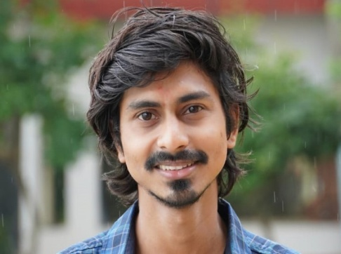
ACHIEVEMENTS
- Official Selection
- Glow Film Fest, 2022
- Cine Town Awards, 2022
- Global Independent Film Festival, 2022
- Kerela International Short Film Festival, 2022
- Dadasaheb Phalke International Film Festival, 2022
- Cine Parbon International Film Festival, 2022
- South Asian Short Film Festival, 2022
- 17th Mumbai International Short Film Festival, 2022
- Brno Film Festival, 2022
- Malhaar Virtual Video Film Festival, 2022

- Winner
- Best Film at 14th Guwahati International Film Festival, 2021-2022
- Best Concept at Motion Horse International Film Festival, 2022
- Best Short Film below 10 minutes at Roshani International Film Festival, 2022
- Best Silent Film at Indo-French International Film Festival, 2022
- Best Silent Film at International Motion Picture Festival of India, 2022
- Best International Short Film at New Jersey Film Awards, 2022
- Best Concept at Royal Peacock Film Festival, 2022
- Best Short Film at Chalchitra Rolling Awards, 2022
- Best Director at One Lead International Film Festival, 2022

CREDITS
Film: RED (2022) (debut)
LANGUAGES
Assamese
Hindi
English
AREAS OF EXPERTISE
Direction
Story Writing
Script Writing
Acting
PERSONAL DETAILS
D.O.B: 26th September 1995

CONTACT DETAILS

Address: Gotanagar, PNGB Road, Maligoan, Guwahati- 781011

Email ID: pulakpkd.3@gmail.com

Phone no.: +91 8811832522
TRAINING
Acting & Direction
Assam Music and Film Institute, Rajgarh, Guwahati (2018)

Filmmaking
Isha Film and Televison Academy
Malad West, Mumbai (2022)
ACADEMIC QUALIFICATION
Bachelor of Commerce
Lalit Chandra Bharali College
Guwahati, Assam

Bachelor of Arts (Assamese)
K.K.Handique State Open University
Guwahati, Assam
PERSONAL SUMMARY
A self-motivated and committed director with strong instinct of good writing skills and direction and has gone through extensive formal training. Committed to achieve the highest standard performance and always willing to learn from others. An avid listener and observer, aiming at a constant involvement and evolving in terms of both professionally and personally with highest emphasis on hard work in order to make significant contributions to the industry and also an explorer to this infinite art form of filmmaking.
PULAK KUMAR DAS

